6/29/2026
Opioid settlement Advisory Committee project data collection and outcome report

STATE OF CONNECTICUT
DEPARTMENT OF MENTAL HEALTH AND ADDICTION SERVICES
A Healthcare Service Agency

NED LAMONT  GOVERNOR |  | NANCY NAVARRETTA, MA, LPC, NCC  COMMISSIONER
Introduction and Background:
Connecticut is expected to receive over $600 million over 18 years as part of the nationwide opioid litigation settlement agreements with various pharmaceutic distributors and opioid manufacturers. Proceeds will be spent on substance use disorder abatement infrastructure, programs, services, supports, and resources for prevention, treatment, recovery, and harm reduction with public involvement, transparency, and accountability. The Opioid Settlement Advisory Committee (OSAC) was established to ensure the proceeds received by the state are allocated appropriately, deliberately, and in accordance with the settlement agreements and enacted laws.
Data provided by the Connecticut Department of Public Health demonstrates that after reaching a peak in 2021, the number of overdose deaths continues to decrease year over year, with an overall decline of 45.5%, including a 15.1% decrease from 989 unintentional drug overdose deaths in Connecticut in 2024 compared to 836 deaths in 2025. While this data is promising testament to the work being done throughout Connecticut, a continued array of services is needed for ongoing reduction in overdose deaths.
Since November 2023, OSAC has approved a total of 18 funding recommendations, resulting in 21 separate projects, allocating a total of $119,193,170 in settlement funding. After OSAC approves each project, the anticipated project data points are developed collaboratively with the OSAC Research and Data Subcommittee, Project Manager, and other key partners. This report provides an update on the implementation status and overview of the available data for each of the approved projects.
Connecticut municipalities also receive Opioid Settlement proceeds directly from the settlement administrator. Information about municipal level settlement allocations and projects can be found on the OSAC website linked below under the Municipal Information section.
Additional information about OSAC and its approved projects, including the Connecticut Opioid Settlement Dashboard, can be found at https://portal.ct.gov/cosac. You can also see each OSAC-Approved Funding Recommendation by holding control and clicking the link at the top of each project section.
Please direct any questions about this report to OSAC@ct.gov.
Sincerely,
The Department of Mental Health and Addiction Services Opioid Settlement Administration Team
Table of Contents
Projects are listed in order of OSAC approval date. Hover over the project title, hold the CTRL key, and click on the link to navigate to the identified section.
Expansion of Syringe Service Program (SSP) Supplies
Mobile Opioid Treatment Program (OTP)
Treatment Pathway Program (TPP) Continuation
Department of Corrections Opioid Treatment Program Expansion
Naloxone Saturation
Harm Reduction Vending Machine Pilot
Primary Prevention Through Education and Reduction of Opioid Diversion
Opioid Deactivation Pouch Mailing
Contingency Management—Adults
Contingency Management—Youth
LiveLOUD Public Awareness and Education
Treatment Bridge Model for Connecticut’s Emergency Departments
CT Collegiate Opioid Overdose Prevention and Recovery Project
SafeSpot Overdose Hotline
Harm Reduction Centers
Housing Empowering Recovery from Opioids (HERO)
Emergency Department Recovery Coaching
Recovery Centers Continuation
CT Drug Data Collaborative
Opioid Treatment Program Access Expansion
Helping Youth and Parents (HYPE) Recovery

Expansion of Syringe Service Program (SSP) Supplies

Brief Description: Expand the state’s SSP supplies at the Department of Public Health
Category: Harm Reduction
Approval Date: November 2023
Total Amount: $2,000,000
Total Years: 4
Contract Start Date: 1/1/24
Implementation Updates: Funding of $500,000 for 1 year was initially approved in November 2023, which was fully expended. An additional $1,500,000 over 3 years was approved in May 2024. Supplies are being disseminated via SSPs statewide.
Reporting:
☒ Data Collection and Output Reporting ☐ Program Evaluation
Anticipated Data Points:
- Distribution Amounts
- Estimated Individuals Served
- Annual CT SSP Report (available each June/July) includes number served, number of unique visits, number of new SSP clients, demographics (gender, age, race/ethnicity), services information (including number of individuals tested for HIV/Hepatitis C, treatment referrals, supply distributions), primary substance reported
  - Note: This report cannot be broken down by funder but provides a comprehensive outline of SSP supply distribution.
Anticipated Reporting Dates:
- Annually by Fiscal Year and/or upon utilization of all funds
Data Collection and Output Reporting:
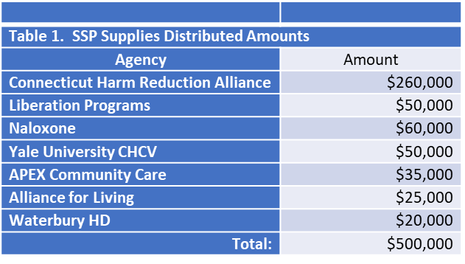
- Annual funding ($500,000 for 1 year) is estimated to serve 6,418 individuals. Additional information is available in Table 1:

- The following data is reflective of FY 25 Syringe Service Data across all providers and
funding sources:
Number of Clients by Race/Ethnicity Combined
Race/Ethnicity Combined | New Clients | Total Clients Served | Total Transactions | Total Naloxone Kits
American In/AK Native | 16 | 30 | 201 | 21
Asian | 10 | 25 | 94 | 19
Black/African American | 907 | 2169 | 15251 | 1989
Hispanic/Latino | 1264 | 3494 | 27653 | 3192
Middle Eastern or North African | 3 | 5 | 11 | 1
Native HI/Pacific Islander | 7 | 24 | 71 | 23
White | 2211 | 5427 | 39948 | 5293
More Than One Race | 63 | 130 | 745 | 134
Declined | 90 | 278 | 2973 | 793
Don’t Know | 51 | 115 | 426 | 263
Not Asked | 495 | 566 | 2520 | 358
Totals | 5117 | 12263 | 89893 | 12086

Sample of Materials Distributed
Material | Material Count | Transactions
Syringe | 2,391,329 | 57,890
Safer Use Kits | 77,344 | 59,539
Testing Strips | 28,767 | 7,498
Sharp Containers | 5985 | 4852
Wound Care Kit | 4742 | 2977
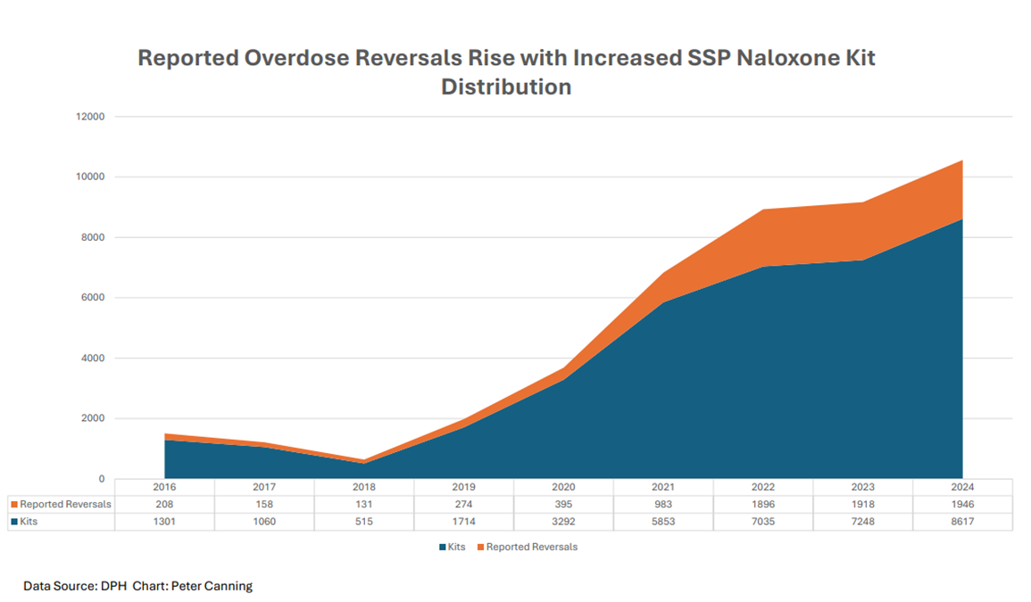

Mobile Opioid Treatment Program (OTP)
Brief Description: Fund 2 Mobile OTPs allowing for easier access to Medications for Opioid Use Disorder (MOUD), particularly Methadone.
Category: Treatment
Approval Date: March 2024
Total Amount: $4,000,000
Total Years: 3
Contract Start Date: 1/1/25
Implementation Updates: A competitive procurement process was utilized to identify the service locations and providers; Community Health Resources (CHR) was contracted to serve the Northeast region, and APT Foundation was contracted to serve the Southeast region. Due to length mobile unit procurement processes and regulatory and licensing requirements, these programs are not yet serving clients through their mobile units. Both units: have been delivered and outfitted to provide services; are DPH licensed and able to provide services within their established communities; and have an established schedule of where they will be providing services. The agencies continue to seek applicants for open staffing positions, though enough staff have been hired and oriented to begin providing services. Both agencies are slated to start providing services in Summer 2026.

Reporting:
☒ Data Collection and Output Reporting ☐ Program Evaluation
Anticipated Data Points:
- Demographic Data
- Connections to Treatment (other than services provided on the vehicle; number and type)
- MOUD inductions on vehicle vs referral to another site
- Engagement Retention in MOUD
- Harm Reduction Supplies dispersed
- Van location (days, hours) & Individuals Served: Per Day/Location, identify number individuals prescribed MOUD/MOUD type, number individuals dosed, number individuals provided education or resources but not started on MOUD
- # individuals with reduced or eliminated substance use
Anticipated Reporting Dates:
- Every 6 months upon contract execution and initiation of service delivery: January 15, July 15
Data Collection and Output Reporting: Pending first report upon initiative of service delivery.

Treatment Pathway Program (TPP) Continuation
Brief Description: Continuation of TPP, a court-base pre-trial diversionary initiative for individuals with substance use disorders charged with nonviolent offenses, providing clinical evaluation and connection to clinical services, recovery coaching, and support services and referrals.
Category: Treatment, Recovery Support
Approval Date: May 2024
Total Amount: $3,840,000
Total Years: 3
Contract Start Date: 7/1/24
Implementation Updates: Project continued as scheduled without interruption.

Reporting:
☒ Data Collection and Output Reporting ☐ Program Evaluation
Anticipated Data Points:
- Demographic Data
- Total number of clinical assessments completed
- New individuals in reporting period per court
- Number individuals connected to treatment through TPP per court
- Number of planned successful discharges
Anticipated Reporting Dates:
- Every 6 months upon contract execution: July 15, January 15
Data Collection and Output Reporting:
Year 1: 6-Month Report (7/1/24-12/31/24):
- New Individuals Served by Court Location:
  - Bridgeport: 26
  - Waterbury: 30
  - Torrington: 15
  - New London: 24
  - Manchester: 38
  - New Haven: 50
  - New Britain: 67
  - Danielson: 35

Total: 285
- Number of Treatment Connections: 189
- Number of Successful Discharges: 37
Year 1: 6-Month Progress Report (1/1/25-6/30/25):
- New Individuals Served by Court Location

  - Bridgeport: 44
  - Waterbury: 27
  - Torrington: 10
  - New London: 39
  - Manchester: 20
  - New Haven: 68
  - New Britain: 36
  - Danielson: 25

Total: 269
- Number of Treatment Connections:
  - Medication Assisted Treatment/Medications for Opioid Use Disorder: 53

  - Withdrawal Management: 75
  - Intensive Outpatient: 129
  - Inpatient Psychiatric Treatment: 4
  - Residential Treatment: 92
  - Recovery Groups: 55

  - Total: 408
- Number of Successful Discharges: 51
NEW: Year 2: 6-Month Report (7/1/25-12/31/25):
New Individuals Served by Court Location
 | 7/1/25-12/31/25 |  | 1/1/26-6/30/26 |  | Annual Total
 | Assessed at Court | Ordered by Court | Assessed at Court | Ordered by Court | Assessed at Court | Ordered by Court
Danielson | 26 | 18
New Haven | 45 | 34
Waterbury | 28 | 19
Bridgeport | 12 | 16
New London | 29 | 16
Hartford | 46 | 26
Middletown | 35 | 21
New Britain | 34 | 40
Total | 255 | 190
Note: The assessments reflect the preliminary tier of individuals served—those evaluated at court—while the number of those ordered by court captures those who proceeded into the program and received TPP services. Showing both categories represents the full scope of the program activities.

Treatment Connections
 | 7/1/25-12/31/25 | 1/1/26-6/30/26 | Annual Total
MAT/MOUD | 32
Withdrawal Management | 81
Intensive Outpatient | 109
Inpatient Psychiatric | 19
Residential | 57
Recovery Groups | 55
Total | 353

Number of Successful Discharges: 47

Additional Narrative Description:
The Treatment Pathways Program initiative is to identify recently arrested persons with substance use issues and connect them to the least restrictive and most appropriate treatment connect as opposed to bond. The Treatment teams continue to form relationships with clients and utilize appropriate resources to address clients’ needs throughout their judicial pre-trial process.
Programs integrate equity-focused strategies into both clinical practice and programmatic design to address behavioral health disparities and enhance client outcomes. Through culturally responsive, trauma-informed, and evidence-based interventions, staff ensure that all individuals receive access to appropriate and effective care within the TPP program. This approach is embedded across the continuum of services, including assessment, individualized treatment planning, care coordination, and discharge planning. By reducing systemic barriers and prioritizing client-centered engagement, programs aim to support equitable access to behavioral health services and promote sustained recovery for justice-involved populations. Staff attend a variety of training opportunities intended to equip the staff with the skills and knowledge needed to effectively serve and support the community.
TPP continues to make meaningful progress toward its mission of supporting individuals involved in the legal system who are struggling with substance use. A key factor in participants' success is the program’s ability to provide immediate, tangible resources that remove barriers and increase client engagement . Using Flex Funds, TPP teams have helped clients not only achieve, but sustain, their recovery goals. Flexible financial support has provided critical relief to clients working to rebuild their lives. The adaptability of these funds ensures that TPP can meet the unique and evolving needs of each participant. Simple yet critical items have proven instrumental in helping clients attend treatment, access support, and take steps toward long-term stability. Items purchased through Flex Funds include but are not limited to cell phones, bus passes, food and clothing, ID cards, driver’s licenses, hygiene products, and housing support.
Client needs are further addressed through connection to critical resources and programs including various housing programs and resources, connections to medical care, transportation, and coordination of basic needs including insurance re-instatement.
One noted challenge is limited housing resources, as this often impacts client engagement and success in the program, though the introduction of flex funds has provided some relief on this challenge and staff continue to build housing resources and connections. The other primary noted obstacle is finding an immediate treatment bed when withdrawal management and residential treatment are the recommended level of care, though clients are connected with outpatient levels of care while awaiting a bed.
Program leadership consistently assesses the successes and challenges of the TPP program. In summer 2025, the decision was made to close TPP at the Manchester and Torrington courts due to a mix of low enrollment and difficulty maintaining the required staffing pattern despite intervention. The Hartford and Middletown courts were identified as areas of need, and TPP has been initiated in both courts.
Success Stories:
“The power and impact of this type of support should not be overlooked. When an individual is granted TPP in New Britain, they receive a backpack filled with self-care necessities and Narcan. In the fall of 2024, a client was granted the program with no belongings. They accepted the backpack, clutching it tightly, as TPP staff transported them to the hospital for immediate medical care. Months later, that same client was thriving. They were maintaining recovery, attending outpatient treatment and living in sober housing. They expressed gratitude for the support they received on their first day in the program. To show their appreciation, they offered to donate supplies for future clients facing similar challenges.”
“The client is 53 years old and has successfully completed the TPP program. He entered the program following a challenging period in his life. Throughout the duration of treatment, the client remained compliant, actively engaged in his care, and demonstrated a strong commitment to setting and achieving personal goals. Upon discharge, the client focused on overcoming barriers to progress and expressed a clear intention to continue his education. Currently, the client is connected with community resources, has secured stable housing, and is in the process of reenrolling in and completing his master’s program. He aspires to work in the behavioral health field, motivated by his own experiences, which he finds both inspiring and empowering. The client aims to use his story to support and guide others facing similar challenges.”
“This client began with TPP in January of this year (2025) and was homeless living in a tent in Waterbury. This client was very resourceful and motivated. TPP helped connect him to treatment which he successfully completed. While he did have 1 relapse while in TPP, he was motivated to return to treatment and make more serious changes. He again completed inpatient treatment and instead of returning back to the Waterbury area, he chose to enter into sober living. Through sober living he began looking for full time employment and attended further groups through his sober living program. This client’s case was disposed of at his last court date and was successfully relieved of TPP.”
“Client P was referred to TPP in Nov 2024. He was initially referred to detox followed by inpatient treatment. Once client completed these recommendations he engaged in outpatient treatment at MCCA. Client engaged in MAT for MH as well as MAT for SA while engaged in engaged in IOP followed by Relapse Prevention and a Men’s Wellness group. Client was able to move back in with his family and engage in family therapy. Client completed TPP after being engaged in the program for 7 months connecting with an outside provider for Mental health to help tackle some past unresolved trauma. Client was able to build a collective toolbox of coping skills for Mental health, anger management and Relapse prevention, while engaged in the TPP program.”
“Over the past year, TPP has witnessed meaningful progress among many of its participants. One individual exceeded the team’s expectations, as they not only overcame personal barriers to recovery, they also fully embraced the recovery community. With the support and structure of TPP, this individual’s confidence and independence strengthened. They completed over 250 volunteer hours with CCAR, and their commitment was recognized with a scholarship to attend CCAR’s Recovery Coach Academy. At the time of their successful completion of TPP, they had reached over 90 days of recovery, secured employment, and resolved all outstanding legal matters. Several weeks later, this client accepted an invitation to speak at a Wheeler Clinic board meeting, where they shared a heartfelt letter expressing gratitude for TPP’s support and guidance."

Department of Corrections Opioid Treatment Program Expansion
Brief Description: Build out Opioid Treatment dosing rooms at 4 additional facilities to ensure access to all FDA-approved medications for opioid use disorder (MOUD) for all individuals incarcerated in and transitioning out of CT DOC.
Category: Treatment
Approval Date: May 2024
Total Amount: $416,650
Total Years: 1
Contract Start Date: 7/1/24
Implementation Updates: All sites continue to work on the build-out of the OTP rooms. Completion is
anticipated by summer 2026.

Reporting:
☒ Data Collection and Output Reporting ☐ Program Evaluation
Anticipated Data Points:
- Build-out completion dates
Anticipated Reporting Dates:
- Upon completion of build-out
Data Collection and Output Reporting: Pending completion of build-out.

Naloxone Saturation
Brief Description: Purchase of Naloxone for overdose reversal to ensure an abundant supply is going into the community, supporting the State’s Naloxone Saturation plan of distribution of 60,000 naloxone kits per year
Category: Harm Reduction, Prevention
Approval Date: May 2024
Total Amount: $9,292,800
Total Years: 4
Contract Start Date: 7/1/25
Implementation Updates: DMHAS continues to provide naloxone to any organizations in need of naloxone to distribute to the community to ensure statewide availability via braided funding. To obtain Naloxone for distribution, please contact Karolina Wytrykowska at Karolina.Wytrykowska@ct.gov. Project was initially approved for $2,323,200 for one year. On 4/7/26, the funding was continued for 3 years at $2,323,200 annually.

Reporting:
☒ Data Collection and Output Reporting ☐ Program Evaluation
Anticipated Data Points:

- Number of kits distributed
- Agency/facility type (PNP, Hospitals, School, etc.)

Anticipated Reporting Dates:
- Annually by Calendar Year and/or upon utilization of all funds
Data Collection and Output Reporting:
Naloxone (brand name Narcan), is an opioid antagonist medication, used as a harm reduction tool to reverse an active overdose. The Department of Mental Health and Addiction Services has made it a priority to make this life saving medication available to all hospital emergency departments, treatment and recovery support providers, municipalities (first responders), and harm reduction service organizations. In 2022, DMHAS created a state naloxone saturation plan of distributing at least 45,000 naloxone kits and distributed close to 60,000 naloxone kits in the following calendar year, at no cost to the receiving organizations across the state. DMHAS continues to exceed the saturation goal with # kits distributed in CY 2024. Naloxone is available over the counter at most CT pharmacies and continues to be covered by Medicaid, however due to stigma, individuals sometimes prefer to get the kit from someone they trust. In addition to DMHAS supported entities, naloxone is distributed by the Department of Corrections (DOC) to individuals leaving their system, and available through pharmacies and municipal funding for emergency response. DMHAS employs an efficient system of purchasing naloxone directly from a distributor, who mails it directly to the organizations requesting the product. Since achieving the saturation goal, Connecticut saw a significant decrease in overdose fatalities for four consecutive years, and that trend is on track to continue for 2025.

DMHAS naloxone distribution by calendar year
2019 | 11,581
2020 | 13,162
2021 | 14,986
2022 | 29,064
2023 | 58,642
2024 | 64,087
2025 | 77,304
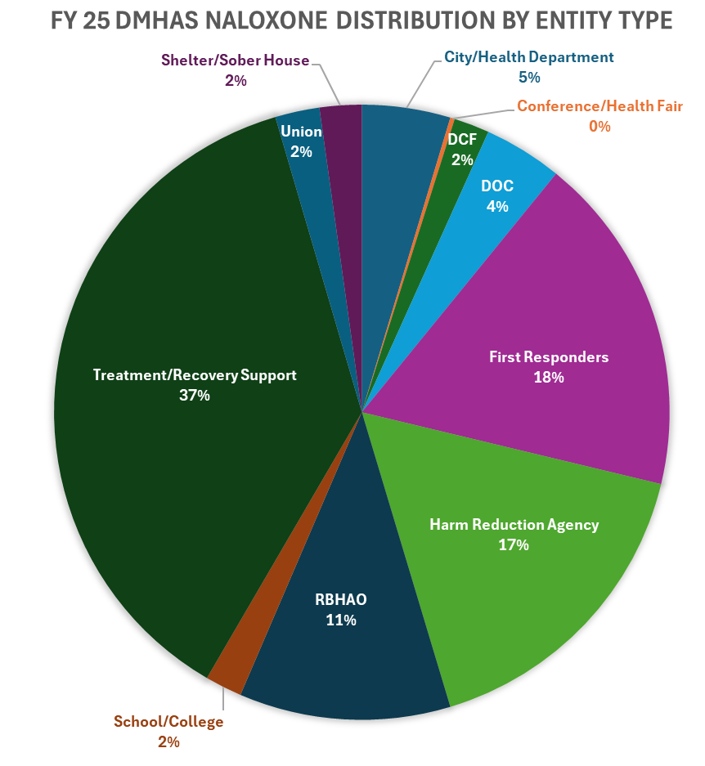

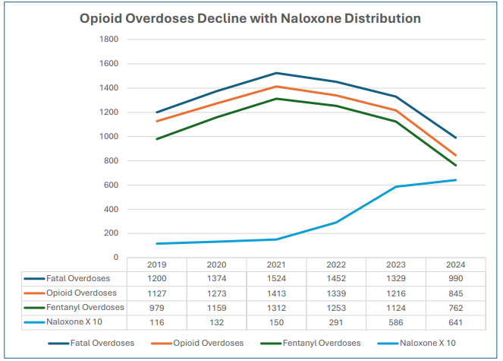

Source: DMHAS Chart by Peter Canning

Harm Reduction Vending Machines
Brief Description: Pilot Harm Reduction Vending Machines in 20 municipalities across Connecticut
Category: Harm Reduction
Approval Date: July 2024
Total Amount: $2,754,784
Total Years: 2
Contract Start Date: 10/1/25
Implementation Updates: Providers continue to meet biweekly with the DMHAS contract manager as part of an active work group advancing the implementation workplan. Most host locations have been confirmed, with letters of support secured where required. Sites are currently navigating local zoning processes and preparing installation areas to meet infrastructure and DCP regulatory needs, including power, foundations, and awnings. Two providers are awaiting final executed contract amendments, which are with the Attorney General’s office and anticipated for signature by the end of next week. Current efforts also include finalizing machine wraps and coordinating with the vendor to establish the shared technology data system.

Reporting:
☒ Data Collection and Output Reporting ☐ Program Evaluation
Anticipated Data Points:
- Vending Machine locations
- Supplies Provided by count by Vending Machine location
- # Unique Individuals Served by Vending Machine location
- Participant Zip Codes Served by VM location
Anticipated Reporting Dates:
- Every 6 months upon contract execution
Data Collection and Output Reporting: Pending; implementation in progress.

Primary Prevention Through Education and Reduction of Opioid Diversion
Brief Description: Primary Prevention through education and reduction of opioid diversion, including Medication Lock boxes and mounted Naloxone boxes
Category: Prevention, Harm Reduction
Approval Date: July 2024
Total Amount: $1,418,000
Total Years: 2
Contract Start Date: 7/1/25
Implementation Updates: Contract fully executed. Contractor has identified Naloxone Box options for purchase and is connecting with key partners for collaboration to identify Naloxone Boxes installation locations; initial Naloxone Boxes to be installed in June 2026. Change the Script continues to attend community events to provide education and resources.
Reporting:
☒ Data Collection and Output Reporting ☐ Program Evaluation
Anticipated Data Points:
- Naloxbox locations and kits disseminated per box
- Services provided and individuals reached
- Supplies disseminated
- Events (location, type, number engaged)
- Advertising communications for events hosted
Anticipated Reporting Dates:
- Every 6 months upon contract execution: January 15th, July 15th
- Presentation to OSAC after 18m of data collection
Data Collection and Output Reporting:
NEW: July 1, 2025-December 1, 2025 Activity Status and Updates
Activity 1: Develop MOU for Partnering Businesses/Organizations/Campuses.
- Memorandum of Understanding was drafted by Program Supervisor following research on MOUs for similar naloxone cabinet projects. Approval by Wheeler Clinic leadership expected early 2026.
Activity 2: Identify Locations for Naloxone Boxes to be Hosted/MOU’s signed.
- Connected with potential host locations including public libraries.
- Explored additional potential host locations by way of the existing network of outreach partners established via the Change the Script campaign; working with these partners to determine if their locations are an appropriate fit for a box or otherwise identify potential locations in their surrounding communities.
- Additional meetings set with potential host locations for early 2026.
Activity 4: Procure Boxes and Naloxone Kits/Install.
- Waiting to identify and confirm locations with signed MOUs before purchasing cabinets. Want to ensure cabinets fit the physical space of each host location appropriately/in accordance with needs of both the project and the host organization.
- Vendor for both cabinets and naloxone has been identified.
Activity 5: Evaluation Plan Completed.
- Updates to come in 2026.
Activity 6: Change the Script messages about naloxone in key locations.
- Working to develop naloxone specific Change the Script messaging to be displayed in 2026 under this project.
Activity 7: Van outreach with Change the Script
- Change the Script attended 21 events reaching 1,022 people from 01 October 2025 to 31 December 2025.
Activity 8: Change the Script materials dissemination.
- Change the Script disseminated 4,196 materials from 01 October 2025 to 31 December 2025.
Activity 9: Active Naloxone Box Use – number of cabinets installed/kits used.
- Updates to come in 2026.
Plans for the next reporting period: Upcoming tasks, planned activities, key milestones to be achieved.
- Continue conducting outreach to identify potential locations for installation of naloxone cabinets including coordinating with each of 5 RBHAO coordinators to best meet the needs of the entire state of CT.
  - By the time this report is completed there are 5 confirmed locations for cabinets (awaiting installment of the physical cabinets), as well as 4 additional potential sites at various stages of the agreement process.
- Continue expanding Change the Script outreach events and increasing the number of materials disseminated.
- Finalize and disseminate additional naloxone messaging and information.
Success: Key wins, positive outcomes, unexpected achievements.
- Change the Script was able to reconnect with nearly all consistent outreach partners and continue building new connections in CT communities despite limited staff capacity for the entirety of the reporting period.
  - Change the Script campaign activities/volume of outreach and individuals reached is fairly similar to prior years of the campaign during these months, again despite limited staffing.
- New staff were hired and trained: one staff member was onboarded late September, a second staff member was onboarded in mid-October. These staff significantly increased program capacity following a nearly 6-month duration of limited staffing. Program still has one empty position.
- Several connections have been made with potential host locations about possibility of hosting a naloxone cabinet. Looking forward to continuing conversations and installing cabinets during the next reporting period.
Barriers/Challenges: Any situations or external factors that may have hindered the project’s progress or prevented goal achievement.
- Virtually no activities related to the naloxone cabinet project nor Change the Script activities were supported, nor dollars expended, from 01 July 2025 through 30 September 2025.
- Two staff members left their roles within the program to external opportunities, thus limiting the capacity for outreach and materials dissemination with the Change the Script campaign as well as the ability to make immediate progress on the naloxone box project. This project provided capacity for an additional position, effectively leaving three positions vacant. 2 of 3 positions were filled by the middle of October 2025.
Lessons Learned: Key insights gained from challenges faces and how they can inform future improvements.
- Some of our greatest strengths come from the relationships and connections that we have been able to build with our Change the Script outreach partners. The ability to maintain strong and effective communication with each of our partners allows us to continuously improve rapport with community members and create new connections across Connecticut for both one-time and repeated outreach events.
  - This network of partners and communication has also been incredibly useful regarding scouting potential locations for naloxone boxes. First meetings with potential host organizations are all resulting from outreach partnerships or connections to tertiary locations facilitated by our direct partners. The plan remains to continue utilizing these positive partner relations to increase outreach and place naloxone boxes.

Drug Deactivation Pouch Mailing
Brief Description: Campaign to mail opioid deactivation pouches to 50,000 homes across CT with potential to remove more than 2 million pills from circulation annually
Category: Prevention
Approval Date: July 2024
Total Amount: $1,967,650
Total Years: 5
Contract Start Date: 1/1/25
Implementation Updates: The Governor’s Prevention Partnership mailed 50,000 Deterra Drug Deactivation Pouches to families across 39 communities during Red Ribbon Week (10/23-10/31/25). The campaign’s message “Put Me to Work, I Can Save a Life” was designed to grab attention and make safe medication disposal simple and accessible. Each mailing was addressed to “Current Resident” to maximize delivery rates, with materials provided in both English and Spanish. Visuals, instructions, and a request form for a Deterra Pouch are available at: https://gppct.org/prevention-pouch-en/. Initial feedback from the current distribution cycle indicates the pouches being used as intended. To reinforce distribution efforts and expand prevention messaging during the high-risk holiday period, GPP implemented a coordinated earned media and digital outreach strategy in November and December 2025.

Reporting:
☐ Data Collection and Output Reporting ☒ Program Evaluation
Anticipated Data Points:
- Number of pouches disseminated by zip code
- Usage rates of the Deterra pouches
- Types of substances deactivated
- Knowledge gains related to medication safety and prevention
- Re-order and follow-up requests
Anticipated Reporting Dates:
- Upon completion of annual mailing campaign, 6 months following completion of annual mailing campaign, and upon utilization of all funds
Data Collection and Output Reporting:
November 2025 Progress Report:
- 50,000 Deterra Drug Deactivation Pouches were mailed to families across 39 communities during Red Ribbon Week (10/23-10/31/25). Mailings were divided into English and Spanish distributions as follows:
  - Spanish-language mailers: 2,674 households in Bridgeport and 2,326 in Waterbury.
  - English-language mailers: Ellington (1,094), New Britain (3,879 across 3 ZIPs), Vernon (11), Vernon Rockville (1,760), Stafford Springs (741 across 2 ZIPs), Union (50), Suffield (751), Enfield (2,788), East Windsor (283), Windsor Locks (840), Willimantic (668), Windham (180), New London (975), East Lyme (528), Ledyard (573), Groton (1,472 across 2 ZIPs), Noank (3), Niantic (708), North Stonington (370 across 2 ZIPs), Norwich (1,797), Preston (344), Lyme (5), Old Lyme (650), Stonington (358), Pawcatuck (557), Waterford (1,078), Ansonia (965), Beacon Falls (459), Derby (658), Meriden (3,012 across 2 ZIPs), Seymour (1,086), and Shelton (2,811), Bridgeport (5,290 across 6 ZIPs), Waterbury (5,779 across 6 ZIPs), Wolcott (11), and Torrington (1,966)
- Additional Project Narrative:
Areas significantly impacted by the opioid epidemic were determined using the State Unintentional Drug Overdose Reporting System (SUDORS) data. Please note, households in Greater Hartford and New Haven received pouches in 2024 through a community distribution approach though other funding sources. Distribution was based on a proportional randomization model to ensure fairness and representativeness. The number of households selected per ZIP code reflected the percentage of that ZIP code’s households relative to the total statewide list. For example: ZIP Code 06030 includes 6,816 households, representing 1.7% of the total. Therefore, 1.7% of the 42,500 total mailings (approximately 725) were randomly selected from that ZIP code.

To raise awareness, GPP revamped PreventionCT.org offering immediate English or Spanish
access, distributed legislative outreach kits, and secured media coverage from WTNH, NBC 30, and CT-N, among others. A statewide press conference on October 29, featuring Governor Ned Lamont, Senator Cathy Osten, Senator Stephen Harding, and Commissioner Nancy Navarretta, highlighted the project’s launch and impact.

Evaluation has begun through a Qualtrics-based system tracking household use, substances
deactivated, prevention knowledge, and reorder rates. GPP is monitoring evolving data privacy laws (PADFA and Connecticut Data Privacy Act) that may affect access to demographic data for future mailings. Despite these challenges, new partnerships have allowed continued outreach to Spanish-speaking households, ensuring prevention starts where it matters most—at home.
Interim Evaluation Reporting for October1, 2025-January 31, 2026: 105 identifiable medications were disposed, including 3,606 dosage units of medications, 583 of which were opioids.

New: June 2026 Progress Report:
- Program Implementation Updates: During May and June, The Governor’s Prevention Partnership continued implementation planning for year 2, reporting on year 1, statewide expansion, and national dissemination plans for Prevention Starts With You at Home. GPP has presented on the project numerous times recently with future planned presentations, generating both local and national interest.
- Program Planning Updates: Following discussions with our mailing vendor, we have identified an operational change that will likely impact Year 2 implementation. While earlier planning anticipated distributing mailings in two phases throughout the year, the vendor has since advised that achieving the USPS bulk mailing rate requires the entirety of the mailing to be processed at one time. This represents a change from the implementation approach previously shared with the ADPC. The Partnership is evaluating the operational implications of this requirement while maintaining fidelity to the overall program goals and statewide reach.
- Next Steps: Over the coming months, efforts will focus on: Finalizing Year 2 mailing logistics based on updated vendor requirements; Continuing evaluation and dissemination of Year 1 outcomes; Expanding national awareness through conference presentations and strategic partnerships; Developing a scalable outreach and exhibit strategy to support national replication of the Prevention Starts With You at Home model.
- Data: June interim reporting indicates that disposal is a lagging indicator, as responses are still being received from the October distribution. Thus far, there have been 131 disposal events.
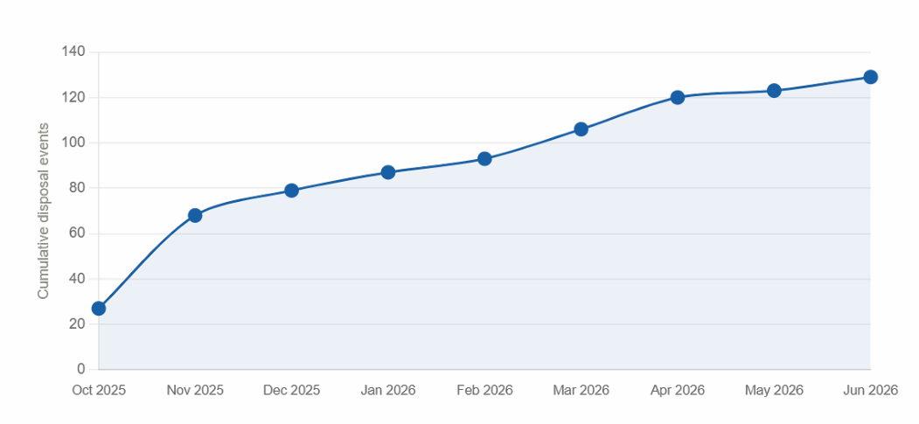

Disposed medications by class thus far for Year 1:
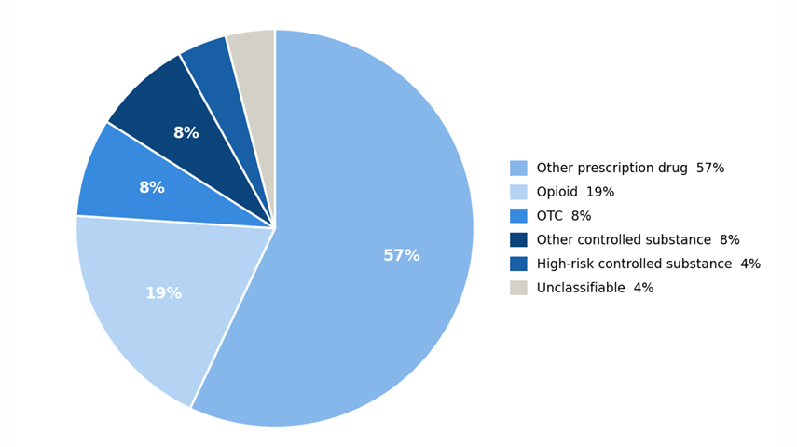

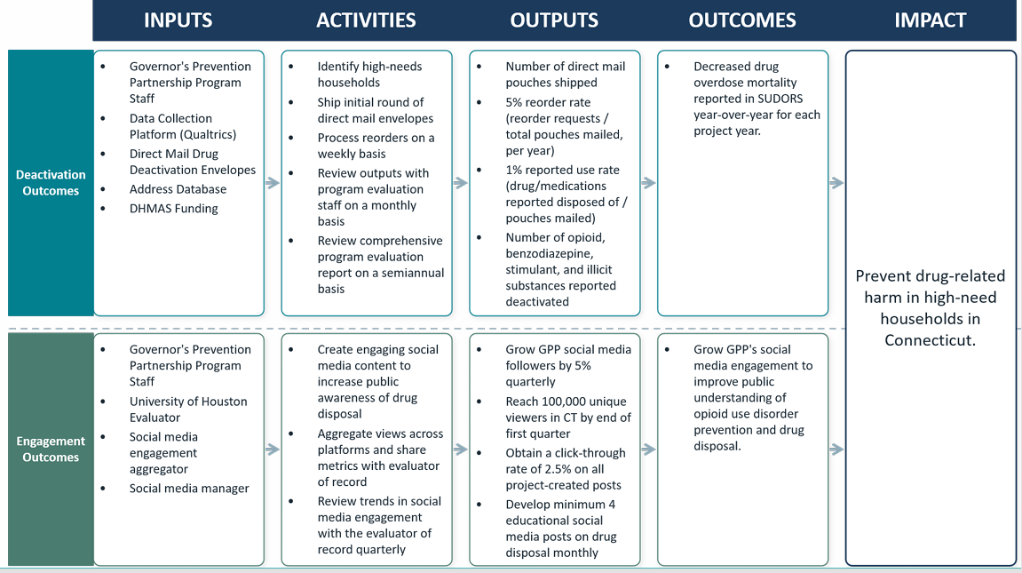
Evaluation Plan: Includes deactivation pouch usage and behavior change. Evaluation is ongoing as data continues to be received from the October 2025 mailing.

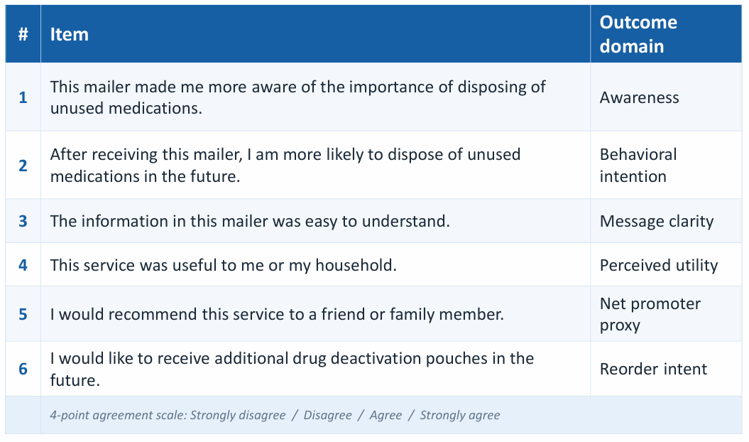

Contingency Management (CM)—Adults
Brief Description: Implementation of Evidence Based Contingency Management protocols to complement existing continuum of substance use disorder treatment at 5 programs serving adults to reduce overdose risk.
Category: Treatment
Approval Date: September 2024
Total Amount: $2,254,242
Total Years: 2
Contract Start Date: 8/1/25
Implementation Updates: Participating agencies have been selected via competitive bidding process, and provider contracts are executed. The contract with UConn School of Medicine for training and technical assistance is executed. All agencies are actively recruiting and enrolling clients into the Program. As of 6/26/26, enrollment and visit data across all programs indicates:
- Total individuals served: 102
- Total incentives earned: $13,206.50
- Average incentive earned per individual (completed treatment): $269.50
- 84% of Urine Drug Tests are Stimulant Negative (806 Neg UDT of 959 total UDT)
Reporting:
☐ Data Collection and Output Reporting ☒ Program Evaluation
Anticipated Data Points:
- Demographic data
- Substances used
- # Individuals served
- Incentives Provided (average per person, total incentive dispersed)
- CM Program Treatment Outcomes/Discharge Reasons
- Average number of visits attended per individual engaged
- Substance Use Reduction Outcomes
OUTCOMES | MEASURES
Individuals engaged in CM have increased treatment retention. | CM staff to enter CM attendance data into IMS CMI; the Contractor to track and report treatment dates expected and attended for individual’s Stimulant Use Disorder treatment services with the Contractor.
CM data is entered accurately and in a timely manner. | Department required data to be entered into CMI by the CM staff concurrently during the CM session.
The Contractor provides high fidelity CM services. | CM Coordinator, Case Manager, and Supervisor to attend all scheduled training, TA sessions, and monitoring/oversight sessions; CM staff to follow incentive schedule and protocol; the Contractor to enroll a minimum of fifty (50) individuals with moderate or severe stimulant use disorder in the CM program annually.

Anticipated Reporting Dates:
- Every 6 months upon contract execution: March 15th, September 15th
Data Collection and Output Reporting:
New: 6-month report: 8/1/25-2/28/26: *Note: this report reflects 7 months of program reporting due to a reporting date error. The next report will cover the remaining 5 months of the project year and annual totals.
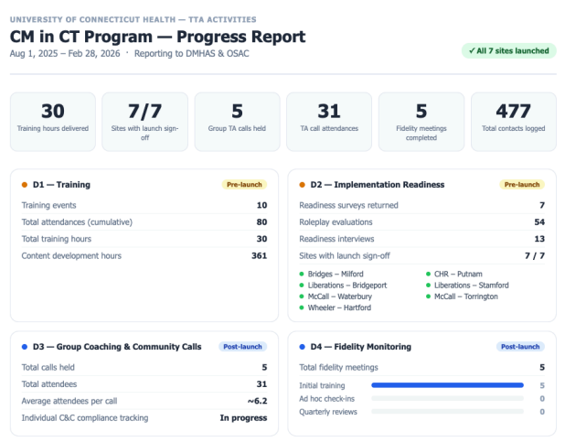
The first reporting period was primarily focused on staff recruitment and training and site readiness. At each participating agency, a Contingency Management (CM) Coordinator and Case Manager were hired, and a CM supervisor was identified. All 3 staff were trained in implementation of CM protocols to ensure there is no break in services in case of staff time off or departure. CM staff and agency leadership worked closely with the Training and Technical Assistance (TTA) providers from UConn School of Medicine to ensure CM staff were trained in CM implementation and agency systems, policies, and procedures were updated to integrate CM services. Training for CM staff included a 3-part training series; implementation readiness surveys, role plays, interviews, and evaluations; and ongoing group coaching, community calls, and fidelity monitoring. The image below depicts the TTA activities provided during this project period:

All programs began providing CM services in late January 2026. Between January-February 2026, 35 individuals were engaged in CM services and $723.00 in incentives was dispersed. The participant demographic breakdown is as follows:

- Gender:
  - Male: 19
  - Female: 15
  - Other: 1
- Race:
  - White/Caucasian: 28
  - Black/African American: 5
  - Other: 2

- Age: 25-34: 7
  - 25-34: 7
  - 35-44: 16
  - 45-54: 6+55-64: 5
  - 65+: 1

Ongoing focus will remain on programmatic recruitment, including engaging individuals from disproportionately impacted populations and continued TTA.

Contingency Management (CM)—Youth
Brief Description: Implementation of Evidence Based Contingency Management protocols to complement existing continuum of substance use disorder treatment at 2 programs serving youth to reduce overdose risk. CM with youth is being implemented as the Multi-Systemic Therapy Substance Use (MST-SU) model.
Category: Treatment
Approval Date: September 2024
Total Amount: $734,468
Total Years: 2
Contract Start Date: 3/1/25
Implementation Updates: The current staff on both teams have been trained in MST-SU by Advanced Behavioral Health (ABH), totaling 9 therapists and 2 supervisors. Teams enrolled their first MST-SU clients in May 2025. Incentives are being utilized as rewards for participating in urinalysis testing, using drug refusal skills appropriately, substance use reduction as demonstrated by urinalysis testing results, and caregiver buy-in. Additional information on CT’s MST-SU program is located here: MST-SU Fact Sheet

Reporting:
☐ Data Collection and Output Reporting ☒ Program Evaluation
Anticipated Data Points:
- Demographic Data
- # Individuals served
- Incentives Provided (average per person, total incentive dispersed)
- Program Completion Rates and Discharge Reasons
- Length of stay and average number of visits attended per individual engaged
- Substances Used and Use Reduction Outcomes
- Outcome Measures:
  - 85% of adolescents complete MST/MST-SU
  - 95% of adolescents/families served will achieve an average length of service of 4 months
  - 80% of adolescents will be abstinent or show a reduction in substance use
Anticipated Reporting Dates:
- Every 6 months upon contract execution: March 15th, September 15th
Data Collection and Output Reporting:
NEW: Year 1: Annual Progress Report Summary (3/1/25-2/28/26)
Admissions
 | Service Type | 3/1/25-8/30/25 | 9/1/25-2/28/26 | Total
Family and Children’s Agency (FCA) | MST | 39 | 40 | 79
Family and Children’s Agency (FCA) | MST SU Ala Carte | 8 | 12 | 20
Family and Children’s Agency (FCA) | MST SU Full Cloth | 0 | 5 | 5
Wheeler Health (WH) | MST | 41 | 51 | 92
Wheeler Health (WH) | MST SU Ala Carte | 9 | 20 | 29
Wheeler Health (WH) | MST SU Full Cloth | 0 | 2 | 2
Total | MST | 80 | 91 | 171
Total | MST SU Ala Carte | 17 | 32 | 49
Total | MST SU Full Cloth | 0 | 7 | 7
Engagement Data
 | 3/1/25-8/30/25 |  | 9/1/25-2/28/26
Average Sessions Attended Per Treatment Episode | 26.5 |  | 32
Average Caseload Utilization (Goal = 50%) | 67% |  | 45%

Discharge Data
 |  |  | 3/1/25-8/30/25 |  | 9/1/25-2/28/26 |  | Total
Total Discharges |  |  | 17 |  | 26 |  | 43
 |  |  | # | % | # | %
Discharge Reasons | Completed |  | 12 | 71% | 22 | 85% | 79.1%
Discharge Reasons | Lack of Engagement |  | 4 | 24% | 0 | 0 | 9.3%
Discharge Reasons | Moved out of catchment |  | 1 | 5% | 2 | 8% | 7.0%
Discharge Reasons | Required residential placement |  | 0 | 0 | 1 | 4% | 2.3%
 | Mandated to alternative program by judicial |  | 0 | 0 | 1 | 4% | 2.3%
Demographics
 |  |  | 3/1/25-8/30/25 |  | 9/1/25-2/28/26 |  | Total
 |  |  | # | % | # | %
Gender | Male |  | 8 | 47% | 19 | 73% | 62.8%
Gender | Female |  | 9 | 53% | 7 | 27% | 37.2%
Race/Ethnicity | Hispanic |  | 7 | 41% | 5 | 19% | 27.9%
Race/Ethnicity | Black |  | 4 | 24% | 9 | 35% | 30.2%
Race/Ethnicity | White |  | 5 | 29% | 8 | 31% | 30.2%
Race/Ethnicity | Multiracial |  | 1 | 6% | 4 | 15% | 11.6%
Age | 12 years old |  | 0 | 0 | 1 | 4% | 2.3%
Age | 13 years old |  | 0 | 0 | 4 | 15% | 9.3%
Age | 14 years old |  | 1 | 5% | 2 | 8% | 7.0%
Age | 15 years old |  | 5 | 30% | 7 | 27% | 27.9%
Age | 16 years old |  | 5 | 30% | 6 | 23% | 25.6%
Age | 17 years old |  | 6 | 35% | 6 | 23% | 27.9%
Primary Language | English |  | 16 | 94% | 22 | 85% | 88.4%
Primary Language | Spanish |  | 1 | 6% | 2 | 7.5% | 7.0%
Primary Language | Haitian Creole |  | 0 | 0 | 2 | 7.5% | 4.7%
Substance Use Data
(Note: Clients may report use of more than one substance)
 |  |  | 3/1/25-8/30/25 |  | 9/1/25-2/28/26 |  | Total
 |  |  | # | % | # | %
Substance of Use | Cannabis |  | 17 | 100% | 26 | 100% | 100%
Substance of Use | Alcohol |  | 0 | 0 | 4 | 15% | 9%
Substance of Use | Morphine |  | 0 | 0 | 1 | 4% | 2%
Substance of Use | Cocaine |  | 0 | 0 | 1 | 4% | 2%
Substance of Use | Hallucinogen |  | 0 | 0 | 1 | 4% | 2%
Substance Use Reduction | Yes |  |  | 76% |  | 73% | 74.5%
Incentives Data
 | 3/1/25-8/30/25 |  |  | 9/1/25-2/28/26
 | # Families | Total Amount | Average/ Family | # Families | Total Amount | Average/ Family | Total
Incentives Received | 0 | 0 | 0 | 9 | $368.52 | $41 | 9 Families  $368.52 Total  $41 Average/Family

Full implementation of the MST-SU model includes the following protocols and interventions: ABC Assessment of Substance Use; Family Drug Management Planning, including Refusal Skills; Objective Monitoring of Youth Use (urine drugs screens and breath scans); and Point and Level Reward System Contingency Contracting. A la carte services describes cases that receive some of the protocols and interventions but not all due to clinical assessment and/or length of time left in the service.
Incentives are used to reinforce behaviors that support a youth’s reduction/abstinence from substances from an ecological perspective. Youth are primarily eligible for incentives; however, caregivers may receive a small incentive like a coffee during a session to develop a monitoring plan early in the morning. Youth receive incentives for any behavior that reinforces or promotes abstinence such as providing baseline urinalysis, practicing refusal skills, sampling a new pro-social activity, reduction / abstinence verified by urinalysis testing, paying for a pro-social activity that can be sustained by the caregiver post treatment. Additionally, incentives may be used to reinforce youth and/or caregiver participation in treatment when there are engagement struggles. Incentives are tracked by each supervisor by client and in weekly case summary reports and are provided on an individual basis, linked to specific interventions.
All vacancies are filled, and all MST-SU staff have been trained in the model.
Providers and ABH continue efforts to identify clients with Opioid Use Disorder (OUD) or at risk of OUD for Contingency Management (CM) services. These efforts include presenting the service to various stakeholders including community agencies, police departments, community care team meetings, schools, ADPC, Urgent Crisis Centers, Probation and DCF. While both providers are receiving a steady stream of referrals, lack of referrals for opioid use is an identified continued obstacle. There has been a particular focus by the network to advertise to entities that service youth with opioid use disorders such as clinics that offer medication for opioid use disorders, inpatient hospitals and substance use intensive outpatient programs. As a result, there was a greater variety in substances used by clients During the second reporting period.
The use of incentives was a barrier from a training perspective in the first quarter. To address this, supervisors participated in monthly meetings facilitated by ABH with a goal to improve on barriers from previous reporting period. Additionally, ABH Experts continue to facilitate “refresher trainings” for all staff with a focus on barriers to implementation and clinician skill development. Teams demonstrated competency in the use of incentives for case management following a fit assessment and additional support and training from ABH. As a result, there was improved application in utilizing incentives. Clinicians also have increased confidence in rolling out CM specific interventions which has resulted in improved outcomes with clients. This continues to be an area the network will work on improving.
Numerous examples of success were provided where substance use and the other referral behaviors were reduced one of which was for a youth with opioid use. It is important to consider that when a decrease in substance use or abstinence from substance use happens congruent with engagement in MST-SU services, the treatment episodes have served as an interruption in advancement of the substance use given substance use disorders are progressive when untreated. 72% of clients experienced a reduction in substance use during this funding year. Treatment serves as an intervention to interrupt the escalation of substance use behaviors. Research shows substance use disorders to be progressive when gone untreated.
Success story: Youth was referred to MST-SU for larceny, threatening, and substance use. The youth smoked marijuana daily and did not follow his mother’s household expectations. While under the influence, the youth was caught searching and stealing from multiple vehicles. The youth’s substance use greatly impacted on the relationship the youth had with his mother’s significant other, causing additional tension in the home. When FCA began CM with the family, both mom and the youth were hesitant about its effectiveness, causing them both not to be forthcoming with vital information. After the youth tested positive for marijuana and morphine, the caregiver became more alarmed about her son’s use. The caregiver now understands what led to her son’s use. Additionally, she learned how to properly monitor his use and fill in monitoring gaps. Through incentive funding, FCA purchased a Ring camera door sensor to alert mom if the youth leaves the home which was often an antecedent to his use. Since, the youth spends more time at home and less time with negative peers. The youth has since improved his relationship with mom’s significant other and the youth is able to receive correction and warmth from him. His school performance increased and he had no new arrest during treatment. The youth displayed a reduction in substance use and will continue to work towards abstinence while engaging in a program.

LiveLOUD Public Awareness and Education
Brief Description: An expansion of LiveLOUD (Life with Opioid Use Disorder) to maximize the impact and reach of the public health campaign and meet the OSAC goals of urgently and efficiently decreasing the adverse impact of opioids. Includes efforts to: Reduce stigma, raise awareness about recovery pathways, prevention and harm reduction information
Category: Prevention
Approval Date: September 2024
Total Amount: $900,000
Total Years: 2
Contract Start Date: 1/1/25
Implementation Updates: Flight 1 of campaign was from 3/10-6/8/25. Flight 2 ran from 8/11-10/17/25 and included SafeSpot and Recovery Month initiatives. Initial funding of $600,000 for 1 year was fully expended. On 4/7/26, the project was continued for 1 year at $300,000; planning meetings have resumed to develop the 2026 campaign. The LiveLOUD website is located at https://liveloud.org/ and printable materials are available at: https://liveloud.org/get-support/toolkit/.

Reporting:
☒ Data Collection and Output Reporting ☐ Program Evaluation
Anticipated Data Points:
- Engagement/Reach Data per tactic (include breakdown by language)
- Communities reached per tactic
- Outline of tactics used
Anticipated Reporting Dates:
- Upon completion of each campaign phase
Data Collection and Output Reporting:
Calendar Year 2025: LiveLOUD Phase 8 Campaign Results Highlights
LiveLOUD (Live Life with Opioid Use Disorder) is a unique initiative from the Connecticut Department of Mental Health & Addiction Services (DMHAS) to maximize the impact and reach of the public health campaign; and meet OSAC goals of urgently and efficiently decreasing the adverse impact of opioids. This includes efforts to reduce stigma, raise awareness about recovery pathways, and prevention and harm reduction information.
The Phase 8 expansion of the LiveLOUD Campaign included two flights (Spring and Fall 2025) to continue to help spread awareness to new audiences; and to reinforce key messages to audiences who may have already seen or engaged with LiveLOUD content. Phase 8 continued the mission to change perceptions and reduce stigma with a clear, consistent message: This is an issue that affects every community. There are options for treating addiction. Every person is worth saving. There is no judgment. The communications strategy provided a trusted, science-based, non-judgmental source of information and support. Utilizing diverse channels for broad awareness and targeted placements, a wide audience was reached across all demographics and locations in Connecticut. This critical effort encouraged Connecticut residents struggling with OUD to access DMHAS resources, including recovery, treatment, and harm reduction information, on LiveLOUD.org.
Research remains at the core of all LiveLOUD behavior change campaigns. Insight was gathered from subject-matter experts to understand the real barriers around treatment and medications for opioid use disorder. Developments, trends, and scientific studies are reviewed and incorporated while maintaining regular communication with DMHAS to stay current on needs and emerging issues. This ongoing collaboration informed the strategies and messaging throughout Phase 8.
Phase 8 media tactics included an enhanced mix of highly engaging social posts across multiple platforms, including the addition of TikTok as a new channel; strategic digital placements; Google search and display advertising; streaming audio, podcasts, and broadcast radio; OTT (streaming TV); Out of Home (OOH) including digital and static billboards; transit advertising; place-based media; and print advertising. All creatives were deployed in both English and Spanish languages.
Target Audience:
- Opioid users and families/loved ones
- English & Spanish speaking
- CT males (White, Black, Hispanic Ages 25-64)
Key Messages:
- Safe Environments/Stay Safe at Home
- Naloxone Saves Lives
- MOUD Works
- Avoid Fake Pills
- Reach Out for Support
Impact Summary:
From March through October 2025, the LiveLOUD Phase 8 campaign achieved the following results:
- Raised awareness: Messages appeared across Connecticut more than 48.4 million times
- Connected with target audiences: The campaign earned more than 879,000 social engagements in English and Spanish
- Engaged audiences: Over 108,000 link clicks drove users to key information on the website
- Expanded reach: Successfully launched on TikTok, generating 2.4 million impressions and
reaching 671,730 unique users
- Remained a trusted resource for both the public and community partners
Key Performance Achievements
- 81% increase in total reach with 93% budget increase - highly efficient scaling
- 115% improvement in Google Search Click Thru Rate (CTR) - significantly better relevance and targeting
- 96% increase in Google impressions - enhanced digital presence
- Platform diversification - added TikTok, Twitch, place-based media, and community print
- Engagement quality - maintained strong engagement rates (25-30%)
- Geographic expansion - broader Out-of-Home (OOH) coverage across Connecticut communities with 64% increase in OOH impressions
- Bilingual reach - strong performance in both English and Spanish across all channels
Media Measurement Definitions:
- Impressions: Number of times information appears
  - Example: The Phase 8 information was shown 48 million times across screens, billboards, bus exteriors, audio and in brick-and-mortar locations
  - includes multiple views by the same people repetition helps reinforce messages
- Reach: Number of people who saw the information
  - Example: 3.6 million unique individuals saw the Phase 8 campaign information
- Engagements: Number of interactions with the information
  - Example: An action was taken on the information over 879,000 times during the Phase 8 campaign
- Engagement Rate: Percentage of time someone took an action on the information they saw
  - Example: Facebook had 269,097 engagements from 1,043,763 impressions=25.78% engagement rate
- Engagement Rate Benchmark: Industry standard or reference point used to evaluate performance against industry averages, competitors, or your own historical data
  - Helps determine if your content resonates with your audience
  - Example: Facebook engagement rate benchmark is 0.15%; the Facebook campaign engagement rate was 25.78%, which is 172x the industry standard
- Click Through Rate (CTR): percentage of people who clicked the link after seeing the video/ad
  - Example: META ads had a 2.48% click-through rate (CTR), which is 2.67x the industry benchmark of 0.9%
- VIDEO VIEWS AT 100%: complete video views
  - Example: Over 53 thousand people watched the TikTok videos from start to completion
*=Media tactics in English & Spanish
Top-Line Performance Metrics
 | Phase 7 (6/24/24-10/1/24) | Phase 8 (3/1/36-10/20/25) | % Change
Overall Reach & Impressions
Total Reach | 2,032,150 | 3,672,094 | +80%
Total Impressions | 28,118,127 | 48,459,137 | +72%
Partnering Organizations Growth
Social Media Whitelisting Partners | 8 | 18 | +125%
Digital Toolkit Folder Downloads | 64 | 115 | +79%
Digital Toolkit Partnering Organizations | 12 | 98 | +717%

Year-Over-Year Channel Performance
Social Media Platforms
 | Phase 7 (6/24/24-10/1/24) | Phase 8 (3/1/36-10/20/25) | % Change
Overall (All Social Media Platforms)
Total Impressions | 3,210,493 | 7,005,111 | 118.19%
Unique Users Reached | 1,563,924 | 2,728,393 | 74.46%
Total Engagements | 792,073 | 879,452 | +11%
Facebook*
Impressions | 915,407 | 1,043,763 | +14%
Engagements | 243,663 | 269,097 | +10%
Engagement Rate | 26.5% | 25.78% | N/A
Engagement Rate Benchmark=0.15% | 177x benchmark | 172x benchmark | N/A
Instagram*
Impressions | 528,794 | 826,829 | +56%
Engagements | 198,974 | 244,834 | +23%
Engagement Rate | 37.08% | 29.61% | N/A
Engagement Rate Benchmark=0.15% | 252x benchmark | 197x benchmark | N/A
META Traffic & Video Ads*
Impressions | 1,542,557 | 2,349,522 | +52%
Engagements | 263,498 | 348,893 | +32%
Traffic Ads Click-Through Rate (CTR) | 1.68% | 2.48% | N/A
Traffic Ads CTR Benchmark | 1.86x benchmark | 2.76x benchmark | N/A
META Whitelisting Partnership
Partnering CT Public Health Organizations | 8 | 18 | +125%
Positive Reactions | 241 | 4,578 | +1,800%
Link Clicks | 265 | 417 | +57%
Shares | 43 | 209 | +386%
Engagement Rate | 38.30% | 14.86% | N/A
Engagement Rate Benchmark = 0.15% | 255x benchmark | 99x benchmark | N/A
NEW: TikTok*
Reach | N/A | 671,730 | N/A
Impressions | N/A | 2,382,406 | N/A
Video Views at 100% | N/A | 53,296 | N/A

Digital Advertising
 | Phase 7 (6/24/24-10/1/24) | Phase 8 (3/1/36-10/20/25) | % Change
Google Ads
Total Impressions | 1,325,409 | 2,602,835 | +96%
Search Ads Impressions | 116,231 | 284,973 | 145.18%
Search Ads Click Through Rate (CTR) | 7.07% | 7.68% | N/A
Display Ads | 1,209,178 | 2,317,862 | +91.7%
Display Advertising
Total Impressions | 3,948,519 | 7,142,401 | +81%
Custom Display | 2,224,477 | 2,803,762 | +26%
Geofencing | 1,724,042 | 2,445,013 | +42%
New: Audience-Based Display | N/A | 1,008,714 | N/A

Video Streaming (Over-the-Top [OTT])
 | Phase 7 (6/24/24-10/1/24) | Phase 8 (3/1/36-10/20/25) | % Change
Total Impressions | 546,429 | 1,565,325 | +186.46%
OTT Video Streaming* | 546,429 | 438,073 | -20%
New: OTT Retargeted Digital Ads* | N/A | 834,119 | N/A
New: Twitch | N/A | 293,133 | N/A

Audio & Radio
 | Phase 7 (6/24/24-10/1/24) | Phase 8 (3/1/36-10/20/25) | % Change
Streaming Audio*
Total Impressions | 876,863 | 1,265,398 | +44%
Reach | 137,078 | 184,024 | +34%
Streaming Audio* | 579,913 | 636,256 | 9.72%
Podcasts* | 296,950 | 629,142 | 111.87%
Broadcast Radio*
Total Impressions | 539,800 | 461,600 | -14.49%

Out-of-Home (OOH)
 | Phase 7 (6/24/24-10/1/24) | Phase 8 (3/1/36-10/20/25) | % Change
Total Impressions | 17,670,614 | 28,990,586 | +64%
Transit Ads |  | 18,227,786
Digital & Static Billboards |  | 9,230,175
New: Place-Based Media | N/A | 10,762,800 impressions | N/A

Print Advertising (NEW)*:
Four publications targeting diverse communities in English and Spanish
 | Phase 7 (6/24/24-10/1/24) | Phase 8 (3/1/36-10/20/25) | % Change
Total Impressions | N/A | 260,000 | N/A

LiveLOUD.org Website Metrics
 | Phase 7 (6/24/24-10/1/24) | Phase 8 (3/1/36-10/20/25) | % Change
New Users | 32,901 | 76,616 | +133%
Pageviews | 58,607 | 109,543 | +87%

Visual Depiction of Phase 8 Statewide Implementation:
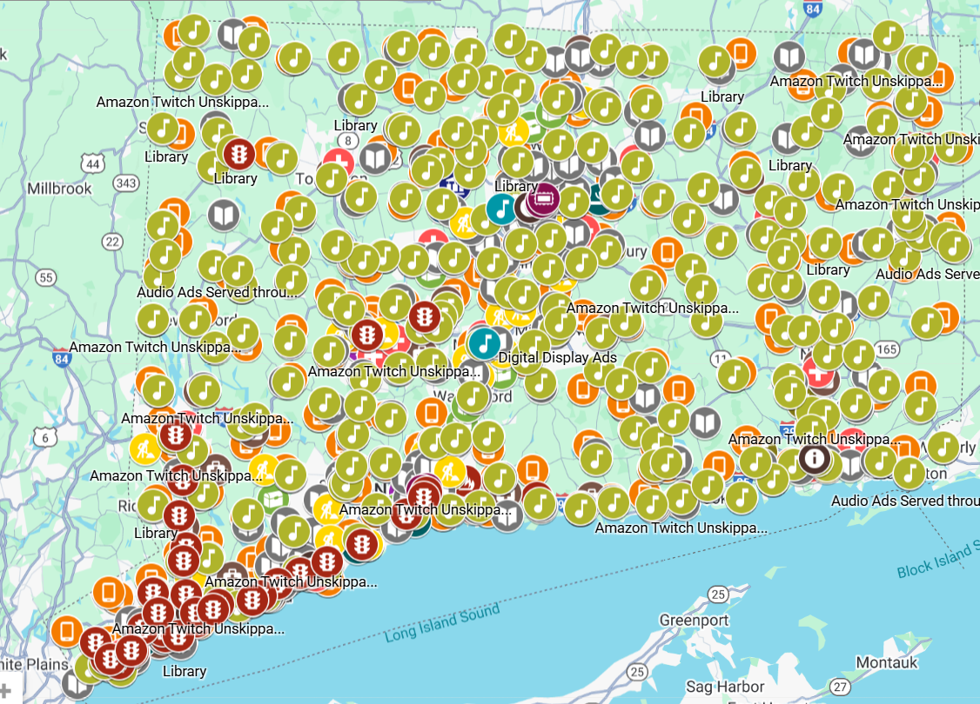

Click here to explore the map further: LiveLOUD Phase 8- OSAC Presentation - Google My Maps
LiveLOUD.org Web Traffic Snapshot: 01/01/25 - 10/20/25
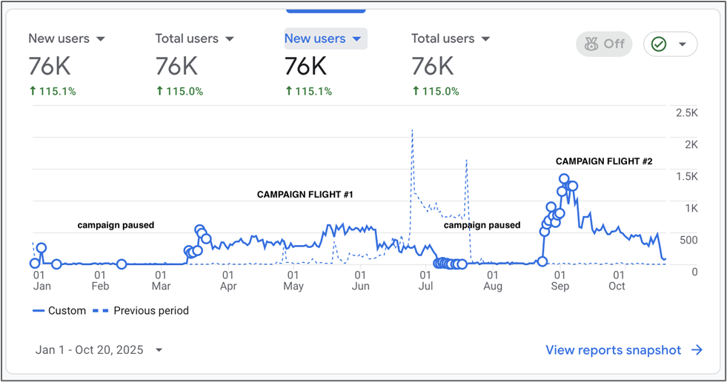

Treatment Bridge Model for Connecticut's Emergency Departments
Brief Description: Initiative with CT hospitals to increase low-barrier Emergency Department-initiated MOUD in CT. Includes funding for: Training and TA, development of processes to screen individuals for OUD and introduce MOUD as a treatment option, support for Site Champion, and 2 recovery navigators per site
Category: Treatment
Approval Date: September 2024
Total Amount: $1,250,000
Total Years: 2
Contract Start Date: 11/1/25
Implementation Updates: Contracts were executed with Yale School of Medicine for Training and Technical Assistance. Day Kimball Hospital was identified as one participating hospital; the contract was executed, staff were hired and received training, and program services are in place. A second participating hospital has been identified; a contract is under negotiation.

Reporting:
☒ Data Collection and Output Reporting ☐ Program Evaluation
Anticipated Data Points:
- # trainings provided/attendees
- # individuals served
- # individuals inducted on MOUD
- # individuals connected to community treatment
- % retained in MOUD at 3 months and 6 months
- If return admission, reason for re-admission
OUTCOMES | MEASURES
Increased number of individuals will be screened for OUD and inducted on MOUD in the Emergency Department (ED). | Contractors shall identify their baseline % of individuals screened for OUD and inducted on MOUD in the ED prior to implementation of this initiative, semi-annual reporting shall indicate a continued increase in screenings and inductions.
Individuals with OUD will be connected to community-based treatment prior to leaving the ED, including to continued MOUD services. | Contractor to track and report on the frequency of MOUD and other treatment connections made for individuals with OUD while in the ED.
Individuals provided MOUD in the ED to experience treatment retention and decreased OUD-related ED visits. | Contractor shall track and report at 3 months and 6 months post ED-induction % of individuals retained in MOUD; % of individuals returning to the ED within 6 months and reason for re-admission.
ED Physicians and direct care staff to have increased knowledge of MOUD initiation and continuation in the ED. | The Contractor shall ensure training and technical assistance hours are completed by staff members as part of this initiative.
Data reporting requirements met in a timely manner. | Department required data shall be submitted to the Department’s data collection system no later than the 15th day of each month.

Anticipated Reporting Dates:
- Every 6 months upon contract execution; May 15th and November 15th.
Data Collection and Output Reporting:
NEW: 6-Month Report: 11/1/25-4/30/26:
Training and consultation provided during reporting period:
- Number and type of training: 1 Full Day In-Person Training on 4/20/26 that included:
  - Overview of Opioid Use Disorder (OUD)
  - Clinical Foundations & Harm Reduction
  - Clinical Opiate Withdrawal Scale (COWS) Score
  - Harm Reduction Basics
  - BNI (Brief Negotiation Interview) Training
- Number of trainees: The 4/20/26 training included 4 staff members from Day Kimball Hospital including 2 Health Promotion Advocates (HPAs), the program supervisor, and the ED Crisis Clinician
- Number of consultation calls: Technical assistance has been provided through regularly scheduled bi-weekly Zoom consultation calls, supplemented by ongoing email-based support. In addition to scheduled calls, the Yale and Day Kimball teams maintain near-daily email communication, supporting rapid-response technical assistance on topics including HPA hiring and onboarding status updates, billing and reimbursement questions (in collaboration with DMHAS), workflow adjustments, and implementation troubleshooting.
Baseline data was established as a comparison point for project implementation. DKH looked at 2 points of time to establish their baseline data: prior to any project implementation and a “soft launch” period in which ED providers were encouraged to initiate MOUD, though the project had not yet officially launched. The baseline data demonstrates substantial opportunity for improvement in OUD screening and MOUD inductions during project implementation:
Day Kimball Baseline Data
 | Pre-launch  12/1/24-11/30/25 | Soft Launch  12/1/25-4/20/26
ED Admissions Screened for OUD | 12/20231 =0.06% | 8/3269 =2%
MOUD Initiation in ED | 12/20231 =0.06% | 8/3269 =2%

Since the initiation of the Treatment Bridge Model technical assistance initiative, Yale University and Day Kimball Health have made steady and substantive progress toward implementing an emergency department–based model for opioid use disorder (OUD) identification of patients with opioid misuse or disorders, initiation of medication for opioid use disorder (MOUD), and facilitated linkage to ongoing care. To date, funding has directly supported structured implementation activities, including workforce development, training delivery, workflow design, and ongoing technical assistance. These efforts have contributed to strengthening Day Kimball Health’s capacity to identify and engage patients with OUD in the emergency department setting and to initiate evidence-based treatment pathways, including buprenorphine and methadone initiation and referral to longitudinal care.
Key program accomplishments include the delivery of foundational trainings alongside the development of essential operational infrastructure. This includes building collaborative relationships, standardized job descriptions, workflow and scheduling frameworks, documentation tools, and clinical reference materials to support consistent and sustainable implementation of the Bridge Model within the emergency department setting.
The 2 HPA positions at Day Kimball Hospital were filled by internal candidates with connections to the emergency department. Additional notable outcomes to date include increased organizational readiness for HPA integration and the establishment of effective communication and problem-solving structures between Yale and Day Kimball Health.
Emerging Challenges: The teams identified an initial challenge related to DKH’s dated EHR system, which presents limitations for efficient data extraction and reporting. This has been navigated collaboratively, and both teams are actively working through workflows together while continuing to monitor the issue closely. The team is also working closely with DKH staff to confirm that required demographic fields are consistently captured within their Empower system to support clinical and reporting needs.
Next Steps: Beginning May 5th, the project will also include biweekly Day Kimball HPA-specific check-in calls, designed to provide structured support for case-based discussions, workflow challenges, and real-time implementation feedback from the HPA team. The Day Kimball HPAs will shadow the Yale HPAs for 2 days in May for live observation and training.

CT Collegiate Opioid Overdose Prevention and Recovery Project
Brief Description: Technical assistance to support opioid overdose education and prevention and developing and/or enhancing recovery friendly communities at CT institutions of higher education including monthly interactive learning cohorts and personalized technical assistance for participating institutions to address individualized capacity building needs for opioids and overdose prevention
Category: Prevention, Recovery Support
Approval Date: November 2024
Total Amount: $631,777
Total Years: 2.5
Contract Start Date: 9/1/25
Implementation Updates: The contract with Wheeler Clinic has been executed and implementation meetings are underway. Wheeler Clinic is working with SAFE Project on an implementation plan for provision of the training and technical assistance sessions. A dedicated Project Coordinator, responsible for project planning, coordination, engagement and recruitment, has been hired. The Technical Assistance Summit was held on 4/10/26 with 39 attendees representing 16 colleges/universities. Content for the day included an overview of the current landscape of recovery, overdose, and stigma; overdose prevention and response; collegiate recovery field; and what stigma looks like and how can it be addressed. Ongoing technical assistance sessions are expected to begin in Summer 2026.

Reporting:
☒ Data Collection and Output Reporting ☐ Program Evaluation
Anticipated Data Points:
- Date, time, and location of the technical assistance meetings, including the number of attendees, role (faculty, staff, student, community member) and collegiate institution affiliation(s)
- Collegiate Recovery Programs/Communities built
- Opioid Overdose Prevention/Response Programs implemented
- Stigma reduction strategies (campaigns, training programs, etc.) designed and implemented
- Percent of campuses involved with action plans drafted
- Percent of drafted action plans that have been implemented
- Individual stigma reduction, as quantified by movement between training pre/post surveys
OUTCOME | MEASURE
Increased awareness of Opioid Overdose Education and Prevention strategies at Connecticut’s Collegiate Institutions | At least fifty percent (50%) of all Collegiate Institutions in Connecticut will send at least one (1) faculty, staff, or student representative to at least six (6) Technical Assistance sessions annually
At least 75% of Collegiate Institutions involved with the project will successfully implement at least one (1) of the strategies identified below by completion of the project:
Build a Collegiate Recovery Program or Community | • Increase in campuses involved with action plans drafted and implemented  • Implementation of a coalition of supportive offices, staff, organizations
Implement an Opioid Overdose Prevention/Response Program | • Increase in campuses involved with action plans drafted and implemented  • Faculty, staff, and students impacted by training  • Implementation of a coalition of supportive offices, staff, and organizations
Design and implement stigma reduction strategies | • Increase in campuses involved with action plans drafted and implemented  • Faculty, staff, and students impacted by  training  • Individual stigma reduction, as quantified by movement between training contractor-developed pre/post surveys

Anticipated Reporting Dates:
- Every 6 months upon contract execution: March 15th, September 15th, and upon project completion
Data Collection and Output Reporting:
NEW: 6 month report: 9/1/25-3/31/26: The first reporting period was primary focused on program development and collegiate recruitment. Milestones include:
- The project coordinator started in January 2026 and began onboarding.
- A contract was executed with SAFE Project to provide the training and technical assistance.
- Meetings were held with project staff and SAFE Project to plan the Summit and begin planning the technical assistance sessions, which are slated to begin in Summer 2026
- The CT Collegiate Opioid & Overdose Prevention & Recovery Summit was planned for April 10, 2026. A flyer was sent via the Connecticut Healthy Campus Initiative listserv to 235 contacts. In addition, the project coordinator sent 27 campus Presidents and their executive assistant a personalized email announcing the project and the summit. The Summit was also announced to 28 attendees at the monthly Connecticut Healthy Campus Initiative meeting in March.

SafeSpot Overdose Hotline
Brief Description: Expansion of SafeSpot, a 24 hour-7-day a week Overdose Hotline, to Connecticut. Operators provide real-time phone-monitored supervision of drug use for individuals using alone. An emergency response is activated if the individual becomes unresponsive.
Category: Harm Reduction
Approval Date: January 2025
Total Amount: $1,513,085
Total Years: 3
Contract Start Date: 7/1/25
Implementation Updates: Contract has been executed. Individuals can call 1-800-972-0590 to utilize the SafeSpot Overdose Hotline. SafeSpot staff continue to provide regular presentations to various entities throughout CT to increase awareness and referrals. To learn more about the overdose hotline, including a brief video on how the hotline works, visit the SafeSpot website at: https://safe-spot.me/how-it-works/. As of 6/26/26, SafeSpot operators have fielded 1,698 calls from 10 unique callers totaling 2,131 use events in Connecticut.

Reporting:
☒ Data Collection and Output Reporting ☐ Program Evaluation
Anticipated Data Points:
- Number of calls
- Number of Drug Use Events (how many times someone uses on the call)
- Average response time
- Zip Code (for understanding how our marketing is working)
- Substance(s) and route(s) of use used by the caller
- Call outcome (Mark Safe vs Overdose vs Disconnect)
- Safety Actions Taken
- Linkages to Care/Resources by types and amounts
Outcome | Measure
Individuals calling into the hotline experience low barrier access to phone monitored supervision of drug use | Calls are answered by an operator within an average of 60 seconds
Increased engagement of individuals using drugs alone with phone monitored supervision of drug use | At least 100 calls from CT are managed monthly
Improvement in the overall health and wellbeing of individuals calling the hotline | 100% of people calling into the hotline have prevented overdose or detected overdose with appropriate medical activation response during the call safety window
Individuals calling into the hotline receive satisfactory support during their calls | Less than 5% of CT calls result in a complaint and all complaints are reviewed by a supervisor for quality assurance
Operators are Connecticut-based | 20 CT-based operators are hired within years 1 and 2 of this contract; hire and training of Spanish speaking cohort in year 2

Anticipated Reporting Dates:
- Quarterly upon contract execution: October 15th, January 15th, April 15th, July 15th
Data Collection and Output Reporting:
NEW: Year 1 Progress Report:
Call Metrics
 | 7/1/25-9/30/25 | 10/1/25-12/31/25 | 1/1/26-3/31/26 | 4/1/26-6/30/26 | Cumulative Total
Total Calls | 1,589 | 1232 | 2123 |  | 4944
CT Calls | 437 calls  509 use events | 338 calls  426 use events | 430 calls  590 use events |  | 1205 calls  1525 use events
Total Callers | 38 | 56 | 134 |  | 224 unique
CT Spotting Callers | 2 | 1 | 5 |  | 5 unique
Average operator pick up time | 13 seconds | 12 seconds | 12 seconds

Safety Actions Utilized
 | 7/1/25-9/30/25 | 10/1/25-12/31/25 | 1/1/26-3/31/26 | 4/1/26-6/30/26 | Cumulative Total
Caller reports drugs checked by program | 11 | 8 | 26
Caller reports using a test strip | 10 | 7 | 55
Caller reports doing a test dose | 8 | 13 | 80
Caller initiates use of a timer | 440 | 365 | 301
Caller verbalizes spacing or pacing | 22 | 84 | 195
Operator initiates use of a timer | 1,018 | 1030 | 1762
Caller switches substance (e.g., fentanyl to cocaine) | 1 | 7 | 27
Operator encourages spacing or pacing between use events to slow use (general) | 11 | 6 | 26
Operator encourages spacing between use events to slow use (perceived intoxication) | 12 | 23 | 74
Operator encourages caller to stand up to gauge intoxication prior to next use event | 15 | 13 | 23

Call Outcomes
 | 7/1/25-9/30/25 | 10/1/25-12/31/25 | 1/1/26-3/31/26 | 4/1/26-6/30/26 | Cumulative Total
Overdose Response Activations (Total) | 5 | 3 | 1
Overdose Response Activations (CT) | 0 | 0 | 0

- Linkage to Care:
  - 7/1/25-9/30/25: No new linkage to care for CT callers in reporting period
  - 10/1/25-12/31/25: CT Caller was given a list of additional warm lines to utilize. On a subsequent call, the caller noted that several of them were not receptive to someone who admitted to having used substances after they tried reaching out.
  - 1/1/26-3/31/26: No new linkage to care for CT callers in reporting period, though report notes new callers were connected to resources already and calling the line specifically for spotting.
- Geographic Distribution (CT only):
  - 7/1/25-9/30/25:
    - 06790: 437 calls
  - 10/1/25-12/31/25:
    - 06790: 338 calls
  - 1/1/26-3/31/26:
    - 06790: 419 calls
    - 06416: 8 calls
    - 06106: 1 call
    - 06513: 1 call
    - 06610: 1 call
- Outreach and Engagement:
7/1/25-9/30/25: During this reporting period, SafeSpot conducted 13 presentations across Connecticut, all held virtually. These sessions focused on raising awareness of SafeSpot, explaining referral pathways, and sharing best practices for integrating phone-based harm reduction support into existing service systems. We continue to receive new presentation and partnership requests nearly every other day as awareness of SafeSpot grows statewide. Advertising and outreach efforts have focused primarily on social media engagement, professional networks, and word-of-mouth referrals from trusted community partners.

10/1/25-12/31/25: Since 7/1/25, SafeSpot conducted 23 presentations across Connecticut, for approximately 475 people. These sessions focused on raising awareness of SafeSpot, explaining referral pathways, and sharing best practices for integrating phone-based harm reduction support into existing service systems. Presentations were given to a variety of agencies, collaborative meetings, task forces, and state agencies across CT. One presentation that was particularly effective was delivered to the Connecticut Department of Corrections Addiction Treatment Leadership Team. This statewide group of directors, representing each of the dozen correctional facilities across the state, was highly receptive to expanding outreach. As a result, they supported having the SafeSpot team present to facility staff and individuals in custody, incorporating materials onto incarcerated individuals’ tablets, displaying posters in common areas, and including cards in naloxone discharge kits. Additionally, several members of the leadership team attended the CT Overdose Prevention Summit in Bridgeport in November. SafeSpot staffed a table and engaged in dozens of conversations with providers from around the state and checked in with the other vendors to obtain business cards for future meetings. The director, safety coordinator, outreach coordinator and community implementation specialist hosted a workshop that was well attended.

1/1/26-3/31/26: A major development the last quarter is that two recently hired Connecticut operators reached sufficient call volume to qualify for field outreach training, expanding SafeSpot's capacity for in-person community engagement. During this reporting period, SafeSpot conducted outreach presentations and engagements across Connecticut, reaching providers, students, people in recovery, and members of the general public through a mix of virtual and in-person events. Virtual presentations included sessions with numerous community-based providers and community supports, the MAT Provider and Outpatient Learning Collaboratives, the Norwich Opioid Task Force, and the Community & Law Enforcement for Addiction Recovery (CLEAR) Team. In-person activities included tabling at the Community Wellness Fair in Colchester, where staff spoke with approximately 50 individuals, and two engagements at Central Connecticut State University in New Britain — a one-on-one meeting with faculty to place materials in the Community Health Education Clinic, and a co-presentation with Change the Script to nursing and counseling students. Staff also met with leadership at Root Center for Advanced Recovery, who agreed to schedule an all-site staff presentation and expressed openness to in-person clinic visits. SafeSpot also met with leadership from the HERO housing program this quarter. As this initiative continues to develop, we are committed to remaining engaged and ensuring SafeSpot is embedded as a resource within the program's implementation as it moves forward. In total, 9 group presentations were provided plus additional one-on-one meetings with specific providers, reaching at least 252 individuals.

- Workforce Development:
7/1/25-9/30/25: SafeSpot launched Hiring Cohort 4 in September, which included our first concerted outreach to recruit Connecticut-based operators. As of November 1, five applicants have been interviewed and received offers of employment, and the sixth remains in process. Two Connecticut operators have officially started. We anticipate all six Connecticut hires will be fully onboard and taking calls by the end of December. Our next hiring cohort will prioritize candidates from Connecticut, Maine, and Spanish-speaking communities. This targeted outreach aims to increase applicant conversion and strengthen our capacity to launch SafeSpot’s Spanish-language hotline in early 2026.
10/1/25-12/31/25: Five CT-based operators successfully completed this hiring cohort. Four have been fully cleared and have already taken a combined total of 24 live calls, while the fifth is completing a final clearance test. Collectively, the cohort has completed 136 hours of training. An additional hiring cohort is planned in March to further strengthen the Connecticut presence and expand Spanish-language capacity in support of launching SafeSpot’s Spanish-language hotline in early 2026.
1/1/26-3/31/26: SafeSpot is preparing to launch Hiring Cohort 5 in late April, with a continued focus on recruiting Connecticut-based operators. Of the 66 individuals who submitted initial interest forms through the SafeSpot website, all were invited to complete a follow-up survey designed to assess continued interest and responsiveness to email communication — a core competency for this remote position. To date, 21 have advanced through this stage, with a few additional survey responses still pending before the official job posting goes live through Boston Medical Center.

Since the last reporting period, Connecticut-based operators have collectively taken 297 calls, a significant increase from the 24 reported previously. Three operators have established themselves as regular, consistent contributors to the line. One operator departed the cohort after securing full-time employment elsewhere, and one is currently on leave due to job-related stress in a separate position.

Recruiting and onboarding Spanish-speaking operators remains a persistent challenge. Several candidates in the Cohort 5 pipeline have Spanish-language capacity, and we are hopeful that some will successfully complete the process — a critical step toward launching SafeSpot's Spanish-language hotline.

- Key Program Achievements:
7/1/25-9/30/25: During this reporting period, SafeSpot achieved several major milestones in our Connecticut implementation. The inaugural Connecticut hiring cohort was launched, and the first locally based operator is ready to begin fielding calls. A strong statewide presence was maintained, finding potential new audiences nearly every other day, and four staff members are confirmed to attend the Connecticut Harm Reduction Conference on November 7th to operate a table and host a workshop. Program operations remain highly responsive, with an average caller hold time of only 13 seconds. SafeSpot also provided sustained peer support to a high-need caller in Torrington.

SafeSpot leadership is in the final stages of submitting an accreditation application to the International Council for Helplines, which would make SafeSpot the first overdose detection hotline in the United States to achieve this distinction. In parallel, SafeSpot leadership initiated a suggestion for collaboration with United Way 211, proposing a statewide hotline coordination group to enhance inter-organizational communication and referral efficiency. SafeSpot also received a Notice of Award from CDC for our 5-year R01 application. This project, which began 10/1/25, will be the first formal evaluation of SafeSpot’s marketing and outreach efforts and will enhance our work in CT to find new callers.

10/1/25-12/31/25: During this reporting period, SafeSpot achieved several major milestones in Connecticut implementation. By the end of January, our call-routing system will automatically prioritize routing Connecticut callers to available Connecticut-based operators, enhancing the local feel of the service and increasing engagement and utilization of CT operators. SafeSpot’s Community Implementation Specialist is now fully trained and has assumed responsibility for Connecticut-specific outreach efforts.

Program operations remained highly responsive, with an average caller hold time of 13 seconds throughout the reporting period, improving further to 12 seconds in the last quarter. SafeSpot also continued to provide sustained peer support to a high-need caller in Torrington. In addition to ongoing engagement, the caller was provided with a list of additional warm lines; during a subsequent call, the caller shared that several of these resources were not receptive after learning the caller had used substances, reinforcing the need for SafeSpot’s nonjudgmental, low-barrier model of care.

SafeSpot has now formally submitted its accreditation application to the Council for Helplines and is awaiting final evaluation. This rigorous process has been underway since early 2023 and has resulted in the development of dozens of organizational policies, a comprehensive overhaul of our training program, the creation of a formal training manual, and the addition of new training modules covering expanded topic areas.

In support of continued growth, one Connecticut-based operator who has completed sufficient call volume will begin methadone clinic tabling in February. Based on prior experience, tabling during morning dosing hours has proven to be the single most effective strategy for identifying and engaging new callers, and we are excited to launch this outreach effort in Connecticut.

1/1/26-3/31/26: In addition to the many successes included above, a notable program achievement this quarter is the growth in unique Connecticut callers, which increased from one or two per month to five — early evidence that sustained outreach efforts are beginning to translate into utilization.

- Emerging Challenges and Planned Improvements:
7/1/25-9/30/25: Applicant retention through the hiring process has been a challenge, with 6 of 28 (21%) prospective Connecticut applicants completing their full applications, which is below our typical conversion rate. Additionally, we expect call volume growth to occur gradually, consistent with Massachusetts’ one-year ramp-up following initial launch. SafeSpot plans to launch a Spanish-language hotline to expand accessibility for Spanish-speaking residents. Recruitment for bilingual operators has been slower than anticipated, prompting a dedicated, accelerated hiring cohort. We have also enhanced our training curriculum by adding two hours of scenario-based roleplay to strengthen operator preparedness and confidence.

10/1/25-12/31/25: Applicant retention through the hiring process continues to be a challenge, with 5 of 28 (18%) prospective Connecticut applicants completing their full onboarding—below the typical conversion rate. Call volume growth in Connecticut is anticipated to follow a gradual trajectory, similar to Massachusetts’ one-year ramp-up following launch. SafeSpot will continue to prioritize the launch of a Spanish-language hotline to expand access for Spanish-speaking residents. While recruitment of bilingual operators has progressed more slowly than anticipated, this is being addressed through targeted outreach and an additional hiring cohort planned for March. Operator preparedness has been strengthened by enhancing the training curriculum, including the addition of two hours of scenario-based roleplay to build confidence and applied skills.

1/1/26-3/31/26: Despite extensive engagement with organizations across the state, Connecticut providers have yet to initiate information calls on behalf of clients or facilitate warm handoffs to the line. By comparison, Massachusetts providers generated 48 information calls during the same period. Recruiting and onboarding Spanish-speaking operators also remains a persistent challenge. Closing the provider engagement gap is a priority for the coming quarter. A training currently being coordinated with operators from the Connecticut Access Line represents a promising near-term opportunity, as this population is well-positioned to facilitate warm handoffs as part of their existing client interactions. SafeSpot is also preparing to launch Hiring Cohort 5 in late April, with a continued focus on Connecticut-based recruitment. Several candidates in the Cohort 5 pipeline have Spanish-language capacity, and we are hopeful that some will successfully complete the process — a critical step toward launching SafeSpot's Spanish-language hotline.

Harm Reduction Centers
Brief Description: Continuation and expansion of Harm Reduction Centers (HRC) offering low-barrier, drop-in support for individuals who use substances, particularly those who are at high risk for opioid overdose
Category: Harm Reduction
Approval Date: January 2025
Total Amount: $6,975,000
Total Years: 3
Contract Start Date: 9/30/25
Implementation Updates: The Harm Reduction Centers in Hartford, New London, New Haven, and Waterbury continue operations as planned. The contract was executed with Liberations for a new Harm Reduction Center in Bridgeport with anticipated launch in August 2026. Updates on the new site are as follows:
- Build-Out Progress: Construction is actively underway and progressing well. Permits have been issued, and the project is now moving through the framing, electrical, and plumbing inspection phases. The focus over the next several weeks will be completing the interior build-out and outfitting the space for operations.
- Staff Training, Policies, and Hiring: Core policies and procedures are currently being developed, with a focus on low-barrier engagement, participant safety, overdose response, safer use practices, behavioral expectations, and day-to-day operational workflows. Systems related to supply ordering, inventory management, and data collection/documentation are in development. The hiring process is underway for the site leadership position. Additional staffing interviews will follow closer to launch.
- Community Engagement and Advisory Development: Early outreach has begun to help establish a Community Advisory Committee, with the goal of building local input and strengthening community relationships around the Harm Reduction Center as it launches. This will help ensure the program remains responsive to neighborhood concerns while building collaborative support for the work.
Reporting:
☒ Data Collection and Output Reporting ☐ Program Evaluation
Anticipated Data Points:
- Total Visits
- Unique Individuals
- Naloxone Kits Distributed
- Harm Reduction Supplies Dispensed
- Client Demographics
- Connections to Care and Medical Support
- Medical Treatment Received (MAT Induction, Testing/Screening for HIV, Hep C, etc, Wound Care)
OUTCOMES | MEASURES
Operate a stigma-free and low barrier drop-in center for individuals who use drugs; without requiring abstinence or an expressed desire for treatment as a prerequisite to access. | Program capacity shall accommodate a minimum of twelve (12) individuals at any one time and serve a minimum of one thousand (1,000) individuals annually. Harm Reduction policies and procedures shall be developed and regularly reviewed and revised as necessary and copies provided to the Department.
Increase engagement between providers of treatment and recovery services, health care and social services and persons seeking such supports. | Harm Reduction Center staff shall track % of individuals identified as having Social Determinants of Health needs; % of individuals who demonstrate improvement in these measures between baseline and six (6) months; number of referrals in which the first appointment was kept; % individuals referred by the Harm Reduction Center that remain engaged in treatment after six (6) months.
Broadly improve the overall health and well-being of individuals who use drugs, through measures including but not limited to reduction of unintentional overdoses and disease transmission. | Number of fatal overdoses in the immediate and surrounding Waterbury area of Harm Reduction Center operation shall be reduced. Trends in the area as it relates to unintentional overdoses, overdose reversals, and testing or support around decreasing the frequency of disease transmission shall be monitored and reported.
Provide harm reduction supplies, naloxone training and distribute kits in the community. | Harm Reduction Center staff shall track total itemized number of harm reduction supplies distributed, number of individuals trained in naloxone administration, number of kits distributed and number of any known overdose reversals as a result of kits distributed and report such information to the Department.
Meet data reporting requirements in a timely manner. | Department required data shall be submitted to the Department's data collection system no later than the 15th day of each month.

Anticipated Reporting Dates:
- Every 6 months upon contract execution: April 15th, October 15th
Data Collection and Output Reporting:
NEW: 6 Month Report: 10/1/25-3/31/25:
Service Utilization
 | Location | 10/1/25-3/31/26 | 4/1/26-9/30/26 | Annual Total
Total Visits | New London | 3444
Total Visits | New Haven | 3100
Total Visits | Hartford | 8859
Total Visits | Waterbury | 1376
Total Visits | Total | 16779
Unique Individuals | New London | 234
Unique Individuals | New Haven | 150
Unique Individuals | Hartford | 712
Unique Individuals | Waterbury | 150
Unique Individuals | Total | 1246

Supplies Distributed
 | 10/1/25-3/31/26 | 4/1/26-9/30/26 | Annual Total
Naloxone Kits | 1,300 kits (2,600 doses)
Test Strips | 140
Safe Syringes | 206,145
Syringes Collected (Safe Disposal) | 200,790
Safer Use Kits | 22,114
Safer Sex Kits | 583
Wound Care Kits | 708

Connections to Care and Support Services
Behavioral Health and Medical Services
 | 10/1/25-3/31/26 | 4/1/26-9/30/26 | Annual Total
MAT/MOUD Induction | 47
Withdrawal Management | 12
Inpatient Treatment | 7
HIV Tests | 176
HCV Tests | 125
STI Tests | 5
Urgent Care / Community Health Center | 22
Syringe Service Program | 25
Social Determinate of Health Services
Housing/Shelter | 158
Food Bank | 60
Onsite Food Pantry | 1972
Employment Services | 6
Case Management | 318
Clothing Bank | 232
Laundry Services | 225

Narrative Summary:
Harm Reduction Centers (HRC) offer a wide range of services to create holistic, person-centered healthcare environment to support the individual in addressing their immediate basic needs and long-term health and wellness goals. Harm Reduction Centers across Connecticut have demonstrated consistent growth and engagement. Center hours vary and try to maximize accessibility, with most open Monday–Friday and offering weekend outreach or services. Shower facilities, food distribution, clothing closets, and respite spaces have been expanded to meet basic needs.
Participants continue to report stigma and negative experiences in hospitals and other traditional healthcare facilities, leading to avoidance of medical care. Partnerships with medical and behavioral health providers have enabled robust access to care, including MOUD, primary care, HIV/HCV testing, and wound care, ensuring this vulnerable population has trusted access points to critically needed care.
Outreach efforts remain a primary driver of engagement, with staff conducting daily community outreach, collaborating with local organizations, and hosting events to reach individuals who may not otherwise access services. Collective outreach resulted in at least 1,056 meaningful connections to the HRC this reporting period. Peer-led groups, onsite wound care, and real-time drug checking are routinely available. Community events (e.g., holiday food and clothing drives, Pride programming) have further increased visibility and access.
Recent statewide data indicates a significant decline in fatal overdoses, attributed in part to expanded naloxone access and harm reduction efforts. However, non-fatal overdoses have increased in the opinion of the HRC staff, reflecting more frequent overdose events but improved survival rates. Staff and participants have anecdotally reported numerous overdose reversals using naloxone-with the assumption that more reversals are occurring that do not get reported.
Drug use patterns are shifting, with more individuals opting to smoke or snort opioids instead of injecting, often due to concerns about xylazine-related wounds. Fentanyl remains dominant in the supply, with increasing presence of xylazine, medetomidine, carfentanil, and benzodiazepines. Polysubstance use, especially stimulants mixed with opioids, is rising. Drug checking programs have detected new substances and confirmed the complexity of the local supply. These trends reinforce the importance of ongoing harm reduction education, drug checking, naloxone distribution, and linkage to treatment.

Housing Empowering Recovery from Opioids (HERO)
Brief Description: Housing Supports for individuals with OUD or at risk for overdose who are experiencing homelessness or homeless prior to entry to substance use disorder (SUD) treatment, who do not have a safe and/or viable housing discharge plan. Includes: Rental Assistance Program (RAP) Housing subsidies, client supports fund, and case management and peer support services.
Category: Recovery Support, Harm Reduction
Approval Date: January 2025
Total Amount: $58,600,000
Total Years: 4
Contract Start Date: 8/1/25
Implementation Updates: All project contracts and MOUs are executed, and the evaluation planning process is underway. The pre-screener was opened on 11/20/25; as of 12/8/25, the pre-screener portal was closed due to exceptionally high demand. The pre-screening portal will reopen in the future if there is program capacity available. As of 6/24/26:
- Pre-screeners Submitted: 602
- Eligible Applicants thus far: 332
- RAP Applications Submitted: 323
- RAP Applications Approved: 280
- Individuals Housed: 90
Remaining pre-screeners will undergo initial review by DMHAS Housing and Homeless Services Unit. After initial screening by DMHAS, applications are forwarded to the direct care providers, who further verify eligibility, help the individual apply for a RAP voucher, and provide case management and recovery support services.

Reporting:
☐ Data Collection and Output Reporting ☒ Program Evaluation
Anticipated Data Points (Note: Evaluation plan is under development and evaluation criteria have not been finalized):

- Number served
- Length of time from voucher approval to housed
- Referrals and connections to treatment
- Exit destinations at program completion
- Demographics

Measure | Outcome
Consumers improve their housing stability. | At least ninety (90%) of consumers have a stable living situation reported in annual reporting period.
Consumers regularly receive services, including case management or peer recovery supports. | At least ninety percent (90%) of consumers have had at least twelve (12) in-person services during the annual reporting period.
Consumers maintain or improve their employment status. | At least fifty (50%) of consumers served annually will maintain or increase their amount of competitive employment.
Anticipated Reporting Dates:
- Every 6 months upon contract execution: February 15th, August 15th
- Comprehensive eval starting at 2.5 months from implementation for report out at year 3
Data Collection and Output Reporting:
NEW: 6-month report: 8/1/25-1/31/26: The first 6 months of implementation of the HERO project primarily focused on contract execution and project planning. During that time, the following tasks were completed:
- Executed contracts with the direct care providers for the provision of wrap-around services, including case management and peer recovery support
- Established on going meeting structure with HERO service providers to include monthly statewide provider meeting and monthly regional meetings to case conference prescreens/applicants
- Executed MOU with State Dept of Housing to give John D’Amelia and Associates (JDA) funding for RAP vouchers and facilitated numerous meetings with JDA to operationalize the RAP application process for HERO clients
- Executed the agreement with UCONN for the program evaluation and facilitated meetings to determine the evaluation process and draft applicant surveys
- The pre-screener was developed and opened on 11/20/25; the pre-screener was subsequently closed due to exceeding program capacity
- Over 600 pre-screeners were received and approximately 300 applications were substantiated as meeting program criteria utilizing DDaP data. The remaining pre-screeners will undergo initial review by DMHAS Housing and Homeless Services Unit.
- Individuals deemed eligible via the initial DMHAS review were connected to the direct care providers, who further verify eligibility, help the individual apply for a RAP voucher, and provide case management and recovery support services

Emergency Department Recovery Coaching
Brief Description: Continuation of Recovery Coaching in the Emergency Departments at 9 acute care hospitals, ensuring Recovery Coaches are available at all Emergency Departments in CT. The Recovery Coaches are available from 8:00am – midnight 7 days per week to support individuals admitted with opioid overdose and drug-related medical emergencies and connect them to treatment and other recovery support services.
Category: Recovery Support
Approval Date: March 2025
Total Amount: $2,160,000
Total Years: 4
Contract Start Date: 7/1/25
Implementation Updates: Project continued without disruption.

Reporting:
☒ Data Collection and Output Reporting ☐ Program Evaluation
Anticipated Data Points:
- # admissions per primary drug of choice
- # referrals by type/level of care (including MOUD)
- readmission rate
- demographics (including town of residence)
- time/day trends of admission
- length of time for RC contact post discharge
- # of follow ups post-discharge
- previous overdose history (lifetime)
OUTCOMES | MEASURES
Maintain an active list of on-call certified, skilled ED Recovery Coaches to ensure 24/7 coverage of designed hospital emergency departments. | A minimum of 1 trained ED Recovery Coach shall be available at each identified hospital 24 hours per day, seven days a week.
Provide ED Recovery Coaching services to identified individuals. | 90% of individuals referred to the ED Recovery Coaching program will receive face-to-face contact within two hours of the request; 250 individuals will receive ED Recovery Coaching at each identified hospital annually.
Develop and disseminate a Resource Handout. | Disseminate a Resource Handout that contains recovery related information and treatment options for use at discharge from the ED.
Establish and maintain MOAs with hospitals as identified by the Department. | Maintain an MOA that enables the ED Recovery Coaches to access referred individuals in the ED. The MOA should indicate protocols for referrals of eligible individuals and include the Resource Handout to be issued with discharge paperwork.
Enroll individuals receiving Recovery Coach services shall enroll in Telephone Recovery Supports. | At least 50% of individuals will use the TRS to support their recovery; each individual enrolled shall receive at least six phone calls and text messages during the first 10 days following the ED event; weekly calls or texts will be provided for the next four weeks
Connect individual receiving Recovery Coach services to appropriate addiction treatment, including medication assisted treatment for individuals with opiate use disorders. | At least 50% of individuals will have at least an admission to addiction treatment within thirty (30) days of discharge.
Anticipated Reporting Dates:
- January 15th, July 15th
Data Collection and Output Reporting:
NEW: Year 1: 3-Month Progress Report (10/1/25-12/31/25):
- Total served: 118
  - Individuals with Opioid Use: 38
  - Individuals with Stimulant Use: 20
  - Individuals with Alcohol Use: 56
  - Individuals with Other Substance Use: 4
  - Individuals with pervious opioid overdose history:
    - Lifetime: 3
    - As reason for current referral: 2
- Demographic information:

  - Age:
    - 18-25: 7
    - 25-34: 14
    - 35-44: 33
    - 45-54: 23
    - 55-64: 29
    - 65+: 41
  - Gender:
    - Male: 86
    - Female: 32
  - Race:
    - Black/African American: 22
    - White: 80
    - Other: 14
    - Unknown: 2
  - Ethnicity:
    - Hispanic: 29
    - Non-Hispanic: 88
    - Unknown: 1

- Town of Residence:

  - Bridgeport: 18
  - Waterbury: 18
  - Hartford: 9
  - New Haven: 9
  - Stratford: 8
  - Farmington: 6
  - Milford: 6
  - Bristol: 5
  - Southington: 3
  - Avon, Oakville Torrington, West Haven, Willimantic: 2 each
  - 26 towns of residence with one admission each

- Return Rate (within 6 months): 15 individuals
- Referrals:
  - Community Recovery Support (includes recovery coaching, faith-based support, self-help groups, harm reduction services, Recovery Community Centers): 89
  - Detox (withdrawal management): 17
  - Hospital Admission: 1
  - Inpatient Treatment: 5
  - IOP (Intensive Outpatient Treatment): 1
  - Medication for Opioid Use Disorder: 5
- Average length of time for first Recovery Coach contact post discharge from the ED: 3 days
- Average number of contacts per individual post discharge from the ED: 5 contacts
- Engagement trends by day of the week and time of the day: Most participant contacts continue to occur during morning hours, representing approximately two-thirds of all interactions. Tuesdays emerge as the highest volume day, with morning contacts peaking relative to other weekdays. Sundays also show elevated morning activity, while Fridays consistently record the lowest engagement, particularly during morning shifts. Afternoon engagement is generally lower across all days, with the lowest volumes observed on Wednesday afternoons. Weekend engagement remains meaningful. Sunday mornings represent a critical period for participant contacts, while Saturday activity is moderate and relatively balanced across morning and afternoon shifts. Overall, the weekly rhythm persists engagement builds early in the week, peaks on Tuesday mornings, tapers midweek, reaches its lowest point on Friday, and rebounds modestly over the weekend. These patterns demonstrate that even with a reduced referral volume, targeted staffing and recovery coach availability should continue to align with the highest engagement periods to ensure timely
- Narrative Summary:
During this reporting period, OSAC-funded hospitals demonstrated notable progress in participant engagement and referral outcomes. All participants are provided with Recovery Coaching services. Participants are provided with direct connection to care post-discharge from the ED depending on individualized needs and preferences. To ensure timely engagement, rapid follow-up, and continuity of care, a Recovery Coach connects with a participant as early as the next day, as individuals are more likely to navigate treatment options successfully, sustain motivation, and establish meaningful connections to ongoing recovery supports.
From this sample of 118 referrals, distinctions were observed in referral patterns compared to the 22 SOR-funded hospitals. Specifically, OSAC hospitals are referring a higher proportion of individuals over the age of 65, indicating that these sites are successfully reaching an older population that may be underrepresented in other programs.
It is important to note that overdose data is likely underreported, as not all events are captured within hospital records or reported by participants. MOUD referrals are often included within detox and inpatient treatment referrals, reflecting integrated approaches to medication-assisted care. Anecdotally, Recovery Coaches have observed many individuals presenting to the emergency department already on MOUD who continue to use substances, frequently reporting that their current dosing is insufficient to manage cravings or withdrawal.
Overall, these findings suggest that OSAC-funded hospitals are effectively connecting a broad spectrum of individuals, including older adults, to recovery resources while highlighting ongoing challenges with adequate dosing, overdose tracking, and continued engagement in MOUD treatment. The observed trends support continued expansion of MOUD education, follow-up care, and tailored interventions for older adults within hospital-based recovery support services.
Several obstacles continue to impact the referral and engagement process across OSAC-funded hospitals. Treatment bed availability, housing resources, and shelter options remain limited, creating barriers for program participants seeking immediate support. MOUD inductions continue to be minimal, in part due to provider concerns about limited follow-up care, fear of producing precipitated withdrawal, and lack of education on induction protocols. Anecdotally, many individuals presenting to the ED are already on MOUD but report that they are underdosed, highlighting the need for closer coordination with prescribing providers. Engagement by hospital varies based on hospital-staff buy-in and perceived service duplication.

Plans to address these obstacles include ongoing provider education on MOUD induction and follow-up protocols, increasing outreach to older adults and underrepresented populations, and continuing to coordinate with hospital staff to reduce perceived service duplication. Efforts will also focus on strengthening communication with hospital leadership to ensure consistent referral processes and engagement despite site-specific barriers.

Recovery Centers Continuation
Brief Description: A 2-year continuation of existing CCAR Recovery Center Programming including Recovery Centers in Torrington, Danbury, and New London; Extended Hours at Bridgeport, Hartford, New Haven, and Torrington locations; and Young People & Family Services. This will be followed by a competitive bidding process for 3 Recovery Centers for 3 additional years.
Category: Recovery Support
Approval Date: May 2025
Total Amount: $6,059,891
Total Years: 5
Contract Start Date: 7/1/25
Implementation Updates: Project continued without disruption

Reporting:
☒ Data Collection and Output Reporting ☐ Program Evaluation
Anticipated Data Points:
- Referrals to services outside the RC (by type + outcome of connection)
- Service utilization during visit (includes individual RC, groups, etc.)
- # visits
- # unique participants
- # individuals served using opioids/opioid use history/at risk of OD
- Demographics (including town of residence)
- Referral source into Recovery Center
Anticipated Reporting Dates:
- January 15th, July 15th
Data Collection and Output Reporting:
NEW: Year 1: 6-Month Progress Report (7/1/25-12/31/25):
Recovery Community Center Visits
 | July 2025 |  | August 2025 |  | September 2025 |  | October 2025 |  | November 2025 |  | December 2025
 | Visits | Individuals | Visits | Individuals | Visits | Individuals | Visits | Individuals | Visits | Individuals | Visits | Individuals | Total  Visits
Torrington | 324 | 133 | 350 | 128 | 271 | 111 | 316 | 113 | 254 | 111 | 297 | 117 | 1812
Danbury | 108 | 42 | 139 | 23 | 123 | 27 | 145 | 48 | 169 | 56 | 92 | 13 | 776
New London | 313 | 190 | 345 | 199 | 340 | 190 | 373 | 157 | 444 | 240 | 640 | 352 | 2455
Totals | 745 | 365 | 834 | 350 | 734 | 328 | 834 | 318 | 867 | 407 | 1029 | 482 | 5043
Unique individuals in the reporting period:
Torrington: 713
Danbury: 209
New London: 1,352

Advocacy Training and Development Activities: A series of trainings delivered covering topics such as " How to Write a Legislative Testimony," "Advocacy 101," or " Power of our Stories”. The trainings support the CCAR community in their advocacy efforts, such as learning about the legislative process and how to get involved in addressing community issues. Also includes topics such as Volunteer Professionalism, CCAR Ambassador, and Effective Communication trainings that prepare volunteers to effectively represent themselves through professional encounters and environments, including professional development and life skills training.
 | July 2025 | August 2025 | September 2025 | October 2025 | November 2025 | December 2025 | Total
Danbury RCC | 1 Activity  5 Attendees | 1 Activity  6 Attendees | 1 Activity  6 Attendees | 11 Activities  65 Attendees | 10 Activities  99 Attendees | 3 Activities  15 Attendees | 27 Activities  196 Attendees
Torrington RCC | 0 Activities | 1 Activity  3 Attendees | 0 Activities | 1 Activity  1 Attendee | 9 Activities  16 Attendees | 8 Activities  19 Attendees | 19 Activities  39 Attendees
New London RCC | 0 Activities | 2 Activities  11 Attendees | 1 Activities  18 Attendees | 10 Activities  44 Attendees | 11 Activities  64 Attendees | 9 Activities  69 Attendees | 33 Activities  206 Attendees
 | 1 Activity  5 Attendees | 4 Activities  20 Attendees | 2 Activities  24 Attendees | 22 Activities  110 Attendees | 30 Activities  179 Attendees | 20 Activities  103 Attendees | 79 Activities  441 Attendees

Outreach Events: Staff and volunteers connect with community providers to build partnerships, share information about CCAR services, and gather resources that support referrals and expand access to needed services for community members.
 | July 2025 | August 2025 | September 2025 | October 2025 | November 2025 | December 2025 | Total
Danbury RCC | 2 Events  27 Attendees | 4 Events  287 Attendees | 2 Events  6 Attendees | 5 Events  109 Attendees | 4 Events  41 Attendees | 2 Events  20 Attendees | 19 Events  490 Attendees
Torrington RCC | 2 Events  11 Attendees | 2 Events  74 Attendees | 2 Events  33 Attendees | 0 Events | 0 Events | 0 Events | 6 Events  118 Attendees
New London RCC | 0 Events | 1 Event  7 Attendees | 0 Events | 1 Event  8 Attendees | 2 Events  2 Attendees | 3 Events  18 Attendees | 7 Events  35 Attendees
Total | 4 Events  38 Attendees | 7 Events  368 Attendees | 4 Events  39 Attendees | 6 Events  117 Attendees | 6 Events  43 Attendees | 5 Events  38 Attendees | 32 Events  643 Attendees

Training: All trainings provided support all pathways of recovery and include: (1) provider presentations for services and referrals, including MOUD and (2) RC Modules: Recovery Coaching trainings that educate the community on the role and practice of recovery coaching. Volunteers who complete these trainings and serve as Volunteer Recovery Coaches may become eligible for a scholarship to the Recovery Coach Academy Training offered through CCAR Training.
 | July 2025 | August 2025 | September 2025 | October 2025 | November 2025 | December 2025 | Total
Danbury RCC | 6 Trainings  33 Attendees | 7 Trainings  42 Attendees | 9 Trainings  34 Attendees | 11 Trainings  65 Attendees | 9 Trainings  67 Attendees | 3 Trainings  15 Attendees | 45 Trainings  256 Attendees
Torrington RCC | 0 Trainings | 2 Trainings  6 Attendees | 1 Training  1 Attendee | 1 Training  1 Attendee | 9 Trainings  16 Attendees | 8 Trainings  19 Attendees | 21 Trainings  43 Attendees
New London  RCC | 5 Trainings  18 Attendees | 5 Trainings  30 Attendees | 1 Training  23 Attendees | 10 Training  44 Attendees | 11 Trainings  64 Attendees | 9 Trainings  69 Attendees | 41 Trainings  248 Attendees
Total | 11 Trainings  51 Attendees | 14 Trainings  78 Attendees | 11 Trainings  58 Attendees | 22 Trainings  110 Attendees | 29 Trainings  147 Attendees | 20 Trainings  103 Attendees | 107 Trainings  547 Attendees

Meetings: All meetings are open discussion groups that support all pathways of recovery. Volunteers and the community choose the topic and follow a defined format. “All Recovery Meetings” are peer-led group discussions where Recoverees can discuss any aspect of their recovery and connect with pathways of support facilitated by trained Volunteer Facilitators.
 | July 2025 | August 2025 | September 2025 | October 2025 | November 2025 | December 2025 | Total
Danbury RCC | 29 Meetings  150 Attendees | 32 Meetings  212 Attendees | 41 Meetings  207 Attendees | 35 Meetings  211 Attendees | 42 Meetings  255 Attendees | 24 Meetings  108 Attendees | 203 Meetings  1143 Attendees
Torrington RCC | 26 Meetings  298 Attendees | 19 Meetings  218 Attendees | 11 Meetings  120 Attendees | 20 Meetings  127 Attendees | 29 Meetings  224 Attendees | 27 Meetings  204 Attendees | 132 Meetings  1191 Attendees
New London RCC | 23 Meetings  306 Attendees | 19 Meetings  286 Attendees | 29 Meetings  341 Attendees | 36 Meetings  406 Attendees | 42 Meetings  514 Attendees | 50 Meetings  697 Attendees | 199 Meetings  2550 Attendees
Totals: | 78 Meetings  754 Attendees | 70 Meetings  716 Attendees | 81 Meetings  668 Attendees | 91 Meetings  744 Attendees | 113 Meetings  993 Attendees | 101 Meetings  1009 Attendees | 534 Meetings  4884 Attendees

MOUD/MAT Referral Requests
 | July 2025 | August 2025 | September 2025 | October 2025 | November 2025 | December 2025 | Total
Torrington | 0 | 0 | 1 | 0 | 0 | 0 | 1
Danbury | 0 | 0 | 0 | 1 | 1 | 0 | 2
New London | 0 | 0 | 0 | 0 | 0 | 0 | 0
Totals: | 0 | 0 | 1 | 1 | 1 | 0 | 3

Staff Recovery Coach Sessions: Coaching session available to all volunteers and community members. Coaching sessions are done as needed, dependent on member initiation.
 | July 2025 | August 2025 | September 2025 | October 2025 | November 2025 | December 2025 | Total
Torrington | 4 | 8 | 6 | 10 | 10 | 28 | 66
Danbury | 12 | 8 | 22 | 13 | 10 | 10 | 75
New London | 12 | 17 | 13 | 16 | 14 | 24 | 96
Totals: | 28 | 33 | 41 | 39 | 34 | 62 | 237

Summary of program highlights and successes:
- CCAR continues to make data collection system updates and upgrades including a new system to enhance the interview process to gather additional OUD and other related information. MOUD is offered as a treatment pathway. If the client chooses that referral, staff will support the individual in identifying a treatment program and initiating the referral process.
- Met with Harvard University Research Scientist Bettina Hoeppner and her research team. The study was to introduce and increase individual participation at Recovery Community Centers in underrepresented communities. Waterbury RCC and New Haven RCC were highlighted in a feature film video to show individuals who are not familiar with RCCs what they are and what recovery support services are offered.
- RCCs participated in the CCAR Recovery Walks alongside other CCAR staff. The event promotes recovery to the larger communities and serves as a resource for people familiar and unfamiliar to learn about recovery, explore many pathways, and connect with various recovery resource providers.
- Welcomed a new Torrington RCC Center Manager and New London RCC Volunteer Manager, and they have been acclimating well in their new roles and connecting with our recovery communities.
- RCCs celebrated the holiday season with volunteers with various activities and events at each center.
Summary of challenges and plans to overcome:
- Severe staff shortages impacted activities and events for programming, causing an adjustment of extended hours as well.
- The winter holiday season is normally a hard time for some members of the recovery community. RCC Staff are readily available for coaching sessions to support community members.
- Weather conditions throughout the state have interrupted our in-person services intermittently and temporarily, causing us to have delayed openings and closings. In these circumstances, our staff works remotely, making telephone recovery support calls and are available to offer other remote support, such as coaching and referral support to any volunteer and Recoveree in need during this time.
Success Stories:
- One of our RCC Recoverees had been an IV heroin user for over two decades. He found himself in a relationship that produced a beautiful baby boy, at which point he began his recovery journey. He experienced a relapse that led to him overdosing and being revived with NARCAN twice on the same day, and his son being taken into DCF custody. He came to our Recovery Community Center, where he was connected to a withdrawal management program. After leaving the inpatient environment, he decided that he wanted the extra layer of support that medication would provide and engaged with the Root Center for Advanced Recovery. His decision to engage with them, in conjunction with meetings, therapy, and working with a recovery coach, not only had his son return to him, but attended CCAR return, achieved his Recovery Coach Professional designation, and found gainful employment as a bilingual outreach worker. He is very pleased with the way things are going and credits his use of MOUD as a recovery tool for a significant portion of his success.
- A RCC Recoveree was working in the medical field during her addiction. She nearly lost her nursing license, but after a lot of hard work in her recovery, she was able to get it reinstated and is now once again working in the medical field. She is currently continuing her education, as she hopes to continue helping people live healthy lives.
- A Recoveree shared “on February 3rd, I will celebrate one year of continued complete sobriety. I have to say that my journey to recovery has been a long one that included years of Methadone treatment, recovery support, and 12-step meetings. Today, my pathway of recovery includes my belief in GOD, 12 Step programs, CCAR, and Suboxone. I began taking Suboxone 2 years ago, and it was after a relapse that I began to take my recovery seriously. I began using my Suboxone as prescribed, and along with the support at CCAR, my recovery has flourished. For me, the Suboxone works best when I support it with GOD, All Recovery Meetings, and one-on-one therapy. This pathway, along with the support of Suboxone, is allowing me to be a productive member of society. I am employed full-time and am a Volunteer Recovery Coach at a Recovery Community Center…I really appreciate having this tool to support me in my recovery. Had I not found this tool, the options were dire: jails, institutions, or death.”

Connecticut Drug Data Collaborative (CT-DDC)
Brief Description: A data platform, including an Administrator Dashboard and Public-Facing website, designed to provide a near real-time, comprehensive view of the substances present in the state. The platform will integrate drug checking data from five existing community drug testing sites, confirmatory testing results from the CT DPH Laboratory, and information from other CT data sources.
Category: Harm Reduction
Approval Date: May 2025
Total Amount: $1,269,414
Total Years: 3
Contract Start Date:
Implementation Updates: Contract awaiting final approvals for execution.

Reporting:
☒ Data Collection and Output Reporting ☐ Program Evaluation
Anticipated Data Points:
- Summary of activities conducted (including number of drug checking results obtained and entered into the database)
- Updates on progress on steps toward implementing the project implementation plan (including database and dashboard creation, entering/uploading data, community notifications of information availability)
- Dashboard Engagement Statistics
- Impact of the project in bridging data gaps including communication on project effectiveness
Anticipated Reporting Dates:
- Every 6 months upon contract execution
Data Collection and Output Reporting: Pending.

Opioid Treatment Program Access Expansion
Brief Description: Increase access to admission and same-day provision of Medications for Opioid Use Disorder (MOUD) at all eight existing non-profit agencies that have Outpatient Opioid Treatment Programs (OTP) in Connecticut.
Category: Treatment
Approval Date: May 2025
Total Amount: $10,050,000
Total Years: 3
Contract Start Date: 11/1/25
Implementation Updates: Contracts are executed with participating agencies. Each agency has submitted an individualized plan for project execution, collected baseline data, and began project implementation. One provider declined the funding; DMHAS is exploring other provider options to ensure there are no service area gaps.

Reporting:
☒ Data Collection and Output Reporting ☐ Program Evaluation
Anticipated Data Points:
- Same day MOUD induction rates for unduplicated individuals
- New staff hired by FTE
- Demographic data
- Insurance type for individuals served
Anticipated Reporting Dates:
- Quarterly upon contract execution: April 15th, July 15th, October 15th, January 15th
Data Collection and Output Reporting:
NEW: Year 1, Quarter 1 Report: 1/1/2026-3/31/2026:
The goal of the OTP Expansion program is to ensure individuals have enhanced access to same day-MOUD, allowing them to receive their medication when they seek it. Given the functioning and structure of OTPs are influenced by numerous factors, the participating organizations were tasked with identifying an implementation plan to utilize the funding to achieve the identified goal in a way that would be effective for their organization.
Early data indicates promising results; programs that have been successful in hiring the needed staff and expanding hours are largely seeing both increased rate of same-day MOUD admissions and census increase, demonstrating the more individuals are getting the help they need when they need it.
Numerous success stories were provided in which a client expressed gratitude for the seamless process of same-day inductions and continue to be engaged in ongoing treatment. Notable success stories include:
“We received a call from our outreach team on a person they met on the street doing their rounds who was interested in starting methadone. They dropped the client off and our team assessed them as appropriate and eligible. Client saw the doctor that same day and was admitted, started on methadone.”
“[A patient] was a walk-in, emergent assessment for OTP treatment services…The night prior to OTP admission, the patient was found overdosed and presented at a local hospital for emergency care. At the hospital, lab testing confirmed a positive pregnant status, unknown to the patient. The patient was accompanied by a case manager from a community Women and Children's rehabilitation program who was supporting OTP treatment services. The patient arrived early afternoon, following OTP dosing hours. The Program Director and medical staff support led to the immediate triage, evaluation, and admission to the opioid treatment program.”
“A client presented for opiate withdrawal management at 12:30 pm, with education and extended MMTP hours the client was able to start MAT same day. Client is still engaged.”
APT Foundation
The APT Foundation has been utilizing a low barrier, “open access” treatment model allowing for same day admissions allowing for same-day access and admission to medications for opioid use disorder (MOUD) six days per week. As such, APT will take alternative approaches to implementation of this project to continue to expand the low-barrier treatment model to other underserved persons who may benefit from MOUD treatment that have not been able to engage in traditional approaches to care.
- Community Outreach and Engagement Amity/Westville area: Targeted outreach and engagement efforts around the Amity Road encampment will aim to build trust and establish connections with individuals who are staying in the area motels and encampments. This population is highly vulnerable and may struggle to access and continue services at a brick-and-mortar clinic. The APT Foundation would provide the following services with our “mini” mobile clinic by staff who have been specifically trained to provide services in this setting with a goal to increase census: Recovery Coach engagement support; admission clinical and physical evaluation; Methadone dispensing; Wound care and other supportive medical services.
- Expansion of Nursing Home Services: This is another vulnerable population barriers to continue MOUD treatment. Increased access to these services will be provided with the goal of increased census by opening additional admissions and expanded reach to include additional nursing homes.
Implementation Updates: Staff is in the processes of being hired and identified for the program. DEA Inspection and sign-off completed, DPH licensing visit, and DMHAS/SOTA visit were each completed. DPH license has been approved, but not in hand as of this report. DPH waiver requests have been submitted for the following regulations: Oral fluid testing in replace of urine toxicology screen specific to mobile services; Permission for the use of external physical examinations specific to SNF served by the mobile unit to facilitate the admission process. Our initial plan is to pilot operations with a SNF in the designated service area prior to extending to a second SNF. APT is in the process of developing their MOU with the identified SNF.
Chemical Abuse Service Agency (CASA)
Same-Day MOUD Induction Rate
Location | Baseline | Q1 | Q2 | Q3 | Q4 | Percent Change
MAAS | 75% | 37/48=77% |  |  |  | 3%
Census Data
Location | Baseline | Q1 | Q2 | Q3 | Q4 | Percent Change
MAAS | 372 | 422 |  |  |  | 13.44%

Implementation Plan: Hire additional staff to increase induction availability hours, including Saturday hours and in-reach for hospitalized individuals.
Staffing Positions: PT Clinician and PT Prescriber (To be hired)
Induction Availability:
- Pre-implementation: Monday-Friday 7:30am- 12:00pm
- Post-implementation: Hours will expand to 1pm and Saturday hours once a prescriber is hired.
Community Health Resources (CHR)
Same-Day MOUD Induction Rate
Location | Baseline | Q1 | Q2 | Q3 | Q4 | Percent Change
Putnam | 25% | 23/23=100% |  |  |  | 75%
Enfield | 50% | 7/11=54% |  |  |  | 4%
Census Data
Location | Baseline | Q1 | Q2 | Q3 | Q4 | Percent Change
Enfield | 199 | 228 |  |  |  | 14.57%
Putnam | 255 | 284 |  |  |  | 11.37%

Implementation Plan: Additional staffing for expanded service hours:
- Enfield: Increase from sporadic coverage of same day admissions and dosing throughout the week of about 6 hours a week to 20 hours
- Putnam: Increase admissions from one day a week (6hrs/Wednesdays) to 5 days a week (20hrs M-F 7am-11am) of access for new patients
Staffing Positions:
- Enfield: 0.5 FTE APRN
- Putnam: 0.5 FTE APRN
Induction Availability:
- Enfield:
  - Pre-implementation: Mon, Wed, Thurs 6:15am-11:45am; Tues 6:15am-8:45am
  - Post-implementation: Mon, Wed, Thurs 6:15am-11:45am; Tues 6:15am-11am; Fridays 7-10am
- Putnam:
  - Pre-implementation: Wednesdays from 1:00 to 4:00 p.m. and limited appointment availability
  - Post-implementation: Monday through Friday from 7:00 a.m. to 12:00 p.m., in addition to Wednesday afternoon hours from 1:00 to 4:00 p.m.
Additional Information:
- Enfield: Since the beginning of this initiative, our program has been able to expand same-day access hours to Fridays, where we previously did not have any prescriber availability. We have also been able to utilize other prescribers for coverage when our primary prescriber has scheduled time off. Of note, 2 individuals additional individuals were offered same day appointments and declined, wanting appointment for another time
- Putnam: Since the beginning of this initiative, our program has expanded same-day access hours to Monday through Friday, addressing prior gaps in prescriber availability. We have also increased flexibility in scheduling for physical exams and medication dose adjustments or changes. In addition, providers now have more protected time to participate in regular interdisciplinary weekly meetings and to offer timely consultations to the care team.
Connecticut Counseling Center (CCC)
Same-Day MOUD Induction Rate
Location |  | Baseline | Q1 | Q2 | Q3 | Q4 | Percent Change
Brookside |  | 29% | 59/65=91% |  |  |  | 62%
Danbury |  | 4% | 40/41=98% |  |  |  | 94%
Meriden |  | 69% | 34/42=81% |  |  |  | 12%
Midland |  | 16% | 53/53=100% |  |  |  | 84%
Norwalk |  | 15% | 6/9=67% |  |  |  | 52%
Census Data
Location | Baseline |  | Q1 | Q2 | Q3 | Q4 | Percent Change
Brookside | 550 |  | 635 |  |  |  | 15.45%
Danbury | 558 |  | 585 |  |  |  | 4.84%
Meriden | 4 |  | 1 |  |  |  | -75%
Midland | 730 |  | 803 |  |  |  | 10%
Norwalk | 181 |  | 193 |  |  |  | 6.63%

Implementation Plan: Increase staffing availability for expanded induction hours.
Staffing Positions: .5FTE CMO, (2) .5FTE APRN, 1FTE Supervising RN
Induction Availability:
- Pre-implementation:
  - Brookside: Monday, Wednesday, Thursday: 7am – 11am
  - Danbury: Tuesday, Wednesday, Thursday: 7am – 11am
  - Meriden: Tuesday, Wednesday, Friday: 7am – 11am
  - Midland: Monday, Wednesday, Thursday, Friday: 7am – 11am
  - Norwalk: Tuesday: 7am-11am
- Post-implementation:
  - Brookside: Monday-Friday, 6am – 1pm
  - Danbury: Monday-Friday, 6am – 1pm
  - Meriden: Monday-Friday, 6am – 1pm
  - Midland: Monday-Friday, 6am – 1pm
  - Norwalk: Monday-Friday, 6am – 1pm (inconsistent due to vacant PT Nurse Practitioner position)
  - Some admissions may happen after 1pm when medical staff is available.
Additional Notes: All staffing positions are filled except for the last .5 FTE Nurse Practitioner. A protocol was developed and put in place to facilitate same day admissions. Relevant Policies and Procedures have been revised. Relevant staff have been trained regarding the new protocols.
Cornell Scott-Hill Health Center
Same-Day MOUD Induction Rate
Location | Baseline | Q1 | Q2 | Q3 | Q4 | Percent Change
Ansonia | 60% | 35/36=97% |  |  |  | 37%
SCRC | 80% | 130/130=100% |  |  |  | 20%
Census Data
Location | Baseline | Q1 | Q2 | Q3 | Q4 | Percent Change
Ansonia | 379 | 415 |  |  |  | 9.5%
SCRC | 557 | 689 |  |  |  | 23.7%

Implementation Plan: Hire additional staff to increase induction availability hours and expand program census.
Staffing Positions:
- Ansonia: 0.83 FTE APRN
- SCRC: 0.5 FTE RN, Two LPN at 0.5 FTE each to expand methadone window hours
Induction Availability:
- Ansonia:
  - Pre-Implementation: Monday, Tuesday, Wednesday, and Friday 5:30am-12:30pm with no vacation or sick coverage
  - Post-Implementation: Monday-Friday 5:30am-12:30pm with vacation and sick coverage
- SCRC:
  - Pre-implementation: Monday-Friday 5:30am-12:30pm with no sick or vacation coverage
  - Post-implementation: Monday-Friday 5:30am-2:00pm with sick and vacation coverage
Additional Note: In Ansonia, one of our providers completing admission physicals was out of FMLA for a significant portion of this reporting period which is the reason we missed one client for same day dosing. We hope to increase our percentage from 97% to closer to 100% for the future reporting periods.
Liberation Programs, Inc.
Same-Day MOUD Induction Rate
Location | Baseline | Q1 | Q2 | Q3 | Q4 | Percent Change
Bridgeport | 100% | 86/86=100% |  |  |  | N/A
Stamford | 100% | 23/23=100% |  |  |  | N/A
Census Data
Location | Baseline | Q1 | Q2 | Q3 | Q4 | Percent Change
Bridgeport | 734 | 790 |  |  |  | 7.60%
Stamford | 307 | 324 |  |  |  | 5.50%

Implementation Plan: Hire additional staff to expand Stamford induction hours to include evenings and in-reach provided at local Skilled Nursing Facilities (SNF); additional staff will also spend time at Bridgeport location to expand census.
Staffing Positions: Hired two additional Medical APRN’s to cover this expansion grant in Stamford (20 hours) and Bridgeport (24 hours); dedicated 16 hours per week to a LPN to dispense, deliver and trouble shoot SNF’s; will hire a 40-hour LPN for evening dispensing in Stamford
Induction Availability:
- Bridgeport:
  - Pre-Implementation: Monday-Friday 5:30AM – 6:30PM; Saturday 5:30AM-11AM
  - Post-Implementation: Same given substantial existing hours
- Stamford:
  - Pre-Implementation: Monday-Friday 5:30AM-2PM; Saturday 5:30AM-11AM
  - Post-Implementation: Monday-Friday 5:30AM-6:30PM; Saturday 5:30-11AM
Additional Notes:
During the timeframe of this report, Liberation Programs, Inc. significantly increased access to treatment across Stamford and Bridgeport, admitting 107 clients into care. We have increased medical time in our Stamford program so we can induct daily.
By expanding intake capacity and streamlining admissions, the agency improved timely access to medication for opioid use disorder (MOUD), allowing individuals to begin treatment when they were ready. This growth represents more than increased capacity. It reflects 107 individuals connected to life-saving care, demonstrating the agency’s ability to effectively leverage expansion funding to meet community needs, and improve access to recovery services.
Recovery Network of Programs
Same-Day MOUD Induction Rate
Location | Baseline | Q1 | Q2 | Q3 | Q4 | Percent Change
CHS | 92% | 41/41=100% |  |  |  | 8%
Kinsella | 94% | 49/49=100% |  |  |  | 6%
Census Data
Location | Baseline | Q1 | Q2 | Q3 | Q4 | Percent Change
CHS | 524 | 549 |  |  |  | 4.77%
Kinsella | 561 | 608 |  |  |  | 8.38%

Implementation Plan: Increase medical and clinical staff to increase prescriber access in both clinics and increase access through streamlined admissions. Increase medical staff to enhance access to MOUD at local SNFS.
Staffing Positions: Two APRNs at 24% effort; two Intake Clinicians at 50% effort; two Physician Assistants at 10% effort; one Transporter at 20% effort; two LPNs at 20% effort; 2 RNs at 25% effort
Induction Availability:
- Pre-Implementatoin: 5:30am-2:30pm at KTC; 5:30am-12:30pm at CHS
- Post-Implementation: 5:30am-2:30pm at KTC; 5:30am-12:30pm at CHS
Additional Notes: Funding allows us to continue to keep our high same day induction rate. Our team maintains the mindset that the most important person in the clinic each day is the new intake. They will move mountains to address their needs right away, and it shows in the overall data. We also maintain our ability to facilitate treatment and medication for Apple Rehab SNF admissions.
Helping Youth and Parents (HYPE) Recovery
Brief Description: Expand access to opioid treatment for adolescents and transitional age youth up to age 21 for statewide availability of Multidimensional Family Therapy (MDFT) for opioid use disorders, known locally as HYPE Recovery, including MDFT Therapist Assistants to deliver post-treatment recovery supports using the evidence-based Recovery Monitoring and Support (RMS) model
Category: Treatment
Approval Date: September 2025
Total Amount: $873,352.18
Total Years: 2
Contract Start Date: TBD
Implementation Updates: The MOU has been executed with DCF for project implementation. DCF will be conducting a competitive bidding process for continuation of MDFT services in Fall 2026 with an anticipated start to services in January 2027.

Reporting:
☐ Data Collection and Output Reporting ☒ Program Evaluation
Anticipated Data Points:
- Number of individuals served by the MDFT for OUD teams
- Substance use disorder(s) for individuals served
- Number of individuals discharged
  - Clients that received OUD protocol
  - Clients that received MAT
  - Clients that received RMS
- Treatment outcomes at discharge
  - Discharge type and reason for discharge (completed or did not complete and reason for non-completers)
- Substance use reduction data
  - Use GAIN data including substance use severity and intensity
- Client demographics
  - Age, race, gender
- Log of prosocial and incentive recovery activity
  - Amount per client (average per person, total incentives dispersed)
  - Funding usage
Anticipated Reporting Dates:
- Quarterly upon contract execution: January 15th, April 15th, July 15th, October 15th
Data Collection and Output Reporting: Pending; first report not yet due.

