12/30/2025
Opioid settlement Advisory Committee project data collection and outcome report

STATE OF CONNECTICUT
DEPARTMENT OF MENTAL HEALTH AND ADDICTION SERVICES
A Healthcare Service Agency

NED LAMONT  GOVERNOR |  | NANCY NAVARRETTA, MA, LPC, NCC  COMMISSIONER
Introduction and Background:
Connecticut is expected to receive over $600 million over 18 years as part of the nationwide opioid litigation settlement agreements with various pharmaceutic distributors and opioid manufacturers. Proceeds will be spent on substance use disorder abatement infrastructure, programs, services, supports, and resources for prevention, treatment, recovery, and harm reduction with public involvement, transparency, and accountability. The Opioid Settlement Advisory Committee (OSAC) was established to ensure the proceeds received by the state are allocated appropriately, deliberately, and in accordance with the settlement agreements and enacted laws.
Data provided by the Connecticut Department of Public Health demonstrates that after reaching a peak in 2021, the number of overdose deaths continues to decrease year over year, including a 26.1% decrease from 1,328 unintentional drug overdose deaths in Connecticut in 2023 compared to 982 deaths in 2024. Based on overdose death data trends for the first half of the year, 2025 deaths are projected to continue to decrease. While this data is promising testament to the work being done throughout Connecticut, a continued array of services is needed for ongoing reduction in overdose deaths.
Since November 2023, OSAC has approved a total of 18 funding recommendations, resulting in 21 separate projects, allocating a total of $111,691,813 in settlement funding. After OSAC approves each project, the anticipated project data points are developed collaboratively with the OSAC Research and Data Subcommittee, Project Manager, and other key partners. This report provides an update on the implementation status and overview of the available data for each of the approved projects.
Connecticut municipalities also receive Opioid Settlement proceeds directly from the settlement administrator. Information about municipal level settlement allocations and projects can be found on the OSAC website linked below under the Municipal Information section.
Additional information about OSAC and its approved projects, including the newly launched Opioid Settlement Dashboard, can be found at https://portal.ct.gov/cosac. You can also see each OSAC-Approved Funding Recommendation by holding control and clicking the link at the top of each project section.
Please direct any questions about this report to OSAC@ct.gov.
Sincerely,
The Department of Mental Health and Addiction Services Opioid Settlement Administration Team
Table of Contents
Projects are listed in order of OSAC approval date. Hover over the project title, hold the CTRL key, and click on the link to navigate to the identified section.
Expansion of Syringe Service Program (SSP) Supplies
Mobile Opioid Treatment Program (OTP)
Treatment Pathway Program (TPP) Continuation
Department of Corrections Opioid Treatment Program Expansion
Naloxone Saturation
Harm Reduction Vending Machine Pilot
Primary Prevention Through Education and Reduction of Opioid Diversion
Opioid Deactivation Pouch Mailing
Contingency Management—Adults
Contingency Management—Youth
LiveLOUD Public Awareness and Education
Treatment Bridge Model for Connecticut’s Emergency Departments
Promote and Expand Opioid Overdose Education and Prevention in CT’s Colleges and Universities
SafeSpot Overdose Hotline
Harm Reduction Centers
Housing Empowering Recovery from Opioids (HERO)
Emergency Department Recovery Coaching
Recovery Centers Continuation
CT Drug Data Collaborative
Opioid Treatment Program Access Expansion
Helping Youth and Parents (HYPE) Recovery

Expansion of Syringe Service Program (SSP) Supplies

Brief Description: Expand the state’s SSP supplies at the Department of Public Health
Category: Harm Reduction
Approval Date: November 2023
Total Amount: $2,000,000
Total Years: 4
Contract Start Date: 1/1/24
Implementation Updates: Funding of $500,000 for 1 year was initially approved in November 2023, which was fully expended. An additional $1,500,000 over 3 years was approved in May 2024. Supplies are being disseminated via SSPs statewide.
Reporting:
☒ Data Collection and Output Reporting ☐ Program Evaluation
Anticipated Data Points:
- Distribution Amounts
- Estimated Individuals Served
- Annual CT SSP Report (available each June/July) includes number served, number of unique visits, number of new SSP clients, demographics (gender, age, race/ethnicity), services information (including number of individuals tested for HIV/Hepatitis C, treatment referrals, supply distributions), primary substance reported
  - Note: This report cannot be broken down by funder but provides a comprehensive outline of SSP supply distribution.
Anticipated Reporting Dates:
- Annually and/or upon utilization of all funds
Data Collection and Output Reporting:
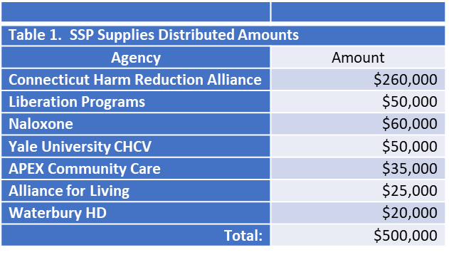
- Initial funding ($500,000 for 1 year starting in January 2024) served an estimated 6,418 individuals. Additional information is available in Table 1:

- FY 25 funding ($500,000 from 7/1/25-6/30/25) served an estimated 6,418 individuals. Additional information is available in Table 1:

- The following data is reflective of FY 25 Syringe Service Data across all providers and
funding sources:
Number of Clients by Race/Ethnicity Combined
Race/Ethnicity Combined | New Clients | Total Clients Served | Total Transactions | Total Naloxone Kits
American In/AK Native | 16 | 30 | 201 | 21
Asian | 10 | 25 | 94 | 19
Black/African American | 907 | 2169 | 15251 | 1989
Hispanic/Latino | 1264 | 3494 | 27653 | 3192
Middle Eastern or North African | 3 | 5 | 11 | 1
Native HI/Pacific Islander | 7 | 24 | 71 | 23
White | 2211 | 5427 | 39948 | 5293
More Than One Race | 63 | 130 | 745 | 134
Declined | 90 | 278 | 2973 | 793
Don’t Know | 51 | 115 | 426 | 263
Not Asked | 495 | 566 | 2520 | 358
Totals | 5117 | 12263 | 89893 | 12086

Sample of Materials Distributed
Material | Material Count | Transactions
Syringe | 2,391,329 | 57,890
Safer Use Kits | 77,344 | 59,539
Testing Strips | 28,767 | 7,498
Sharp Containers | 5985 | 4852
Wound Care Kit | 4742 | 2977

Mobile Opioid Treatment Program (OTP)
Brief Description: Fund 2 Mobile OTPs allowing for easier access to Medications for Opioid Use Disorder (MOUD), particularly Methadone.
Category: Treatment
Approval Date: March 2024
Total Amount: $4,000,000
Total Years: 3
Contract Start Date: 1/1/25
Implementation Updates: A competitive procurement process was utilized to identify the service locations and providers; Community Health Resources (CHR) was contracted to serve the Northeast region, and APT Foundation was contracted to serve the Southeast region. Due to length mobile unit procurement processes and regulatory and licensing requirements, these programs are not yet serving clients through their mobile units. APT’s mobile unit has been delivered; they are currently working on licensure and regulatory approvals. DEA inspection was completed and are in the process of applying for DPH licensure. Program RN is hired and training in other locations. Mobile Unit drivers have been accredited by DOT to operate the unit. CHR’s mobile unit has been delivered. Staff for the program is hired, including a Recovery Support Specialist and therapist, and a Program RN is in the final hiring stages. The program is working on applying for all needed accreditations and licenses. Both agencies are in collaboration with community providers to establish locations.

Reporting:
☒ Data Collection and Output Reporting ☐ Program Evaluation
Anticipated Data Points:
- Demographic Data
- Connections to Treatment (other than services provided on the vehicle; number and type)
- MOUD inductions on vehicle vs referral to another site
- Engagement Retention in MOUD
- Harm Reduction Supplies dispersed
- Van location (days, hours) & Individuals Served: Per Day/Location, identify number individuals prescribed MOUD/MOUD type, number individuals dosed, number individuals provided education or resources but not started on MOUD
- # individuals with reduced or eliminated substance use
Anticipated Reporting Dates:
- Every 6 months upon contract execution and initiation of service delivery: January 15, July 15
Data Collection and Output Reporting: Pending first report upon initiative of service delivery.

Treatment Pathway Program (TPP) Continuation
Brief Description: Continuation of TPP, a court-base pre-trial diversionary initiative for individuals with substance use disorders charged with nonviolent offenses, providing clinical evaluation and connection to clinical services, recovery coaching, and support services and referrals.
Category: Treatment, Recovery Support
Approval Date: May 2024
Total Amount: $3,840,000
Total Years: 3
Contract Start Date: 7/1/24
Implementation Updates: Project continued as scheduled without interruption.

Reporting:
☒ Data Collection and Output Reporting ☐ Program Evaluation
Anticipated Data Points:
- Demographic Data
- Total number of clinical assessments completed
- New individuals in reporting period per court
- Number individuals connected to treatment through TPP per court
- Number of planned successful discharges
Anticipated Reporting Dates:
- Every 6 months upon contract execution: July 15, January 15
Data Collection and Output Reporting:
Year 1: 6-Month Report (7/1/24-12/31/24):
- New Individuals Served by Court Location:
  - Bridgeport: 26
  - Waterbury: 30
  - Torrington: 15
  - New London: 24
  - Manchester: 38
  - New Haven: 50
  - New Britain: 67
  - Danielson: 35

Total: 285
- Number of Treatment Connections: 189
- Number of Successful Discharges: 37
Year 1: 6-Month Progress Report (1/1/25-6/30/25)
- New Individuals Served by Court Location

  - Bridgeport: 44
  - Waterbury: 27
  - Torrington: 10
  - New London: 39
  - Manchester: 20
  - New Haven: 68
  - New Britain: 36
  - Danielson: 25

Total: 269
- Number of Treatment Connections:
  - Medication Assisted Treatment/Medications for Opioid Use Disorder: 53

  - Withdrawal Management: 75
  - Intensive Outpatient: 129
  - Inpatient Psychiatric Treatment: 4
  - Residential Treatment: 92
  - Recovery Groups: 55

  - Total: 408
- Number of Successful Discharges: 51
Additional Narrative Description:
The Treatment Pathways Program initiative is to identify recently arrested persons with substance use issues and connect them to the least restrictive and most appropriate treatment connect as opposed to bond. The Treatment teams continue to form relationships with clients and utilize appropriate resources to address clients’ needs throughout their judicial pre-trial process.
Programs integrate equity-focused strategies into both clinical practice and programmatic design to address behavioral health disparities and enhance client outcomes. Through culturally responsive, trauma-informed, and evidence-based interventions, staff ensure that all individuals receive access to appropriate and effective care within the TPP program. This approach is embedded across the continuum of services, including assessment, individualized treatment planning, care coordination, and discharge planning. By reducing systemic barriers and prioritizing client-centered engagement, programs aim to support equitable access to behavioral health services and promote sustained recovery for justice-involved populations. Staff attend a variety of training opportunities intended to equip the staff with the skills and knowledge needed to effectively serve and support the community.
TPP continues to make meaningful progress toward its mission of supporting individuals involved in the legal system who are struggling with substance use. A key factor in participants' success is the program’s ability to provide immediate, tangible resources that remove barriers and increase client engagement . Using Flex Funds, TPP teams have helped clients not only achieve, but sustain, their recovery goals. Flexible financial support has provided critical relief to clients working to rebuild their lives. The adaptability of these funds ensures that TPP can meet the unique and evolving needs of each participant.
Simple yet critical items have proven instrumental in helping clients attend treatment, access support, and take steps toward long-term stability. Items purchased through Flex Funds include but are not limited to cell phones, bus passes, food and clothing, ID cards, driver’s licenses, hygiene products, and housing support.
Client needs are further addressed through connection to critical resources and programs including various housing programs and resources, connections to medical care, transportation, and coordination of basic needs including insurance re-instatement.
One noted challenge is limited housing resources, as this often impacts client engagement and success in the program, though the introduction of flex funds has provided some relief on this challenge and staff continue to build housing resources and connections. The other primary noted obstacle is finding an immediate treatment bed when withdrawal management and residential treatment are the recommended level of care, though clients are connected with outpatient levels of care while awaiting a bed.
Program leadership consistently assesses the successes and challenges of the TPP program. In summer 2025, the decision was made to close TPP at the Manchester and Torrington courts due to a mix of low enrollment and difficulty maintaining the required staffing pattern despite intervention. The Hartford and Middletown courts were identified as areas of need, and TPP has been initiated in both courts.
Success Stories:
“The power and impact of this type of support should not be overlooked. When an individual is granted TPP in New Britain, they receive a backpack filled with self-care necessities and Narcan. In the fall of 2024, a client was granted the program with no belongings. They accepted the backpack, clutching it tightly, as TPP staff transported them to the hospital for immediate medical care. Months later, that same client was thriving. They were maintaining recovery, attending outpatient treatment and living in sober housing. They expressed gratitude for the support they received on their first day in the program. To show their appreciation, they offered to donate supplies for future clients facing similar challenges.”
“The client is 53 years old and has successfully completed the TPP program. He entered the program following a challenging period in his life. Throughout the duration of treatment, the client remained compliant, actively engaged in his care, and demonstrated a strong commitment to setting and achieving personal goals. Upon discharge, the client focused on overcoming barriers to progress and expressed a clear intention to continue his education. Currently, the client is connected with community resources, has secured stable housing, and is in the process of reenrolling in and completing his master’s program. He aspires to work in the behavioral health field, motivated by his own experiences, which he finds both inspiring and empowering. The client aims to use his story to support and guide others facing similar challenges.”
“This client began with TPP in January of this year (2025) and was homeless living in a tent in Waterbury. This client was very resourceful and motivated. TPP helped connect him to treatment which he successfully completed. While he did have 1 relapse while in TPP, he was motivated to return to treatment and make more serious changes. He again completed inpatient treatment and instead of returning back to the Waterbury area, he chose to enter into sober living. Through sober living he began looking for full time employment and attended further groups through his sober living program. This client’s case was disposed of at his last court date and was successfully relieved of TPP.”
“Client P was referred to TPP in Nov 2024. He was initially referred to detox followed by inpatient treatment. Once client completed these recommendations he engaged in outpatient treatment at MCCA. Client engaged in MAT for MH as well as MAT for SA while engaged in engaged in IOP followed by Relapse Prevention and a Men’s Wellness group. Client was able to move back in with his family and engage in family therapy. Client completed TPP after being engaged in the program for 7 months connecting with an outside provider for Mental health to help tackle some past unresolved trauma. Client was able to build a collective toolbox of coping skills for Mental health, anger management and Relapse prevention, while engaged in the TPP program.”
“Over the past year, TPP has witnessed meaningful progress among many of its participants. One individual exceeded the team’s expectations, as they not only overcame personal barriers to recovery, they also fully embraced the recovery community. With the support and structure of TPP, this individual’s confidence and independence strengthened. They completed over 250 volunteer hours with CCAR, and their commitment was recognized with a scholarship to attend CCAR’s Recovery Coach Academy. At the time of their successful completion of TPP, they had reached over 90 days of recovery, secured employment, and resolved all outstanding legal matters. Several weeks later, this client accepted an invitation to speak at a Wheeler Clinic board meeting, where they shared a heartfelt letter expressing gratitude for TPP’s support and guidance."

Department of Corrections Opioid Treatment Program Expansion
Brief Description: Build out Opioid Treatment dosing rooms at 4 additional facilities to ensure access to all FDA-approved medications for opioid use disorder (MOUD) for all individuals incarcerated in and transitioning out of CT DOC.
Category: Treatment
Approval Date: May 2024
Total Amount: $416,650
Total Years: 1
Contract Start Date: 7/1/24
Implementation Updates: All sites continue to work on the build-out of the OTP rooms. Completion is
anticipated by summer 2026.

Reporting:
☒ Data Collection and Output Reporting ☐ Program Evaluation
Anticipated Data Points:
- Build-out completion dates
Anticipated Reporting Dates:
- Upon completion of build-out
Data Collection and Output Reporting: Pending completion of build-out.

Naloxone Saturation
Brief Description: Purchase of Naloxone for overdose reversal to ensure an abundant supply is going into the community, supporting the State’s Naloxone Saturation plan of distribution of 60,000 naloxone kits per year
Category: Harm Reduction, Prevention
Approval Date: May 2024
Total Amount: $2,323,200
Total Years: 1
Contract Start Date: 7/1/25
Implementation Updates: DMHAS continues to provide naloxone to any organizations in need of naloxone to distribute to the community to ensure statewide availability via braided funding. To obtain Naloxone for distribution, please contact Karolina Wytrykowska at Karolina.Wytrykowska@ct.gov.

Reporting:
☒ Data Collection and Output Reporting ☐ Program Evaluation
Anticipated Data Points:

- Number of kits distributed
- Agency/facility type (PNP, Hospitals, School, etc.)

Anticipated Reporting Dates:
- Annually by Calendar Year and/or upon utilization of all funds
Data Collection and Output Reporting:
Naloxone (brand name Narcan), is an opioid antagonist medication, used as a harm reduction tool to reverse an active overdose. The Department of Mental Health and Addiction Services has made it a priority to make this life saving medication available to all hospital emergency departments, treatment and recovery support providers, municipalities (first responders), and harm reduction service organizations. In 2022, DMHAS created a state naloxone saturation plan of distributing at least 45,000 naloxone kits and distributed close to 60,000 naloxone kits in the following calendar year, at no cost to the receiving organizations across the state. DMHAS continues to exceed the saturation goal with # kits distributed in CY 2024. Naloxone is available over the counter at most CT pharmacies and continues to be covered by Medicaid, however due to stigma, individuals sometimes prefer to get the kit from someone they trust. In addition to DMHAS supported entities, naloxone is distributed by the Department of Corrections (DOC) to individuals leaving their system, and available through pharmacies and municipal funding for emergency response. DMHAS employs an efficient system of purchasing naloxone directly from a distributor, who mails it directly to the organizations requesting the product. Since achieving the saturation goal, Connecticut saw a significant decrease in overdose fatalities for four consecutive years, and that trend is on track to continue for 2025.

DMHAS naloxone distribution by calendar year
2019 | 11,581
2020 | 13,162
2021 | 14,986
2022 | 29,064
2023 | 58,642
2024 | 64,087
2025 | 77,304
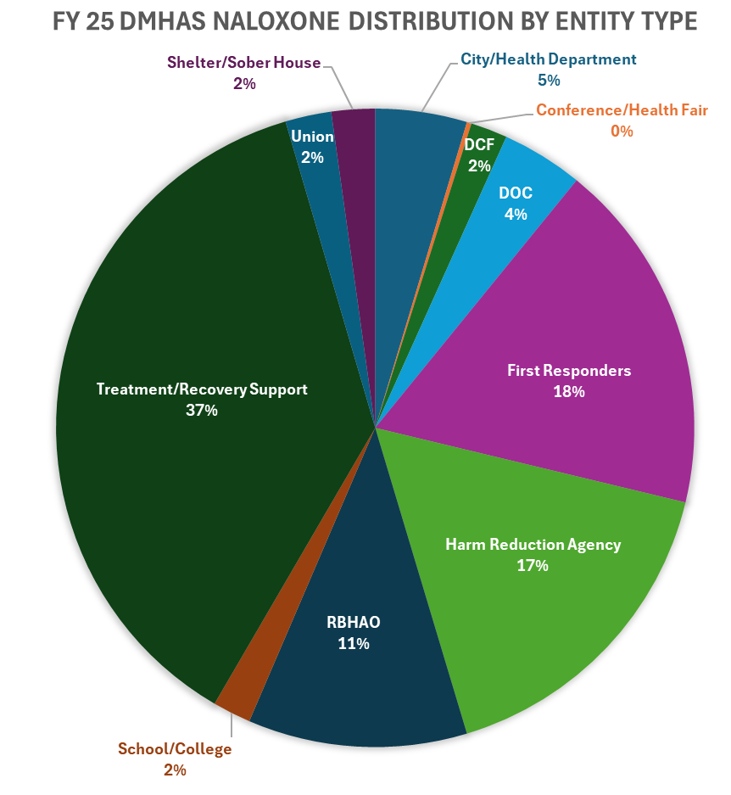

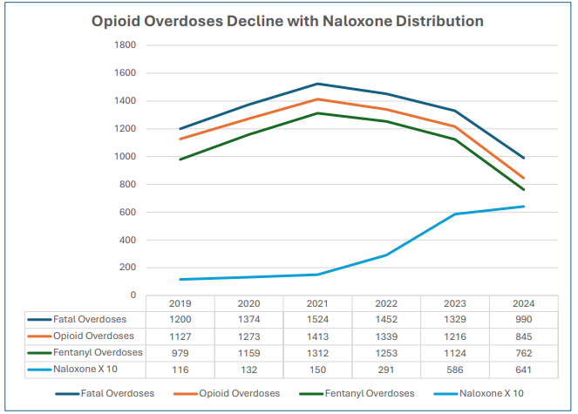

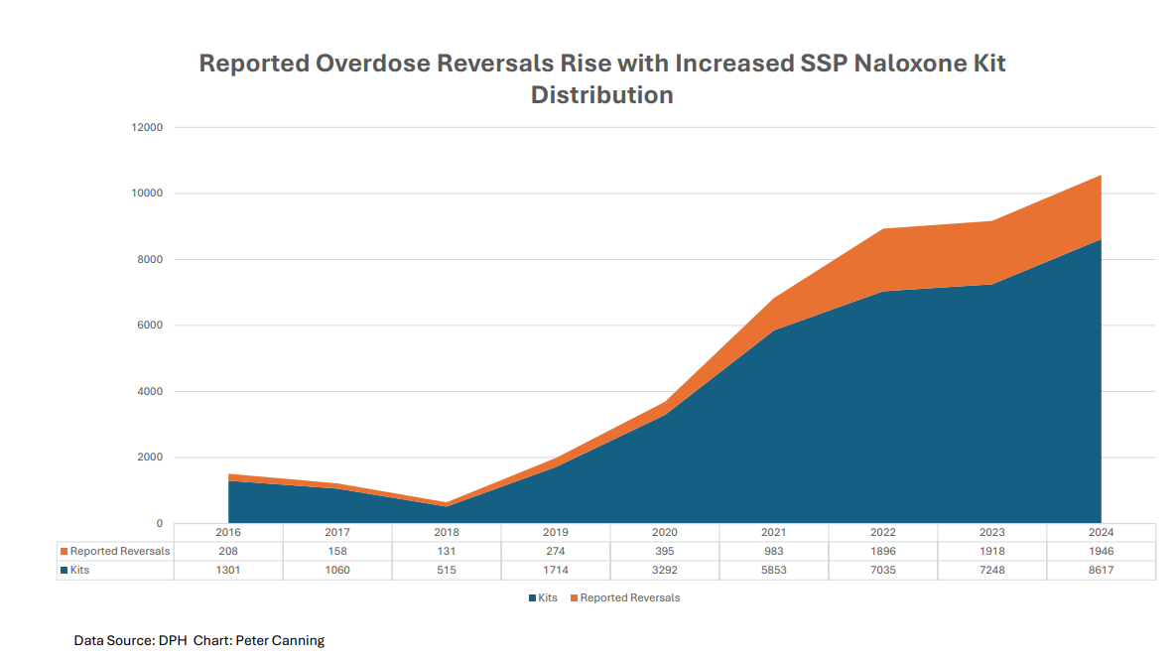
Source: DMHAS Chart by Peter Canning

Harm Reduction Vending Machines
Brief Description: Pilot Harm Reduction Vending Machines in 20 municipalities across Connecticut
Category: Harm Reduction
Approval Date: July 2024
Total Amount: $2,754,784
Total Years: 2
Contract Start Date: 10/1/25
Implementation Updates: Contracts are being finalized for implementation. A Vending Machine distribution company has been identified, and the vending machines that will be purchased have been selected. Selected agencies are developing protocols and building their budgets.
Reporting:
☒ Data Collection and Output Reporting ☐ Program Evaluation
Anticipated Data Points:
- Vending Machine locations
- Supplies Provided by count by Vending Machine location
- # Unique Individuals Served by Vending Machine location
- Participant Zip Codes Served by VM location
Anticipated Reporting Dates:
- Every 6 months upon contract execution
Data Collection and Output Reporting: Pending; implementation in progress.

Primary Prevention Through Education and Reduction of Opioid Diversion
Brief Description: Primary Prevention through education and reduction of opioid diversion, including Medication Lock boxes and mounted Naloxone boxes
Category: Prevention, Harm Reduction
Approval Date: July 2024
Total Amount: $1,418,000
Total Years: 2
Contract Start Date: 7/1/25
Implementation Updates: Contract fully executed. Contractor has identified Naloxone Box options for purchase and is connecting with key partners for collaboration to identify Naloxone boxes installation locations. Change the Script continues to attend community events to provide education and resources.
Reporting:
☒ Data Collection and Output Reporting ☐ Program Evaluation
Anticipated Data Points:
- Naloxbox locations and kits disseminated per box
- Services provided and individuals reached
- Supplies disseminated
- Events (location, type, number engaged)
- Advertising communications for events hosted
Anticipated Reporting Dates:
- Every 6 months upon contract execution: January 15th, July 15th
- Presentation to OSAC after 18m of data collection
Data Collection and Output Reporting: Pending. First report not yet due.

Drug Deactivation Pouch Mailing
Brief Description: Campaign to mail opioid deactivation pouches to 50,000 homes across CT with potential to remove more than 2 million pills from circulation annually
Category: Prevention
Approval Date: July 2024
Total Amount: $1,967,650
Total Years: 5
Contract Start Date: 1/1/25
Implementation Updates: The Governor’s Prevention Partnership mailed 50,000 Deterra Drug Deactivation Pouches to families across 39 communities during Red Ribbon Week (10/23-10/31/25). The campaign’s message “Put Me to Work, I Can Save a Life” was designed to grab attention and make safe medication disposal simple and accessible. Each mailing was addressed to “Current Resident” to maximize delivery rates, with materials provided in both English and Spanish. Visuals, instructions, and a request form for a Deterra Pouch are available at: https://gppct.org/prevention-pouch-en/. Initial feedback from the current distribution cycle indicates the pouches being used as intended. To reinforce distribution efforts and expand prevention messaging during the high-risk holiday period, GPP implemented a coordinated earned media and digital outreach strategy in November and December 2025.

Reporting:
☐ Data Collection and Output Reporting ☒ Program Evaluation
Anticipated Data Points:
- Number of pouches disseminated by zip code
- Usage rates of the Deterra pouches
- Types of substances deactivated
- Knowledge gains related to medication safety and prevention
- Re-order and follow-up requests
Anticipated Reporting Dates:
- Upon completion of annual mailing campaign, 6 months following completion of annual mailing campaign, and upon utilization of all funds
Data Collection and Output Reporting:
November 2025 Progress Report:
- 50,000 Deterra Drug Deactivation Pouches were mailed to families across 39 communities during Red Ribbon Week (10/23-10/31/25). Mailings were divided into English and Spanish distributions as follows:
  - Spanish-language mailers: 2,674 households in Bridgeport and 2,326 in Waterbury.
  - English-language mailers: Ellington (1,094), New Britain (3,879 across 3 ZIPs), Vernon (11), Vernon Rockville (1,760), Stafford Springs (741 across 2 ZIPs), Union (50), Suffield (751), Enfield (2,788), East Windsor (283), Windsor Locks (840), Willimantic (668), Windham (180), New London (975), East Lyme (528), Ledyard (573), Groton (1,472 across 2 ZIPs), Noank (3), Niantic (708), North Stonington (370 across 2 ZIPs), Norwich (1,797), Preston (344), Lyme (5), Old Lyme (650), Stonington (358), Pawcatuck (557), Waterford (1,078), Ansonia (965), Beacon Falls (459), Derby (658), Meriden (3,012 across 2 ZIPs), Seymour (1,086), and Shelton (2,811), Bridgeport (5,290 across 6 ZIPs), Waterbury (5,779 across 6 ZIPs), Wolcott (11), and Torrington (1,966)
- Additional Project Narrative:
Areas significantly impacted by the opioid epidemic were determined using the State Unintentional Drug Overdose Reporting System (SUDORS) data. Please note, households in Greater Hartford and New Haven received pouches in 2024 through a community distribution approach though other funding sources. Distribution was based on a proportional randomization model to ensure fairness and representativeness. The number of households selected per ZIP code reflected the percentage of that ZIP code’s households relative to the total statewide list. For example: ZIP Code 06030 includes 6,816 households, representing 1.7% of the total. Therefore, 1.7% of the 42,500 total mailings (approximately 725) were randomly selected from that ZIP code.

To raise awareness, GPP revamped PreventionCT.org offering immediate English or Spanish
access, distributed legislative outreach kits, and secured media coverage from WTNH, NBC 30, and CT-N, among others. A statewide press conference on October 29, featuring Governor Ned Lamont, Senator Cathy Osten, Senator Stephen Harding, and Commissioner Nancy Navarretta, highlighted the project’s launch and impact.

Evaluation has begun through a Qualtrics-based system tracking household use, substances
deactivated, prevention knowledge, and reorder rates. GPP is monitoring evolving data privacy laws (PADFA and Connecticut Data Privacy Act) that may affect access to demographic data for future mailings. Despite these challenges, new partnerships have allowed continued outreach to Spanish-speaking households, ensuring prevention starts where it matters most—at home.

Contingency Management (CM)—Adults
Brief Description: Implementation of Evidence Based Contingency Management protocols to complement existing continuum of substance use disorder treatment at 5 programs serving adults to reduce overdose risk.
Category: Treatment
Approval Date: September 2024
Total Amount: $2,254,242.00
Total Years: 2
Contract Start Date: 8/1/25
Implementation Updates: Participating agencies have been selected via competitive bidding process, and provider contracts are executed. Contract with UConn School of Medicine for training and technical assistance has been executed. All CM Coordinator, Case Manager, and Supervisor positions are filled, allowing each location to continue toward implementation of services with clients. All staff have either completed or are scheduled for their initial training, and all programs are working on their readiness assessments and participating in coaching and Q+A calls. Service implementation at all programs is expected to begin by January 5, 2026.

Reporting:
☐ Data Collection and Output Reporting ☒ Program Evaluation
Anticipated Data Points:
- Demographic data
- Substances used
- # Individuals served
- Incentives Provided (average per person, total incentive dispersed)
- CM Program Treatment Outcomes/Discharge Reasons
- Average number of visits attended per individual engaged
- Substance Use Reduction Outcomes
OUTCOMES | MEASURES
Individuals engaged in CM have increased treatment retention. | CM staff to enter CM attendance data into IMS CMI; the Contractor to track and report treatment dates expected and attended for individual’s Stimulant Use Disorder treatment services with the Contractor.
CM data is entered accurately and in a timely manner. | Department required data to be entered into CMI by the CM staff concurrently during the CM session.
The Contractor provides high fidelity CM services. | CM Coordinator, Case Manager, and Supervisor to attend all scheduled training, TA sessions, and monitoring/oversight sessions; CM staff to follow incentive schedule and protocol; the Contractor to enroll a minimum of fifty (50) individuals with moderate or severe stimulant use disorder in the CM program annually.

Anticipated Reporting Dates:
- Every 6 months upon contract execution: February 15th, August 15th
Data Collection and Output Reporting: Pending first report.

Contingency Management (CM)—Youth
Brief Description: Implementation of Evidence Based Contingency Management protocols to complement existing continuum of substance use disorder treatment at 2 programs serving youth to reduce overdose risk. CM with youth is being implemented as the Multi-Systemic Therapy Substance Use (MST-SU) model.
Category: Treatment
Approval Date: September 2024
Total Amount: $734,468
Total Years: 2
Contract Start Date: 3/1/25
Implementation Updates: The current staff on both teams have been trained in MST-SU by Advanced Behavioral Health (ABH), totaling 9 therapists and 2 supervisors. Teams enrolled their first MST-SU clients in May 2025. Since the last reporting period, 21 youths were admitted to MST SU, including youth with opioid use disorder and polysubstance use. Incentives are being utilized as rewards for participating in urinalysis testing, using drug refusal skills appropriately, substance use reduction as demonstrated by urinalysis testing results, and caregiver buy-in. Additional information on CT’s MST-SU program is located here: MST-SU Fact Sheet

Reporting:
☐ Data Collection and Output Reporting ☒ Program Evaluation
Anticipated Data Points:
- Demographic Data
- # Individuals served
- Incentives Provided (average per person, total incentive dispersed)
- Program Completion Rates and Discharge Reasons
- Length of stay and average number of visits attended per individual engaged
- Substances Used and Use Reduction Outcomes
- Outcome Measures:
  - 85% of adolescents complete MST/MST-SU
  - 95% of adolescents/families served will achieve an average length of service of 4 months
  - 80% of adolescents will be abstinent or show a reduction in substance use
  - 80% of adolescents will be living at home at time of discharge
  - 80% of adolescents will show improvement in school attendance at time of discharge
  - 75% of adolescents will have no new arrests during treatment
  - 80% of parent/caregivers will have the necessary parenting skills to handle future problems
Anticipated Reporting Dates:
- Every 6 months upon contract execution: March 15th, September 15th
Data Collection and Output Reporting:
Year 1: 6-Month Progress Report Summary (3/1/25-8/30/25)
- Individuals Served in MST (client and their families):
  - Family and Children’s Agency (FCA): 39 clients
    - MST-SU ala carte services: 8
  - Wheeler Health (WH): 41 clients
    - MST-SU ala carte services: 9
- Discharge Data: 17 clients
  - Gender: 47% male, 53% female
  - Language: 94% English as their primary language, 6% monolingual Spanish speaking
  - Age: 5% were 14 years old, 30% were 15 years old, 30% were 16 years old and 35% were 17 years old.
  - Discharge Reasons: 71% completed, 24% were discharged due to lack of engagement, 5% were discharged due to moving out of catchment
  - Substance Use Data:
    - 76% of youth experienced a reduction in substance use
    - 100% of clients presented with cannabis use
  - Engagement:
    - Clients attended 26.5 sessions per treatment episode across the network
    - Average CM utilization was 67% of total caseload (Goal=50%)
- Additional Narrative Description:

Full implementation of the MST-SU model includes the following protocols and interventions: ABC Assessment of Substance Use; Family Drug Management Planning, including Refusal Skills; Objective Monitoring of Youth Use (urine drugs screens and breath scans); and Point and Level Reward System Contingency Contracting. A la carte services describes cases that receive some of the protocols and interventions but not all due to clinical assessment and/or length of time left in the service.

Providers and ABH continue efforts to identify clients with Opioid Use Disorder (OUD) or at risk of OUD for services for Contingency Management (CM) services. These efforts include presenting the service to various stakeholders including community agencies, schools, ADPC, Probation and DCF. There has been a particular focus by the network to advertise to entities that service youth with opioid use disorders such as clinics that offer medication for opioid use disorders, inpatient hospitals and substance use intensive outpatient programs.

The use of incentives for CM has been identified as a barrier from a training perspective. Providers have not been adhering to the model's fidelity, particularly in implementing the incentive component of CM. The Department of Children and Families (DCF) has discussed this issue with the Advanced Behavioral Health (ABH) and the model developer. A fit assessment is currently underway to better understand the underlying factors contributing to this situation. ABH and DCF will monitor this issue as a follow-up item monthly and expect the model developer's consultants to address this topic during their weekly consultation calls as well. Additionally, we have requested that this process be documented, along with an oversight of what is being reviewed in supervision regarding fidelity to the model.

Numerous examples of success were provided where substance use and the other referral behaviors were reduced. These success stories are not related to youth with active opioid use disorders. However, it is important to consider that when a decrease in substance use or abstinence from substance use happens congruent with engagement in MST-SU services, the treatment episodes have served as an interruption in advancement of the substance use given substance use disorders are progressive when untreated.
LiveLOUD Public Awareness and Education
Brief Description: An expansion of LiveLOUD (Life with Opioid Use Disorder) to maximize the impact and reach of the public health campaign and meet the OSAC goals of urgently and efficiently decreasing the adverse impact of opioids. Includes efforts to: Reduce stigma, raise awareness about recovery pathways, prevention and harm reduction information
Category: Prevention
Approval Date: September 2024
Total Amount: $600,000
Total Years: 1
Contract Start Date: 1/1/25
Implementation Updates: Flight 1 of campaign was from 3/10-6/8/25. Flight 2 ran from 8/11-10/17/25 and included SafeSpot and Recovery Month initiatives. Funding has been fully expended. The LiveLOUD website is located at https://liveloud.org/ and printable materials are available at: https://liveloud.org/get-support/toolkit/.

Reporting:
☒ Data Collection and Output Reporting ☐ Program Evaluation
Anticipated Data Points:
- Engagement/Reach Data per tactic (include breakdown by language)
- Communities reached per tactic
- Outline of tactics used
Anticipated Reporting Dates:
- Upon completion of each campaign phase
Data Collection and Output Reporting:
Calendar Year 2025: LiveLOUD Phase 8 Campaign Results Highlights
LiveLOUD (Live Life with Opioid Use Disorder) is a unique initiative from the Connecticut Department of Mental Health & Addiction Services (DMHAS) to maximize the impact and reach of the public health campaign; and meet OSAC goals of urgently and efficiently decreasing the adverse impact of opioids. This includes efforts to reduce stigma, raise awareness about recovery pathways, and prevention and harm reduction information.
The Phase 8 expansion of the LiveLOUD Campaign included two flights (Spring and Fall 2025) to continue to help spread awareness to new audiences; and to reinforce key messages to audiences who may have already seen or engaged with LiveLOUD content. Phase 8 continued the mission to change perceptions and reduce stigma with a clear, consistent message: This is an issue that affects every community. There are options for treating addiction. Every person is worth saving. There is no judgment. The communications strategy provided a trusted, science-based, non-judgmental source of information and support. Utilizing diverse channels for broad awareness and targeted placements, a wide audience was reached across all demographics and locations in Connecticut. This critical effort encouraged Connecticut residents struggling with OUD to access DMHAS resources, including recovery, treatment, and harm reduction information, on LiveLOUD.org.
Phase 8 media tactics included an enhanced mix of highly engaging social posts across multiple platforms, including the addition of TikTok as a new channel; strategic digital placements; Google search and display advertising; streaming audio, podcasts, and broadcast radio; OTT (streaming TV); Out of Home (OOH) including digital and static billboards; transit advertising; place-based media; and print advertising. All creatives were deployed in both English and Spanish languages.
Target Audience:
- Opioid users and families/loved ones
- English & Spanish speaking
- CT males (White, Black, Hispanic Ages 25-64)
Key Messages:
- Safe Environments/Stay Safe at Home
- Naloxone Saves Lives
- MOUD Works
- Avoid Fake Pills
- Reach Out for Support
Impact Summary:
From March through October 2025, the LiveLOUD Phase 8 campaign achieved the following results:
- Raised awareness: Messages appeared across Connecticut more than 48.4 million times
- Connected with target audiences: The campaign earned more than 879,000 social engagements in English and Spanish
- Engaged audiences: Over 108,000 link clicks drove users to key information on the website
- Expanded reach: Successfully launched on TikTok, generating 2.4 million impressions and
- reaching 671,730 unique users
- Remained a trusted resource for both the public and community partners
Top-Line Performance Metrics
Overall Reach & Impressions
- Total Reach: 3,672,094 (+81% vs Phase 7)
- Total Impressions: 48,459,137 (+72% vs Phase 7)
Social Media Performance
- Total Social Engagements: 879,452 (+11% vs Phase 7)
- Average Engagement Rate: 25.78% - 29.61% across platforms
Partnering Organizations Growth
- 18 Social Media Whitelisting Partners (+125% vs Phase 7)
- Digital Toolkit Folder Downloads: 115 (+80% vs Phase 7)
- Digital Toolkit Partnering Organizations: 98 (+717% vs Phase 7)
Year-Over-Year Channel Performance
Social Media Platforms
- Facebook
  - Impressions: 1,043,763 (+14% vs Phase 7)
  - Engagements: 269,097 (+10% vs Phase 7)
  - Engagement Rate: 25.78% (172x benchmark)
- Instagram
  - Impressions: 826,829 (+56% vs Phase 7)
  - Engagements: 244,834 (+23% vs Phase 7)
  - Engagement Rate: 29.61% (197x benchmark)
- META Traffic & Video Ads
  - Impressions: 2,349,522 (+52% vs Phase 7: 1,542,557)
  - Engagements: 348,893 (+32% vs Phase 7: 263,498)
  - Click-Through Rate: 2.48% (2.76x benchmark)
- META Whitelisting Partnership
  - 18 partnering CT Public Health Organizations (+125% vs Phase 7)
  - Positive Reactions: 4,578 (+1,800% vs Phase 7)
  - Link Clicks: 417 (+57% vs Phase 7)
  - Shares: 209 (+386% vs Phase 7)
  - Engagement Rate: 14.86% (99x benchmark)
- NEW: TikTok
  - A new major platform expansion
  - Reach: 671,730
  - Impressions: 2,382,406
Digital Advertising
- Google Ads
  - Total Impressions: 2,602,835 (+96% vs Phase 7)
  - Search Ads: 284,973 impressions with 7.68% CTR (vs 7.07% in Phase 7)
  - Display Ads: 2,317,862 impressions (+91.7% vs Phase 7)
- Display Advertising
  - Total Impressions: 7,142,401 (+81% vs Phase 7)
  - Custom Display: 2,803,762 impressions (+26%)
  - Geofencing: 2,445,013 impressions (+42%)
  - NEW: Audience-Based Display: 1,008,714 impressions
Video Streaming (OTT)
- Total Impressions: 731,206 (+34% vs Phase 7)
- OTT: 438,073 impressions
- NEW: Twitch: 293,133 impressions
Audio & Radio
- Streaming Audio
  - Total Impressions: 1,265,398 (+44% vs Phase 7)
  - Reach: 184,024 (+34% vs Phase 7)
  - Reach: maintained strong presence in English and Spanish markets
- Broadcast Radio
  - Total Impressions: 461,600
Out-of-Home (OOH)
- Total Impressions: 28,990,586 (+64% vs Phase 7: 17,670,614)
  - Transit Ads: 18,227,786 impressions
  - Digital & Static Billboards: 9,230,175 impressions
    - LiveLOUD billboards rotated across high-traffic locations in Bridgeport, Hartford, New Britain, New Haven, New London, Norwich, Stratford, and Torrington
  - NEW: Place-Based Media: 10,762,800 impressions
Print Advertising (NEW in Phase 8)
- Total Impressions: 260,000
- NEW: Four publications targeting diverse communities
  - English and Spanish language coverage
Key Performance Achievements
- 81% increase in total reach with 93% budget increase - highly efficient scaling
- 115% improvement in Google Search Click Thru Rate (CTR) - significantly better relevance and targeting
- 96% increase in Google impressions - enhanced digital presence
- Platform diversification - added TikTok, Twitch, place-based media, and community print
- Engagement quality - maintained strong engagement rates (25-30%)
- Geographic expansion - broader OOH coverage across Connecticut communities with 64% increase in OOH impressions
- Bilingual reach - strong performance in both English and Spanish across all channels
LiveLOUD.org Website Metrics: 03/01/25 - 10/20/25
- New Users: 76,616 (+132.87% vs Phase 7)
- Pageviews: 109,543 pages viewed (+87% vs Phase 7)
- Flight #1 averaged 330 people per day visiting the LiveLOUD website.
- Flight #2 averaged over 600 people per day visiting the LiveLOUD website.

Visual Depiction of Phase 8 Statewide Implementation:
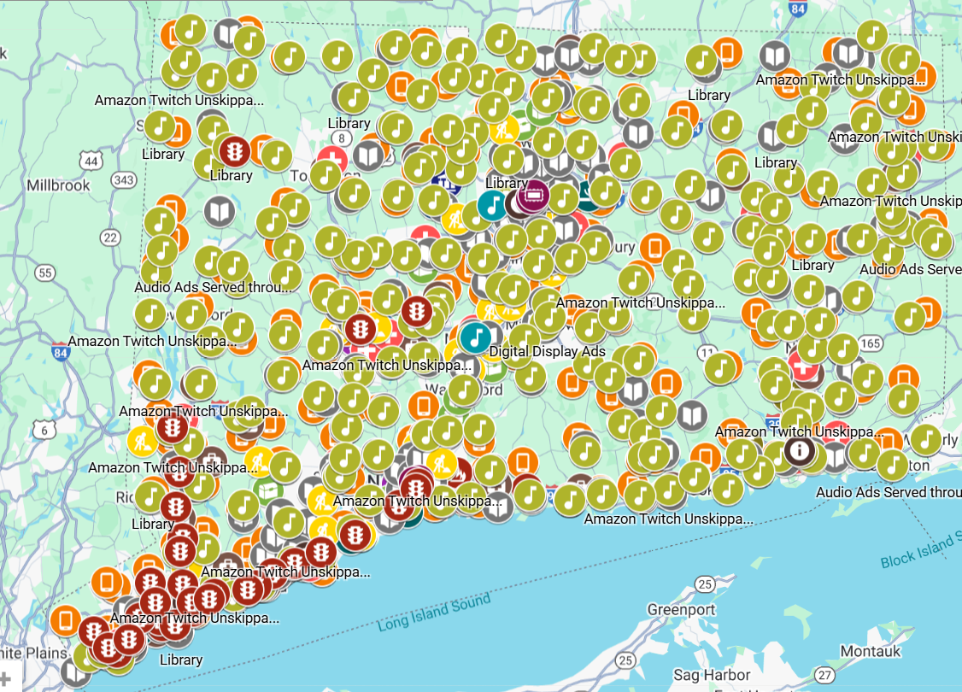

Click here to explore the map further: LiveLOUD Phase 8- OSAC Presentation - Google My Maps
LiveLOUD.org Web Traffic Snapshot: 01/01/25 - 10/20/25
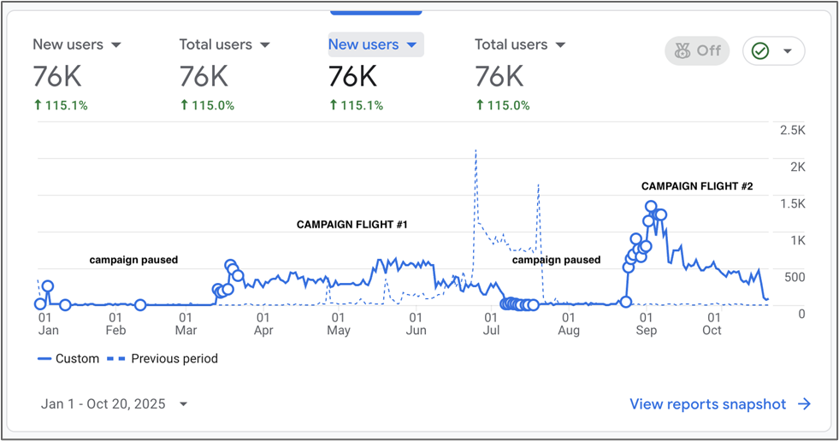

Treatment Bridge Model for Connecticut's Emergency Departments
Brief Description: Initiative with CT hospitals to increase low-barrier Emergency Department-initiated MOUD in CT. Includes funding for: Training and TA, development of processes to screen individuals for OUD and introduce MOUD as a treatment option, support for Site Champion, and 2 recovery navigators per site
Category: Treatment
Approval Date: September 2024
Total Amount: $1,250,000
Total Years: 2
Contract Start Date: 11/1/25
Implementation Updates: Contracts are being finalized with the TA provider and participating hospitals. Program Implementation meetings are scheduled.

Reporting:
☒ Data Collection and Output Reporting ☐ Program Evaluation
Anticipated Data Points:
- # trainings provided/attendees
- # individuals served
- # individuals inducted on MOUD
- # individuals connected to community treatment
- % retained in MOUD at 3 months and 6 months
- If return admission, reason for re-admission
OUTCOMES | MEASURES
Increased number of individuals will be screened for OUD and inducted on MOUD in the Emergency Department (ED). | Contractors shall identify their baseline % of individuals screened for OUD and inducted on MOUD in the ED prior to implementation of this initiative, semi-annual reporting shall indicate a continued increase in screenings and inductions.
Individuals with OUD will be connected to community-based treatment prior to leaving the ED, including to continued MOUD services. | Contractor to track and report on the frequency of MOUD and other treatment connections made for individuals with OUD while in the ED.
Individuals provided MOUD in the ED to experience treatment retention and decreased OUD-related ED visits. | Contractor shall track and report at 3 months and 6 months post ED-induction % of individuals retained in MOUD; % of individuals returning to the ED within 6 months and reason for re-admission.
ED Physicians and direct care staff to have increased knowledge of MOUD initiation and continuation in the ED. | The Contractor shall ensure training and technical assistance hours are completed by staff members as part of this initiative.
Data reporting requirements met in a timely manner. | Department required data shall be submitted to the Department’s data collection system no later than the 15th day of each month.

Anticipated Reporting Dates:
- Every 6 months upon contract execution
Data Collection and Output Reporting: Pending; report not yet due.

Promote and Expand Opioid Overdose Education and Prevention in CT's Colleges and Universities
Brief Description: Technical assistance to support opioid overdose education and prevention and developing and/or enhancing recovery friendly communities at CT institutions of higher education including monthly interactive learning cohorts and personalized technical assistance for participating institutions to address individualized capacity building needs for opioids and overdose prevention
Category: Prevention, Recovery Support
Approval Date: November 2024
Total Amount: $631,777
Total Years: 2.5
Contract Start Date: 9/1/25
Implementation Updates: The contract with Wheeler Clinic has been executed and implementation meetings are underway. Wheeler Clinic is working with SAFE Project on an implementation plan for provision of the training and technical assistance sessions. A dedicated Project Coordinator, responsible for project planning, coordination, engagement and recruitment, has been hired. The Technical Assistance Summit is slated for Spring 2026, after which the Training Sessions and campus-specific training sessions will begin.

Reporting:
☒ Data Collection and Output Reporting ☐ Program Evaluation
Anticipated Data Points:
- Date, time, and location of the technical assistance meetings, including the number of attendees, role (faculty, staff, student, community member) and collegiate institution affiliation(s)
- Collegiate Recovery Programs/Communities built
- Opioid Overdose Prevention/Response Programs implemented
- Stigma reduction strategies (campaigns, training programs, etc.) designed and implemented
- Percent of campuses involved with action plans drafted
- Percent of drafted action plans that have been implemented
- Individual stigma reduction, as quantified by movement between training pre/post surveys
OUTCOME | MEASURE
Increased awareness of Opioid Overdose Education and Prevention strategies at Connecticut’s Collegiate Institutions | At least fifty percent (50%) of all Collegiate Institutions in Connecticut will send at least one (1) faculty, staff, or student representative to at least six (6) Technical Assistance sessions annually
At least 75% of Collegiate Institutions involved with the project will successfully implement at least one (1) of the strategies identified below by completion of the project:
Build a Collegiate Recovery Program or Community | • Increase in campuses involved with action plans drafted and implemented  • Implementation of a coalition of supportive offices, staff, organizations
Implement an Opioid Overdose Prevention/Response Program | • Increase in campuses involved with action plans drafted and implemented  • Faculty, staff, and students impacted by training  • Implementation of a coalition of supportive offices, staff, and organizations
Design and implement stigma reduction strategies | • Increase in campuses involved with action plans drafted and implemented  • Faculty, staff, and students impacted by  training  • Individual stigma reduction, as quantified by movement between training contractor-developed pre/post surveys

Anticipated Reporting Dates:
- Every 6 months upon contract execution: March 15th, September 15th, and upon project completion
Data Collection and Output Reporting: Pending. Report is not yet due.

SafeSpot Overdose Hotline
Brief Description: Expansion of SafeSpot, a 24 hour-7-day a week Overdose Hotline, to Connecticut. Operators provide real-time phone-monitored supervision of drug use for individuals using alone. An emergency response is activated if the individual becomes unresponsive.
Category: Harm Reduction
Approval Date: January 2025
Total Amount: $1,513,085
Total Years: 3
Contract Start Date: 7/1/25
Implementation Updates: Contract has been executed. Individuals can call 1-800-972-0590 to utilize the SafeSpot Overdose Hotline. SafeSpot staff continue to provide regular presentations to various entities throughout CT to increase awareness and referrals. To learn more about the overdose hotline, including a brief video on how the hotline works, visit the SafeSpot website at: https://safe-spot.me/how-it-works/

Reporting:
☒ Data Collection and Output Reporting ☐ Program Evaluation
Anticipated Data Points:
- Number of calls
- Number of Drug Use Events (how many times someone uses on the call)
- Average response time
- Zip Code (for understanding how our marketing is working)
- Substance(s) and route(s) of use used by the caller
- Call outcome (Mark Safe vs Overdose vs Disconnect)
- Safety Actions Taken
- Linkages to Care/Resources by types and amounts
Outcome | Measure
Individuals calling into the hotline experience low barrier access to phone monitored supervision of drug use | Calls are answered by an operator within an average of 60 seconds
Increased engagement of individuals using drugs alone with phone monitored supervision of drug use | At least 100 calls from CT are managed monthly
Improvement in the overall health and wellbeing of individuals calling the hotline | 100% of people calling into the hotline have prevented overdose or detected overdose with appropriate medical activation response during the call safety window
Individuals calling into the hotline receive satisfactory support during their calls | Less than 5% of CT calls result in a complaint and all complaints are reviewed by a supervisor for quality assurance
Operators are Connecticut-based | 20 CT-based operators are hired within years 1 and 2 of this contract; hire and training of Spanish speaking cohort in year 2

Anticipated Reporting Dates:
- Quarterly upon contract execution: October 15th, January 15th, April 15th, July 15th
Data Collection and Output Reporting:
Year 1, Quarter 1 Progress Report: July 1-September 30, 2025
- Number of calls received:
  - Total: 1860
  - Connecticut: 533 (628 use events)
  - Massachusetts: 112 (189 use events)
- Unique spotting callers:
  - Total: 57
  - Connecticut: 2
  - Massachusetts: 19
- Average time (in seconds) from call initiation to operator pick up: 0:13 seconds
- Rates of safety actions taken by caller and noted by operator including but not limited to:
  - Caller reports having drugs checked by program: 0
  - Caller reports using a test strip (fentanyl, xylazine, other): 7
  - Caller reports doing a test dose: 4
  - Caller initiates use of a timer: 484
  - Caller verbalizes spacing or pacing: 18
  - Operator initiates use of a timer: 1082
  - Caller switches substance (e.g., fentanyl to cocaine): 2
  - Operator encourages spacing or pacing between use events to slow down use (general): 1
  - Operator encourages spacing in between use events to slow down use (due to caller perceived intoxication): 3
  - Operator encourages caller to stand up to gauge level of intoxication prior to additional use event: 6
- Call Outcomes
  - Number of overdose response activations:
    - Total: 5
    - Connecticut: 0
  - Linkage to Care: No new linkage to care for CT callers in reporting period
- Geographic Distribution (CT only):
  - 06790 (538 calls)
- Outreach and Engagement: During this reporting period, SafeSpot conducted 13 presentations across Connecticut, all held virtually. These sessions focused on raising awareness of SafeSpot, explaining referral pathways, and sharing best practices for integrating phone-based harm reduction support into existing service systems. We continue to receive new presentation and partnership requests nearly every other day as awareness of SafeSpot grows statewide. Advertising and outreach efforts have focused primarily on social media engagement, professional networks, and word-of-mouth referrals from trusted community partners.
- Workforce Development: SafeSpot launched Hiring Cohort 4 in September, which included our first concerted outreach to recruit Connecticut-based operators. As of November 1, five applicants have been interviewed and received offers of employment, and the sixth remains in process. Two Connecticut operators have officially started. We anticipate all six Connecticut hires will be fully onboard and taking calls by the end of December. Our next hiring cohort will prioritize candidates from Connecticut, Maine, and Spanish-speaking communities. This targeted outreach aims to increase applicant conversion and strengthen our capacity to launch SafeSpot’s Spanish-language hotline in early 2026.
- Additional Narrative Highlights (including achievements, challenges, and planned improvements):
Key Program Achievements:
During this reporting period, SafeSpot achieved several major milestones in our Connecticut implementation. The inaugural Connecticut hiring cohort was launched, and the first locally based operator is ready to begin fielding calls. A strong statewide presence was maintained, finding potential new audiences nearly every other day, and four staff members are confirmed to attend the Connecticut Harm Reduction Conference on November 7th to operate a table and host a workshop. Program operations remain highly responsive, with an average caller hold time of only 13 seconds. SafeSpot also provided sustained peer support to a high-need caller in Torrington.

SafeSpot leadership is in the final stages of submitting an accreditation application to the International Council for Helplines, which would make SafeSpot the first overdose detection hotline in the United States to achieve this distinction. In parallel, SafeSpot leadership initiated a suggestion for collaboration with United Way 211, proposing a statewide hotline coordination group to enhance inter-organizational communication and referral efficiency.

SafeSpot also received a Notice of Award from CDC for our 5-year R01 application. This project, which began 10/1/25, will be the first formal evaluation of SafeSpot’s marketing and outreach efforts and will enhance our work in CT to find new callers.

Emerging Challenges and Planned Improvements:
Applicant retention through the hiring process has been a challenge, with 6 of 28 (21%) prospective Connecticut applicants completing their full applications, which is below our typical conversion rate. Additionally, we expect call volume growth to occur gradually, consistent with Massachusetts’ one-year ramp-up following initial launch. SafeSpot plans to launch a Spanish-language hotline to expand accessibility for Spanish-speaking residents. Recruitment for bilingual operators has been slower than anticipated, prompting a dedicated, accelerated hiring cohort. We have also enhanced our training curriculum by adding two hours of scenario-based roleplay to strengthen operator preparedness and confidence.

Harm Reduction Centers
Brief Description: Continuation and expansion of Harm Reduction Centers (HRC) offering low-barrier, drop-in support for individuals who use substances, particularly those who are at high risk for opioid overdose
Category: Harm Reduction
Approval Date: January 2025
Total Amount: $6,975,000
Total Years: 3
Contract Start Date: 9/30/25
Implementation Updates: The contract was executed with Liberations for a new Harm Reduction Center in Bridgeport with anticipated launch in early 2026; current focus is on construction of new site, development of project policies and procedures, and hiring and training of staff. The Harm Reduction Centers in Hartford, New London, New Haven, and Waterbury continue operations as planned.

Reporting:
☒ Data Collection and Output Reporting ☐ Program Evaluation
Anticipated Data Points:
- Total Visits
- Unique Individuals
- Naloxone Kits Distributed
- Harm Reduction Supplies Dispensed
- Client Demographics
- Connections to Care and Medical Support
- Medical Treatment Received (MAT Induction, Testing/Screening for HIV, Hep C, etc, Wound Care)
OUTCOMES | MEASURES
Operate a stigma-free and low barrier drop-in center for individuals who use drugs; without requiring abstinence or an expressed desire for treatment as a prerequisite to access. | Program capacity shall accommodate a minimum of twelve (12) individuals at any one time and serve a minimum of one thousand (1,000) individuals annually. Harm Reduction policies and procedures shall be developed and regularly reviewed and revised as necessary and copies provided to the Department.
Increase engagement between providers of treatment and recovery services, health care and social services and persons seeking such supports. | Harm Reduction Center staff shall track % of individuals identified as having Social Determinants of Health needs; % of individuals who demonstrate improvement in these measures between baseline and six (6) months; number of referrals in which the first appointment was kept; % individuals referred by the Harm Reduction Center that remain engaged in treatment after six (6) months.
Broadly improve the overall health and well-being of individuals who use drugs, through measures including but not limited to reduction of unintentional overdoses and disease transmission. | Number of fatal overdoses in the immediate and surrounding Waterbury area of Harm Reduction Center operation shall be reduced. Trends in the area as it relates to unintentional overdoses, overdose reversals, and testing or support around decreasing the frequency of disease transmission shall be monitored and reported.
Provide harm reduction supplies, naloxone training and distribute kits in the community. | Harm Reduction Center staff shall track total itemized number of harm reduction supplies distributed, number of individuals trained in naloxone administration, number of kits distributed and number of any known overdose reversals as a result of kits distributed and report such information to the Department.
Meet data reporting requirements in a timely manner. | Department required data shall be submitted to the Department's data collection system no later than the 15th day of each month.

Anticipated Reporting Dates:
- Every 6 months upon contract execution: April 15th, October 15th
Data Collection and Output Reporting:
Note: OSAC funding for the Harm Reduction Centers (HRC) did not begin until 9/30/25, when the previous funding source was exhausted. Information included is reflective of data collected under the previous funding source.
Project Summary of Data Across All Sites (October 1, 2023-October 1, 2025)
- Total Visits: 11,873
- Unique Individuals: 2,360
- Supplies Distributed:
  - Naloxone: 3,536 kits
  - Dispensed Syringes: 588,580
  - Returned Syringes: 550,629
  - Xylazine Testing Strips: 260
  - Fentanyl Testing Strips: 1,878
  - Safe Use Kits: 13,428
- Connections to Care and Medical Support:
  - Withdrawal Management: 166
  - MOUD Inductions: 143
  - Testing (HIV-Hep C): 611
  - Wound Care: 740
  - Mental Health: 83
Narrative Summary:
As demonstrated above, Harm Reduction Centers (HRC) offer a wide range of services to create holistic, person-centered healthcare environment to support the individual in addressing their immediate basic needs and long-term health and wellness goals. In addition to the connection noted above, the HRC services include a mix of case management, including support in securing housing and phones; food services; clothing closets; laundry services; hair dressing services; and showers. The HRC also maintain numerous collaborative relationships via community connections to ensure all individual’s needs are met.
Some recent notable successes include:
- “Outreach continues to be a major contributor to engagement, with roughly half of all visits resulting directly from community-based outreach. We collaborate daily with a wide range of partners, including CHD, the Waterbury Health Department, Waterbury Hospital, local shelters, the soup kitchen, and other community organizations. These partnerships strengthen our ability to connect with individuals who might not otherwise access care.”
- “at least 27 individuals have reported using Narcan provided by Apex to save another person’s life”
- “By remaining open later than many service providers and maintaining strong community partnerships, Apex serves as a vital access point during after-hours, bridging the gap between daytime service closures and the opening of local shelters, ensuring that support, safety, and care are always within reach.”
- “To reach individuals who may not engage during standard hours, we have implemented scheduled night outreach from 7:00 p.m. to 10:00 p.m., meeting community members where they are and providing essential harm reduction supplies.”
- The in-house nurse “has been an integral piece in advocating for individuals with wounds and other medical needs that are resistant to going to local emergency rooms due to the way they are treated by staff. [She] has accompanied clients to location emergency rooms and stayed with them to be sure they are being treated respectfully.”
- “having a clinic here every Friday has resulted in many people being inducted onto MOUD care and have other medical needs addressed.”
- HRC participants have been active “in the community cleaning up the trash and needles in the neighborhood near the HRC. The areas we have been cleaning are Schools, parks, libraries, encampments, and areas with a lot of activity. We have been doing this to provide a clean and safe environment for the community. We have been doing this three times a week. The New Haven Police Department and Members from the City Hall have been calling and emailing thanking all of us for the work we have been doing in the community.”
- HRC staff was at an event where an individual experienced an overdose “we went running over to see what was wrong. When we got over there we then administered Narcan and got medical attention for the individual…he came to HRC and asked for help. We found him at a treatment facility that had a bed for him. We transported him to the facility where he is doing well.”
- “Wound care has remained a critical part of our services. Many people in our community still avoid hospitals and medical providers. As a result, accessible wound care is more important than
ever. To meet this need, we continue to distribute a large number of wound care kits and work closely with Cornell Scott Hill Health Center to provide on site wound care services. We also ensure that participants are connected to further medical support when needed.”

Housing Empowering Recovery from Opioids (HERO)
Brief Description: Housing Supports for individuals with OUD or at risk for overdose who are experiencing homelessness or homeless prior to entry to substance use disorder (SUD) treatment, who do not have a safe and/or viable housing discharge plan. Includes: Rental Assistance Program (RAP) Housing subsidies, client supports fund, and case management and peer support services.
Category: Recovery Support, Harm Reduction
Approval Date: January 2025
Total Amount: $58,600,000
Total Years: 4
Contract Start Date: 8/1/25
Implementation Updates: Contracts are executed with the direct care providers. The pre-screener was opened on 11/20/25; as of 12/8/25, the pre-screener portal was closed due to exceptionally high demand. Over 600 pre-screeners were received and approximately 300 applications were substantiated as meeting program criteria thus far. Remaining pre-screeners will undergo initial review by DMHAS Housing and Homeless Services Unit. The pre-screening portal will reopen in the future if there is program capacity available. After initial screening by DMHAS, applications are forwarded to the direct care providers, who further verify eligibility, help the individual apply for a RAP voucher, and provide case management and recovery support services.

Reporting:
☐ Data Collection and Output Reporting ☒ Program Evaluation
Anticipated Data Points (Note: Evaluation plan is under development and evaluation criteria have not been finalized):

- Number served
- Length of time from voucher approval to housed
- Referrals and connections to treatment
- Exit destinations at program completion
- Demographics

Measure | Outcome
Consumers improve their housing stability. | At least ninety (90%) of consumers have a stable living situation reported in annual reporting period.
Consumers regularly receive services, including case management or peer recovery supports. | At least ninety percent (90%) of consumers have had at least twelve (12) in-person services during the annual reporting period.
Consumers maintain or improve their employment status. | At least fifty (50%) of consumers served annually will maintain or increase their amount of competitive employment.
Anticipated Reporting Dates:
- Every 6 months upon contract execution: February 15th, August 15th
- Comprehensive eval starting at 2.5 months from implementation for report out at year 3
Data Collection and Output Reporting: Pending; not yet due.
Emergency Department Recovery Coaching
Brief Description: Continuation of Recovery Coaching in the Emergency Departments at 9 acute care hospitals, ensuring Recovery Coaches are available at all Emergency Departments in CT. The Recovery Coaches are available from 8:00am – midnight 7 days per week to support individuals admitted with opioid overdose and drug-related medical emergencies and connect them to treatment and other recovery support services.
Category: Recovery Support
Approval Date: March 2025
Total Amount: $2,160,000
Total Years: 4
Contract Start Date: 7/1/25
Implementation Updates: Project continued without disruption.

Reporting:
☒ Data Collection and Output Reporting ☐ Program Evaluation
Anticipated Data Points:
- # admissions per primary drug of choice
- # referrals by type/level of care (including MOUD)
- readmission rate
- demographics (including town of residence)
- time/day trends of admission
- length of time for RC contact post discharge
- # of follow ups post-discharge
- previous overdose history (lifetime)
OUTCOMES | MEASURES
Maintain an active list of on-call certified, skilled ED Recovery Coaches to ensure 24/7 coverage of designed hospital emergency departments. | A minimum of 1 trained ED Recovery Coach shall be available at each identified hospital 24 hours per day, seven days a week.
Provide ED Recovery Coaching services to identified individuals. | 90% of individuals referred to the ED Recovery Coaching program will receive face-to-face contact within two hours of the request; 250 individuals will receive ED Recovery Coaching at each identified hospital annually.
Develop and disseminate a Resource Handout. | Disseminate a Resource Handout that contains recovery related information and treatment options for use at discharge from the ED.
Establish and maintain MOAs with hospitals as identified by the Department. | Maintain an MOA that enables the ED Recovery Coaches to access referred individuals in the ED. The MOA should indicate protocols for referrals of eligible individuals and include the Resource Handout to be issued with discharge paperwork.
Enroll individuals receiving Recovery Coach services shall enroll in Telephone Recovery Supports. | At least 50% of individuals will use the TRS to support their recovery; each individual enrolled shall receive at least six phone calls and text messages during the first 10 days following the ED event; weekly calls or texts will be provided for the next four weeks
Connect individual receiving Recovery Coach services to appropriate addiction treatment, including medication assisted treatment for individuals with opiate use disorders. | At least 50% of individuals will have at least an admission to addiction treatment within thirty (30) days of discharge.
Anticipated Reporting Dates:
- January 15th, July 15th
Data Collection and Output Reporting: Pending; not yet due.
Recovery Centers Continuation
Brief Description: A 2-year continuation of existing CCAR Recovery Center Programming including Recovery Centers in Torrington, Danbury, and New London; Extended Hours at Bridgeport, Hartford, New Haven, and Torrington locations; and Young People & Family Services. This will be followed by a competitive bidding process for 3 Recovery Centers for 3 additional years.
Category: Recovery Support
Approval Date: May 2025
Total Amount: $6,059,891
Total Years: 5
Contract Start Date: 7/1/25
Implementation Updates: Project continued without disruption

Reporting:
☒ Data Collection and Output Reporting ☐ Program Evaluation
Anticipated Data Points:
- Referrals to services outside the RC (by type + outcome of connection)
- Service utilization during visit (includes individual RC, groups, etc.)
- # visits
- # unique participants
- # individuals served using opioids/opioid use history/at risk of OD
- Demographics (including town of residence)
- Referral source into Recovery Center
Anticipated Reporting Dates:
- January 15th, July 15th
Data Collection and Output Reporting: Pending; not yet due.
Connecticut Drug Data Collaborative (CT-DDC)
Brief Description: A data platform, including an Administrator Dashboard and Public-Facing website, designed to provide a near real-time, comprehensive view of the substances present in the state. The platform will integrate drug checking data from five existing community drug testing sites, confirmatory testing results from the CT DPH Laboratory, and information from other CT data sources.
Category: Harm Reduction
Approval Date: May 2025
Total Amount: $1,269,414
Total Years: 3
Contract Start Date:
Implementation Updates: Contracts awaiting final approvals for execution.

Reporting:
☒ Data Collection and Output Reporting ☐ Program Evaluation
Anticipated Data Points:
- Summary of activities conducted (including number of drug checking results obtained and entered into the database)
- Updates on progress on steps toward implementing the project implementation plan (including database and dashboard creation, entering/uploading data, community notifications of information availability)
- Dashboard Engagement Statistics
- Impact of the project in bridging data gaps including communication on project effectiveness
Anticipated Reporting Dates:
- Every 6 months upon contract execution
Data Collection and Output Reporting: Pending.

Opioid Treatment Program Access Expansion
Brief Description: Increase access to admission and same-day provision of Medications for Opioid Use Disorder (MOUD) at all eight existing non-profit agencies that have Outpatient Opioid Treatment Programs (OTP) in Connecticut.
Category: Treatment
Approval Date: May 2025
Total Amount: $10,050,000
Total Years: 3
Contract Start Date:
Implementation Updates: Contracts are executed or awaiting final review for execution. Each agency has submitted an individualized plan for project execution.

Reporting:
☒ Data Collection and Output Reporting ☐ Program Evaluation
Anticipated Data Points:
- Same day MOUD induction rates for unduplicated individuals
- New prescribing staff hired by FTE
- Demographic data
- Insurance type for individuals served
Anticipated Reporting Dates:
- Quarter upon contract execution: January 15th, April 15th, July 15th, October 15th
Data Collection and Output Reporting: Pending; first report not yet due.

Helping Youth and Parents (HYPE) Recovery
Brief Description: Expand access to opioid treatment for adolescents and transitional age youth up to age 21 for statewide availability of Multidimensional Family Therapy (MDFT) for opioid use disorders, known locally as HYPE Recovery, including MDFT Therapist Assistants to deliver post-treatment recovery supports using the evidence-based Recovery Monitoring and Support (RMS) model
Category: Treatment
Approval Date: September 2025
Total Amount: $873,352.18
Total Years: 2
Contract Start Date: TBD
Implementation Updates: Awaiting Office of Policy Management and Office of the Attorney General review and final approval.
Reporting:
☐ Data Collection and Output Reporting ☒ Program Evaluation
Anticipated Data Points:
- Number of individuals served by the MDFT for OUD teams
- Substance use disorder(s) for individuals served
- Number of individuals discharged
  - Clients that received OUD protocol
  - Clients that received MAT
  - Clients that received RMS
- Treatment outcomes at discharge
  - Discharge type and reason for discharge (completed or did not complete and reason for non-completers)
- Substance use reduction data
  - Use GAIN data including substance use severity and intensity
- Client demographics
  - Age, race, gender
- Log of prosocial and incentive recovery activity
  - Amount per client (average per person, total incentives dispersed)
  - Funding usage
Anticipated Reporting Dates:
- Quarterly upon contract execution
Data Collection and Output Reporting: Pending program initiation.

