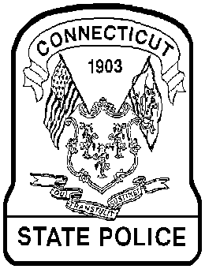

 WANTED BY THE
CONNECTICUT STATE POLICE
 | CRIME: | Robbery
 | DATE: | 12/19/10
 | TIME: | 1512 hrs.
 | LOCATION: | 67 Lebanon Ave  Colchester, CT 06415
 | SUSPECT: | John, Rudy T  (DOB: 04/22/82)
 | CLOTHING: | Dark hooded sweatshirt and dark pants
 | WEAPON: | Knife/Gun
 | VEHICLE: | CT Reg. 130YKO  1998 Buick Century color Blue. Located and Seized by Troop K.
Description of crime:

On the above date and time, Troop K received a 911 call of a reported robbery at the Clothes Pin Laundromat located at 67 Lebanon Ave. in the town of Colchester, CT. It was reported that a black male entered the Laundromat and placed an unknown object against an employee’s neck. The male subject then demanded that the employee give him money from the cash register. The male then walked out to his car and drove away from the scene in the above mentioned vehicle. Troop K holds an active arrest warrant for Rudy T. John (DOB: 04/22/82) for the charges of Criminal Attempt to Commit Robbery First Degree and Threatening Second Degree. Anyone with information regarding this incident or the whereabouts of the suspect is asked to contact the Connecticut State Police Troop K in Colchester at 860-537-7500. Additional information obtained during this investigation indicates that the suspect is armed with a firearm. The suspect is also believed to be involved in several other armed robberies in the surrounding area.

 | Case number: |  | 1000679471
 | Investigating Officer: |  | Detective Mike Browning

EDMC-K

