



**STATE OF CONNECTICUT**

**DEPARTMENT OF EMERGENCY SERVICES AND PUBLIC PROTECTION**

**DIVISION OF STATE POLICE**

**Special Licensing & Firearms Unit**

TO: All Security Guard and Patrol Service Agencies

FROM: Special Licensing and Firearms Unit

Department of Public Safety

SUBJECT: Badges

Pursuant to Connecticut General Statutes 29-161s and Sec. 29-161x-6 of the regulations of Connecticut State Agencies, the enclosed illustration of a badge is what has been prescribed for use by uniformed security officers.

The prescribed badge, identical to the rectangular type shown in the illustration, **shall be issued to all uniformed employees of such services.**

The prescribed badge shall be rectangular in shape, not less than two (2) inches in width and not less than two and one half (2½) inches in height. The badge must have straight sides, top and bottom. The badge shall be free of protruding angles or design on all four (4) sides. The badge shall contain the inscription of “SECURITY”, and the agency’s name and the agency’s state license number, which shall be sufficiently prominent to be identifiable at all times. The badge must be metal or woven (which will cover embroidered). **Silk screening is not authorized.**

The hat emblem may be of any design or shape, bearing the agency’s name.

Aside from the existing statutory restrictions of certain seals and designs, no restrictions are placed on color or any type of design that might be embossed or otherwise placed on the badge face.

The statute that covers the security badge design has been effective since 1969. These guidelines have been issued to all security services. Should you need any further assistance with this matter, contact the Special Licensing and Firearms Unit, (security) at 860-685-8046.

2 Inches

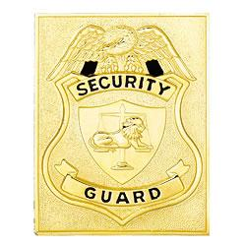

**Officer**

AA-01

Security Company Name

2 ½ inches

**Sample Badge**