

STATE OF CONNECTICUT
The Department of Administrative Services
(Statewide Leasing and Property Transfer)

Request for Proposals (RFP) SB 21-02
SALE ONLY
18-20 TRINITY STREET and 30 TRINITY STREET, HARTFORD, CONNECTICUT
(Separate buildings to be sold individually or together)
*PLEASE NOTE: These buildings are located within a Historic Preservation Ordinance Zone*
Proposal Due date: July 9, 2021 by 2:00 PM EST
Josh Geballe
Commissioner

Table of Contents:
I. Statement of Objectives 3
II. Background 3
III. Scope of Project and Qualifications…………………………………………………………… 3-6
IV. Proposal Submission Requirements 6
V. Evaluation of Proposals……………………………………………………………………..….………8
VI. Timeline of RFP and Instructions for Submission of Proposals 8-9
VII. Conditions 9-12

Attachments:
Attachment A Contract Proposal Form
Attachment B OPM Ethics Form 1: Gift and Campaign Contribution Certification
Attachment C Nondiscrimination Certification
Attachment D SEEC Notice of Campaign Contribution and Solicitation Limitations
Attachment E Sample Purchase and Sale Agreement

Statement of Objectives

The State of Connecticut, Department of Administrative Services (“DAS”), is requesting proposals from prospective purchasers (“Proposers”) who wish to purchase the properties located at 18-20 Trinity Street, Hartford, CT, Assessor Parcel ID 246-443-003 and 30 Trinity Street, Hartford, CT Assessor Parcel ID 246-443-008 (the “Properties”).

The Property shall be put to its highest and best use, consistent with the City of Hartford and State of Connecticut’s economic development goals. Mixed-use, multifamily redevelopment of the Property is consistent with the City Plan priorities of increasing density and enhancing connections.

Website link to 18-20 Trinity and 30 Trinity Street, Hartford, CT please click here.

Background

Vacant, State-Owned Properties in a historic preservation district directly across the street from the Capitol. The properties are adjacent to The Bushnell.

Hartford has seen significant real estate development projects completed across the city, and there are many opportunities still available such as the Trinity Street Properties. It is rare that one, let alone two properties directly across the street from Capitol are available. Follow this link to the Capital Region Development Authority (CRDA) and City of Hartford preliminary plan of the Bushnell South Development Area, please click here.

Property Description

- Summary

18-20 Trinity Street consists of an 87,637 square foot office building on a .85 acre, level and essentially rectangular shaped lot with frontage on both Trinity Street and Clinton Street. There are 43 on-site parking spaces on this parcel.

30 Trinity Street consists of a 76,665 square foot office building on a .80 acre slightly sloping, rectangular shaped lot on the corner of Trinity Street and Elm Street. There are 24 on-site parking spaces on this parcel.

The properties are located in southwestern portion of the City of Hartford’s Downtown District. Hartford is the capitol of Connecticut and has a population of approximately 123,088. For more information about Hartford please click here.

The Properties are both located in a Mixed Use (MX-1) Zone, are within the Government district, are in the Central Business District and the Asylum Avenue historic district. The 18-20 Trinity Street parcel abuts Bushnell Theater and the 30 Trinity Street parcel looks on to Bushnell Park to the North. The Properties are directly across the Street from the State Capitol and within a short walk to the Legislative Office Building and State courthouses. They are within a mile walk or drive from Union Place and Sigourney Street stations, XL Center, Wadsworth Atheneum, UCONN Hartford, Connecticut Science Center, Capital Community College and Dunkin Donuts Park, and are a 30-minute drive to Bradley International Airport.

The properties will be sold in “as-is” condition.

Frontage: 18-20 Trinity Street - 122’ on Capitol Avenue & 103’ on Clinton Street
30 Trinity Street – 142’ on Trinity Street & 261.7’ on Elm Street

Zoning: MX-1 (mixed-use)

Improvements:

Figure 1: 18-20 Trinity Street (Trinity Street View)

Figure 2: 18-20 Trinity Street ( Clinton Street View)

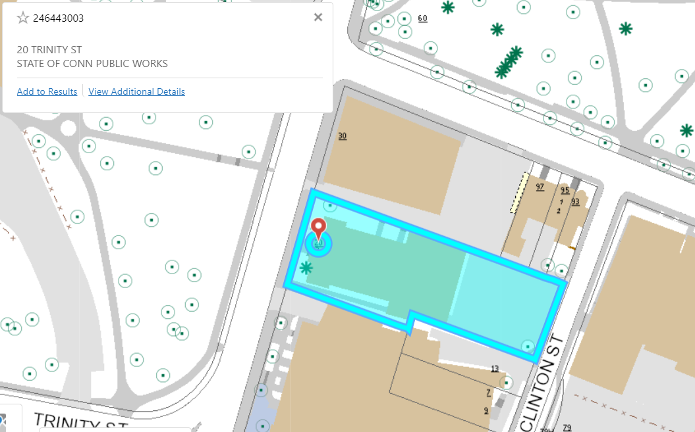
Figure 3: 18-20 Trinity Street GIS Capture
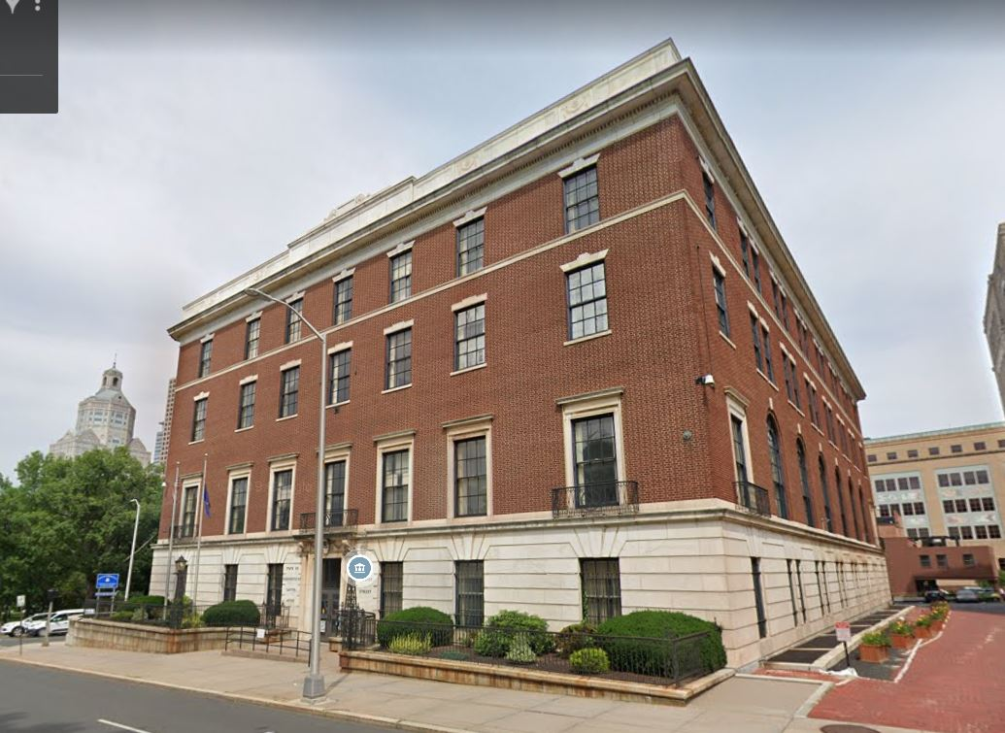
Figure 4: 30 Trinity Street (Trinity Street View)
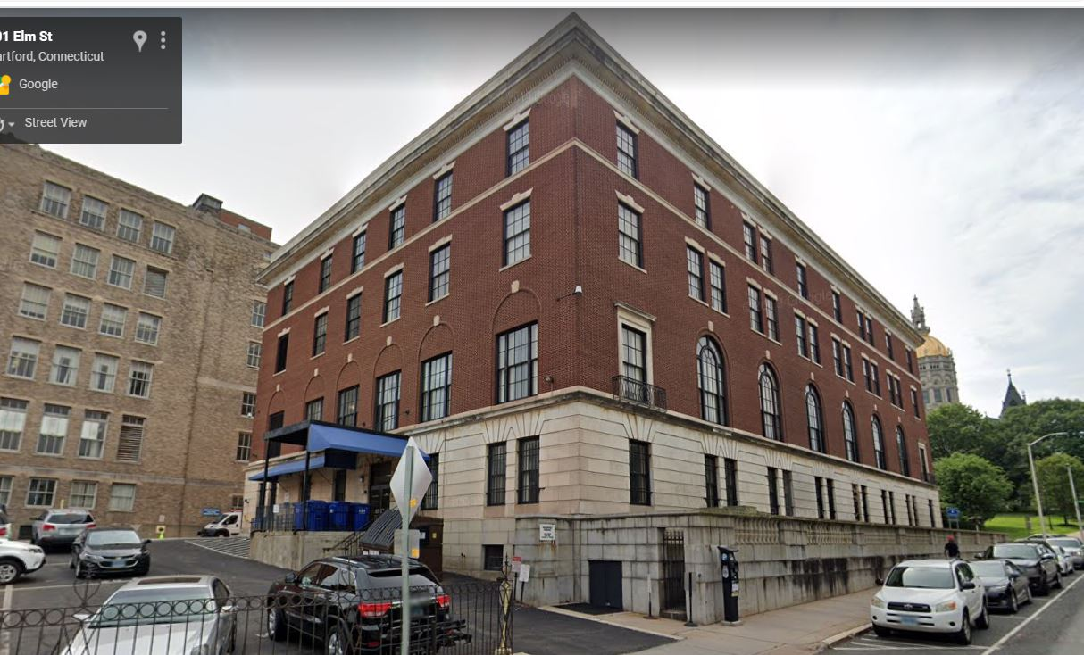
Figure 5: 30 Trinity Street ( Elm Street View)
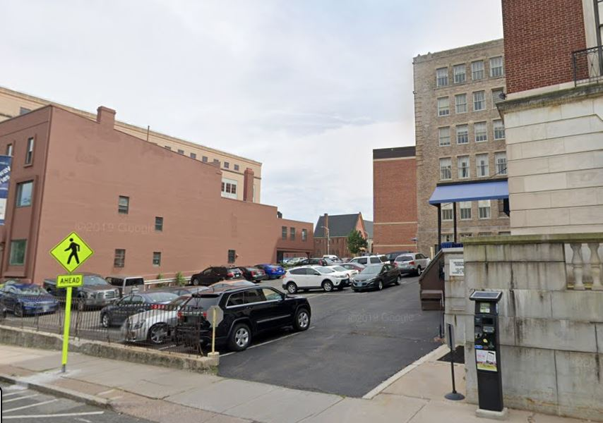
Figure 6: 30 Trinity Street Parking
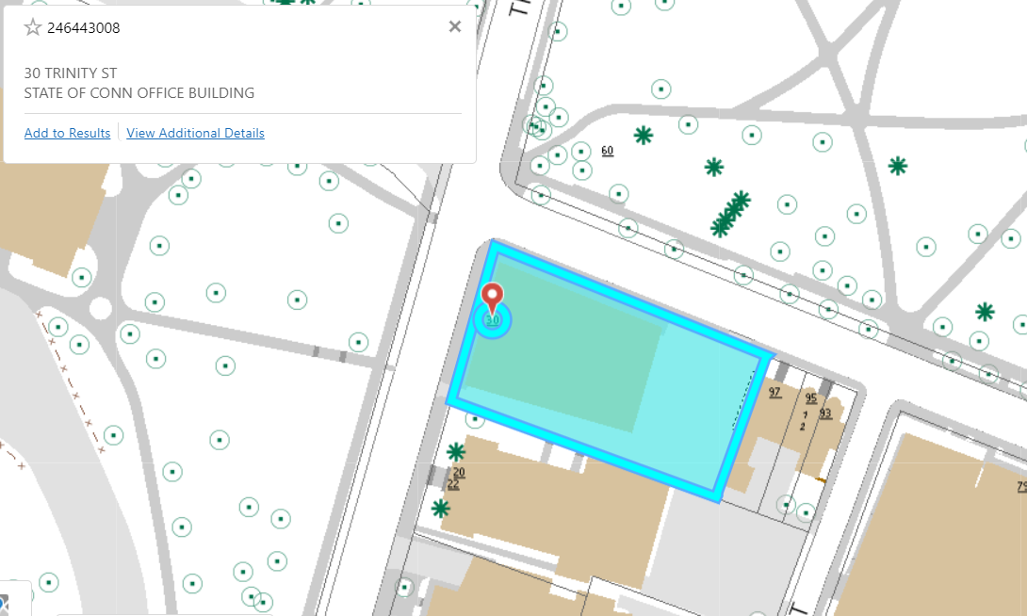
Figure 7: 30 Trinity Street GIS Capture

B. Development Considerations

Commissions and Similar Fees. Under no circumstances will DAS or other state entities or agencies be liable for any real estate brokerage commissions, finder’s fees, or other forms of compensation related in any way to activities undertaken by any person or entity as a result of this RFP.
Connecticut Environmental Policy Act (“CEPA”). Redevelopment of the Property may be subject to CEPA which will require an Environmental Impact Evaluation (EIE). If so, DAS and/or DECD will be the sponsoring agency and submitter of the EIE but expects that the EIE will be prepared by the Proposer at its sole expense.
Zoning and Entitlements. The Property is currently zoned MX-1 (mixed use). Proposers will be responsible for securing all permits for the work, including the general building permits and any rezoning and/or approvals or entitlements required for the envisioned redevelopment project.
- Proposal Submission Requirements
Note: unnecessarily elaborate brochures and other presentations, beyond those sufficient to present a complete and effective proposal are neither necessary nor desired. Maximum page limits are indicated below for each section.

Concept (maximum of four pages)

Provide information describing the concept that is consistent for the reuse or redevelopment of the Property. At a minimum, the following items should be addressed in this section:

Description of the proposed project on the Property including number, square footage, and types of uses to be created; anchor tenant uses; schedule; approach to providing any required debt and equity; local, state, or federal assistance or actions; and other aspects necessary to convey an understanding of the scope and nature of the envisioned project and how it promotes the City of Hartford’s vision for the area and the State of Connecticut’s desire for economic development.

- Visual information to further illustrate the proposed concept (e.g., conceptual drawings, letters of intent, narrative, schedule/timeline, and site plan, etc.) provided in an appendix would be excluded from the page limitation.

Qualifications (maximum five pages)

Provide information describing Proposer’s qualifications, experience and past performance in the design, construction, financing, operations, and maintenance of a project of comparable size and scope as that proposed for the Property and demonstrate Proposer’s ability to fund predevelopment costs. At a minimum, the following items should be addressed in this section:

- Identification, organizational history, background, and qualifications of the firm(s) comprising the project team, key individuals, and their anticipated roles in the project.
- Identification and brief biography of the person(s) who would be primarily responsible for interfacing with DAS in negotiating a final purchase and sale agreement.

- Examples of projects completed within the last five years that demonstrate relevant development experience, particularly those with public partners located in Connecticut. For each project, describe the size and type(s) of uses, summarize the approach to providing debt and equity, indicate the team members completing the work, and describe how the project benefited the community at-large.
- Proof of funds is required.

C. Financial Offer (no page limit)

Provide information describing Proposer’s offer to the State to purchase the Property. At a minimum, the following items should be addressed in this section:

- Relevant terms and conditions for the purchase of either 18-20 Trinity or 30 Trinity or both, but not limited to, the following:
  - Purchase price, or other terms, including any adjustments for closing date, entitlements received, or other factors.
  - Earnest money amount, timing, and conditions.
  - Due diligence period, conditions to close, and timing to close.
  - All proposed terms or conditions.
- A sample Purchase and Sale Agreement for sales by the State of Connecticut is presented in Attachment E.

D. Company Background / RFP Compliance (no page limitation)

Please provide the following information - please note that DAS may request supplementary information to assure that the Proposer’s competence, business organization, and financial resources are adequate to successfully perform the specified project:

- Table of contents with page numbers for each required component of the proposal, with sufficient detail to facilitate easy reference to all requested information.
- Name, title, telephone number, and e-mail address of the appropriate person to contact concerning the proposal.
- Bankruptcies / Litigation / Judgments - a statement indicating whether the contracting and financially responsible entities, any controlling entities, any principal personnel or key development team members or other proposed equity investors have (i) declared bankruptcy during the past five (5) years; (ii) are involved in any business-related litigation, liens or legal claims; or (iii) have had a business-related judgment against it/them during the five (5) year period immediately prior to the published date of the RFP. For any such matters, briefly describe each instance.
- History of violations of State of Connecticut statutes and regulations relating to ethics during the five (5) year period immediately prior to the published date of the RFP.
- Completed forms found in Attachment A through G.
- Demonstration of ability to comply with State of Connecticut contracting statutes and regulations.

Evaluation of Proposals

Proposer’s information should be prepared simply and economically, providing a straightforward, concise description of how each requirement will be met. Emphasis should be on completeness and clarity of content.
Failure to respond to all points may be grounds for rejection. Likewise, failure to supply any information required to accompany the proposals may cause rejection of the proposal as noncompliant. DAS reserves the right to request additional information and/or presentations if clarification is needed. Proposals that do not substantially conform to the contents of the request may be disregarded and considered as unresponsive. DAS reserves the right to reject all proposals and cancel the RFP.

General Process

The award will be based upon a comprehensive review and analysis of proposals to select the proposal which best meets the needs of the State of Connecticut and other stakeholders such as the City of Hartford.

B. Best Value Award

Award(s) will be made to the proposer(s) offering the best value as determined by DAS. By submitting a proposal in response to this RFP, a proposing party concurs with this method of award and will not, under any circumstances or in any manner, dispute any award made using this method. The award will be contingent upon the successful negotiation of specific terms and conditions to be included in the resulting contract. DAS reserves the right to negotiate with one or more Proposers, including but not limited to sales price, use, terms and conditions before making the final selection.

C. Criteria

Each proposal will be assessed for its feasibility, responsiveness, effectiveness, and thoroughness. Each proposal will be evaluated based on the following criteria:

- Financial consideration provided.
- Overall benefit to the City of Hartford and the State of Connecticut.
- Apparent feasibility of the proposed project.
- Depth and quality of experience with similar projects and apparent financial capacity to undertake the envisioned project.
- Adherence to RFP requirements and extent of any adverse circumstances.
The order in which the selection criteria are listed is indicative of their relative importance.

- TIMELINE OF RFP and INSTRUCTIONS FOR SUBMISSION OF PROPOSALS
The proposal process will be governed by the following timelines:

- Questions and Answers

All questions and requests for clarification must be in writing and submitted by May 28, 2021, no later than 2:00 P.M. E.S.T. to Shane P. Mallory by email only to shane.mallory@ct.gov. Include the RFP number and title in the subject line. All questions will be answered as an addendum to this RFP only. No verbal questions will be accepted or answered.

Questions, with answers, will be posted on the DAS Statewide Leasing and Property Transfer website on or before June 30, 2021. It is the responsibility of the proposers to visit the website to retrieve the questions and answers. Proposers should visit this website frequently prior to the due date for possible addenda in addition to questions and answers.

Optional Pre-Submission Tours (all COVID-19 protocols will be observed)

To attend one of the tours please follow these links to register (registration is required):

18-20 Trinity Street.

Book Tour

30 Trinity Street.

Book Tour

If you are unable to attend one of the pre-scheduled tours, please submit a request by email to Thomas Piacenza at Thomas.Piacenza@ct.gov with a copy to Shane Mallory, (shane.mallory@ct.gov), no later than May 31, 2021.

Instructions for Submission of Proposals

      - E-mail your proposal to Shane P. Mallory (shane.mallory@ct.gov), with a copy to Thomas Piacenza (Thomas.Piacenza@ct.gov): Include the RFP number (SB21-02) and the “SALE – 18-20 Trinity and 30 Trinity Street, Hartford, Connecticut” title in the subject line. Please note that the attachment cannot be over 25MG. If needed, please send zip files or separate e-mails.

2. Proposals must be received by the DAS Statewide Leasing and Property Transfer DeparTment via Shane.mallory@ct.gov no later than July 9, 2021 by 2:00 pm Eastern Standard Time.

- CONDITIONS

- Restriction on Communications

All communications concerning this solicitation are to be in writing and directed to: Shane P. Mallory at shane.mallory@ct.gov. Proposers are not permitted to communicate with other Proposers, other individuals at DAS, other state agencies and/or staff regarding this solicitation during the period between Request for Proposal issue date and the announcement of award, except during any interviews, tours or demonstrations requested by DAS.

- Costs for Proposal Preparation

Proposers shall bear all costs incurred in responding to this RFP without limitation.

- Disqualification of Proposals

DAS reserves the right to consider as acceptable only those proposals submitted in accordance with all requirements set forth in this RFP and which demonstrate an understanding of the scope of the work. Any proposal offering any other set of terms and conditions contradictory to those included in this RFP may be disqualified without further notice.

Proposer may be disqualified, and the proposal automatically rejected for any one or more of the following reasons:

      - The proposal shows noncompliance with applicable law.

      - The proposal is conditional, incomplete, or irregular in such a way as to make the proposal indefinite or ambiguous as to its meaning.

      - The proposal has any provision reserving the right to accept or reject award, or to enter into a contract pursuant to an award, or provisions contrary to those required in the solicitation.

      - The Proposer is debarred or suspended by the State of Connecticut.

      - The Proposer is in default of any prior contract or for misrepresentation

- Rights Reserved

DAS reserves the right to award or to reject any and all proposals, in whole or in part, and to waive technical defects, irregularities and omissions if, in its judgment, the best interest of DAS will be served.

- Compliance with State and Federal Laws and DAS Policies

Any contract awarded as a result of this RFP shall be in full compliance with the statutes and regulations of the State of Connecticut and include the contract provisions required by the State. Any portion of the contract determined to be in conflict with said statutes and/or regulations will be interpreted so as to be in compliance. Under no circumstances can DAS enter into a contract which requires DAS or the State to agree to indemnify another party or agree to binding arbitration.

- Inspection of Proposals and Confidential Information

DAS treats Proposals as confidential until after a contract is finalized (defined as approved by the State of Connecticut Attorney General’s Office). At that time, they become subject to disclosure under the Freedom of Information Act. DAS is a public entity and its records, including responses to this RFP, are public records. See Conn. Gen. Stat. §§1-200, et seq., and especially §1-210(b)(24). Due regard will be given for the protection of proprietary or confidential information contained in all proposals received, Conn. Gen. Stat. §1-210(b)(5). However, all materials associated with this RFP are subject to the terms of the Connecticut Freedom of Information Act (“FOIA”) and all applicable rules, regulations and administrative decisions. If a firm is interested in preserving the confidentiality of any part of its proposal, it will not be sufficient merely to state generally that the proposal is proprietary or confidential in nature and not, therefore, subject to release to third parties. Instead, those particular sentences, paragraphs, pages or sections that a firm believes to be exempt from disclosure under FOIA must be specifically identified as such. Convincing explanation and rationale sufficient to justify each exemption consistent with Section 1-210(b) of FOIA must accompany the proposal. Firms should not require that their entire proposal, nor the majority of the proposal, be confidential. Any submitted proposal, once execution of a contract is complete and any completed contract will be considered public information. DAS has no obligation to initiate, prosecute or defend any legal proceeding or to seek a protective order or other similar relief to prevent disclosure of any information that is sought pursuant to a FOIA request. The contractor has the burden of establishing the availability of any FOIA exemption in any proceeding where it is an issue. In no event shall DAS have any liability for the disclosure of any documents or information in its possession which DAS believes are required to be disclosed pursuant to FOIA or other requirements of law.

- Contract Invalidation

If any provision of the contract is found to be invalid, such invalidation will not be construed to invalidate the entire contract.

- Out of Pocket Expenses

DAS will not pay proposers’ out of pocket expenses.

- RFP Terms and Conditions

The terms and conditions should be reviewed carefully to ensure full responsiveness to the RFP. The contract will be, in form and substance, consistent with applicable DAS policy and regulations and State of Connecticut statutes and regulations regarding the creation and execution of such contract. The failure of any proposer to receive or examine any contract, document, form, addenda or to visit the sites and acquaint itself with conditions there-existing, when applicable, will not relieve it of any obligation with respect to its proposal or any executed contract. The submission of a proposal shall be conclusive evidence and understanding of intent to incorporate such terms and conditions into a contract.

- Supplemental Information

As part of the review, DAS may request a proposer to supply, in writing, clarifications, additional documentation or information needed to fairly evaluate each proposal. Proposers may be required to provide a written response within three (3) business days of receipt of any request for clarification by DAS. DAS reserves the right to correct inaccurate awards resulting from clerical errors.

- Meetings with Proposers

At its discretion, DAS may convene meetings with one or more proposers in order to gain a fuller understanding of the proposals. The meetings may involve demonstrations, interviews, presentations, or site visits. If DAS decides meetings are warranted, DAS will contact proposers to make an appointment. DAS, at its option, may elect to “short-list” the number of proposers brought in for meetings based on the evaluation criteria included in this RFP.

- Miscellaneous

      - Late proposals are not acceptable and will be rejected. DAS is not responsible for delivery delays or errors.

      - Submission of a proposal in response to this RFP is your acknowledgement that subjective criteria will be used in the evaluation of proposals. An Award will be made to the responsible proposer who is determined to be the most advantageous to DAS. Price, although an important consideration, will not be the sole determining factor.

      - Proposer warrants that: proposer did not participate in the RFP development process, did not have detailed knowledge of the contents of this RFP prior to its issuance, that its proposal was not made in connection with any competing proposer submitting a separate response to this RFP, and that the proposal is submitted without collusion or fraud of any kind.

      - Any alleged oral agreement or arrangement made by a proposer with any State agency or employee will be superseded by the written agreement.

      - Proposers may withdraw their proposals at any time prior to the time and date set for opening.

      - No additions or changes to the original proposal will be allowed after submittal unless as part of the negotiation process. While changes are not permitted, clarification at the request of DAS may be required at the proposer’s expense.

      - All proposals submitted in response to this RFP become the property of the State of Connecticut and are subject to the provisions of section 1-210 of the Connecticut General Statutes (Freedom of Information). See Section VII.G.

      - Any and all prices quoted in a proposal shall be valid for a minimum period of 120 days from the due date of the Proposal.

      - Any contract awarded is subject to contract compliance requirements mandated by Section 4a-60 of the Connecticut General Statutes.

      - For all state contracts as defined in Connecticut General Statutes §9-612(f)(2), having a value in a calendar year of $50,000 or more or a combination or series of such agreements or contracts having a value of $100,000 or more, the authorized signatory to this Agreement expressly acknowledges receipt of the State Elections Enforcement Commission’s notice advising state contractors of state campaign contribution and solicitation prohibitions, and will inform its principals of the contents of the notice. See Attachment H.

      - Any contract awarded shall be subject to Executive Order No. 3 of Governor Thomas J. Meskill, promulgated June 16, 1971, concerning labor employment practices, Executive Order No. 17 of Governor Thomas J. Meskill, promulgated February 15, 1973, concerning the listing of employment openings and Executive Order No. 16 of Governor John G. Rowland promulgated August 4, 1999, concerning violence in the workplace. The Contract may also be subject to Executive Order No. 14 of Governor M. Jodi Rell, promulgated April 17, 2006, concerning procurement of cleaning products and services and to Executive Order No. 49 of Governor Dannel P. Malloy, promulgated May 22, 2015, mandating disclosure of certain gifts to public employees and contributions to certain candidates for office. If Executive Order No. 14 and/or Executive Order No. 49 are applicable, they are deemed to be incorporated into and are made a part of the Contract as if they had been fully set forth in it. At the Contractor’s request, DAS shall provide a copy of these orders to the Contractor.

ATTACHMENT A
CONTRACT PROPOSAL

Please read carefully
State of Connecticut
Department of Administrative Services
450 Columbus Blvd.
Hartford, CT 06106

THIS FORM MUST BE RETURNED WITH PROPOSAL
RFP NUMBER  DAS #2102 |  | DATE OF OPENING  N/A | TIME OF OPENING |  |  |  | AMOUNT OF SURETY (if required)  - None - |  |  |  |  |  |  |  | DATE ISSUED  April 16, 2021
COMMODITY CLASS/SUBCLASS AND DESCRIPTION  Sale– 340 Capitol Avenue, Hartford, Connecticut |  |  |  |  |  |  | PRE-PROPOSAL SITE VISIT:  N/A
CONTACT:  Shane P. Mallory |  |  |  | E-MAIL:  Shane.mallory@ct.gov
FOR  Department of Administrative Services |  |  |  |  |  |  |  | CONTRACT PERIOD:  To be determined
REQUEST FOR PROPOSAL
Pursuant to the provisions of Sections 10a-151b and 4-217 of the General Statutes of Connecticut as amended. SEALED PROPOSALS WILL BE RECEIVED by the Statewide Leasing and Property Transfer Department of the Department of Administrative Services for the purchase of the above referenced property.
AFFIRMATION OF PROPOSER
The undersigned affirms and declares:
- That this proposal is executed and signed with full knowledge and acceptance of the provisions of the laws of the State of Connecticut, and the terms and conditions listed herein.
- That should any part of this proposal be accepted in writing by DAS within one hundred twenty (120) calendar days from the date of opening unless an earlier date for acceptance is specified in proposal schedule, said proposer will furnish and deliver the commodities and / or services for which this proposal is made, at the rates offered and fee schedule proposed, and in compliance with the provisions listed herein. Should award of any part of this proposal be delayed beyond the period of one hundred twenty (120) days or an earlier date specified in proposal schedule, such award shall be conditioned upon proposer’s acceptance.
PROPOSAL. The undersigned, accepting the conditions set forth herein, hereby agrees in strict accordance therewith, to furnish and deliver the services to the state agency or state agencies named in the proposal at the prices proposed therein.
 | TYPE OR PRINT NAME OF INDIVIDUAL |  |  |  |  |  |  |  |  |  |  |  | DOING BUSINESS AS (Trade Name)
SIGNATURE  WHEN PROPOSER | BUSINESS ADDRESS STREET CITY STATE ZIP CODE
IS AN  INDIVIDUAL | WRITTEN SIGNATURE OF INDIVIDUAL SIGNING THIS PROPOSAL |  |  |  |  |  |  |  | SOCIAL SECURITY NUMBER |  |  |  |  |  |  |  | DATE EXECUTED
 | TYPEWRITTEN NAME |  |  |  |  |  |  |  |  |  |  |  |  | TELEPHONE NUMBER
 | NAME (Type or print names of all partners) TITLE |  |  |  |  |  |  |  |  |  |  | NAME TITLE
 | NAME TITLE |  |  |  |  |  |  |  |  |  |  | NAME TITLE
SIGNATURE  WHEN PROPOSER  IS A FIRM | DOING BUSINESS AS (Trade Name) |  |  |  |  | BUSINESS ADDRESS STREET CITY STATE ZIP CODE
 | WRITTEN SIGNATURE OF PARTNER SIGNING THIS PROPOSAL |  |  |  |  |  |  |  |  | F.E.I. NUMBER |  |  |  |  |  | DATE EXECUTED
 | TYPEWRITTEN NAME |  |  |  |  |  |  |  |  |  |  |  |  | TELEPHONE NUMBER
 | FULL NAME OF CORPORATION |  |  |  |  |  |  |  |  |  |  |  |  | INCORPORATED IN WHAT STATE
SIGNATURE  WHEN PROPOSER | BUSINESS ADDRESS STREET CITY STATE ZIP CODE |  |  |  |  |  |  |  |  |  |  |  |  | F.E.I. NUMBER
IS A  CORPORATION | PRESIDENT |  |  |  | SECRETARY |  |  |  |  |  |  |  |  | TREASURER
 | WRITTEN SIGNATURE OF CORPORATE OFFICIAL OR PERSON DULY AUTHORIZED TO SIGN PROPOSALS ON BEHALF OF THE ABOVE CORPORATION |  |  |  |  |  |  |  |  |  |  |  |  |  |  |  |  | TITLE
 | TYPEWRITTEN NAME |  |  |  |  |  |  |  |  |  | TELEPHONE NUMBER |  |  |  |  |  |  | DATE EXECUTED
FOR ALL PROPOSERS | NAME AND TITLE OF INDIVIDUAL TO CONTACT CONCERING THE PROPOSAL |  |  |  |  |  |  |  |  |  | E-MAIL |  |  |  |  |  |  | TELEPHONE

  Attachment B | STATE OF CONNECTICUT  STATE OF CONNECTICUT  GIFT AND CAMPAIGN CONTRIBUTION CERTIFICATION
OPM Ethics Form 1 Rev. 5-26-15 Page 1 of 2

Written or electronic certification to accompany a State contract with a value of $50,000 or more, pursuant to C.G.S. §§ 4-250, 4-252(c) and 9-612(f)(2) and Governor Dannel P. Malloy’s Executive Order 49.

INSTRUCTIONS:

Complete all sections of the form. Attach additional pages, if necessary, to provide full disclosure about any lawful campaign contributions made to campaigns of candidates for statewide public office or the General Assembly, as described herein. Sign and date the form, under oath, in the presence of a Commissioner of the Superior Court or Notary Public. Submit the completed form to the awarding State agency at the time of initial contract execution and if there is a change in the information contained in the most recently filed certification, such person shall submit an updated certification either (i) not later than thirty (30) days after the effective date of such change or (ii) upon the submittal of any new bid or proposal for a contract, whichever is earlier. Such person shall also submit an accurate, updated certification not later than fourteen days after the twelve-month anniversary of the most recently filed certification or updated certification.

CHECK ONE: Initial Certification 12 Month Anniversary Update (Multi-year contracts only.)
Updated Certification because of change of information contained in the most recently filed certification or twelve-month anniversary update.

GIFT CERTIFICATION:

As used in this certification, the following terms have the meaning set forth below:

- “Contract” means that contract between the State of Connecticut (and/or one or more of it agencies or instrumentalities) and the Contractor, attached hereto, or as otherwise described by the awarding State agency below;
- If this is an Initial Certification, “Execution Date” means the date the Contract is fully executed by, and becomes effective between, the parties; if this is a twelve-month anniversary update, “Execution Date” means the date this certification is signed by the Contractor;
- “Contractor” means the person, firm or corporation named as the contactor below;
- “Applicable Public Official or State Employee” means any public official or state employee described in
C.G.S. §4-252(c)(1)(i) or (ii);
- “Gift” has the same meaning given that term in C.G.S. § 4-250(1);
- “Principals or Key Personnel” means and refers to those principals and key personnel of the Contractor, and its or their agents, as described in C.G.S. §§ 4-250(5) and 4-252(c)(1)(B) and (C).

I, the undersigned, am a Principal or Key Personnel of the person, firm or corporation authorized to execute this certification on behalf of the Contractor. I hereby certify that, no gifts were made by (A) such person, firm, corporation, (B) any principals and key personnel of the person firm or corporation who participate substantially in preparing bids, proposals or negotiating state contracts or (C) any agent of such, firm, corporation, or principals or key personnel who participates substantially in preparing bids, proposals or negotiating state contracts, to (i) any public official or state employee of the state agency or quasi-public agency soliciting bids or proposals for state contracts who participates substantially in the preparation of bid solicitations or request for proposals for state contracts or the negotiation or award of state contracts or (ii) any public official or state employee of any other state agency, who has supervisory or appointing authority over such state agency or quasi-public agency.

I further certify that no Principals or Key Personnel know of any action by the Contractor to circumvent (or which would result in the circumvention of) the above certification regarding Gifts by providing for any other Principals, Key Personnel, officials, or employees of the Contractor, or its or their agents, to make a Gift to any Applicable Public Official or State Employee. I further certify that the Contractor made the bid or proposal for the Contract without fraud or collusion with any person.

CAMPAIGN CONTRIBUTION CERTIFICATION:
OPM Ethics Form 1 Rev. 5-26-15 Page 2 of 2
I further certify that, on or after January 1, 2011, neither the Contractor nor any of its principals, as defined in C.G.S. § 9-612(f)(1), has made any campaign contributions to, or solicited any contributions on behalf of, any exploratory committee, candidate committee, political committee, or party committee established by, or supporting or authorized to support, any candidate for statewide public office, in violation of C.G.S. § 9-612(f)(2)(A). I further certify that all lawful campaign contributions that have been made on or after January 1, 2011 by the Contractor or any of its principals, as defined in C.G.S. § 9-612(f)(1), to, or solicited on behalf of, any exploratory committee, candidate committee, political committee, or party committee established by, or supporting or authorized to support any candidates for statewide public office or the General Assembly, are listed below:

Lawful Campaign Contributions to Candidates for Statewide Public Office:

Contribution Date Name of Contributor Recipient Value Description
_________________________________________________________________________________________________
_________________________________________________________________________________________________
_________________________________________________________________________________________________
_________________________________________________________________________________________________
_________________________________________________________________________________________________
_________________________________________________________________________________________________
_________________________________________________________________________________________________

Lawful Campaign Contributions to Candidates for the General Assembly:

Contribution Date Name of Contributor Recipient Value Description
_________________________________________________________________________________________________
_________________________________________________________________________________________________
_________________________________________________________________________________________________
_________________________________________________________________________________________________
_________________________________________________________________________________________________
_________________________________________________________________________________________________
_________________________________________________________________________________________________

Sworn as true to the best of my knowledge and belief, subject to the penalties of false statement.

__________________________________ _________________________________________
Printed Contractor Name Printed Name of Authorized Official

___________________________________
Signature of Authorized Official

Subscribed and acknowledged before me this ______ day of __________________, 20___.

___________________________________________
Commissioner of the Superior Court (or Notary Public)
____________________________

My Commission Expires

Attachment C


STATEOFCONNECTICUT

NONDISCRIMINATION CERTIFICATION—Affidavit
By Entity
For Contracts Valued at $50,000 or More

Documentation in the form of an affidavit signed under penalty of false statement by a chief executive officer, president, chairperson, member, or other corporate officer duly authorized to adopt corporate, company, or partnership policy that certifies the contractor complies with the nondiscrimination agreements and warranties under Connecticut General Statutes §§ 4a-60 and 4a-60a, as amended

INSTRUCTIONS:

For use by an entity (corporation, limited liability company, or partnership) when entering into any contract type with the State of Connecticut valued at $50,000 or more for any year of the contract. Complete all sections of the form. Sign form in the presence of a Commissioner of Superior Court or Notary Public. Submit to the awarding State agency prior to contract execution.

AFFIDAVIT:

I, the undersigned, am over the age of eighteen (18) and understand and appreciate he obligations of

an oath. I am_________________________ of _______________________________ an entity
Signatory’s Title Name of Entity

duly formed and existing under the laws of ______________________________________
Name of State or Commonwealth
I certify that I am authorized to execute and deliver this affidavit on behalf of_____________________
And that _______________________________ Name of Entity

Name of Entity

has a policy in place that complies with the nondiscrimination agreements and warranties of Connecticut General Statutes §§4a-60and 4a-60a,as amended.

Authorized Signatory

Printed Name

Sworn and subscribed to before me on this _______day of____________, 20____.

Commissioner of the Superior Court/ Commission Expiration Date Notary Public

Attachment D

Contract Provisions
Attachment E

PURCHASE AND SALE AGREEMENT

THIS PURCHASE AND SALE AGREEMENT (the “Agreement”) is made the ____ day of ______________, 2021, by and between THE STATE OF CONNECTICUT, acting through the Commissioner of Administrative Services or his designee, with an address and place of business at 450 Columbus Boulevard, Suite 1501, Hartford, Connecticut 06103 (“Seller” or “State”), pursuant to Section 4b-21 of the Connecticut General Statutes, and [BUYER NAME], [a Connecticut Corporation, limited liability company, etc.] with an address and place of business at [ADDRESS] (“Purchaser”).

WITNESSETH:

1. SALE OF PROPERTY. For fair and adequate consideration acknowledged received, Seller hereby agrees to sell and Purchaser hereby agrees to purchase, subject to the terms and conditions set forth in this Agreement, all of Seller’s right, title and interest in and to that certain piece or parcel of land, with all buildings and other improvements thereon, located at [PROPERTY ADDRESS] in the City of Hartford, County of Hartford and State of Connecticut, as more particularly described in Exhibit A attached hereto and made a part hereof.

2. PURCHASE PRICE. The purchase price shall be [PRICE] ($[_______]) Dollars (the “Purchase Price”), paid as follows:

(a) [AMOUNT] ($[_______]) Dollars at the time Purchaser executes this Agreement (the “Deposit”). The Deposit shall be held by Seller in a non-interest-bearing account and may be co-mingled with other funds of Seller unrelated to this transaction. Delivery and acceptance of the Deposit shall not constitute evidence of a binding, effective and enforceable agreement between the parties; and

(b) The balance of [PRICE] ($[_______]) Dollars by wire transfer, bank check or certified funds at Closing (as defined in Section 4 below).

3. TITLE.

(a) The Purchaser shall bear all costs for title examinations, abstracts, surveys, title insurance and any and all other inspections of the title to the Property that the Purchaser may require.

(b) The Seller shall convey such title as the Seller has in and to the Property subject to, and without limitation: (i) any and all provisions of any ordinance, municipal regulation, or public or private law; (ii) any declarations, restrictions, covenants, and easements of record; (iii) any state of facts which an accurate survey or personal inspection of the Property might reveal; and (iv) current property taxes.

4. CLOSING. Subject to the other terms of this Agreement, the closing shall be held at the offices of the Department of Administrative Services, 450 Columbus Boulevard, Hartford, Connecticut, unless otherwise agreed, on the date which is ________ (__) days following the State’s acquisition of the final Seller Approval (as defined below), or earlier as may be agreed upon between the parties.

5. CLOSING DOCUMENTS. At Closing, Seller shall deliver to Purchaser the following:

(a) A quit claim deed in substantially the same form as Exhibit B attached hereto and made a part hereof (the “Deed”);

(b) An affidavit of title with respect to the Property in the form provided by a recognized title insurance company authorized to do business in the State of Connecticut;

(c) An affidavit made under penalty of perjury, to the effect that Seller is not a “foreign person” in the sense of the Internal Revenue Code, Section 1445;

(d) Documents to clear those items of title that Seller has elected to cure, if not earlier provided; and

(e) Such other documents as are reasonably requested by counsel for Purchaser and as necessary to consummate the transaction contemplated by this Agreement; provided the same do not impose upon Seller any obligation or liability not specifically provided for herein.

6. PERSONAL PROPERTY. The Seller shall not be obligated to remove any personal property from the Property; however, Seller reserves the right to remove any and all personal property from the Property prior to Closing. To the extent permitted by all applicable laws and regulations, any personal property at the Property after the Closing shall be deemed abandoned and Purchaser may retain or dispose of such personal property at its discretion.

7. ADJUSTMENTS. All taxes, water charges or other governmental charges and assessments applicable to the Property shall be adjusted at Closing. All charges and expenses for taxes, utilities such as water, sewer, electricity and gas that relate to a period prior to the Closing shall be paid by Seller. All such charges and expenses that relate to a period on and after the Closing shall be paid by Purchaser.

8. SELLER’S CONTINGENCIES. The Seller’s obligation to convey the Property to Purchaser is contingent upon Seller obtaining, free from appeal after the expiration of any statutory appeal period, all approvals, rulings, waivers or releases from the Office of Policy and Management, State Properties Review Board, the Legislative Committees of Cognizance, the Office of the Attorney General of the State of Connecticut, and any other agency or board whose approval is required by law (collectively the “Seller Approvals”). If the Property was purchased or improved with proceeds of tax-exempt obligations issued or to be issued by the State, the approval of the Office of the State Treasurer may, if so determined by the State, also be required as a Seller Approval. The Seller shall use its diligent and reasonable efforts to obtain the Seller Approvals. Upon request of Purchaser, Seller shall provide to the Purchaser copies of pertinent documents filed or received by the Seller in the course of pursuing Seller’s Approvals and copies of Seller’s Approvals as they are received. Upon Seller’s receipt of all Seller’s Approvals, Seller shall provide written notice to the Purchaser that this contingency has been satisfied.

If any one required Seller Approval is denied, or if one or more Seller Approvals are obtained with conditions that are materially adverse to the Purchaser as determined by the Seller in its sole discretion, either party may terminate this Agreement upon ten (10) days’ prior written notice to the other. Upon such termination, the Seller shall return the Deposit within ten (10) days from receipt of such written notice of termination and all rights and obligations of the parties to each other under this Agreement shall be terminated. Termination pursuant to this subsection shall not be deemed a default.

9. CONDITION OF PROPERTY; INDEMNIFICATION; COMPLIANCE WITH LAWS; DEFINITIONS.

(a) Purchaser shall accept the Property and such improvements in “AS IS” condition without any warranty or reliance upon oral or written representations from the Seller concerning the conditions of the Property or its improvements, including but not limited to, dimensions, soil conditions, groundwater or other environmental conditions, municipal restrictions on use, encumbrances or uses by third parties. The provisions of this Paragraph 9(a) shall survive the Closing.

(b) For a period of ________ (__) days commencing on the date of this Agreement, Purchaser and the Purchaser’s designees shall have reasonable access during normal business hours to the Property from time to time as and when the Purchaser shall reasonably deem necessary for the purpose of making, at the sole cost and expense of the Purchaser, such measurements, surveys, examinations, inspections, tests and analyses of the Property, including without limitation, soil borings, groundwater and other environmental testing (“Inspections”) that the Purchaser deems necessary or desirable. Prior to entering the Property, the Purchaser shall (i) deliver or cause to be delivered to Seller from the contractor entering the Property a certificate of insurance, in form and substance reasonably acceptable to the Seller and issued by insurers of recognized responsibility licensed to do business in the State of Connecticut and reasonably satisfactory to the Seller, with respect to the Property, with limits not less than $1,000,000 single event limit on which Seller is named as an additional insured; and (ii) notify the Seller’s manager on the Property, to be identified by Seller in writing to Purchaser upon final approval of this Agreement, no less than three (3) days in advance of its intended activities. No such activities may be conducted until the Seller has granted its written approval, which approval will not be unreasonably withheld or delayed, giving due consideration to the safety concerns of the Seller. Purchaser and/or its agents shall conduct such activities in a manner designed not to disturb any lawful occupants of the Property at the time thereof. Upon the completion of such activities, the Purchaser shall promptly restore the Property to a condition substantially similar to its condition prior to the start of such activities; provided, however, that the Purchaser’s obligation to restore the Property is in all respects subject to applicable environmental laws and the Purchaser shall not be required to restore the Property, indemnify the Seller, or be liable to the Seller for failing to restore the Property if restoration would result in a violation of any State or federal law or regulation, unless the violation is directly attributable to the Purchaser’s own acts or omissions. In the event any environmental condition or contamination results from Purchaser’s activities on the Property, Purchaser shall remediate any such condition or hazard.
(c) Indemnification.
(1) The Purchaser shall indemnify, defend and hold harmless the State and its officers, representatives, agents, servants, employees, successors and assigns from and against any and all (1) Claims arising, directly or indirectly, from the negligent acts or omissions of the Purchaser or any of its employees, agents, contractors, or invitees in connection with this Agreement (collectively, the “Acts”); (2) liabilities, damages, losses, costs and expenses, including but not limited to, attorneys' and other professionals' fees, arising, directly or indirectly, in connection with the Claims, the Acts or the Agreement, and (3) any and all liability, loss, costs and expenses, including reasonable attorneys’ fees, damages, liens and judgments for personal injury or property damage resulting directly or indirectly from, or occurring during, the Inspections or other activities on the Property by the Purchaser or the Purchaser’s designees. The Purchaser shall use counsel reasonably acceptable to the State in carrying out its obligations under this section.

(2) The Purchaser shall not be responsible for indemnifying or holding the State harmless from any liability arising due to the negligence of the State or any third party acting under the direct control or supervision of the State.
(3) The Purchaser’s duties under this section shall remain fully in effect and binding in accordance with the terms and conditions of the Agreement, without being lessened or compromised in any way, even where the Purchaser is alleged or is found to have merely contributed in part to the Acts .

(4) This section shall survive the termination of the Agreement and shall not be limited by reason of any insurance coverage.

(d) The parties agree to comply with the requirements of Connecticut Transfer Act, C.G.S. § 22a-134 et seq., to the extent applicable.

(e) After the Closing Date, Purchaser shall assume responsibility for compliance with all laws, and regulations, inclusive of environmental regulations, pertaining to the Property and the operation thereof, and shall complete the assessment and Remediation of any contamination discovered on the Property before or after the closing. “Remediation” means to contain, remove or abate pollution, potential sources of pollution and substances in soil or sediment which pose an unacceptable risk to human health or the environment as required by and in compliance with applicable environmental laws, and regulations, inclusive of the Connecticut Remedial Standard Regulations, RCSR §22a-133 K-1 et seq. Effective as of the closing, Purchaser also shall assume responsibility for compliance with the Transfer Act, if applicable.

(f) Definitions.

The following terms shall have the following meanings as used in this Agreement:

(1) Claims: all actions, suits, claims, demands, investigations and proceedings of any kind, open, pending or threatened, whether mature, unmatured, contingent, known or unknown, at law or in equity, in any forum.

(2) Environmental Laws: Any Federal, State or local statute, law, ordinance, code, rule, regulation, order, or decree regulating or relating to the protection of human health or the environment, or imposing liability or standards of conduct concerning any hazardous, toxic or waste, substance, element, compound, mixture or material, as now or at any time hereafter in effect including, without limitation, the Federal Comprehensive Environmental Response, Compensation and Liability Act, as amended, 42 U.S.C. Sec. 9601 et seq., the Superfund Amendments and Reauthorization Act, 42 U.S.C. Secs. 9601 et seq., the Federal Oil Pollution Act of 1990, §§ 2701, et seq., the Federal Toxic Substance Control Act, 15 U.S.C. §§ 6901 et seq., the Federal Hazardous Material Transportation Act, 49 U.S.C. §§ 1801 et seq., the Federal Clean Air Act, 42 U.S.C. § 7401 et seq., the Federal Water Pollution Control Act, 33 U.S.C. § 1251 et seq., the River and Harbors Act of 1899, 33 U.S.C. §§ 401 et seq., and all rules and regulations of the Environmental Protection Agency, or any other state or federal department, board, or agency, or any other agency or governmental board or entity having jurisdiction over environmental or health and safety matters, as such have been amended.

(3) Hazardous Materials: (i) asbestos or materials containing asbestos, (ii) polychlorinated biphenyls, (iii) radioactive substances, (iv) carcinogens, (v) oil and petroleum products, and (vi) pollutants, wastes, substances, materials, toxins or contaminants identified, defined, regulated or controlled by the Environmental Laws.

10. PURCHASER’S REPRESENTATIONS AND WARRANTIES. The Purchaser represents and warrants with the Seller as follows, such representations and warranties to be true as of the date hereof with the same force and effect as though such representations and warranties had been made as of the Closing Date, and shall survive the Closing:

- Purchaser-, [individually and collectively, have full power and authority OR is duly organized and validly existing under the laws of the State of Connecticut, and has full power and authority] to enter into this Agreement and to carry out its contemplated transactions;
- Purchaser shall not bring, treat, create, handle, store or dispose of any Hazardous Materials on the Premises in violation of applicable laws.
- The obligations of the Purchaser under this Agreement are valid and legally binding on the Purchaser;
- The person(s) executing this Agreement on behalf of the Purchaser is legally authorized to act on behalf of and bind the Purchaser [individually and collectively-IF INDIVIDUALS]; and
- The transactions contemplated by this Agreement are not in violation of, nor prohibited by, the terms of the [certificate of incorporation, laws, articles of organization, operating agreement,] or any other agreement, license, commitment, oral or written, of the Purchaser.

11. SELLER’S REPRESENTATIONS. The Seller represents to the Purchaser as follows, such representations to be true to the best of the Seller’s knowledge as of the date hereof and shall survive the Closing:

(a) The Seller has full power and authority to carry out the obligations of this Agreement;

(b) The obligations of the Seller under this Agreement are valid obligations of the Seller and are legally binding on the Seller; and

(c) The person executing this Agreement on behalf of the Seller is legally authorized to act on behalf of and bind the State.

12. BROKER. Each Party represents that it has involved no real estate agent or broker in this transaction. The Purchaser hereby agrees to indemnify, defend and hold harmless the Seller from any and all liability, loss, cost or expense, including reasonable attorneys’ fees, damages, liens or judgments arising from any claim, action or proceeding for commission or other compensation by any broker or agent claiming to have brought about this transaction on behalf of the Purchaser.

13. NOTICES. Notices permitted or required under this Agreement shall be deemed received upon personal delivery, or upon one (1) business day following pick up by overnight courier (provided a receipt for delivery is obtained), or three (3) business days following mailing by certified mail, postage prepaid, return receipt requested to:

SELLER: State of Connecticut
Department of Administrative Services
450 Columbus Boulevard, Suite 1501
Hartford, CT 06103
Attn: Commissioner

WITH A COPY TO: State of Connecticut
Department of Administrative Services
450 Columbus Boulevard, Suite 1402
Hartford, CT 06103
Attn: Administrator of Statewide Leasing and Property Transfer

PURCHASER: [_________________________]

WITH A COPY TO: [_________________________]

Any address or name specified above may be changed by a notice given to the addressee by the other party in accordance with this Section. The inability to deliver because of a changed address of which no notice was given or rejection or other refusal to accept any notice shall be deemed to be the receipt of this notice as of the date of such inability to deliver or rejection or refusal to accept.

14. DEFAULT.

(a) In the event of a default by the Purchaser of its obligations under this Agreement, Seller shall notify Purchaser in writing of the nature of the default. Purchaser shall have fifteen (15) days from receipt of such notice to cure the default or make reasonable provisions to cure such default if such cure cannot be completed within the fifteen (15) day period, provided that the time period for such cure shall not exceed thirty (30) days from the receipt of such notice. In the event Purchaser fails to cure the default, Seller shall have the right to terminate this Agreement with written notice to Purchaser. Seller, at its sole option, may either retain the Deposit as liquidated damages for the default, in which event this Agreement shall terminate and neither of the parties shall have any further rights against the other, or the Seller may seek whatever remedy may be available to the Seller, excluding however, the right to specific performance.

(b) In the event of a default by Seller of its obligations under this Agreement, Purchaser shall notify Seller in writing of the nature of the default. Seller shall have fifteen (15) days from receipt of such notice to cure the default or make reasonable provisions to cure such default if such cure cannot be completed within the fifteen (15) day period, provided that the time period for such cure shall not exceed thirty (30) days from the receipt of such notice. In the event Seller fails to cure the default, Purchaser shall have the right to terminate this Agreement by giving written notice to the Seller of such termination, in which event the Seller shall return the Deposit to the Purchaser within ten (10) days of receipt of such notice of termination and all obligations of the parties shall be terminated.

15. RISK OF LOSS. Risk of loss or damage to the Property or any portion thereof by fire or other casualty until the time of the delivery of the Deed as provided in this Agreement is assumed by and shall remain with the Seller. Notwithstanding, Seller shall not have any obligation or liability, except at the Seller's option, for the repair or replacement of any such loss or damage to the Property. In the event that the Seller does not elect to repair or replace, or fails to repair or replace within ninety (90) days following any such loss, damage or casualty, the Purchaser, at its sole discretion, may (a) opt to waive the casualty and close on the Property or (b) declare this Agreement void, thereupon which the Seller shall return the Deposit. Upon receipt of the Deposit, further claims and obligations between the parties hereto by reason of this Agreement shall be deemed released and discharged.

16. CONDEMNATION.

(a) Prior to the Closing, the Seller shall promptly notify the Purchaser in the event that all or any portion of the Property is or is threatened to be taken by any federal authority under the power of eminent domain or condemnation, which notice shall include copies of any notices or other documents related to such taking.

(b) In the event of a taking as referred to in subsection (a), the Purchaser shall either (i) elect to rescind this Agreement, whereupon all obligations of the parties to each other shall terminate and the Seller shall return the Deposit within ten (10) days, or (ii) accept a conveyance of the Property pursuant to the provisions of this Agreement, subject, however, to the condemnation claim, in which event the Purchaser shall pay the full Purchase Price and the Seller shall assign the Seller’s right to such condemnation claim to the Purchaser (except that if the Seller has received the proceeds of the condemnation prior to Closing, the amount of the award received by the Seller shall be reflected as a credit in favor of Purchaser against the Purchase Price).

17. DRAFTING ROLES. The parties agree that each has played a material role in the negotiation and drafting of this Agreement, and that the document shall not be construed against any party merely because of that party’s role in the drafting thereof.

18. COUNTERPARTS. This Agreement may be executed in two or more counterparts, each of which shall be deemed an original but all of which together shall constitute but one and the same agreement.

19. FORUM AND CHOICE OF LAW. The parties deem the Agreement to have been made in the City of Hartford, State of Connecticut. Both parties agree that it is fair and reasonable for the validity and construction of the Agreement to be, and it shall be, governed by the laws and court decisions of the State of Connecticut, without giving effect to its principles of conflicts of laws. To the extent that any immunities provided by Federal law or the laws of the State of Connecticut do not bar an action against the State, and to the extent that these courts are courts of competent jurisdiction, for the purpose of venue, the complaint shall be made returnable to the Judicial District of Hartford only or shall be brought in the United States District Court for the District of Connecticut only, and shall not be transferred to any other court, provided, however, that nothing here constitutes a waiver or compromise of the sovereign immunity of the State of Connecticut. The Purchaser waives any objection which it may now have or will have to the laying of venue of any claims in any forum and further irrevocably submits to such jurisdiction in any suit, action or proceeding.

20. NO RECORDING. It is agreed between the parties that the neither party shall record this Agreement, or notice of same, on the Land Records of the City of Hartford. Should the Purchaser for any reason record this Agreement, then the Purchaser shall be deemed hereby to have appointed the Seller its attorney-in-fact to file a release of said recorded instrument and it is hereby agreed that upon the recording of any such release by the Seller, any recording of this Agreement by the Purchaser shall not constitute an encumbrance or cloud on title in any respect whatsoever. The Purchaser shall reimburse the Seller for all reasonable costs incurred by the Seller to obtain such release.

21. COOPERATION. Upon the Purchaser’s request and at no cost to the Seller, the Seller agrees to execute and deliver to the Purchaser such additional instruments, certificates and documents as the Purchaser may reasonably require, whether or not after the Closing Date, in order to provide the Purchaser with the rights and benefits to which the Purchaser is entitled under this Agreement. The Seller shall execute at no cost to the Seller, as owner of record of the Property, whatever applications the Purchaser may reasonably request in order to obtain all of the licenses, permits, and approvals necessary for the intended use of the Property. Nothing in this provision shall obligate Seller to accept or undertake obligations or liabilities not expressly set forth in this Agreement.

22. ENTIRE AGREEMENT. This Agreement, including all exhibits hereto, constitutes the entire understanding between the parties with respect to the Property and no oral statements, representations, promises or understanding not set forth in this Agreement shall bind the parties unless reduced to writing and signed by both parties. This Agreement shall supersede all prior written agreements between the parties and their predecessors. No changes, amendments, or modifications of any of the terms or conditions of this Agreement shall be valid unless reduced to writing, signed by both parties, and approved by the Office of the Attorney General of the State of Connecticut.

23. ASSIGNMENT. The Purchaser may not assign its interest in this Agreement without the prior written consent of the Seller, which consent may be withheld in Seller’s sole discretion.

24. GOVERNOR’S EXECUTIVE ORDERS. This Agreement is subject to the provisions of Executive Order No. Three of Governor Thomas J. Meskill, promulgated June 16, 1971, concerning labor employment practices, Executive Order No. Seventeen of Governor Thomas J. Meskill, promulgated February 15, 1973, concerning the listing of employment openings and Executive Order No. Sixteen of Governor John G. Rowland promulgated August 4, 1999, concerning violence in the workplace, all of which are incorporated into and are made a part of the Agreement as if they had been fully set forth in it. The Agreement may also be subject to the applicable parts of Executive Order No. 14 of Governor M. Jodi Rell, promulgated April 17, 2006, concerning procurement of cleaning products and services and to Executive Order No. 49 of Governor Dannel P. Malloy, promulgated May 22, 2015, mandating disclosure of certain gifts to public employees and contributions to certain candidates for office. If Executive Order 14 and/or Executive Order 49 are applicable, they are deemed to be incorporated into and are made a part of the Agreement as if they had been fully set forth in it. At the Purchaser’s request, the Seller shall provide a copy of these orders to the Purchaser.

25. SOVEREIGN IMMUNITY. The parties acknowledge and agree that nothing in the Agreement shall be construed as a modification, compromise or waiver by the State of any rights or defenses of any immunities provided by Federal law or the laws of the State of Connecticut to the State or any of its officers and employees, which they may have had, now
have or will have with respect to all matters arising out of the Agreement. To the extent that this section conflicts with any other section, this section shall govern.

26. WAIVERS; EXTENSIONS. No waiver of any breach of any provision of this Agreement will be considered a waiver of any preceding or succeeding breach of such provision or of any other provision of this Agreement. No extension of time for the performance of any obligation or act will be considered an extension of time for the performance of any other obligation or act.

27. BINDING EFFECT; NO THIRD-PARTY BENEFIT. This Agreement will bind and inure to the benefit of the parties and their respective successors and assigns. The parties and their respective successors and assigns are the sole beneficiaries of this Agreement and nothing contained in this Agreement is intended to confer any benefit or rights upon any person who is not a party (as used herein, any reference to Seller or the State shall be construed to include any governmental agency of the State of Connecticut).

28. CALCULATION OF TIME. Unless otherwise specified elsewhere in this Agreement, a period of time stated as a number of days shall be construed to mean calendar days; provided, however, that when any period of time, so stated would end upon a Saturday, Sunday or State or federal legal holiday, such period will be considered to end upon the next day following which is not a Saturday, Sunday or state or federal legal holiday. “State,” for the purpose of this Section, means the State of Connecticut.

29. CAPTIONS. The captions herein are solely for the convenience of the parties and shall have no meaning or effect in construing this Agreement.

30. INSTRUMENT NOT AN OFFER. This instrument shall not be deemed an offer to sell the Property or to convey title thereto and shall be of no force and effect of any kind until it has been duly executed by all parties and all applicable authorization as required by the Connecticut General Statutes have been obtained.

31. ADDITIONAL PROVISIONS. The Agreement is subject to the non-discrimination provisions set forth in Exhibit C attached hereto and made a part hereof.

32. STATE CONTRACTS. For all State contracts, defined in Conn. Gen. Stat. §9-612(f)(1) as having a value in a calendar year of $50,000 or more, or a combination or series of such agreements or contracts having a calendar year value of $100,000 or more, the authorized signatory to this Agreement expressly acknowledges receipt of the State Elections Enforcement Commission’s notice advising state contractors of state campaign contribution and solicitation prohibitions, and will inform its principals of the contents of the notice, as set forth in "Notice to Executive Branch State Contractors and Prospective State Contractors of Campaign Contribution and Solicitation Limitations,” attached as Exhibit D.

33. RIGHTS AND REMEDIES CUMULATIVE. The rights and remedies of the parties to this Agreement, whether provided by law or by this Agreement, shall be cumulative, and the exercise by it, at the same or different times, or any other such remedies for the same default or breach by the other party, shall not be a waiver of its other remedies.

34. SEVERABILITY. If any court shall hold a provision or provisions of this Agreement to be invalid, the remainder of this Agreement shall not be thereby affected if the Agreement can be effectively accomplished pursuant to the remaining provisions.

[REMAINDER OF THIS PAGE INTENTIONALLY BLANK]
The parties have executed this Agreement as of the date first written above.

[PURCHASER]

By: ________________________________
Its

STATE OF CONNECTICUT

By:________________________________
Noel Petra
Its Deputy Commissioner

Approved:
STATE PROPERTIES REVIEW BOARD

By:__________________________________ Date signed: ________________
Edwin S. Greenberg
Chairman

Approved:
OFFICE OF POLICY AND MANAGEMENT

By:__________________________________ Date signed: ________________
Konstantinos Diamantis,
Deputy Secretary

Approved:
William Tong
ATTORNEY GENERAL

By:______________________________ Date signed:_____________
Joseph Rubin
Assistant Deputy Attorney General

Approved:
FINANCE, REVENUE AND BONDING COMMITTEE

By:__________________________________ Date signed: ________________

Senate Co-Chair

FINANCE, REVENUE AND BONDING COMMITTEE

By:__________________________________ Date signed: ________________

Senate Co-Chair

Approved:
FINANCE, REVENUE AND BONDING COMMITTEE

By:__________________________________ Date signed: ________________

House Chair

Approved:
GOVERNMENT ADMINISTRATION AND ELECTIONS COMMITTEE

By:__________________________________ Date signed: ________________

Senate Co-Chair

GOVERNMENT ADMINISTRATION AND ELECTIONS COMMITTEE

By:__________________________________ Date signed: ________________

Senate Co-Chair

Approved:
GOVERNMENT ADMINISTRATION AND ELECTIONS COMMITTEE

By:__________________________________ Date signed: ________________

House Chair

EXHIBIT A

EXHIBIT B

QUIT CLAIM DEED

TO ALL PEOPLE TO WHOM THESE PRESENTS SHALL COME, GREETING:

KNOW YE, THAT IT, THE STATE OF CONNECTICUT (“Grantor”), acting herein by Shawn T. Wooden , its Treasurer, duly authorized, pursuant to Section 4b-21 of the Connecticut General Statutes, for good and valuable consideration received to its full satisfaction, does by these presents, for itself and its successors and assigns, justly and absolutely grant, remise, release and forever QUIT CLAIM unto [NAME], [TENANTS IN COMMON/a Connecticut corporation, etc.] (“Grantee”), their successors and assigns forever, all such right and title as it, the said Grantor, has or ought to have in or to that certain piece or parcel of land commonly referred to as [PROPERTY ADDRESS], located in the [City of_____, County of ______], State of Connecticut, and as more particularly bounded and described in Schedule A attached hereto and made a part hereof (the “Property”).

TO HAVE AND TO HOLD, the Property unto it, the Grantee, its successors and assigns, to the only use and behoof of it, its successors and assigns forever, so that neither it the Grantor, nor any person or persons in its name and behalf, shall or will hereafter claim or demand any right or title to the Property or any part thereof, but they and any one of them shall by these present be excluded and forever barred.

IN WITNESS WHEREOF, the said Grantor, acting herein by its said Treasurer, duly authorized, has hereunto set its hand this ____ day of ____________, 20__.

Signed in the presence of: GRANTOR:

STATE OF CONNECTICUT

_______________________________ By:____________________________
Name Shawn T. Wooden
Its Treasurer
Duly Authorized
_______________________________
Name

STATE OF CONNECTICUT )
) ss. Hartford ____________, 20__
COUNTY OF HARTFORD )

Before me, the undersigned officer, personally appeared, Shawn T. Wooden, Treasurer, of the State of Connecticut, known to me to be the person described in the foregoing instrument, and acknowledged that he executed the same in the capacity therein stated and for the purposes therein contained as his free act and deed.

____________________________________
Commissioner of the Superior Court/
Notary Public

Approved:
STATE PROPERTIES REVIEW BOARD

By:__________________________________ Date signed: ________________
Edwin S. Greenberg
Its Chairman

WILLIAM TONG
ATTORNEY GENERAL

By:______________________________ Date signed:_____________
Joseph Rubin
Associate Attorney General

SCHEDULE A

EXHIBIT C
NON-DISCRIMINATION PROVISIONS
(a) For purposes of this Section, the following terms are defined as follows:

    - "Commission" means the Commission on Human Rights and Opportunities;
    - "Contract" and “contract” include any extension or modification of the Contract or contract;
    - "Contractor" and “contractor” include any successors or assigns of the Contractor or contractor;
    - "Gender identity or expression" means a person's gender-related identity, appearance or behavior, whether or not that gender-related identity, appearance or behavior is different from that traditionally associated with the person's physiology or assigned sex at birth, which gender-related identity can be shown by providing evidence including, but not limited to, medical history, care or treatment of the gender-related identity, consistent and uniform assertion of the gender-related identity or any other evidence that the gender-related identity is sincerely held, part of a person's core identity or not being asserted for an improper purpose;
    - “good faith" means that degree of diligence which a reasonable person would exercise in the performance of legal duties and obligations;
    - "good faith efforts" shall include, but not be limited to, those reasonable initial efforts necessary to comply with statutory or regulatory requirements and additional or substituted efforts when it is determined that such initial efforts will not be sufficient to comply with such requirements;
    - "marital status" means being single, married as recognized by the state of Connecticut, widowed, separated or divorced;
    - "mental disability" means one or more mental disorders, as defined in the most recent edition of the American Psychiatric Association's "Diagnostic and Statistical Manual of Mental Disorders", or a record of or regarding a person as having one or more such disorders;
    - "minority business enterprise" means any small contractor or supplier of materials fifty-one percent or more of the capital stock, if any, or assets of which is owned by a person or persons: (1) who are active in the daily affairs of the enterprise, (2) who have the power to direct the management and policies of the enterprise, and (3) who are members of a minority, as such term is defined in subsection (a) of Connecticut General Statutes § 32-9n; and
    - "public works contract" means any agreement between any individual, firm or corporation and the State or any political subdivision of the State other than a municipality for construction, rehabilitation, conversion, extension, demolition or repair of a public building, highway or other changes or improvements in real property, or which is financed in whole or in part by the State, including, but not limited to, matching expenditures, grants, loans, insurance or guarantees.

For purposes of this Section, the terms “Contract” and “contract” do not include a contract where each contractor is (1) a political subdivision of the state, including, but not limited to, a municipality, unless the contract is a municipal public works contract or quasi-public agency project contract, (2) any other state, including but not limited to any federally recognized Indian tribal governments, as defined in C.G.S. § 1-267, (3) the federal government, (4) a foreign government, or (5) an agency of a subdivision, state or government described in the immediately preceding enumerated items (1), (2), (3),or (4).

(b) (1) The Contractor agrees and warrants that in the performance of the Contract such Contractor will not discriminate or permit discrimination against any person or group of persons on the grounds of race, color, religious creed, age, marital status, national origin, ancestry, sex, gender identity or expression, status as a veteran, intellectual disability, mental disability or physical disability, including, but not limited to, blindness, unless it is shown by such Contractor that such disability prevents performance of the work involved, in any manner prohibited by the laws of the United States or of the State of Connecticut; and the Contractor further agrees to take affirmative action to ensure that applicants with job-related qualifications are employed and that employees are treated when employed without regard to their race, color, religious creed, age, marital status, national origin, ancestry, sex, gender identity or expression, status as a veteran intellectual disability, mental disability or physical disability, including, but not limited to, blindness, unless it is shown by the Contractor that such disability prevents performance of the work involved; (2) the Contractor agrees, in all solicitations or advertisements for employees placed by or on behalf of the Contractor, to state that it is an "affirmative action-equal opportunity employer" in accordance with regulations adopted by the Commission; (3) the Contractor agrees to provide each labor union or representative of workers with which the Contractor has a collective bargaining Agreement or other contract or understanding and each vendor with which the Contractor has a contract or understanding, a notice to be provided by the Commission, advising the labor union or workers’ representative of the Contractor's commitments under this section and to post copies of the notice in conspicuous places available to employees and applicants for employment; (4) the Contractor agrees to comply with each provision of this Section and Connecticut General Statutes §§ 46a-68e and 46a-68f and with each regulation or relevant order issued by said Commission pursuant to Connecticut General Statutes §§ 46a-56, 46a-68e and 46a-68f; and (5) the Contractor agrees to provide the Commission on Human Rights and Opportunities with such information requested by the Commission, and permit access to pertinent books, records and accounts, concerning the employment practices and procedures of the Contractor as relate to the provisions of this Section and Connecticut General Statutes § 46a-56. If the contract is a public works contract, the Contractor agrees and warrants that he will make good faith efforts to employ minority business enterprises as subcontractors and suppliers of materials on such public works projects.

(c) Determination of the Contractor's good faith efforts shall include, but shall not be limited to, the following factors: The Contractor's employment and subcontracting policies, patterns and practices; affirmative advertising, recruitment and training; technical assistance activities and such other reasonable activities or efforts as the Commission may prescribe that are designed to ensure the participation of minority business enterprises in public works projects.
(d) The Contractor shall develop and maintain adequate documentation, in a manner prescribed by the Commission, of its good faith efforts.
(e) The Contractor shall include the provisions of subsection (b) of this Section in every subcontract or purchase order entered into in order to fulfill any obligation of a contract with the State and such provisions shall be binding on a subcontractor, vendor or manufacturer unless exempted by regulations or orders of the Commission. The Contractor shall take such action with respect to any such subcontract or purchase order as the Commission may direct as a means of enforcing such provisions including sanctions for noncompliance in accordance with Connecticut General Statutes §46a-56; provided if such Contractor becomes involved in, or is threatened with, litigation with a subcontractor or vendor as a result of such direction by the Commission, the Contractor may request the State of Connecticut to enter into any such litigation or negotiation prior thereto to protect the interests of the State and the State may so enter.
(f) The Contractor agrees to comply with the regulations referred to in this Section as they exist on the date of this Contract and as they may be adopted or amended from time to time during the term of this Contract and any amendments thereto.
(g) (1) The Contractor agrees and warrants that in the performance of the Contract such Contractor will not discriminate or permit discrimination against any person or group of persons on the grounds of sexual orientation, in any manner prohibited by the laws of the United States or the State of Connecticut, and that employees are treated when employed without regard to their sexual orientation; (2) the Contractor agrees to provide each labor union or representative of workers with which such Contractor has a collective bargaining Agreement or other contract or understanding and each vendor with which such Contractor has a contract or understanding, a notice to be provided by the Commission on Human Rights and Opportunities advising the labor union or workers' representative of the Contractor's commitments under this section, and to post copies of the notice in conspicuous places available to employees and applicants for employment; (3) the Contractor agrees to comply with each provision of this section and with each regulation or relevant order issued by said Commission pursuant to Connecticut General Statutes § 46a-56; and (4) the Contractor agrees to provide the Commission on Human Rights and Opportunities with such information requested by the Commission, and permit access to pertinent books, records and accounts, concerning the employment practices and procedures of the Contractor which relate to the provisions of this Section and Connecticut General Statutes § 46a-56.
(h) The Contractor shall include the provisions of the foregoing paragraph in every subcontract or purchase order entered into in order to fulfill any obligation of a contract with the State and such provisions shall be binding on a subcontractor, vendor or manufacturer unless exempted by regulations or orders of the Commission. The Contractor shall take such action with respect to any such subcontract or purchase order as the Commission may direct as a means of enforcing such provisions including sanctions for noncompliance in accordance with Connecticut General Statutes § 46a-56; provided, if such Contractor becomes involved in, or is threatened with, litigation with a subcontractor or vendor as a result of such direction by the Commission, the Contractor may request the State of Connecticut to enter into any such litigation or negotiation prior thereto to protect the interests of the State and the State may so enter.

EXHIBIT D

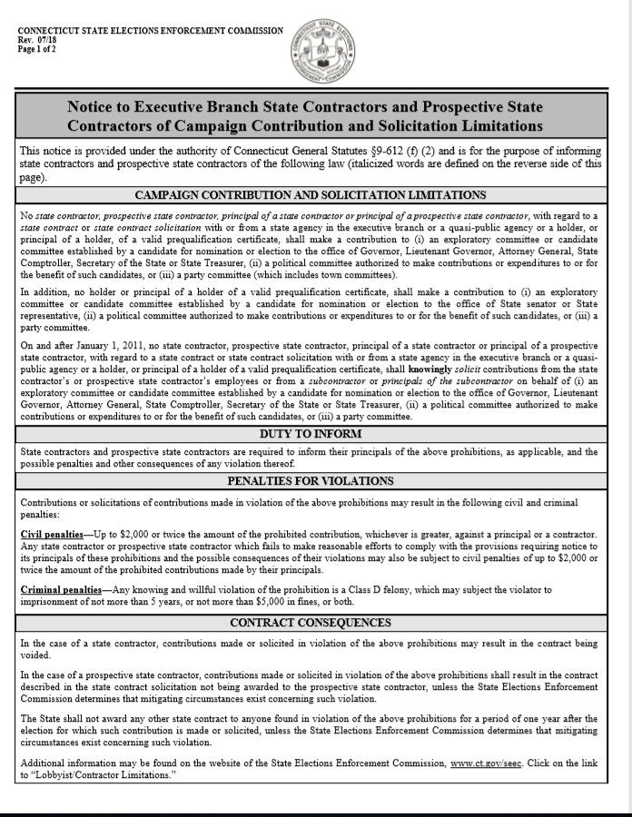

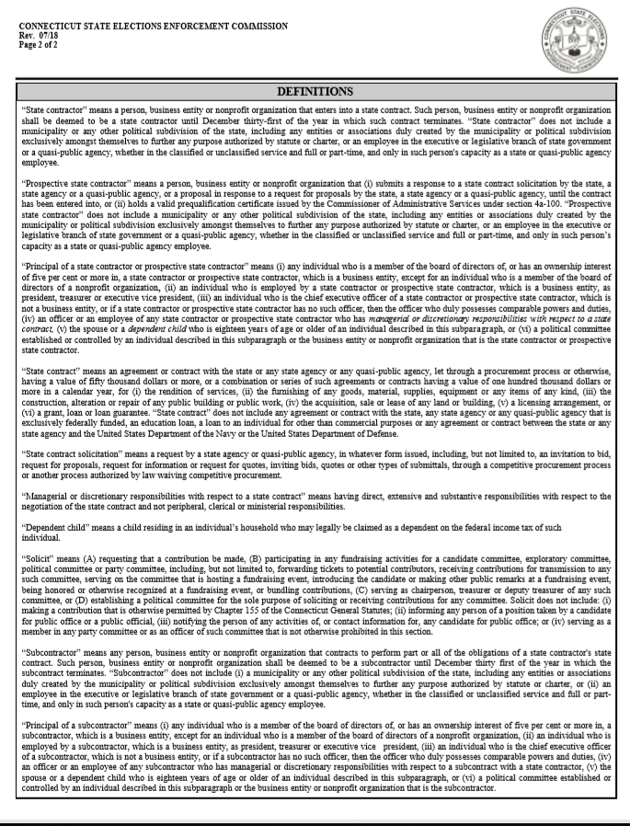

For more information about public transportation services, see https://www.hartfordline.com/route_stations/hartford.aspx; https://www.hartfordtransit.org/, and https://www.cttransit.com/services/hartford-dash-shuttle

