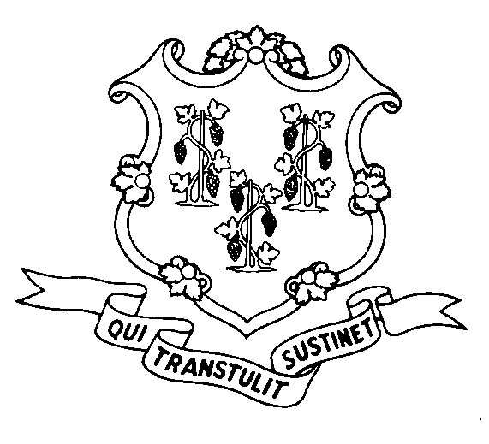
STATE OF CONNECTICUT
DEPARTMENT OF SOCIAL SERVICES
UNIFORM POLICY MANUAL

______________________________________ July 1, 2008
Claudette J. Beaulieu, Deputy Commissioner Effective Date

POLICY TRANSMITTAL NO.: UP-08-17

SUBJECT: State Administered General Assistance (SAGA) Cash Standards

Last year, the General Assembly enacted legislation to provide for cost of living increases for the SAGA cash assistance program based on the increase in the average monthly Consumer Price Index. This transmits revised policy concerning the amounts of the assistance standards under the State Administered General Assistance (SAGA) cash program.

Effective July 1, 2008, the monthly standards of assistance under the SAGA cash program will increase 2.8% and are as follows:

$212 for unemployable individuals;
$212 for transitional individuals with a shelter obligation;
$53 for transitional individuals without a shelter obligation;
$53 for transitional individuals in emergency shelters;
TFA standard minus $50 for SAGA Family cases.

INSTRUCTIONS FOR UPDATING THE UPM:

Remove and Recycle Insert

P-8080.45 pages 3-4 P-8080.45 pages 3-4
P-8080.60 pages 3-4 P-8080.60 pages 3-4

DISPOSITION: This Policy Transmittal may be recycled once the UPM has been updated.

DISTRIBUTION: UPM list

RESPONSIBLE UNIT: Adult Support, (860) 424-5250
Date Issued:

SM

25 SIGOURNEY STREET - HARTFORD, CONNECTICUT 06106-5033
An Equal Opportunity / Affirmative Action Employer
Printed on Recycled or Recovered Paper

