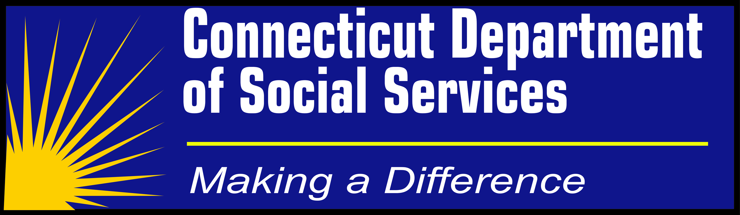

Special Notice about Medicaid Applications
For Long-Term Services and Supports

Important information

Please MAIL new applications to one of four
DSS Long-Term Services and Supports (LTSS) Application Centers

**Special Application Process at DSS**
To better serve our applicants, clients and providers, DSS has four Long-Term Services and Supports (LTSS) Application Processing Centers. These Centers receive and process new applications from specific cities and towns for nursing home and Medicaid waiver home care applications.
The Long-Term Services and Supports Application Centers are located in the DSS Waterbury, Bridgeport, Hartford and New Haven field offices. Please check the table in this notice for which Application Processing Center to use, based on your city or town.
Application packets with as much documentation as possible should be mailed directly to the appropriate LTSS Application Center. Please discontinue mailing new applications to the DSS ConneCT Scanning Center. We cannot accept applications by fax because of the size and volume of most LTSS applications. We have begun accepting applications online. If you would like to apply go to www.connect.ct.gov and click on the Apply Now button.
Please note that these Centers will process new applications only. Long-term services and supports redeterminations and interim changes, as well as boarding home applications and redeterminations, will continue to be processed through the statewide ConneCT model. This means that all paperwork for redeterminations and interim changes, as well as boarding home applications and redeterminations, should be sent to the DSS ConneCT Scanning Center at P.O. Box 1320, Manchester CT 06045 (not to the new LTSS Application Centers).

(notice continued >>)
The LTSS Application Centers will also support admissions and discharges affecting area nursing homes in the ASCEND system.
For questions specific to a pending case after an application is made, clients should call the assigned caseworker directly. Applicants will be provided a worker’s contact information once the case is assigned. For all other general calls or questions, the DSS Benefits Center staff will serve you at 1-855-6-CONNECT (1-855-626-6632).
Thank you for your participation in this process. We look forward to working with you.
--CT Department of Social Services
DSS Long-Term Services and Supports Application Centers
Waterbury Office  249 Thomaston Avenue  Waterbury, CT 06702  For: Barkhamsted, Beacon Falls, Berlin, Bethlehem, Bristol, Burlington, Canaan, Cheshire, Colebrook, Cornwall, Goshen, Hartland, Harwinton, Kent, Litchfield, Middlebury, Morris, Naugatuck, New Britain, New Hartford, Norfolk, North Canaan, Oxford, Plainville, Plymouth, Prospect, Roxbury, Salisbury,  Sharon, Southbury, Southington, Thomaston, Torrington, Warren, Washington, Waterbury, Watertown, Winchester, Wolcott, Woodbury. | Bridgeport Office  925 Housatonic Avenue  Bridgeport, CT 06606  For: Bethel, Bridgeport, Bridgewater, Brookfield,  Danbury, Darien, Easton, Fairfield, Greenwich,  Monroe, New Canaan, New Fairfield, New Milford,  Newtown, Norwalk, Redding, Ridgefield  Sherman, Stamford, Stratford, Trumbull,  Weston, Westport, Wilton.
Hartford Office  3580 Main Street  Hartford, CT 06106  For: Andover, Ashford, Avon, Bloomfield ,Bolton, Brooklyn, Canterbury, Canton, Chaplin, Columbia, Coventry, East Granby, East Hartford, East Windsor, Eastford, Ellington, Enfield, Farmington, Glastonbury, Granby, Hampton, Hartford, Hebron, Killingly, Manchester, Mansfield, Marlborough, Newington, Plainfield, Pomfret,  Putnam, Rocky Hill, Scotland, Simsbury, Somers, South Windsor, Stafford, Sterling, Suffield, Thompson, Tolland, Union, Vernon, West Hartford, Wethersfield, Willington, Windham, Windsor Locks, Windsor, Woodstock. | New Haven Office  50 Humphrey Street  New Haven, CT 06513  For: Ansonia, Bethany, Bozrah, Branford, Chester, Clinton, Colchester, Cromwell, Deep River, Derby, Durham, East Haddam, East Hampton, East Haven, East Lyme, Essex, Franklin, Griswold, Groton, Guilford, Haddam, Hamden, Killingworth,  Lebanon, Ledyard, Lisbon, Lyme, Madison, Meriden, Middlefield, Middletown, Milford, Montville, New Haven, New London, North Branford, North Haven, North Stonington, Norwich, Portland, Preston, Old Lyme, Orange, Salem, Seymour, Shelton, Sprague, Stonington, Voluntown, Wallingford, Waterford, Westbrook, West Haven, Woodbridge.

Special thanks to the Connecticut Association of Health Care Facilities,
LeadingAge Connecticut, and the Connecticut Department of Public Health
for helping distribute this message.

[CT DSS/May 28, 2014]

