Strategic Map Update 2017
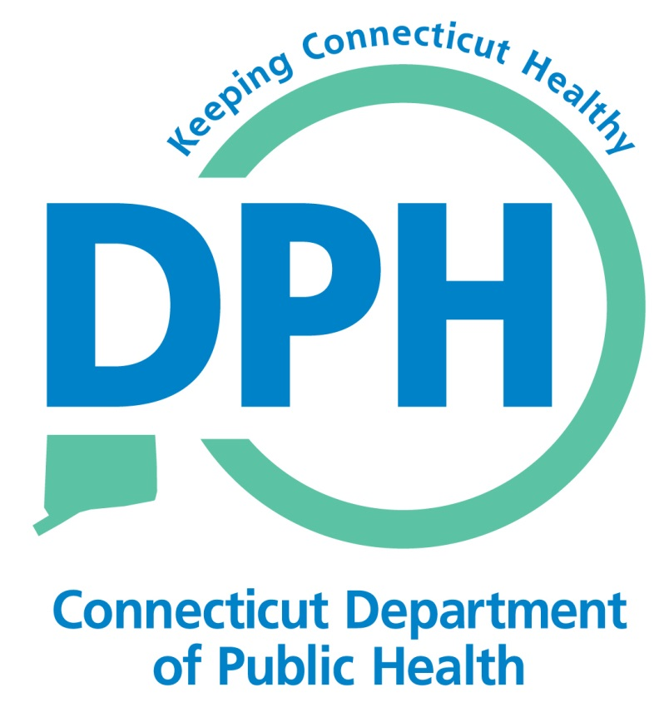
Implementation Planning Worksheet

Central Challenge
Improve Population Health in Connecticut through Engagement, Innovation, Expertise Leadership, and Action

Strategic Priority or Goal: [ add in strategic priority]

Track of Work/Objectives: [add in track of work]

Result | Deadline | Accountability | Status/Comment

Track of Work: an objective or set of related objectives on the strategic map

Result: “what”—a specific outcome to be achieved in support of the track of work/objectives

Deadline: “when”—the date by which the result will be achieved

Accountability: “who”—the person or group responsible for achieving the result

Status/Comment : - the status in reaching the result. Note if: on track, off track, completed (with date), comments as needed.

