HEALTHCARE QUALITY AND SAFETY BRANCH
BLAST FAX 2020-08
TO: All Hospitals and Nursing Homes

FROM: Deputy Commissioner Heather Aaron, MPH, LNHA
CC: Barbara Cass, RN., Branch Chief, Healthcare Quality and Safety Branch
DATE: March 11, 2020
SUBJECT: Guidance for Certifying COVID-19 Deaths

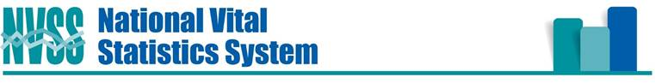
Guidance for Certifying COVID-19 Deaths
March 4, 2020

NCHS is receiving questions about how deaths involving the new coronavirus strain should be reported on
death certificates. We are working on formal guidance to certifiers to be published as soon as possible. In the meantime, to address the immediate need, here is some basic information that can be shared in advance of the more formal and detailed guidance. It is important to emphasize that Coronavirus Disease 2019 or COVID-19 should be reported on the death certificate for all decedents where the disease caused or is assumed to have caused or contributed to death. Other terminology, e.g., SARS-CoV-2, can be used as long as it is clear that it indicates the 2019 coronavirus strain, but we would prefer use of WHO’s standard terminology, e.g., COVID-19. Specification of the causal pathway leading to death in Part I of the certificate is also important. For example, in cases when COVID-19 causes pneumonia and fatal respiratory distress, both pneumonia and respiratory distress should be included along with COVID-19 in Part I. Certifiers should include as much detail as possible based on their knowledge of the case, medical records, laboratory testing, etc. If the decedent had other chronic conditions such as COPD or asthma that may have also contributed, these conditions can be reported in Part II. Here is an example:
For more general guidance and training on cause-of-death reporting, certifiers can be referred to the Cause of Death mobile app available through https://www.cdc.gov/nchs/nvss/mobile-app.htm and the Improving Cause of Death Reporting online training module, which can be found at https://www.cdc.gov/nchs/nvss/improving_cause_of_death_reporting.htm.

Steven Schwartz, PhD
Director – Division of Vital Statistics
National Center for Health Statistics
3311 Toledo Rd | Hyattsville, MD 20782

