**BLAST FAX 2019-26**

TO: All Providers

FROM: Cheryl Davis, RN, BSN, Public Health Services Manager

Facility Licensing and Investigations Section

DATE: November 27, 2019

SUBJECT: Submission of Hospital Prospective Nurse Staffing Plan Connecticut General Statutes 19a-89e and Records and Reports regarding Incidents of Workplace Violence Connecticut General Statutes 19a-490r

______________________________________________________________________________

In accordance with Connecticut General Statutes 19a-89e and Connecticut General Statutes 19a-490r, please submit these documents as they apply to your facility type to the Department by **December 31, 2019.**

The Yearly Report Submission to DPH-Facility Licensing and Investigations Section (FLIS) is a web based submission. Please do not submit paper or faxed reports to the Department.

**How to Submit:**

1. Please visit <https://dphflisevents.ct.gov> and select **“Yearly Report Submission to DPH-FLIS”** button as shown in the picture below

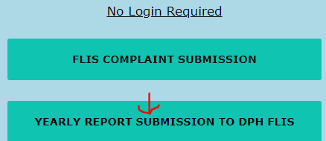

1. Please select the appropriate report in the “Submission type”.

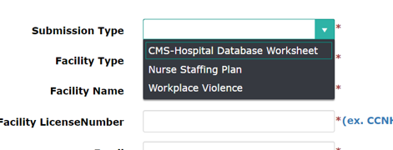

1. Complete the entire form and follow the prompts. Please make sure to check the “Affidavit of Submitter” before clicking the submit button.
2. Upon successful submission the website will display a confirmation number for your future reference.

Please contact Surjit Sethuraman @ [Surjit.sethuraman@ct.gov](mailto:Surjit.sethuraman@ct.gov) or Michael Lavorgna @ [Michael.lavorgna@ct.gov](mailto:Michael.lavorgna@ct.gov) with any technical questions.