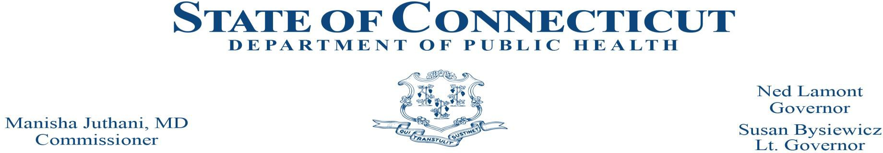

FACILITY LICENSING AND INVESTIGATIONS SECTION

BLAST FAX 2024-6

TO: Executive Directors Substance Abuse Facilities, Psychiatric Outpatient Clinics for Adults, Mental Health Residential Living, Mental Health Community Residences, Mental Health Day Treatment & Infirmaries

FROM: Jennifer Olsen-Armstrong, Section Chief
Facility Licensing and Investigations Section

DATE: August 2, 2024

SUBJECT: Web Based Reportable Event System: Substance Abuse Facilities, Psychiatric Outpatient Clinics for Adults, Mental Health Residential Living, Mental Health Community Residences, Mental Health Day Treatment & Infirmaries
______________________________________________________________________________

Action Required!

The Department of Public Health’s (DPH) Facility Licensing and Investigations Section (FLIS) has developed a web based online reportable events system. Effective September 15, 2024, Substance Abuse Facilities, Psychiatric Outpatient Clinics for Adults, Mental Health Residential Living, & Infirmaries should submit Reportable Events to the Connecticut Department of Public Health (DPH) Facility Licensing and Investigation Section (FLIS) through a web-based portal.

The portal streamlines the reporting system, allows users to view and track events filed for their facility, and allows for bidirectional communication with DPH.

Please complete the survey below to register to access the portal. Each facility should have administrators(s) for the portal who will have administrative rights to create/delete/activate/inactivate users for their assigned facility.

Please register to attend training session on the portal. Sessions will be held between August 28, 2024, and September 5, 2024. See below for additional details.

DPH FLIS Reportable Events Web Page: https://portal.ct.gov/dphreportableevents

Phase 1: Enrollment

Enrollment is a two-step process, so please make sure to complete both the steps to get access to DPH FLIS Event Tracking System.

Step 1: Please visit https://bit.ly/3yaRcBH to submit your authorized Facility Administrators for your facility. Only these administrators will be approved in the system, so it is very important for each facility to designate at least two administrators and submit their information. Please submit this information by the close of business on August 12, 2024.

Step 2: Each authorized individual administrator must register online on the DPH FLIS Events website. Visit https://dphflisevents.ct.gov and click "Register as a Facility Administrator" button and complete the online registration form.

Administrators will not be granted access to the DPH FLIS Events Tracking System until the above steps are completed.

Phase 2: Training

Four live webinar sessions will be conducted between August 28th and September 5th to demonstrate the DPH FLIS Report Tracking System website. Please sign up for a session using the link below. If you have multiple license types, you only need to select one session.

- Infirmaries: August 28, 2024, at 10:00 AM to 11:00 AM.
- Substance Abuse Facilities: August 29, 2024, at 1:00 PM to 2:00 PM.
- Psychiatric Outpatient Clinics for Adults & Mental Health Day Treatment: September 4, 2024, at 10:00 AM to 11:00 AM
- Mental Health Residential Living Mental Health Community Residences: September 5, 10:30 AM to 11:30 AM

The training slides and manual will be made available on the FLIS website: FLIS (ct.gov)

Phase 3: Go-Live
To register for one of the dates:

Infirmaries Webinar - https://bit.ly/3LKLxFv

Substance Abuse Facilities Webinar - https://bit.ly/3WLyuZJ

Psychiatric Outpatient Clinics for Adults & Mental Health Day Treatment Webinar - https://bit.ly/3yg3s3R

Mental Health Residential Living and Mental Health Community Residences Webinar - https://bit.ly/46tomsN

The anticipated Go-Live date is September 15, 2024. Updates will be available on the DPH website.
FLIS (ct.gov).

The accounts will be activated by 8 AM on the Go-Live date of September 15th.

Reportable events submissions via FAX will not be accepted from any facility once their designated Go-Live date has passed.

Please submit questions to: DPH.FLISBHEvents@ct.gov

If you have received this fax in error, please contact Zufreen Baksh-Jagan at Zufreen.Baksh-Jagan@ct.gov Thank you for your attention to this important initiative.

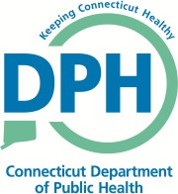
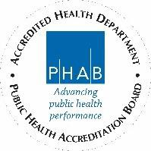
Telecommunications Relay Service 7-1-1 410 Capitol Avenue, P.O. Box 340308
Hartford, Connecticut 06134-0308 www.ct.gov/dph
Affirmative Action/Equal Opportunity Employer

