WIC Vendor Portal Application Worksheet – Open Enrollment
This worksheet allows you to capture required information and documents/files that you will need to have when you sit down at a computer to register as a user and enter the portal for the purpose of applying for WIC authorization. This application cannot be accessed by tablet or mobile device. Personal computer or laptop only. This application process will require you to enter demographic information in a variety of internet screens.

PLEASE NOTE: The Connecticut WIC Program requires that all vendors be SNAP authorized and open continuously for one full calendar year prior to application to be eligible for authorization.

You will also be required to upload documents to the application through the portal. These uploads can take the form of PDF, word documents, and images. For help with scanning, search your mobile device’s app store for “scanner apps.” You may also want to consult with your local office supply store about scanning.

Lastly, please turn off the pop-up blocker in your internet browser to ensure that all required screens and pop-ups can open. You may search your browser for help turning off the pop-up blocker by clicking on the magnifying glass or using the search function in the browser.

Store Name:

Street Address:

City, State, Zip:

Store Phone Number:

The allowable formats for documents and files that need to be uploaded to complete your portal application are the following: PDF, DOC, JPEG, GIF, PNG
Documents/Files to Upload to your Portal Application (required documents/files based on your store’s specific demographics):
- Owner Information Form (print from WIC Retailers webpage and complete in full)
- Photocopy/electronic image of owner’s Driver’s License/state or federal identification
- Photocopy/electronic image of store manager’s Driver’s License/state or federal identification
- OS-114 forms-Sales and Use Tax Summary, including Line 21, for the LAST FOUR TAX FILING QUARTERS (specific time period indicated on the Sales Information screen)

Information about you, your store, and your employees that you need to complete the WIC portal application.
Authorized SNAP Number:

Connecticut Tax ID Number:

FEIN/SSN:

Owner DL/ID State & Number:

Store Manager DL/ID State & Number (if appropriate):

Owner Email:

Store Manager Email (if appropriate):

Store Email:

Cash Register System Type: | - Integrated If Integrated, your TPP:  - Stand Beside
Language You Wish to Be Trained In

Number of store workers and how many will handle WIC transactions | Store Workers:  How many will handle WIC transactions:
What do you estimate the percentages of your future food sales by type of payment will be? Total must equal 100%. | Cash______% WIC_______% SNAP______%  Credit Card/Debit Card______%  Other (personal checks, etc.) _____%

Store Hours for the Store Details screen

Day | Sunday | Monday | Tuesday | Wednesday | Thursday | Friday | Saturday
Store Hours | AM | AM | AM | AM | AM | AM | AM
 | PM | PM | PM | PM | PM | PM | PM

Information required for the Formula Suppliers button on the Store Details screen

Please list the wholesalers and distributors from which you will be purchasing infant formula.

Information required for the Sales Information screen

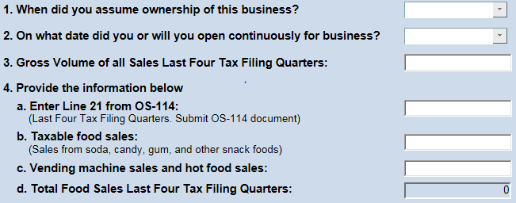

Please enter the Lowest and Highest Price for the category of food product listed below. See the WIC Approved Food Guide on the following pages for specific products and brand names allowed.
Product | Size | Lowest Price | Highest Price
Cheese | 1 lb.
Eggs – Large | 1 dozen
Milk, Low-Fat (1% Skim) | gallon
Peanut Butter | 16-18 oz. jar
Whole Wheat/Whole Grain Bread | 1 lb.
Dry Legumes | 1 lb.
Infant Fruits or Vegetables | 4 oz.
Infant Cereal | 8 oz. box
Breakfast Cereal – Cold | 12 oz. box
Juice – Fluid | 64 oz./half gallon
Infant Formula – Similac Advance | 12.4 oz. can of powder (blue label) |  | ONE PRODUCT/ONE PRICE
Information required for the Food Price Entry screen

