Presenter’s Guide

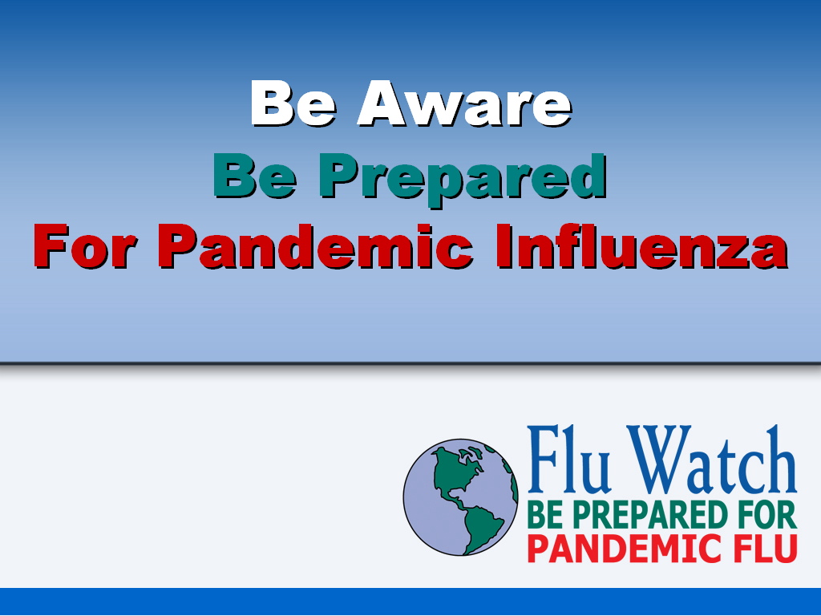

Supplemental guide for pandemic influenza and preparedness presentation

Developed by:

State of Connecticut
Department of Public Health
August 2007



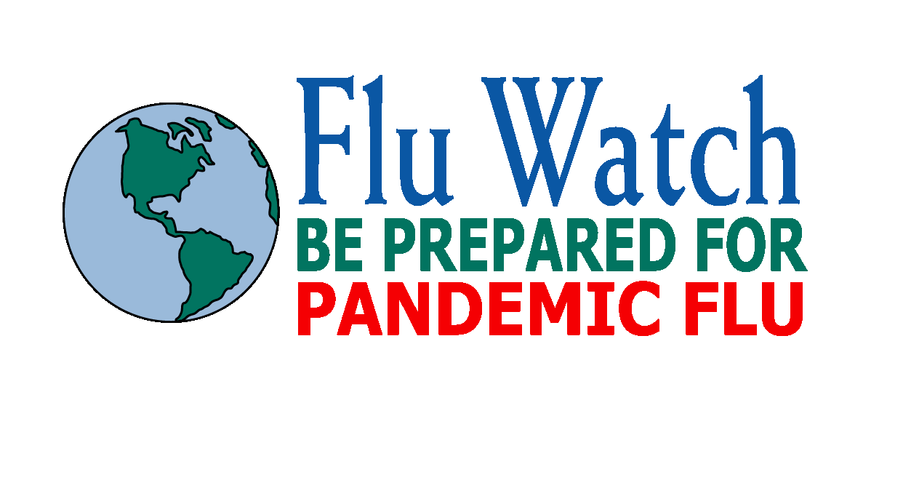

The Be Aware, Be Prepared for Pandemic Influenza Presentation for Local Health Departments and Districts was developed to provide an informative and educational presentation to local communities on pandemic influenza. In addition to educating the audience on the basics of pandemic influenza, the presentation also provides information on how people can prepare themselves, their families, and their communities.

This presentation has been designed as a tool for local health departments and districts to help educate various groups in their communities, including community and religious leaders, businesses, emergency personnel, and community members on pandemic influenza. We encourage local health departments and districts to reach out to these groups, not only to educate them about pandemic flu and preparedness, but also to familiarize community organizations with their local health departments and districts.

This presenter’s guide includes talking points and other tools to help the presenter give an in-depth and complete look at pandemic flu and preparedness.

The CD-ROM contains two PowerPoint presentations: “CT DPH PanFlu LHD Presentation for Viewer.ppt” and “CT DPH PanFlu LHD Presentation.ppt”. The CD-ROM also contains PowerPoint Viewer, a program that allows you to run the PowerPoint presentation from a computer that does not have PowerPoint installed. PowerPoint Viewer does not allow you to edit or personalize your presentation. The PowerPoint presentation labeled “CT DPH PanFlu LHD Presentation for Viewer.ppt” is for use with the PowerPoint Viewer and can run from the provided CD, but it cannot be personalized without a full version of PowerPoint. To use the PowerPoint Viewer, simply open “CT DPH PanFlu LHD Presentation for Viewer.ppt” from the CD on a computer that does not have PowerPoint installed.

The presentation referenced in this guide is “CT DPH PanFlu LHD Presentation.ppt”, which contains a place on the title slide for the Local Health Department’s name and a second slide for the presenter’s name and contact information. This version of the presentation can be run using PowerPoint or PowerPoint Viewer. Please remember, if you are using PowerPoint Viewer, you will be unable to personalize the presentation, regardless of which version you use. To personalize “CT DPH PanFlu LHD Presentation.ppt”, copy the file to the hard drive of a computer with PowerPoint or a portable drive or disk, make the changes on the title slide and the second slide to personalize it, and then either use the computer, disk, or drive where you saved the presentation. You cannot personalize and save “CT DPH PanFlu LHD Presentation.ppt” to the provided CD.

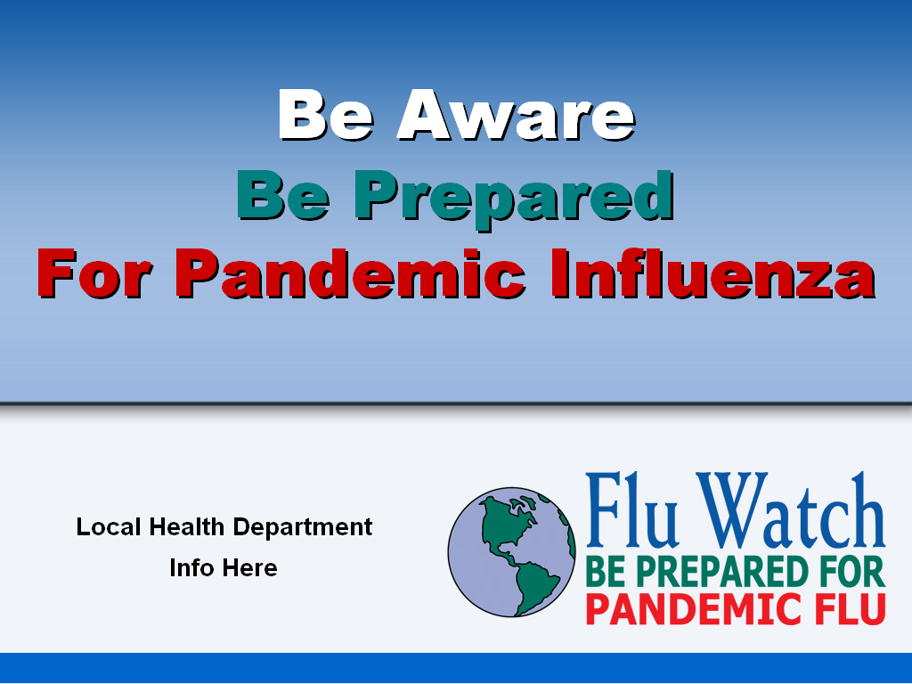

Slide 1: Be Aware, Be Prepared for Pandemic Influenza

This introductory slide includes the presentation title, local health department logo and, if desired, local health contact information, and FluWatch logo.

(“CT DPH PanFlu LHD Presentation for Viewer.ppt” version of the presentation does not have the section on this slide for the local health department logo and information.)

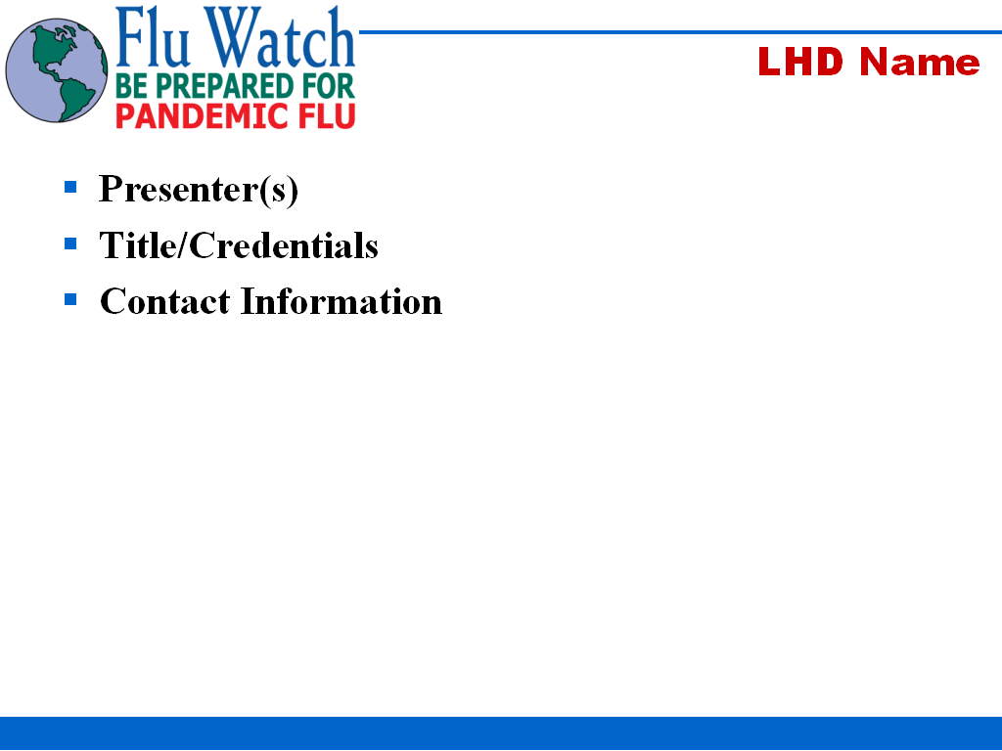

Slide 2: Presenter Information

This slide includes the presenters’ names, title and credentials, and contact information.

Be sure to complete this slide to include the presenter’s information.

Talking Points:

- Discuss the presenters’ role in the health department as well as their role in pandemic flu preparedness.

- Briefly discuss the role the LHD will play in the event of pandemic flu.

(“CT DPH PanFlu LHD Presentation for Viewer.ppt” version of the presentation does not have this slide for the presenter’s name, title/credentials and contact information.)

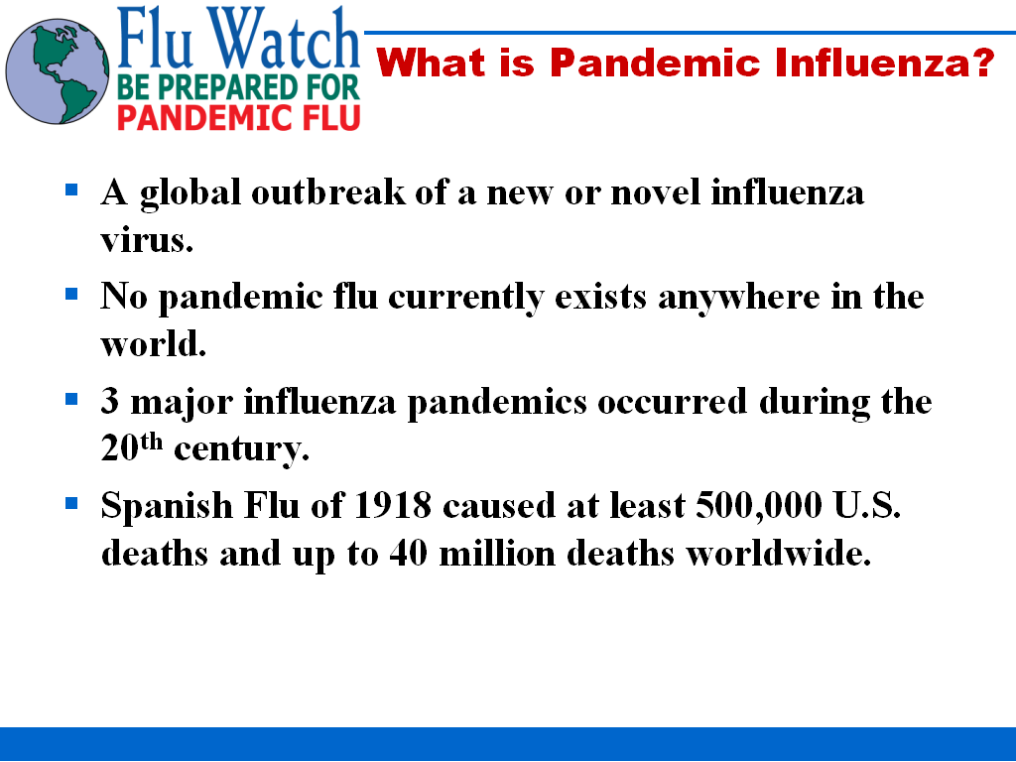

Slide 3: What is Pandemic Influenza?

This slide provides background information on pandemic influenza.

Definitions:

Pandemic: Worldwide outbreak of disease

Flu: Viral infection of the nose, throat and lungs

Avian flu: Flu virus that generally infects birds, but sometimes infects humans

Seasonal flu: Flu virus that usually occurs in the winter months

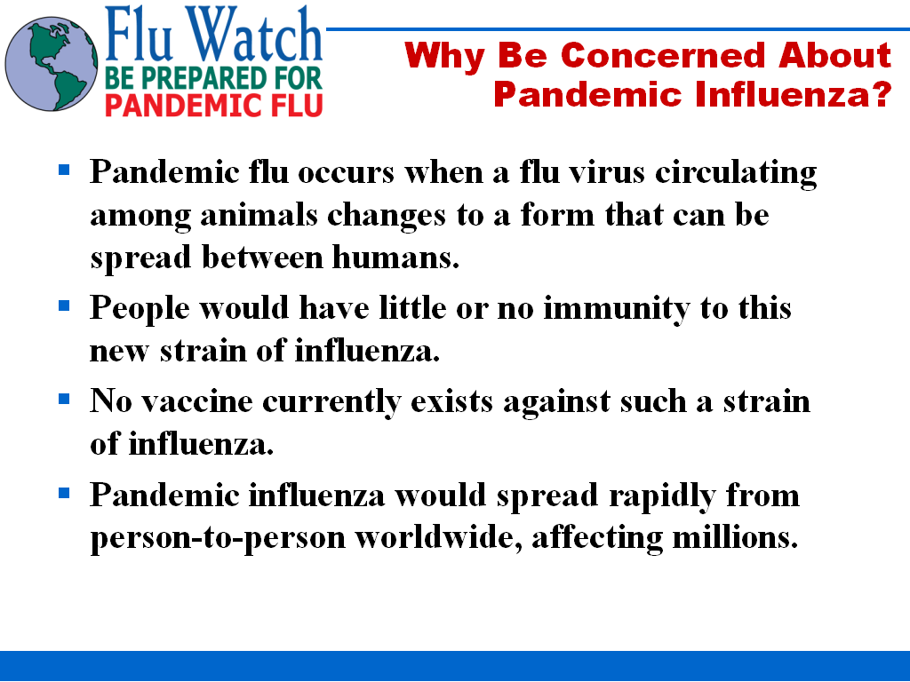

Slide 4: Why Be Concerned about Pandemic Influenza?

This slide gives information on why pandemic influenza should be a concern.

Definitions:

Virus strain: a group of organisms within a species or variety, characterized by some particular quality

Antiviral medication: Given to help prevent viral infection or treat those who are infected

Vaccine: Usually given as a preventive measure. Currently available viral vaccines are usually made from either killed virus or weakened versions of the live virus or pieces of the virus that stimulate an immune response to the virus.

Slide 4: Why Be Concerned about Pandemic Influenza? (continued)

This slide gives information on why pandemic influenza should be a concern.

Talking Points:

- Pandemic flu will be a result of a mutating virus
  - Viruses mutate by nature
  - Virus would have mutated to where it will be easily transmissible among humans

- Pandemic flu will be a new or novel virus
  - People will have little or no immunity because they will not have had previous exposure to the virus strain

- Virus is unknown
  - Since we don’t know when the pandemic will occur, we can not identify what the virus will be until the pandemic begins
  - We can not determine how effective vaccines or antivirals will be against the strain until the virus has been identified
  - Once the virus has been identified, it may take 3 to 6 months to develop and/or produce sufficient quantities of vaccines or antivirals
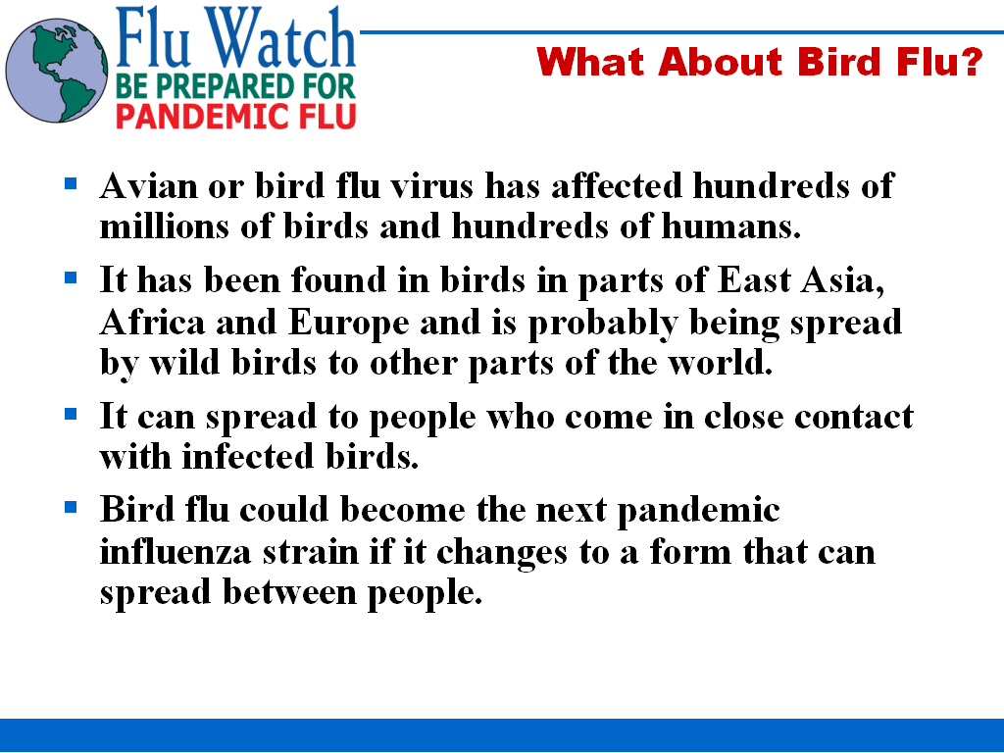

Slide 5: What About Bird Flu?

This slide gives information on avian flu.

Talking Points:

- H5N1 is the “bird flu” virus that is currently affecting humans in parts of East Asia, Africa and Europe that we are hearing about
  - Two types: Low-pathogenic and high-pathogenic
    - Low-pathogenic is common in birds around the world, usually only causes mild symptoms (little concern)
    - High-pathogenic spreads more rapidly through flocks, 90-100% mortality rate among poultry (high concern)
  - Mortality rate for high-pathogenic is approximately 60% among humans

- Avian flu spread through direct contact between humans and infected birds
  - Transmitted through contact with infected birds’ secretions/excretions or surfaces contaminated with secretions/excretions
  - Transmission of virus from human-to-human very rare, but has been documented
  - Thoroughly cooking infected poultry kills avian flu virus

Slide 5: What About Bird Flu? (continued)

This slide gives information on avian flu.

Useful Websites:

These websites provide information and current statistics on avian influenza and surveillance:

University of Minnesota, Center for Infectious Disease Research & Policy:
http://www.cidrap.umn.edu/

NBII Wildlife Disease Information Node:
http://wildlifedisease.nbii.gov/ai/

U.S. Department of Health and Human Services:
http://www.pandemicflu.gov/

CT Flu Watch:
http://www.ct.gov/ctfluwatch
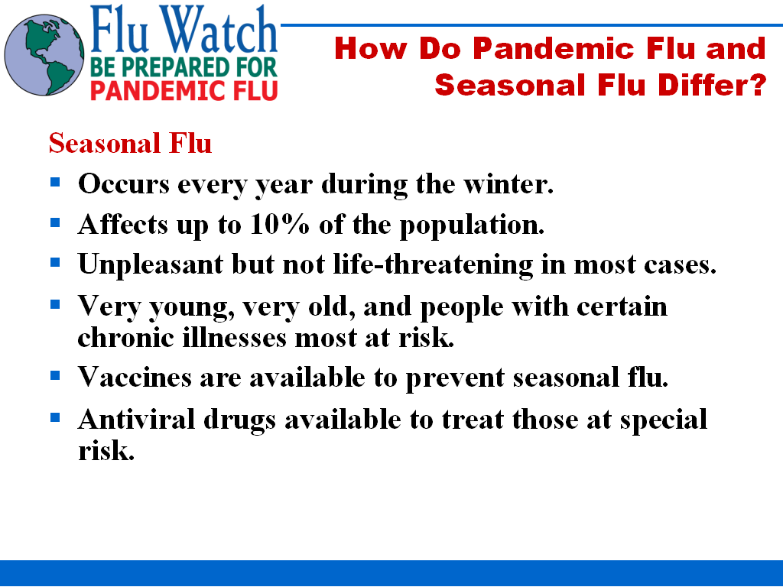

Slide 6: How do Pandemic Flu and Seasonal Flu Differ?

Seasonal Flu

This slide provides information on seasonal influenza.

Talking Points:

- Approximately 36,000 deaths per year in U.S.

- People usually have some immunity built up from previous exposure

- There is a vaccine available, but it must be updated annually and has to match the virus that is circulating that particular season

- Priority groups for vaccination
    - Children 6 months to 5 years old
    - Adults 50+
    - People with underlying medical conditions
    - Pregnant women
    - People in nursing homes or long-term care facilities
    - Healthcare providers
    - People living with those at high risk for the flu
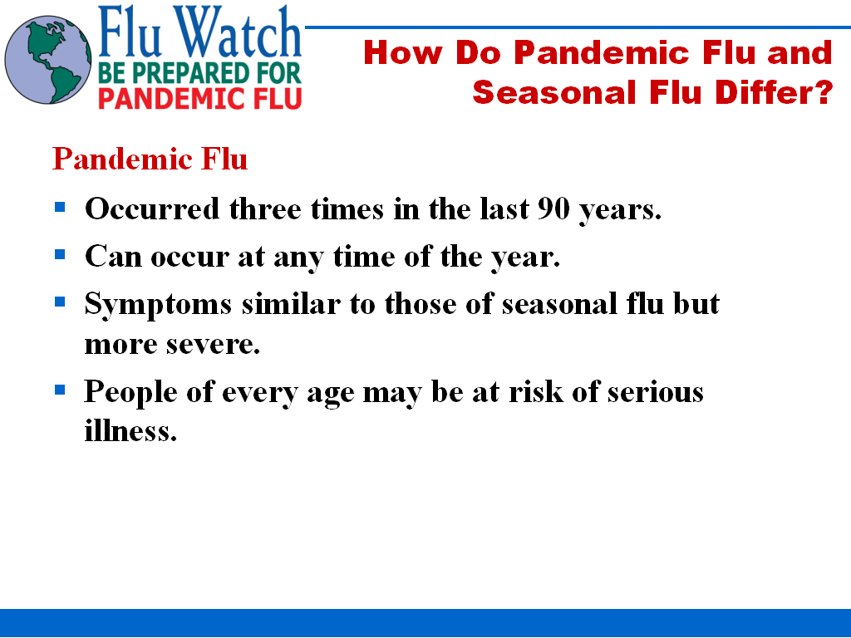

Slide 7: How do Pandemic Flu and Seasonal Flu Differ?

Pandemic Flu

Talking Points:

- 3 pandemics in 20th century
- 1918: Spanish Flu
  - Between September 1918 and April 1919 there were approximately 500,000 deaths in the U.S.
  - Attack and mortality rate highest among people aged 20-50
- 1957: Asian Flu
  - Identified in Far East in February 1957, arrived in U.S. in summer of 1957, 2nd wave arrived in U.S. in January 1958
  - Vaccine production began May 1957, limited vaccines available by August 1957
  - Nearly 70,000 deaths in the U.S.
- 1968: Hong Kong Flu
  - Early U.S. cases in Sept. 1968, became widespread in U.S. Dec. 1968
  - Between September 1968 and March 1969: nearly 34,000 U.S. deaths
  - Lower number of deaths may be due to school breaks in December (which is when the virus peaked in U.S.), increased immunity from Asian Flu pandemic, and improved medicine
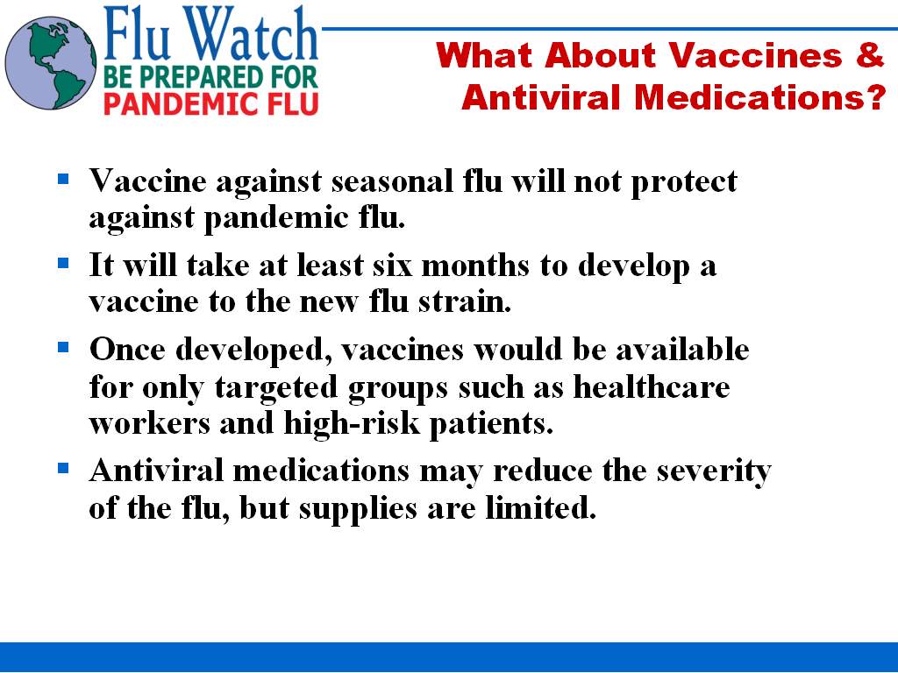

Slide 8: What About Vaccines & Antiviral Medications?

Talking Points:

- Until the virus has been identified, we can not determine how effective existing vaccines and antiviral medications will be

- Vaccines
  - If a vaccine does not exist, it will take at least 6 months to develop
  - Once developed, vaccines will be in short supply and only available to target groups like healthcare workers and high-risk patients

  - Antiviral medications
  - Only moderately effective
    - Must be administered within 48 hours of symptoms to be effective
    - Virus may be resistant to existing antivirals
  - May be in limited supply during a pandemic
  - State of Connecticut will have available 500,000 courses of antivirals for use during a pandemic

Slide 8: What About Vaccines & Antiviral Medications? (continued)

Talking Points:

  - Non-Pharmaceutical Interventions will be important
  - Proper hand washing and respiratory etiquette
  - Social distancing
  - Voluntary quarantine and isolation

Useful Online Resources:

U.S. Department of Health and Human Services & Centers for Disease Control and Prevention:

Interim Pre-Pandemic Planning Guidance: Community Strategy for Pandemic Influenza Mitigation in the United States:
http://www.pandemicflu.gov/plan/community/community_mitigation.pdf

Pandemic Mitigation
http://www.pandemicflu.gov/plan/community/mitigation.html

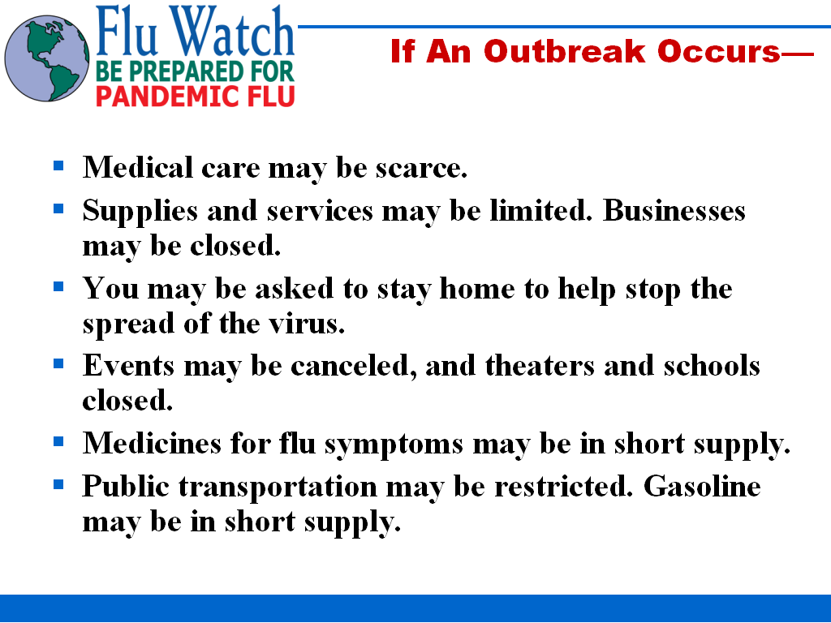

Slide 9: If an Outbreak Occurs-

Talking Points:

  - Hospitals and other medical facilities may be overwhelmed
  - Hospitals, clinics, and doctors’ offices will be experiencing a large volume of people sick from the flu, in addition to their non-pandemic flu cases and emergencies
  - They will also experience a staffing shortage due to illness from the flu

  - If you are sick with the flu or have been exposed, you will likely be asked to stay home.

  - Staffing shortages may cause businesses (like banks, grocery stores, government offices) to operate for a limited number of hours or close completely

  - Services like electricity and garbage collection may also be interrupted due to staffing shortages

  - To limit the spread of the virus, events where large people may gather might be canceled

***Please note that these are things that may happen in the event of a SEVERE pandemic. A milder pandemic will be less disruptive.***
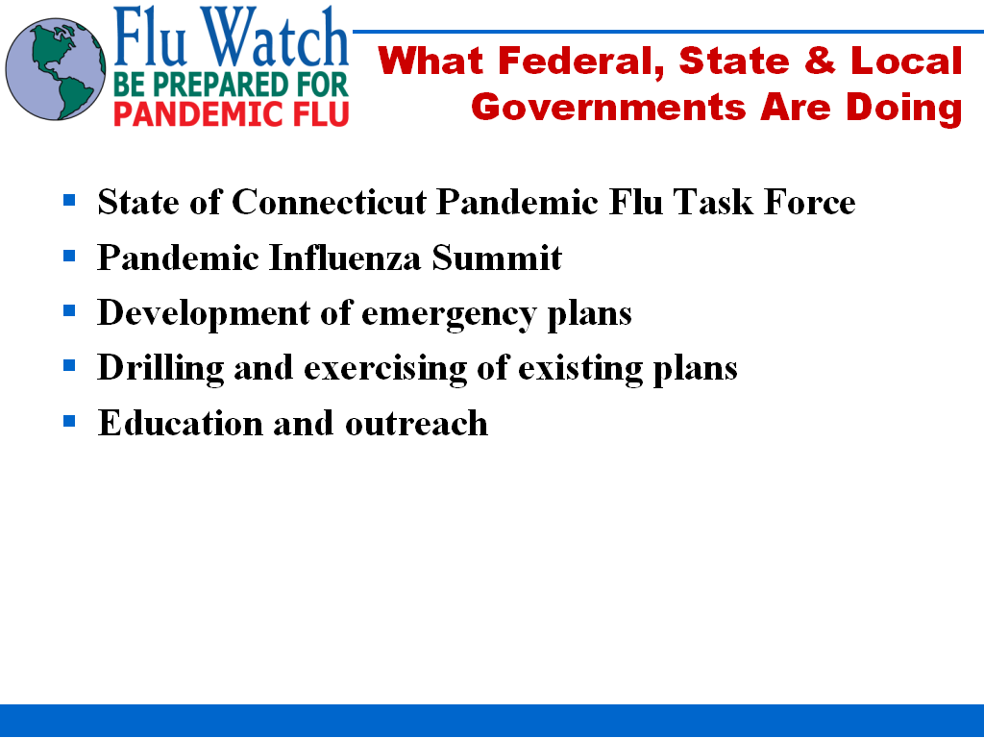

Slide 10: What Federal, State & Local Governments are Doing

Talking Points:

  - $1.35 Million federal grant awarded to State of Connecticut for Pandemic Flu Preparedness

  - Pandemic Flu Task Force
  - Made up of Departments of Public Health, Environmental Protection, Emergency Management and Homeland Security and Agriculture
  - Works with other state and local agencies on pandemic flu preparedness
  - Established CT Flu Watch Website (www.ct.gov/ctfluwatch)

  - Pandemic Influenza Summit
  - Hosted by Department of Public Health on February 2, 2006
  - Governor Rell and federal Health and Human Services Secretary Mike Leavitt and Dr. Julie Gerberding, Director of the Centers for Disease Control and Prevention were speakers

  - Federal, state and local governments developing and drilling plans for pandemic flu which include emergency preparedness and continuity of operations planning

  - Educational campaigns and presentations informing people of pandemic flu
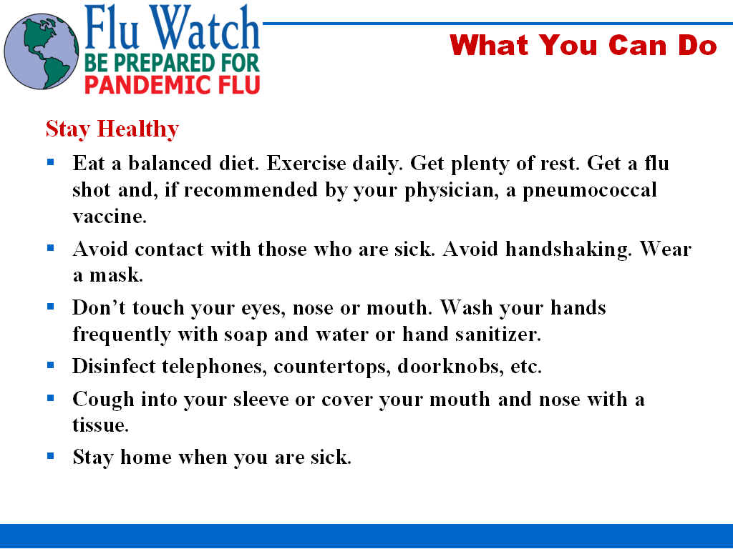

Slide 11: What You Can Do (continued)

Stay Healthy

Talking Points:

  - Healthy bodies will be able to defend themselves better from infection or severe illness

  - Pneumococcal vaccine is a one-time vaccine that protects against pneumonia (a potential complication of the flu)

  - People often get the flu when they touch a surface that has the virus and then touch their eyes, nose, or mouth

  - Washing hands helps protect you from the flu and other viruses

  - Disinfecting commonly used surfaces often will kill the virus on those surfaces

  - Staying home when you are sick will prevent spreading the virus to people who are healthy
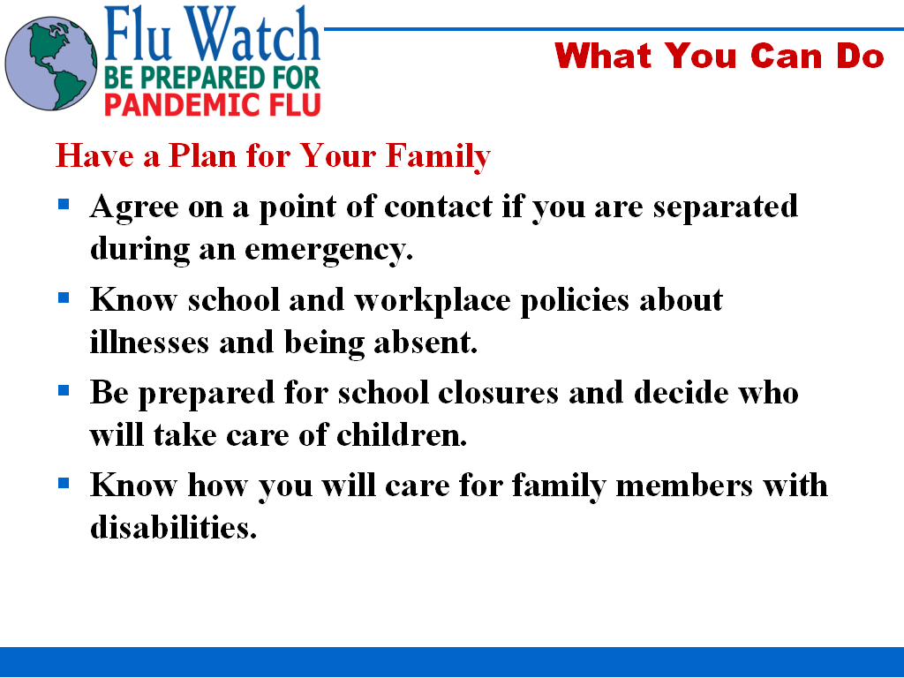

Slide 12: What You Can Do

Have a Plan for Your Family

Talking Points:

- Talk to your human resources office or school attendance clerk regarding absentee policies

- Have a plan for who will care for your children if schools or daycares are closed

- Have a plan for friends and family members with special needs
  - During a pandemic, services may not be available for people with special needs
  - Consider how you would take care of friends and family if special services are unavailable
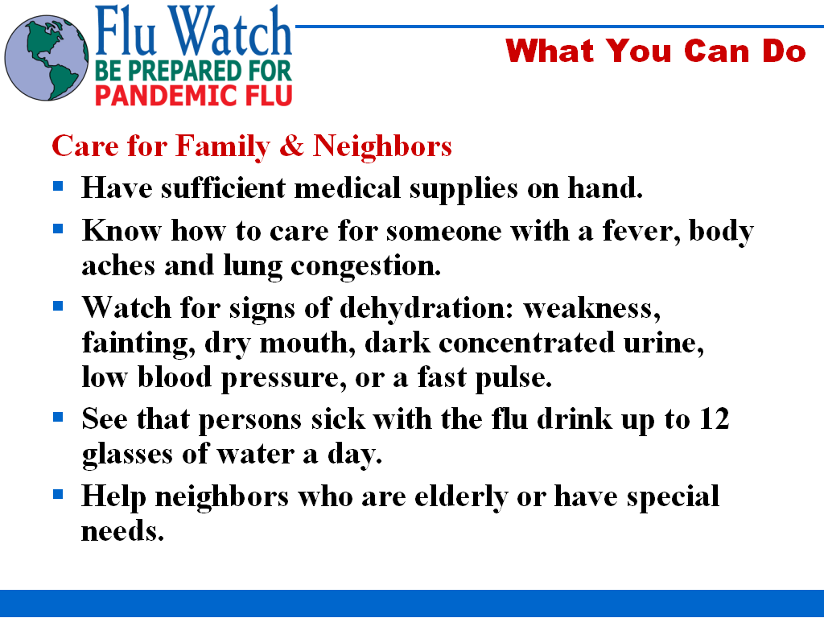

Slide 13: What You Can Do

Care for Family & Neighbors

Talking Points:

- Have a supply of cold remedies and fever reducers (ibuprofen and acetaminophen)

- Consult with your physician on what medications you can and can not take if you have the flu

- Stock up on at least 2 weeks’ worth of water (at least 1 gallon per person each day)

- Identify family, friends, and neighbors who have special needs and may need your help during a pandemic
  - Talk to them about preparedness
  - Discuss with them what their needs are and how to plan for these needs during a pandemic

Online Resource:
American Red Cross: Home Care for Pandemic Flu
http://www.redcross.org/news/ds/panflu/careforothers.html
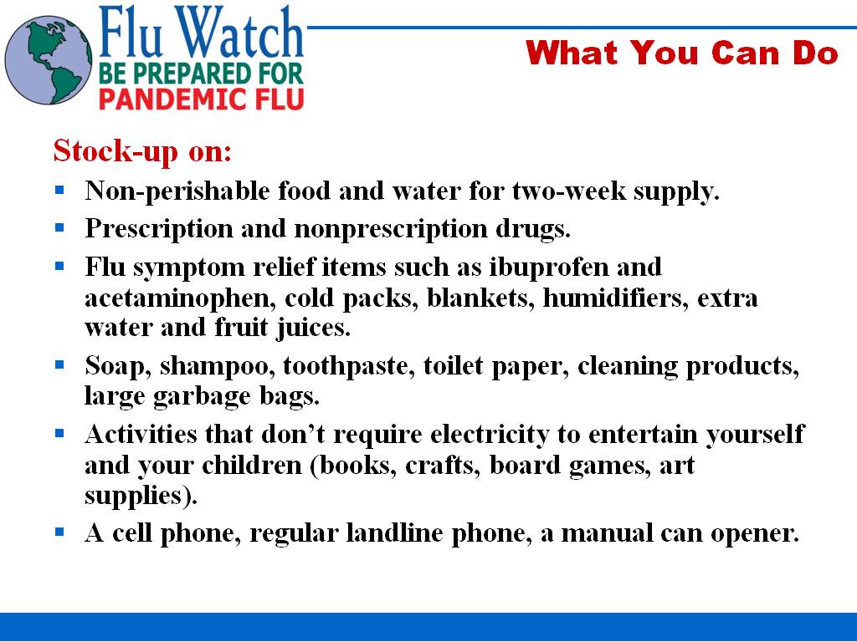

Slide 14: What You Can Do

Stock-up on:

Talking Points:

- Grocery stores may be closed so it is important to stock up on food and supplies now

- Even if grocery stores remain open, there may be limited stock and going to them may increase your chance of exposure to pandemic flu

- Store non-perishable foods and foods that require minimal cooking

- Each pandemic wave can last between two to six weeks, so store at least two weeks’ worth of food and supplies

- Discuss with your physician and pharmacist what flu medications you can use, how to obtain maintenance prescription medications, and how to properly store them

- Electricity may be interrupted and may not be immediately restored due to staffing shortages. Be sure to have activities that do not require electricity, a charged cell phone, a non-cordless landline phone, and a manual can opener.
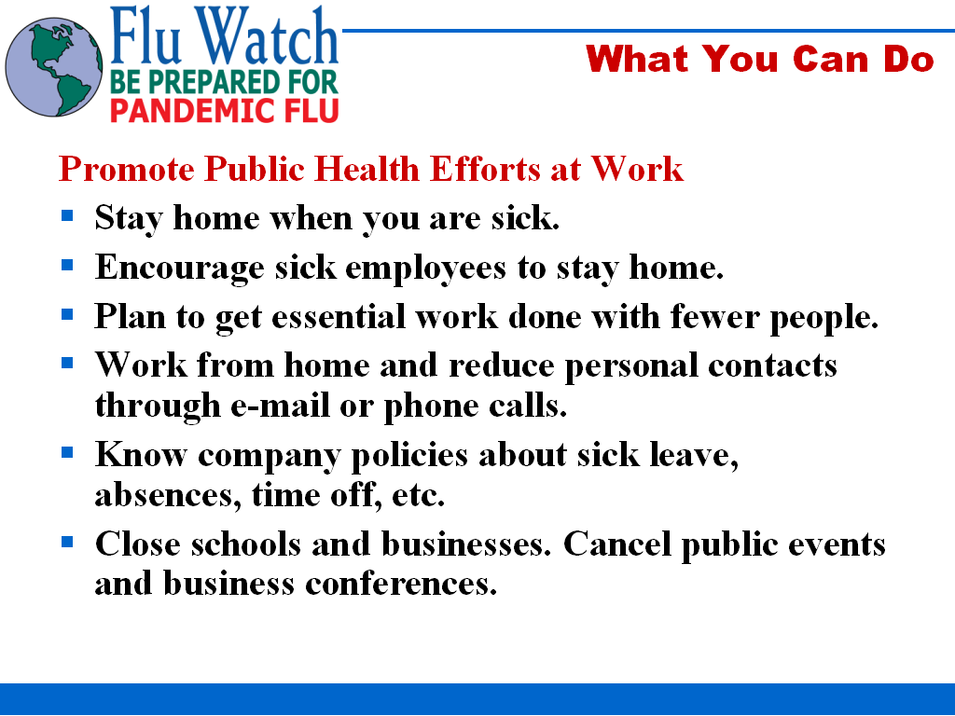

Slide 15: What You Can Do

Promote Public Health Efforts at Work

Talking Points:

- Staying home when you are sick will help prevent healthy employees from getting sick

- In a pandemic there could be 40-50% absenteeism, plan on how to get work done with fewer people

- Be ready to perform duties that you don’t normally perform. Make sure employees are cross-trained.

- Explore having employees telecommute (work from home)

- Discuss sick leave policies with your human resources office

- Employers should consider voluntarily closing their business during a severe pandemic to limit the spread of the virus
  - Closing may also be cost-effective since business may be slow and it may be more costly to operate a business if there are no customers
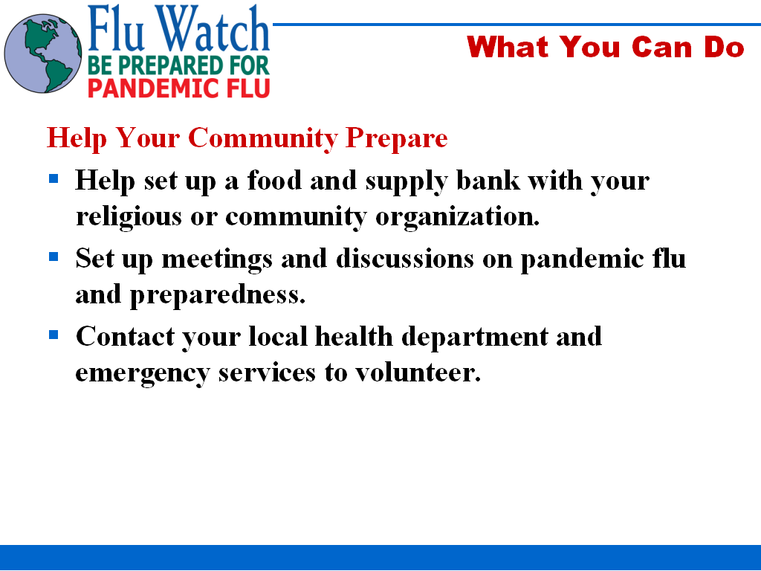

Slide 16: What You Can Do

Help Your Community Prepare

Talking Points:

- Many in your community may not have the necessary means to set aside enough provisions for their family

- Setting up a food and supply bank can serve the community in any type of emergency (hurricanes, severe flooding, etc.)

- Discuss pandemic flu at town hall meetings, school board meetings, or set up public discussions within your community

- During a pandemic, your health department may need your help. Contact your local health department to see how you can help.

