
“The workshop helped me understand that I’m not alone”.
Live Well participant

Open to people with diabetes, pre-diabetes and their support person. Class size is limited.

Call 1-800-994-9422
for locations, dates and times.


Live Well with Diabetes
Join a FREE 21/2 hour Live Well with Diabetes workshop, held each week for six weeks.

Learn from trained volunteers and professional leaders with health conditions themselves on how to better manage your diabetes.

Set your own goals and make a step-by-step plan to improve your health – and your life.





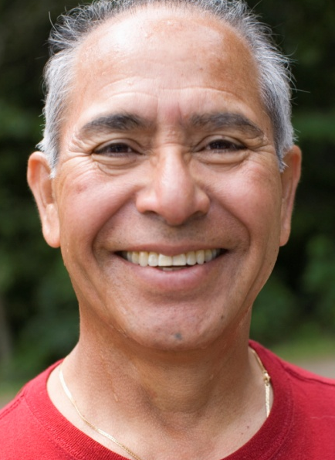



To register, get more information or find out more about the next diabetes workshop, please call 1-800-994-9422

Learn how to feel better...healthier...happier

Are you sick and tired of being sick and tired?
There is help!
You don’t have to stop doing the things you love to do. The key to getting the most out of life is learning to manage your symptoms.
Live Well with Diabetes will help you control your diabetes so it does not control you!
Live Well is the Connecticut version of the Stanford University evidence based program.
If you have Diabetes, this course could make all the difference. A caregiver or relative is welcome to attend with you. They too will benefit.

How does it work?
Attend the 2 1/2 hour sessions once a week for 6 weeks.
Live Well with Diabetes will help you learn how to:

- Manage blood sugar

- Communicate better with your healthcare professional

- Care for your feet

- Manage sick days

- Fight fatigue

- Build your confidence

- Eat healthy

- AND MORE!

