Executive Summary (EXSUM)
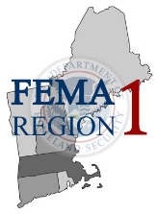 | Date: 11/13/2019 Time: 12:00 EST  Location(s): New England-Wide  Incident: Energy Sector Cyber and Physical Attacks / Extreme Cold  Regional Response Posture: R1 Level I  WebEOC Incident Name: Exercise – EPPI (GridEx) – 2019-11-13  Report Produced By: John Smith  Contact Email: smith.john@fema.gov

EVENT MAP
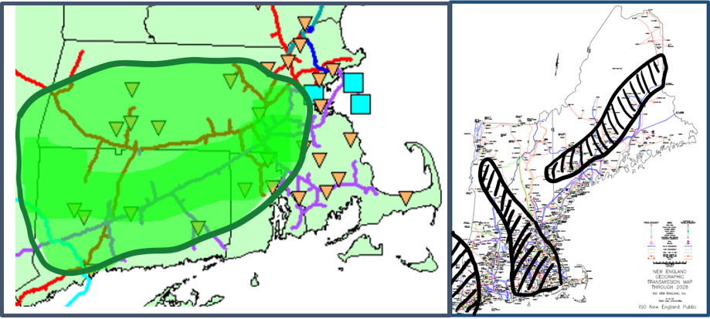

Incident Overview
Opening Remarks
FEMA Region 1 is currently operating at Level – I, assisting all states within the Region. FEMA Region 1 is monitoring Connecticut, Massachusetts and Rhode Island response to attacks to the gas and electrical infrastructure and associated loss of services to residents. The New England Region also continues to experience record cold temperatures, with multiple sheltering efforts are on-going.
Situation Update
As of 12:00 EST, FEMA Region 1, has been receiving numerous reports of cyber related attacks on the gas infrastructure across the region, causing large amounts of loss of services to the gas infrastructure. Loss of gas has caused rolling black outs in the FEMA Region 1 area. As of 10:00 EDT, DHS has reported that the Nation State of Krasnovia has infected energy sector computer networks with APT123.
Multiple sectors in FEMA Region 1 are requesting aid for assistance from FEMA Region 1 and FEMA Headquarters.

Regional Response Actions
Regional Priorities
Our Regional priorities are and focused on:
  - Maintaining situational awareness
  - Identification and coordination of potential unmet needs
  - Response and staging of commodities and teams, as well as resources and capabilities
  - Coordination with State Agencies restoring critical lifelines.
Current O-Period Objectives
Our Regional priorities are and focused on:
  - Maintaining situational awareness, response to cyber and physical related attacks, and assistance to Region 1 States
  - Identification and coordination of potential unmet needs
  - Response and staging of commodities and teams, as well as resources and capabilities.
  - Coordination with State Agencies restoring critical lifelines.
State Operations
SEOC Status |  | IMAT | LNO |  | Declaration Status |  | Request In Process
Connecticut: Level I |  | ☐ | ☐ |  | Connecticut: In Process |  | ☒YES ☐NO
Maine: Level II |  | ☐ | ☐ |  | Maine: None |  | ☐YES ☒NO
Massachusetts: Level I |  | ☐ | ☐ |  | Massachusetts: In Process |  | ☒YES ☐NO
New Hampshire: Level II |  | ☐ | ☐ |  | New Hampshire: None |  | ☐YES ☒NO
Rhode Island: Level I |  | ☐ | ☐ |  | Rhode Island: In Process |  | ☒YES ☐NO
Vermont: Level II |  | ☐ | ☐ |  | Vermont: None |  | ☐YES ☒NO
Regional Operations
RRCC Activation Level
LEVEL I
ESFs Activated
ESF 1: ☐ | ESF 4: ☒ |  |  | ESF 7: ☒ |  | ESF 10: ☒ |  | ESF 13: ☒
ESF 2: ☒ | ESF 5: ☒ |  |  | ESF 8: ☒ |  | ESF 11: ☐ |  | ESF 14: ☐
ESF 3: ☐ | ESF 6: ☒ |  |  | ESF 9: ☐ |  | ESF 12: ☒ |  | ESF 15: ☐
DCE: ☐ | Other: |  |  | Other: |  | Other: |  | Other:

Activated Staging Area | Activated Responder Base Camp
Westover AFB  255 Padgette St.  Chicopee, MA 01022  Hours of Operation: 24 Hrs/Day | Fort Devens  61 Quebec Street  Devens, MA 01434  Hours of Operation: 24 Hrs/Day

Lifeline Updates
List as Potential Impact, Actual Impact, or Response Action
 | Health and Medical
 | Potential Impact: Increased numbers of Medical Facilities could be impacted if large scale energy infrastructure is compromised.
 | Potential Impact:
 | Actual Impact: Charlotte Hungerford Hospital in CT has notified the State the requirement that evacuations of the facility are inevitable.
 | Actual Impact:
 | Response Action: Assets for evacuation of hospitals are being routed to staging areas within the affected states.
 | Response Action: Monitor request for resources, pre-stage if necessary resources that would be required
 | Transportation
 | Potential Impact: Potential for energy sector failure could impact mass transit, to include rail and busses.
 | Potential Impact:
 | Actual Impact: Unknown impact of rolling black-outs on the transportation system, more field information is required.
 | Actual Impact:
 | Response Action: Coordination with States on potential need for assistance.
 | Response Action:
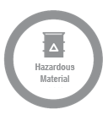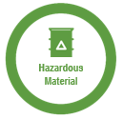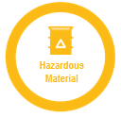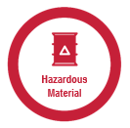 | Hazardous Waste
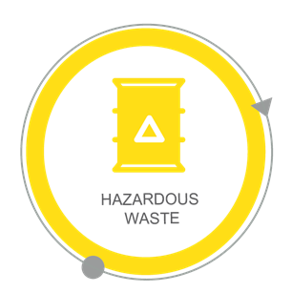 | Potential Impact:
 | Potential Impact:
 | Actual Impact: Numerous gas calls throughout the region has notably taxed local fire services regarding response to calls for service.
 | Actual Impact:
 | Response Action:
 | Response Action: Hazardous Materials teams throughout the Region are being staged based on the threat of gas leaks and mitigation need.
 | Communications
 | Potential Impact:
 | Actual Impact: Loss of telemetry systems in the energy sector from cyber-related attacks on the gas sector, not enough intel is available for assistance.
 | Actual Impact: Phone systems are compromised in CT and more information is needed for response.
 | Actual Impact: Intrusion into the market system has been noted, unsure if the market will be effected.
 | Response Action: Determine logistics and availability of back-up communication support
 | Response Action:
 | Safety and Security
 | Potential Impact: Physical and Cyber-attacks could impact the delivery of regional law enforcement and homeland security
 | Potential Impact: Local Law Enforcement could be taxed as patrols are increased.
 | Actual Impact: Law Enforcement is responding to numerous reports of both unmanned and manned aircraft in the energy sector, using large amounts of resources
 | Actual Impact: Fire Services have been taxed for calls for services with numerous gas metering calls.
 | Response Action: Pre-Authorize ESF-13 for mutual aid to FEMA Region 1
 | Response Action: States are calling back second and third shifts to assist with increase in law enforcement activity.
 | Food, Water, Shelter
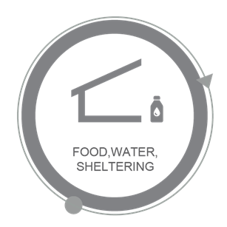 | Potential Impact: Long-term cold could increase the need of sheltering and warming shelters. Regional resources may be required.
 | Potential Impact:
 | Actual Impact: Regional increase in requests for assistance in warming shelter assistance, becoming an unknown impact as increasing energy sectors lost.
 | Actual Impact: Hospitals and Life Safety Facilities are affected where unknown status of electrical reserves are in question.
 | Response Action: Determine the availability of sheltering asset to assist FEMA Region 1, and deploy forward.
 | Response Action:
 | Energy (Power & Fuel)
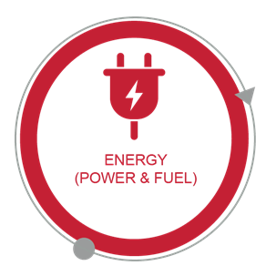 | Potential Impact:
 | Potential Impact:
 | Actual Impact: The Tennessee Gas Pipeline has been compromised from cyber-attacks and has caused loss of service and pressure to North Western Connecticut and parts of Eastern Massachusetts. Loss of gas services has hindered the ability of heating for residents within the region.
 | Actual Impact: Electrical outages are reported throughout the Region causing service interruptions to the commercial and residential customers.
 | Response Action: Mutual Aid gas services for restoration of the pipelines within the region are being deployed forward.
 | Response Action: Mutual Aid electrical services for restoration are being deployed forward for assistance throughout the region.

Limiting Factors and Potential Future Requirements
List as Unmet Need, Limiting Factor or Anticipated Future Requirements
Limiting Factor: Lack of complete information on all fronts.
Limiting Factor: Large-Scale infrastructure compromise and lack of complete intelligence of attacks.
Potential Future Requirements: Assistance with infrastructure integrity both physical and virtual. Numerous requests for assistance are expected as situation escalates.
Unmet Need: Mutual aid for restoration of electrical and gas systems throughout FEMA Region 1.

