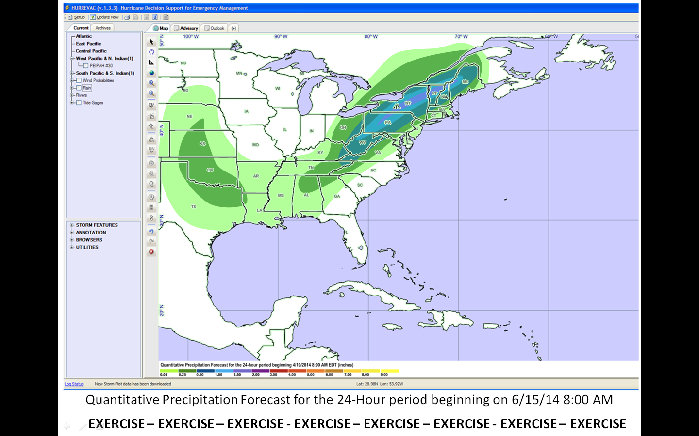

24-Hour Precipitation Forecast

Another slow moving cold front will approach Southern New England during the next 24 hours. Most of the heavy rainfall is expected to stay to our North and West across New York State and PA. 0.25” – 0.50” in Connecticut.