State of Connecticut

Vaccination Site Planning and Checklist

Template

Provided by the CT Department of Emergency Services and Public Protection/Division of Emergency Management and Homeland Security, in collaboration with the Department of Public Health, the CT Military Department, and the Department of Transportation
January 27, 2021 Version 1.0

Vaccination Site Planning Overview:
Mass Vaccination Sites are selected and managed through state and local public health departments and districts working with vaccination providers, as well as with municipal and state Emergency Management and other state and local partners (EMS, police, fire, Chief Executive Officer, CT Military Department, etc..) to provide command and control and resource support for the site’s operations. When the vaccination sites are operational, command and control is structured ideally using the Incident Command System (ICS).
Smaller vaccination sites may be selected and managed by individual vaccination providers, in coordination with and the collaboration of other local, state, and private sector partners. Although this template focuses on larger scale vaccination sites, the planning concepts will be useful for any size vaccination site that may require state, local or volunteer resources or approvals to start or maintain operations.
This Vaccination Site Planning and Checklist Template is a companion document to the one-page Vaccination Site Planning Coordination Guide.

Concept of Operations
The primary purpose for a vaccination site is to provide the COVID-19 vaccine to the appropriate populations identified by the CT Department of Public Health current phase of the vaccination process. Each site may require, for example, the following operational services:
- Transportation / Traffic Control
- Registration
- Distribution of COVID-19 Vaccine
- Medical monitoring of post vaccinated patients
- Security if needed
- Snow clearance plan for winter operations
The preliminary step in setting up a COVID vaccine site is to convene a group of local, state, non-profit and private sector partners as appropriate to the potential site location. This group should include local public health, emergency management, law enforcement, fire, the local site owner or tenant, and the vaccination provider. The State Department of Public Health and the state Division of Emergency Management and Homeland Security (DEMHS) Regional Coordinator should also be notified. Other partners should be added to the group as appropriate, and may include local EMS, public works, social service agencies, Red Cross, United Way, etc…
Vaccination Site Requirements:
For each requirement identified, the group should determine:
- Where is the asset or resource coming from? Who is providing it?
- Who is paying for the resource? Has the funding source been identified?
- Who are the Points of Contact for each agency or entity involved?
- Who is the site “Incident Commander,” i.e., the individual overseeing the whole operation?
- How long is the facility going to be open, per day, per week or longer? What is our staffing and resource plan for each day? If the facility is going to be open for multiple days, for how long will current staff and resources be available?
- Who is responsible for creating any required external communications for the site?
Both personnel and physical resources should be procured at the local level or through the vaccine provider. If those resources are overwhelmed, a request for assistance can be made through the DEMHS Regional Coordinator to be posted on Web EOC, the state’s system for maintaining real-time situational awareness, including requests to the state for assistance.
Special note for facility selection: if the site that is selected is State of Connecticut-owned (Commuter Lots, Parking Garages, etc.), the CT Department of Administrative Services must be notified, as well as the CT Department of Transportation, which must do a review of the site for review of traffic operations. Sites that are on a State of Connecticut road, site operators are asked to work with Conn DOT to adjust operations to avoid traffic congestion.
Personnel Requirements:
In order to set up a mass vaccination site, the group must determine the number of individuals needed to run the site. Personnel categories include the following:
- Healthcare professionals authorized to provide vaccinations
- Healthcare staff (for example, medical/pharmacy techs, medical/ pharmacy students, medical/pharmacy residents, etc…) with knowledge about vaccines, experience handling vaccines, experience preparing vaccine doses, knowledge of signs of adverse reactions etc…
- Non-medical personnel to fill a variety of roles, which may include:
  - Traffic control
  - Checking people in
  - Security
  - Multi lingual and other communications skills
  - Information Technology (IT) skills

Worker Protection:

Personal Protective Equipment (PPE) PPE should be provided in accordance with state and federal law. PPE will be defined by guidelines from the CDC and CT Department of Public Health.

Facility Requirements:
The facility selected to serve as a Vaccination Site needs to have an infrastructure to facilitate vaccine operations and adequate space. The site should have ample separate parking capable of accommodating buses if necessary, emergency apparatus, and cars/vans/trucks. Considerations for the location may include that the site:
- Be accessible and equipped to provide services for persons with access or functional needs and disabilities
- Be capable of being accessible for required service periods (12 hours)
- Be able to support the use of its parking area – ideally a paved space allowing for proper drainage and snow clearing eliminating safety concerns.
- Have Internet access
- Provide adequate lighting and heating
- Have easy to clean floors
- Have restrooms, with adequate handwashing locations
- Have adequate and appropriate spacing to accommodate designated throughput routes for vaccinated persons
- Be close to major population centers/Interstate / Highways/Public Transportation
- Be accessible to vulnerable / underserved populations – ideally accessible by public transportation
- Logistically support operations, including signage such as:
  - Entrances and exits
  - Locations of restrooms
  - Flow of people in the facility
  - Designated registration, clinic locations etc…
  - Outdoor location signs, times of operation, traffic flow etc….
- Have required Air Flow Rates
- Have outdoor air intake ability
- Is able to accept Tents, Trailers, Tie Downs, and Concrete Barriers/blocks (Outdoor Facility)
- Obtain any applicable CT DPH Licenses, including FLIS if necessary
- Has the ability to meet appropriate cleaning/sanitizing requirements

Planning Considerations and Recommendations:
In order to maintain a steady flow of people receiving the vaccinations, it is recommended that the Operations Section Chief (person running the internal operations of the facility) appoint a Flow Monitor who can adjust staffing at the various locations in the facility to remedy “bottlenecks” when they occur.

Staffing Pattern/ Incident Command System Structure:
It is recommended that, to the extent possible, an ICS structure be used to maintain appropriate leadership, staffing and span of control over staff members (usually 5 – 7 staff members to each manager position.) The recommended staffing for each station is to be multiplied by the number of vaccination lines required to achieve the designated throughput of distributed vaccines.

Suggested Responsibilities Matrix--The following chart provides examples of roles for local, state and private sector entities, departments and agencies, depending on site size:
JOB FUNCTION | BRANCH | AGENCY (Suggested Agency)
Incident Commander | Both medical and operational oversight needed | TBD
Operations Section Chief | This person would be in charge of the operations of the facility | TBD
Transportation Supervisor | Transportation –External Traffic Control | TBD (Local Police Officer, CERT Team member, or contracted parking attended)
Transportation Attendant | Transportation | TBD (Local Police Officer, CERT Team member, or contracted parking attended)
Registration Supervisor | Registration | TBD (CERT Team member, Non- Medical MRC Member, VOAD, or volunteer agency, National Guard*)
Registration Attendant | Registration | TBD (CERT Team member, Non- Medical MRC Member, VOAD, or volunteer agency, National Guard*)
Vaccine Distribution Supervisor | Vaccine Distribution | TBD (Site Sponsor employee, contracted vaccinator [DPH Staffing Guide], MRC Team Member, Local Vaccine Volunteers, National Guard*)
Vaccinator | Vaccine Distribution | TBD (Site Sponsor employee, contracted vaccinator [DPH Staffing Guide], MRC Team Member, Local Vaccine Volunteers, National Guard*)
Post Vaccination Monitoring Supervisor | Monitoring | TBD (Site Sponsor employee, Trained CERT Member, MRC Team Member, Local Vaccine Volunteers, National Guard*)
Post Vaccination Attendant | Monitoring | TBD (Site Sponsor employee, Trained CERT Member, MRC Team Member, Local Vaccine Volunteers, National Guard*)
* National Guard personnel are for supplemental purposes after all other resources are exhausted.

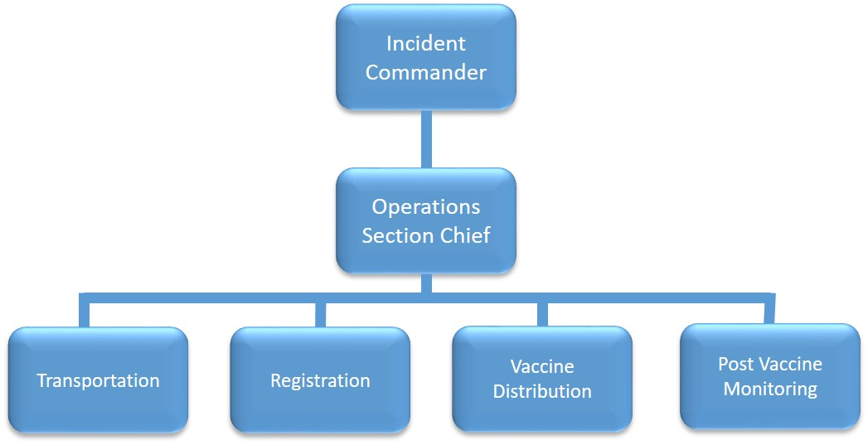

Suggested Station Services and Procedures:
The following is an overview of potential services and procedures, particularly for a mass vaccination site. Please refer to DPH and other public health guidance for details.
Station: | Transportation
Responsibilities: | Provides flow of vehicles and people to complete vaccination process.
Minimum Estimate of People Required for this Station: |  |  |  |  | #
Position Name: | Transpiration Supervisor | Reports To: | Operations Chief | # of Persons | #
Position Name: | Transportation Attendant | Reports To: | Transportation Supervisor | # of Persons | #

The Transportation Station is a dynamic station where assistance is given to the flow of traffic from patients arriving and leaving from the vaccination site. This is a coordinated effort; potentially several agencies that are assisting with the flow of vehicles and people at the vaccination site. Transportation must be flexible to accommodate an interior or exterior vaccination operation.

NOTE: Members of the Transportation Station are suggested to have training in traffic control, such as CERT members, law enforcement or other agencies.

Station: | Registration
Responsibilities: | Provides registration of patients to be vaccinated
Minimum Estimate of People Required for this Station: |  |  |  |  | #
Position Name: | Registration Leader | Reports To: | Operations Chief | # of Persons | #
Position Name: | Data Entry | Reports To: | Registration Leader | # of Persons | #

Registration Specialist will assist patients with the registration process for receiving vaccines. Once registration is completed, staff will direct them to the vaccination distribution station.
Station: | Vaccine Distribution
Responsibilities: | Administers COVID-19 Vaccine
Minimum Estimate of People Required for this Station: |  |  |  |  | #
Position Name: | Vaccine Distribution Leader | Reports To: | Operations Chief | # of Persons | #
Position Name: | Immunization Specialist * | Reports To: | Vaccine Distribution Leader | # of Persons | #
Position Name: | Bi-Lingual Staff Member | Reports To: | Vaccine Distribution Leader | Recommended
* Licensed Medical Professionals, with CT DPH approval to conduct vaccinations.
Members of the COVID-19 Distribution Station will administer the supplied vaccine to the registered patients from the Registration Station. Vaccines will be administered following manufacturer recommendations and guidance from CT DPH, and CDC. Upon completion of vaccination, the appropriate paperwork is completed and a time is marked to reflect vaccination time and patient is forwarded to the Post Vaccination Monitoring Station.
Station: | Post Vaccine Monitoring
Responsibilities: | Monitors Vaccinated Patients
Minimum Estimate of People Required for this Station: |  |  |  |  | #
Position Name: | Vaccination Monitoring Leader | Reports To: | Operations Chief | # of Persons | #
Position Name: | Vaccination Monitoring Attendant | Reports To: | Vaccine Monitoring Leader | # of Persons | #

Upon arrival of the vaccinated patient, the vaccination-monitoring attendant will identify the vaccination time that is clearly marked by the vaccine distribution specialist. Using the provided clock/timer, the attendant will monitor the recently vaccinated patients for the recommended waiting period. Attendants will monitor for signs and symptoms of anaphylaxis, or severe allergic reaction. After the allotted waiting time, the attendant(s) will direct the patient to leave the vaccination site.

NOTE: Members of the Post Vaccine Monitor Station should be trained to a minimum of requirements set by state Department of Public Health, including appropriate training in the identification of severe allergic reactions.

Important Contact Numbers and E-mail Addresses
Position | Name | Cell Phone Number | E-mail Address
Vaccine Provider Entity POC
Owner/Tenant of Site POC
CT DPH – Emergency Preparedness
CT DEMHS Region X Coordinator
Local Emergency Management Director
Police Chief
Fire Chief
Public Health Director
EMS Chief
Public Works
Social Services/Human Services
CERT Leader
MRC Leader
Hospital Emergency Manager

Vaccination Site Equipment and Use
Item | Vendor | Use | Quantity
Signs incl. Variable Message Signs
Traffic Cones
Loud Speakers
Freezer
Tables/Chairs/Medical Partitions
Computers
Clock/Timer
Vaccine Supplies
PPE and sanitation materials
Medical/ non-med waste containers
CO Detectors (outdoor facilities
Signage for current vaccine phase
Touchless Appliances
CO Detectors (Outdoor Facilities)

