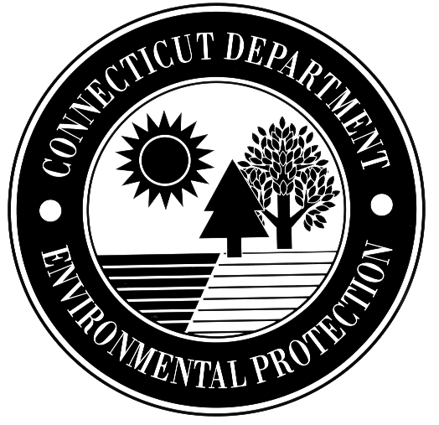
STATE OF CONNECTICUT
DEPARTMENT OF ENVIRONMENTAL PROTECTION
BUREAU OF NATURAL RESOURCES

Application for Fur Buyer’s License

DEP USE ONLY
Permit No.
Deposit Ref.

Part I: Applicant Information
1. Name and address of applicant:
Name:
Mailing Address:
City/Town: State: Zip Code:
Business Phone: ext. Fax:

- If application is being made for a license as Authorized Agent, list the name and address of the Resident Fur Buyer for whom the agent will act.
Name:
Mailing Address:
City/Town: State: Zip Code:
Business Phone: ext. Fax:

Part II: Fee Information
The application fee for the Fur Buyer’s License is $55.00

Part III: Certification
“I hereby make application for a license to engage in the business of buying raw furs produced in the State of Connecticut. I will produce my license for examination upon request of any Conservation Officer or other official authorized to serve criminal process. I agree to furnish a report of activities in such form as prescribed by the Connecticut Department of Environmental Protection. I also certify that this application is on complete and accurate forms as prescribed by the commissioner without alteration of the text.
I declare, under the penalties of false statement, that the submitted information is true, accurate and complete to the best of my knowledge and belief.”

Signature of Applicant |  | Date
Name of Applicant (print or type) |  | Title (if applicable)
Please make check payable to the Department of Environmental Protection. Mail completed application and fee to:
Department of Environmental Protection
License and Revenue Unit
79 Elm Street
Hartford, CT 06106-5127

