

Department of Energy & Environmental Protection

Bureau of Materials Management & Compliance Assurance
79 Elm Street - 4th Floor

Hartford, Connecticut 06106-5127

Annual Municipal Recycling Report
For FY 2024-2025

This report regarding municipal recycling activity for the previous fiscal year is required to be submitted by September 30th of each year to the Connecticut Department of Energy & Environmental Protection (DEEP) -CGS Sec 22a-220(h).
(PLEASE SUBMIT THIS FY2025 REPORT NO LATER THAN NOVEMBER 30, 2025)

Parts 1 through 5 can be completed and submitted to the CT Department of Energy & Environmental Protection via any one of the following methods
- Fax (860) 424-4059 Attn: Solid Waste Facility Reporting- Paula Guerrera; Or
- Scanned & E-Mailed To Paula.Guerrera@ct.gov (Do not send hard copy if sending electronically); Or
- Land-Mailed to CT DEEP; Bureau of MM&CA – Recycling Office; 79 Elm Street - 4th Floor; -Hartford, CT 06106-5127; Attn: Solid Waste Facility Reporting- Paula Guerrera.
  - Must be double-sided and preferably on paper with a minimum 30% post-consumer content.
  - PLEASE CONSERVE PAPER – Do not send unused pages or sections. Indicate (at bottom of this page) the total number of pages in your report.

Questions? Please visit the CT DEEP Website, contact Paula Guerrera (860) 424-3334.

1.
Name of City/Town

Mailing Address: Zip Code

2. Recycling Contact: Name:

Title:

Phone #: Fax #: Email:

- Reporting Period: July 1, 2024 through June 30, 2025

Number of Pages in This Report:

PART 1: Materials Recycled from Residential Sources

Materials Recycled from Residential Sources
(A)  Recyclable Item | (B)  Name/Address - First Destination for Residential Recyclables  (after the municipal transfer station or municipal compost site, if applicable) | (C)  Amount Recycled | (D)  Units of Measure
Bottles/Cans/Cartons/Paper (BCP)  - First Destination Is a  CT SW Facility  Includes Res & NonRes | Destination Name:  Town: State:  Check all that apply:  Single Stream Dual Stream Material Collected Separately | NA | NA
 | Destination Name:  Town: State:  Check all that apply:  Single Stream Dual Stream Material Collected Separately | NA | NA
Bottles/Cans/Cartons/Paper  - First Destination Is  NOT a CT SW Facility and located out-of-state  Tonnage Includes Res & NonRes | Destination Name:  Town: State:  Check all that apply:  Single Stream Dual Stream Material Collected Separately
Destination Name:
Town: State:
Check all that apply:
Single Stream Dual Stream Material Collected Separately
Storage Batteries (vehicle batteries)  Tonnage Includes Res & NonRes | Destination Name:  Town: State:
Destination Name:

Town: State:
Scrap Metal –  Tonnage Includes Res & NonRes | Destination Name:  Town: State:
Scrap Metal –  Tonnage Includes Res & NonRes | Destination Name:  Town: State:
Waste Oil (gallons)  Includes Res & NonRes | Destination Name:  Town: State: |  | Gallons
Waste Oil (gallons)  Includes Res & NonRes | Destination Name:  Town: State: |  | Gallons
Used Textiles (clothing, shoes, linens etc.)  Tonnage Includes Res & NonRes | Destination Name:  Town: State:
Electronics  Check Types Included:  CEDs (CT e-Waste Recycling Program)  Non-CEDs  Tonnage Includes Res & NonRes | Destination Name:  Town: State:
Destination Name:

Town: State:
NiCd Batteries  Includes Res & NonRes | Destination Name:  Town: State:
PLASTIC WRAP/FILM  Includes Res & NonRes | Destination Name:  Town: State:

Source-Separated Organics

If source separated organics or any products (compost, mulch, etc.) made from those organics by the municipality are sent to a CT permitted composting or recycling facility, please report the receiving facility so that the tonnage is not 2x counted. Any organic material burned (with or without energy production) cannot be counted as recycled!!!!
Incoming Leaves  1 CY=0.25 tons  Leaves are composted at municipal compost site  compost used at municipal sites compost is given or sold to residents  compost is sold or sent to a permitted composting.  Tonnage Includes Res & NonRes | Destination:  Address:
Destination:
Address:
Brush (from yard waste)  1CY(loose) = 0.15 tons  sent to a permitted composting or recycling facility  chipped and used on municipal sites  chipped and given to residents  Tonnage Includes Res & NonRes | Destination:  Address:
Grass  Grass clippings are sent to a permitted composting or recycling facility | Destination:  Address:
Yard Waste Mixed  composted at municipal compost site  compost is used on municipal sites  compost is given or sold to residents  Tonnage Includes Res & NonRes | Destination:  Address:
Destination:
Address:
Destination:
Address:
Food Scraps  Tonnage Includes Res & NonRes | Destination Name:  Town: State:
Food Scraps  Tonnage Includes Res & NonRes | Destination Name:  Town: State:
Paint  Tonnage Includes Res & NonRes | Destination Name:  Town: State:
Mattresses  Tonnage Includes Res & NonRes | Destination Name:  Town: State:
Other – Specify:  Tonnage Includes Res & NonRes | Destination Name:  Town: State:

PART 2: Materials Recycled from NON-Residential Sources

OTHER RECYCLABLES - Materials Recycled from NON-Residential Sources
(A)  Recyclable Item | (B)  Name/Address - First Destination for Other Recyclables  (after the municipal transfer station or municipal compost site, if applicable) | (C)  Amount Recycled | (D)  Units of Measure
Non-Residential Bottles/Cans/Paper | Destination Name:  Town: State:  Check all that apply:  Single Stream Dual Stream Material Collected Separately | NA | NA
Non-Residential Bottles/Cans/Paper | Destination Name:  Town: State:  Single Stream Dual Stream Material Collected Separately | NA | NA
Non-Residential  Bottles/Cans/Paper  - First Destination Is  Not a CT SW Facility | Destination Name:  Town: State:  Check all that apply:  Single Stream Dual Stream Material Collected Separately
Destination Name:

Town: State:
Check all that apply:
Single Stream Dual Stream Material Collected Separately
Other Specify Type of Recyclable::  Only Residential  Only Non-Residential  Includes Res & NonRes | Destination Name:  Town: State:
Other Specify Type of Recyclable  Only Residential  Only Non-Residential  Includes & Res & NonRes | Destination Name:  Town: State:

PART 3: Information Regarding Collectors (Haulers) of Solid Waste (SW) and Recyclables Operating Within the Borders of the Municipality
Please list below the haulers or collectors operating in your municipality and provide their contact information- including their e-mail address: (Please duplicate this page if additional space is needed.)
3A: Collector (Hauler) Contact Information
Name of Hauling Company | Mailing Address &  E-mail Address | Contact Name | Phone Number | Did Hauler Register in Your Municipality in FY2024? | Did Hauler Submit FY2024 Annual Report To Your Municipality?
 | Mailing:  E-mail: |  |  | Yes  No | Yes  No
 | Mailing:  E-mail: |  |  | Yes  No | Yes  No
 | Mailing:  E-mail: |  |  | Yes  No | Yes  No
 | Mailing:  E-mail: |  |  | Yes  No | Yes  No
 | Mailing:  E-mail: |  |  | Yes  No | Yes  No
 | Mailing:  E-mail: |  |  | Yes  No | Yes  No
 | Mailing:  E-mail: |  |  | Yes  No | Yes  No
 | Mailing:  E-mail: |  |  | Yes  No | Yes  No
 | Mailing:  E-mail: |  |  | Yes  No | Yes  No
 | Mailing:  E-mail: |  |  | Yes  No | Yes  No
 | Mailing:  E-mail: |  |  | Yes  No | Yes  No
Attach additional sheets if needed

3B: Collection Service(s) Information
Name of Hauling Company | Source of SW & RECY Hauled  Check all that apply. | Types of SW &/or RECY Hauled by the Collector  Check all that apply. | Collector Offers Subscription Service for Residential Curbside Collection of:  Check all that apply.
 | Residential  Non-Residential | MSW; Recyclables; C&D;  Yard Waste Landclearing ;  Food Scraps Special Waste  Other – Specify- | MSW  Recyclables
 | Residential  Non-Residential | MSW; Recyclables; C&D;  Yard Waste Landclearing ;  Food Scraps Special Waste  Other – Specify- | MSW  Recyclables
 | Residential  Non-Residential | MSW; Recyclables; C&D;  Yard Waste Landclearing ;  Food Scraps Special Waste  Other – Specify- | MSW  Recyclables
 | Residential  Non-Residential | MSW; Recyclables; C&D;  Yard Waste Landclearing ;  Food Scraps Special Waste  Other – Specify- | MSW  Recyclables
 | Residential  Non-Residential | MSW; Recyclables; C&D;  Yard Waste Landclearing ;  Food Scraps Special Waste  Other – Specify- | MSW  Recyclables
 | Residential  Non-Residential | MSW; Recyclables; C&D;  Yard Waste Landclearing ;  Food Scraps Special Waste  Other – Specify- | MSW  Recyclables
 | Residential  Non-Residential | MSW; Recyclables; C&D;  Yard Waste Landclearing ;  Food Scraps Special Waste  Other – Specify- | MSW  Recyclables
 | Residential  Non-Residential | MSW; Recyclables; C&D;  Yard Waste Landclearing ;  Food Scraps Special Waste  Other – Specify- | MSW  Recyclables
 | Residential  Non-Residential | MSW; Recyclables; C&D;  Yard Waste Landclearing ;  Food Scraps Special Waste  Other – Specify- | MSW  Recyclables
 | Residential  Non-Residential | MSW; Recyclables; C&D;  Yard Waste Landclearing ;  Food Scraps Special Waste  Other – Specify- | MSW  Recyclables
 | Residential  Non-Residential | MSW; Recyclables; C&D;  Yard Waste Landclearing ;  Food Scraps Special Waste  Other – Specify- | MSW  Recyclables
Attach additional sheets if needed

Please note: All collectors hauling solid waste (including recyclables) generated within the borders of your municipality are required to: (1) register annually in your municipality and (2) report annually to your municipality – CGS Sec 22a-220a(d).
The collector/hauler reporting form can be found at: www.ct.gov/DEEP/solidwastereporting or by clicking on links below:
Annual Collector/Hauler Reporting Form to be submitted to the municipalities in which the collector/hauler operates Word pdf Instructions

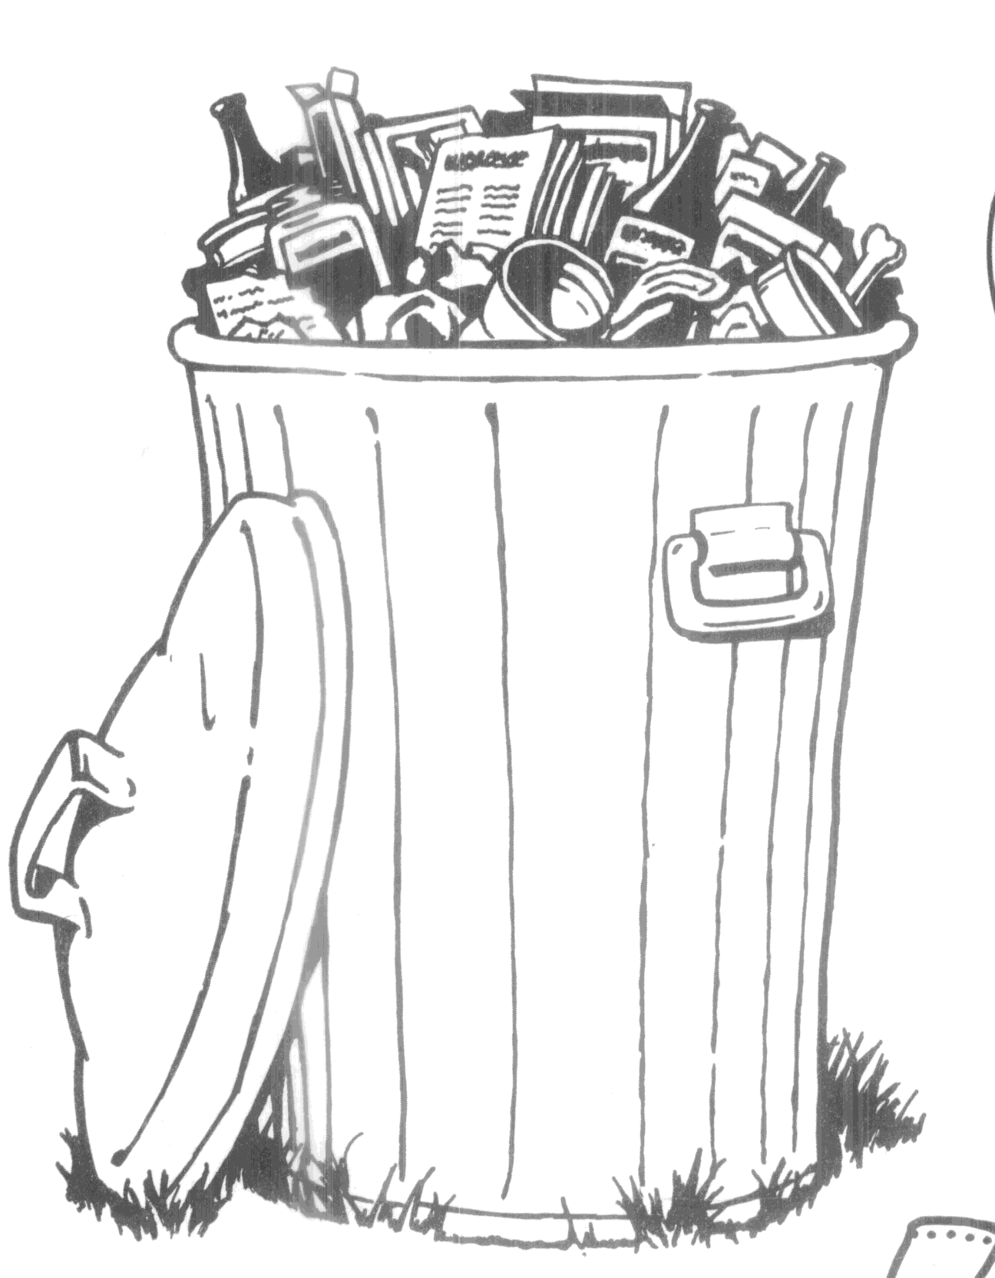 Part 4: Solid Waste Disposed (Please Report Disaster Debris Separately From Other Material)
Please indicate the first destination(s) (landfill, resource recovery facility, or regional multi-town transfer station) where solid waste generated in your town is received for disposal.
- If first destination is your municipal transfer station – report the first destination of waste sent out from your transfer station.
- If first destination is out-of-state, report (in Column C) the tonnage delivered to that facility.
  - If you are unable to get information regarding tonnage sent to that out-of-state facility, report information regarding the hauler who transported that waste out-of-state.
(A)  Type of Solid Waste Disposed | (B)  Name and Address of First Destination (i.e. Receiving Facility  (after the municipal transfer station, if applicable) | (C)  Tons this FY
MSW ¹  • First Destination Is a CT SW Facility (after the municipal transfer station, if applicable) | Destination Name:  Town: State: | NA
 | Destination Name:  Town: State: | NA
Oversized MSW¹- (furniture, mattresses, carpets, etc)  • First Destination Is a CT SW Facility (after the municipal transfer station, if applicable) | Destination Name:  Town: State: | NA
 | Destination Name:  Town: State: | NA
MSW¹  • First Destination Is Not a CT SW Facility (after the municipal transfer station, if applicable) | Destination Name:  Town: State: | Tons:
 | Destination Name:  Town: State: | Tons:
Oversized MSW¹- (furniture, mattresses, carpets, etc)  • First Destination Is Not a CT SW Facility (after the municipal transfer station, if applicable) | Destination Name:  Town: State: | Tons:
 | Destination Name:  Town: State: | Tons:
MIXED C&D - CONSTRUCTION & DEMOLITION WASTE (after the municipal transfer station, if applicable) | Destination Name:  Town: State: | Tons:
DISASTER DEBRIS (after the municipal transfer station, if applicable) | Destination Name:  Town: State: | Tons:
LAND CLEARING DEBRIS (logs and stumps) (after the municipal transfer station, if applicable) | Destination Name:  Town: State: | Tons:
¹ MSW is solid waste from residential, commercial and industrial sources; excluding hazardous, biomedical, sludge; etc.
² SPECIAL WASTE is any waste other than hazardous or radioactive waste which requires special handling for safe disposal such as sewage treatment, water treatment, and industrial sludges; fly ash and casting sands or slag; contaminated dredge spoils, etc.

‘

Part 5: Certification of Data Reported
Municipality: Reporting Period: July 1 2024 - June 30, 2025

Certification of document. This document, which is required to be submitted to the Commissioner of Energy and Environmental Protection, shall be signed by the municipal CEO or a duly authorized representative of such CEO, and by the individual(s) responsible for actually preparing such document, and each such individual shall certify in writing as follows:

“I have personally examined and am familiar with the information submitted in this document and all attachments thereto, and I certify, based on reasonable investigation, including my inquiry of those individuals responsible for obtaining the information, that the submitted information is true, accurate and complete to the best of my knowledge and belief. I understand that any false statement made in the submitted information may be punishable as a criminal offense under §53a-157b of the Connecticut General Statutes and any other applicable law.”

Municipal Recycling Contact Signature:

Signature - Municipal Recycling Contact Date

Printed Name – Municipal Recycling Contact E-mail Address

Municipal CEO Signature:

Signature Of Municipal CEO Date

Printed Name - Municipal CEO E-mail Address

Part 6: Survey Questions re Municipal Recycling Program

The Part 6 survey is currently being hosted on SurveyMonkey and a unique URL will be e-mailed to municipal recycling contacts in August. This survey contains program-specific questions related to municipal solid waste program performance and municipal compliance with basic statutory recycling requirements.

Municipalities must complete BOTH the quantitative section (Parts 1-5); AND the web-based survey section (Part 6) FOLLOWED AT A LATER DATE in order to satisfy their reporting obligation.

