A current copy of this form can be found here: Radiation (ct.gov).

CERTIFICATE OF DISPOSITION OF MATERIALS
PLEASE READ THESE INSTRUCTIONS BEFORE COMPLETING DEEP FORM 314.

RCSA 22a-153-20 establishes the radiological criteria for license terminations/decommissioning of facilities licensed as well as other facilities under RCSA 22a-153-1 and subject to CGS section 22a-148 and RCSA sections 22a-153-1 to 22a-153-150, inclusive. See the current volumes of the NUREG-1556 Technical Report Series (“Consolidated Guidance About Materials Licenses”) for guidance. A copy of this guidance can be found here: NRC.gov. Print or type unless otherwise noted. Double-sided printing is preferred.

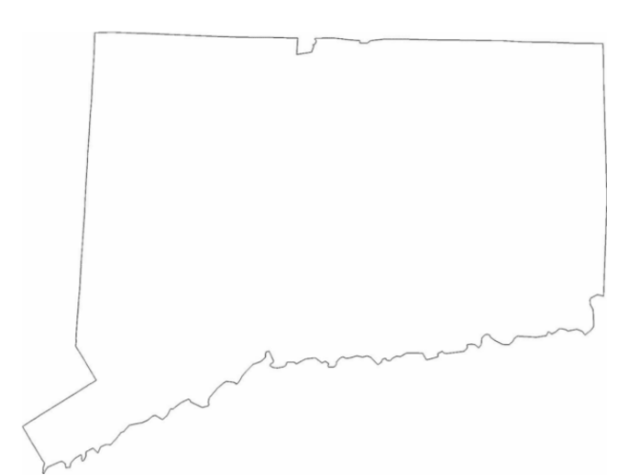

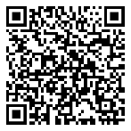
Affirmative Action, Equal Employment Opportunity and Americans with Disabilities
The Connecticut Department of Energy and Environmental Protection is an Affirmative Action/Equal Opportunity Employer that is committed to complying with the requirements of the Americans with Disabilities Act (ADA). Please contact us at (860) 418-5910 or deep.accommodations@ct.gov if you: have a disability and need a communication aid or service; have limited proficiency in English and may need information in another language; or if you wish to file an ADA or Title VI discrimination complaint.
Radioactive Materials Program
Radiation Division
State of Connecticut Department of Energy and Environmental Protection
79 Elm Street
Hartford, CT 06106

SUBMIT CERTIFICATES TO:
INSTRUCTIONS
Section B Item 2.
Licensees should describe the specific radioactive material transfer actions. If radioactive wastes were
generated in terminating this license, the licensee should describe the disposal actions taken, including the disposition of low-level radioactive waste, mixed waste, greater-than-Class-C waste, and sealed sources.
Section B Item 2.a.
The information provided concerning the transfer of radioactive material to another licensee should specify the date of the transfer, the name of the licensee recipient, an individual contact name and telephone number for the licensee recipient, and the recipient's license number.
Section B Item 2.b.
For disposal of radioactive materials, licensees should describe the specific disposal method or procedure (e.g., decay-in-storage). For those cases when radioactive materials are disposed of by a licensed disposal site or by a waste contractor, the licensee should specify the name, address, and telephone number of the licensed disposal site operator or waste contractor.
Section B Item 2.c.
"Residual radioactivity," as defined in 10 CFR 20, means radioactivity in 'areas' (structures, materials, soils, etc.) remaining as a result of activities (licensed and unlicensed) under the licensee's control from sources used by the licensee, excluding background radiation.
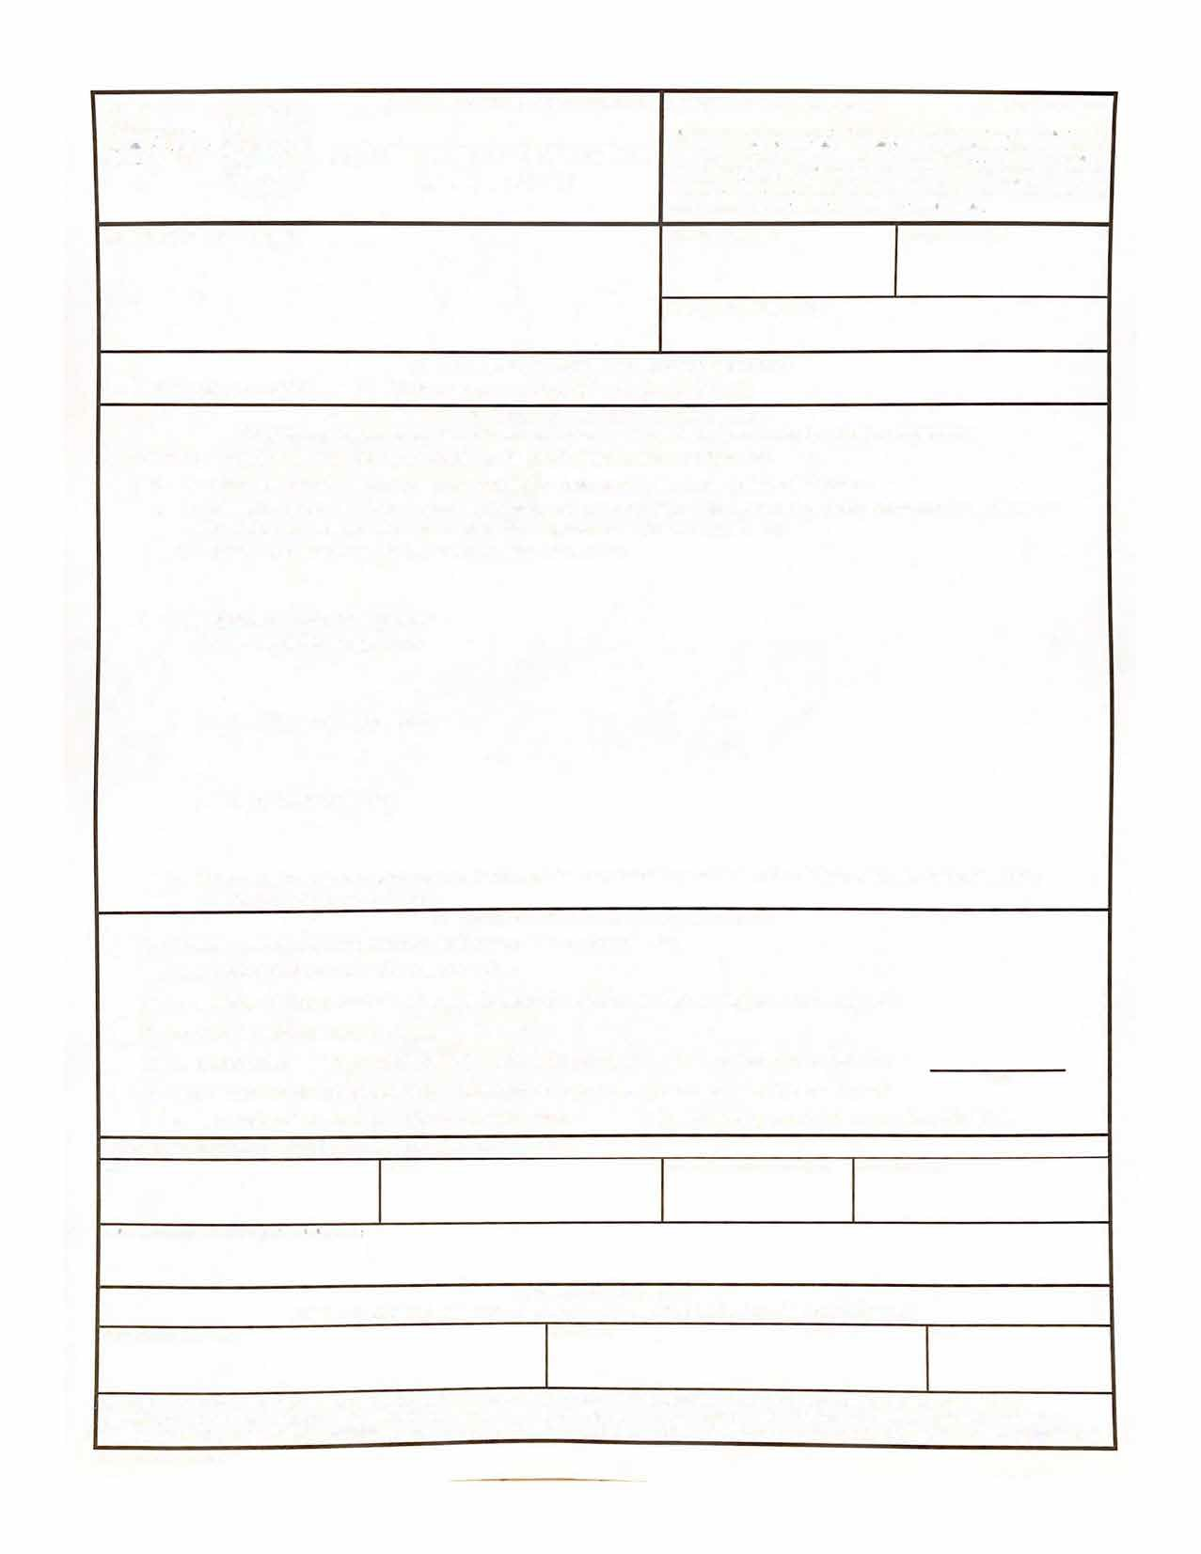
DATE
I certify the submitted information is true, accurate and complete to the best of my knowledge and belief and is on complete and accurate forms as prescribed by the commissioner without alteration of text.
SIGNATURE *
TELEPHONE (Include Area Code) E-MAIL ADDRESS
CERTIFICATE OF DISPOSITION OF MATERIALS
C. CERTIFYING OFFICIAL
TITLE
NAME
PRINTED NAME AND TITLE

LICENSE EXPIRATION DATE
A. LICENSE STATUS (Check the appropriate box)
B. DISPOSAL OF RADIOACTIVE MATERIAL
(Check the appropriate boxes and complete as necessary. If additional space is needed, provide attachments)
The licensee, or any individual executing this certificate on behalf of the licensee, certifies that:

A current copy of this form can
DEEP FORM 314
(08-2025)

be found here: Radiation (ct.gov).
STATE OF CONNECTICUT DEPARTMENT OF ENERGY AND ENVIRONMENTAL PROTECTION

DEEP-RAD-FORM-314 (08-2025)
LICENSE NUMBER
LICENSEE NAME AND ADDRESS

This license has not yet expired; please terminate it.

This license has expired.

No radioactive materials have ever been procured or possessed by the licensee under this license.
All activities authorized by this license have ceased, and all radioactive materials procured and/or possessed by the licensee under this license number cited above have been disposed of in the following manner.
a. Transfer of radioactive materials to the licensee listed below:
b. Disposal of radioactive materials:
1. Directly by the licensee:
c. All radioactive materials have been removed such that any remaining residual radioactivity is within the limits of RCSA 22a-153-20.
2. By licensed disposal site:
3. By waste contractor:

- A radiation survey was conducted by the licensee. The survey confirms:

C. SURVEYS PERFORMED AND REPORTED
a. the absence of licensed radioactive materials

b. that any remaining residual radioactivity is within the limits of RCSA 22a-153-20.
2. A copy of the radiation survey results:
a. is attached; or b. is not attached (Provide explanation); or c. was forwarded to DEEP on:
Date
3. A radiation survey is not required as only sealed sources were ever possessed under this license, and
a. The results of the latest leak test are attached; and/or b. No leaking sources have ever been identified.

The person to be contacted regarding the information provided on this form:

* BY ENTERING MY NAME ABOVE, I AGREE THAT I AM PROVIDING MY LEGAL SIGNATURE, AND AM LEGALLY BOUND BY THE CERTIFICATIONS ABOVE.”

WARNING: FALSE STATEMENTS IN THIS CERTIFICATE MAY BE SUBJECT TO CIVIL AND/OR CRIMINAL PENALTIES. DEEP REGULATIONS REQUIRE THAT SUBMISSIONS TO DEEP BE COMPLETE AND ACCURATE IN ALL MATERIAL RESPECT. IN ACCORADANCE WITH THE PROVISIONS SECTION 22a-6, SECTION 53A-157B, AND SECTION 22A-158C OF THE CONNECTICUT GENERAL STATUTES AND IN ACCORDANCE WITH ANY OTHER APPLICABLE STATUTE, MAKES IT A CRIMINAL OFFENSE TO MAKE A WILLFULLY FALSE STATEMENT OR REPRESENTATION TO ANY DEPARTMENT OR AGENCY OF THE STATE OF CONNCETICUT TO ANY MATTER WITHIN ITS JURISDICTION.
Mail all future correspondence regarding this license to:

