For Immediate Release
January 23, 2025

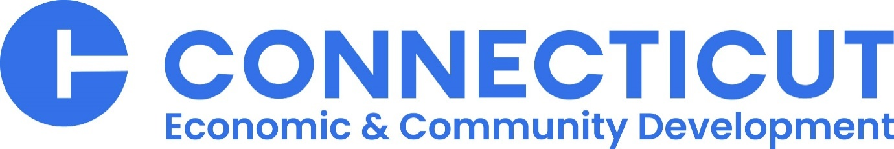

DECD Announces Selection of Three Finalist Teams Under the Connecticut Innovation Clusters Program

(HARTFORD, CT) – The Connecticut Department of Economic and Community Development (DECD) today announced it has selected three finalist teams for ultimate funding consideration under the state’s $100 million Innovation Clusters Program.
Launched last year, the Innovation Clusters Program was created to support growth in critical sectors of the Connecticut economy. The program will leverage private and public investment to support the application of next-generation technologies, such as artificial intelligence and quantum computing, to accelerate innovation in Connecticut’s high-growth clusters.
DECD issued a request for information (RFI) on June 3, 2024, and received 32 submittals, which were reviewed and evaluated. Three finalist teams were formed by aligning compatible RFI respondents and are now invited to move forward in the RFP process. Each team must submit fully defined project proposals to the department by April 15, 2025.
Once received, DECD will conduct an in-depth review of the three submittals to determine how much, if any, funding each project will receive under the $100 million program. Each submission is required to have at least a dollar-for-dollar match of non-state funding. Final awards are expected to be announced in June.
“Innovation Clusters aims at strong public-private partnerships that incorporate novel technology and innovation in ways that will be truly transformative at the local level for Connecticut’s core industry sectors. We received a strong batch of initial responses, and we look forward to reviewing the final proposals,” said DECD Commissioner and Chief Innovation Officer Daniel O’Keefe. “The Innovation Clusters Program is one component of Governor Lamont’s broader strategy to strengthen our innovation economy and partner with the private sector to create jobs, boost vibrancy, and build dynamic ecosystems that benefit workers, entrepreneurs, and companies alike.”
The three project teams are:

AI Innovation Institute
Project team includes the CIC, UConn, City of Stamford, Stamford Downtown Special Services District.
The AI Innovation Institute is proposed to be a destination for startup acceleration, workforce training, and technology programming centered around the fast-growing Connecticut industries including fintech, artificial intelligence and cybersecurity. UConn would launch the AI Innovation Institute with a state-of-the-art supercomputing platform and a world-class faculty director. Proposed public infrastructure improvements will strengthen the connectivity between the Stamford Transportation Center, downtown Stamford and the UConn Stamford building located at 1 University Place. The AI Innovation Institute aims to advance AI technology in a manner that enhances efficiency, security and customer experience, ultimately fostering a more inclusive and competitive innovation ecosystem that will benefit Connecticut’s core economic sectors. The application envisions approximately 800,000 square feet of space including residential and commercial real estate development within a half-mile of the Stamford Transportation Center.

Connecticut Center for Applied AI
Project team includes the CT Center for Advanced Technology, CIC, City of Hartford, RMS Companies and expressions of interest from eight higher education institutions and seven major corporate partners.
The Connecticut Center for Applied AI is proposed as a vibrant, urban campus anchoring the emerging digital innovation, workforce, and data analytics capabilities spread across the universities, companies and citizens of Connecticut’s capital city. The mission of this center would be to apply the leading edge of vetted, commercial grade generative and analytical AI solutions to real-world, thoughtfully designed challenges and AI use-cases from corporate, academic, government and not-for-profit partners, creating a hub for collaboration, education, and the responsible development of transformative AI technologies. The applicant has not identified a specific location within the city of Hartford but anticipates constructing new space of approximately 60,000 square feet.

Quantum & Bioscience Cluster
Project Team consists of QuantumCT, Yale University, UConn, University of New Haven, Quinnipiac University, CIC, Ancora L&G, Winstanley Enterprises, Cure Rare Disease, BioCT and the City of New Haven.
The Quantum & Bioscience Cluster envisions a globally competitive innovation district building on the state’s life science infrastructure to solidify Connecticut’s leadership in bioscience and foster growth in quantum technologies. The proposed cluster would build up the area generally around the campus of Yale-New Haven Health, Yale University and CT State Gateway Community College, along with over three million square feet of existing life science buildings that house companies such as Alexion-AstraZeneca Rare Disease and BioLabs at 101 College Street.

As part of the Cluster initiative, Ancora L&G would develop Science at Square 10 at 265 South Orange Street and Winstanley Enterprises will construct a new life science building on Parcel B of Downtown Crossing. Taken together, these developments would add over 550,000 square feet of space, growing the district to national scale. These projects will enable growth in the bio/life sciences, necessary support services and, notably, a new space for the transformational Yale/UConn quantum research and commercialization initiative, QuantumCT.
Project elements focus on inclusive growth and include investments in workforce and cultural equity as well as new public infrastructure of promenades, bike and pedestrian paths, and streetscape enhancements, all designed to connect the district to Union Station and nearby transit-oriented housing developments.

###

Contact:
Jim Watson
Connecticut Department of Economic and Community Development
Jim.Watson@ct.gov
860-306-3737 (cell)

