Manufacturing Innovation Fund Advisory Board
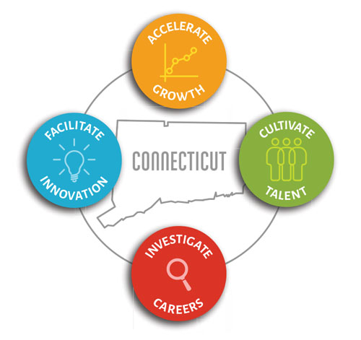

Meeting Agenda

TEAMS Meeting Call In Number: 1-860-840-2075
Participant Passcode: 378 830 850#

Thursday, August 6, 2020
9:00 a.m. - 10:30 a.m.

- Welcome & Introductions

- June Minutes (Vote)

- Governor’s Workforce Council & The Workforce Development Unit

- Defense Manufacturing Communities Support Program

- Portfolio

- College Connections (Vote)

  - MVP with new program parameters (Vote)

- Program Updates
  - Industry 4.0 Supply Chain Initiative
  - Incumbent Worker Training

- 2020 Annual Report

- Other Business

