Manufacturing Innovation Fund Advisory Board
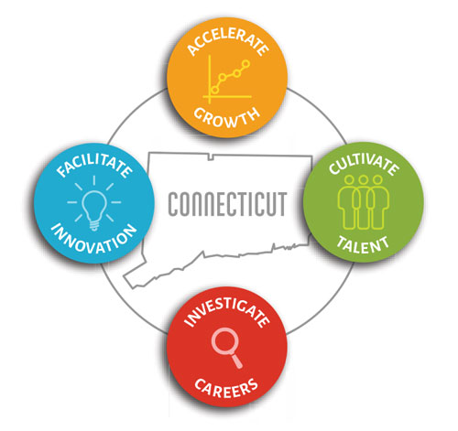

Meeting Agenda

TEAMS Meeting Call In Number: 1-860-840-2075
Participant Passcode: 845 257 773#

Tuesday, April 6, 2021
10:30 a.m. - 12:00 p.m.

- Welcome & Introductions

- February Minutes (Vote)

- Portfolio

• CT Digital Model Initiative

- Governor’s Workforce Council Workforce Strategic Plan

- HRAM Program Update

- MIF Website

- Other Business

