Manufacturing Innovation Fund Advisory Board
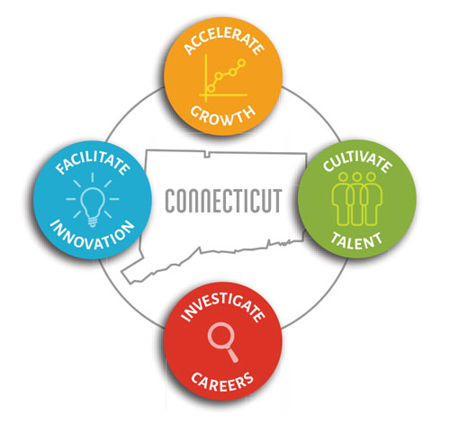

2022 Meeting Schedule

(to be voted upon at the February 17, 2022 MIF Advisory Board meeting)

February 17, 2022

April 21, 2022

June 16, 2022

August 18, 2022

October 20, 2022

December 15, 2022

Meetings will be held from 1:00 p.m. – 2:30 p.m.

