Manufacturing Innovation Fund Advisory Board
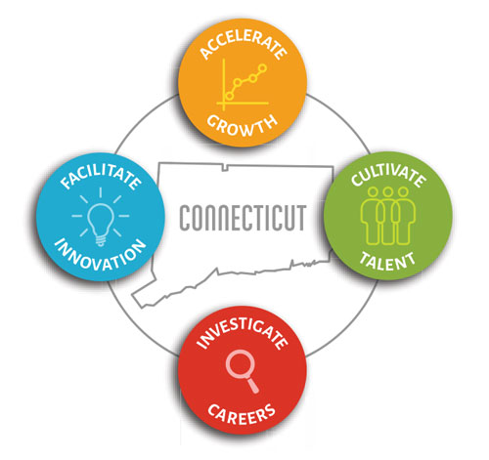

2022 Meeting Schedule
(Revised: 11/4/2022)

February 17, 2022 1:00 – 2:30 p.m.

April 21, 2022 1:00 – 2:30 p.m.

June 16, 2022 1:00 – 2:30 p.m.

August 18, 2022 1:00 – 2:30 p.m.

October 20, 2022 1:00 – 2:30 p.m.

November 22, 2022* 3:00 – 4:30 p.m.

December 15, 2022 2:30 – 4:00 p.m.

*November 22nd meeting has been added to the schedule

