Manufacturing Innovation Fund Advisory Board
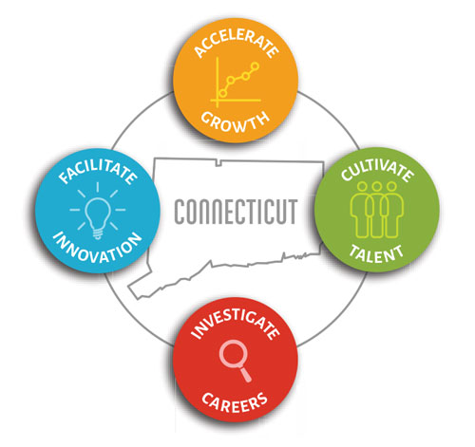

2021 Meeting Schedule (proposed)

(to be voted upon at the February 2, 2021 MIF Advisory Board meeting)

February 2, 2021

April 6, 2021

June 1, 2021

August 3, 2021

October 5, 2021

December 7, 2021

Meetings will be held from 10:30 a.m. – 12:00 p.m.

