Manufacturing Innovation Fund Advisory Board
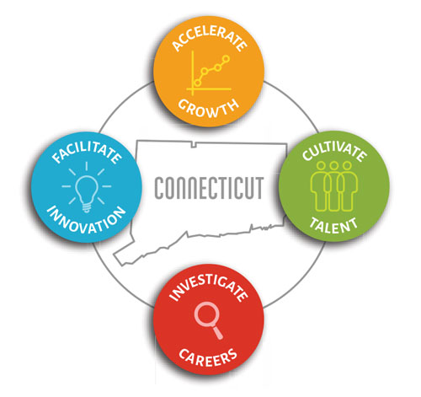

Meeting Agenda

TEAMS Meeting Call In Number: 1-860-840-2075
Participant Passcode: 619 502 111#

Tuesday, August 3, 2021
10:30 a.m. - 12:00 p.m.

- Welcome & Introductions

- June Minutes (Vote)

• Office of Workforce Strategy Update

- Portfolio

- Incumbent Worker Training (Vote)

- Other Business

- Executive Session

