Manufacturing Innovation Advisory Board
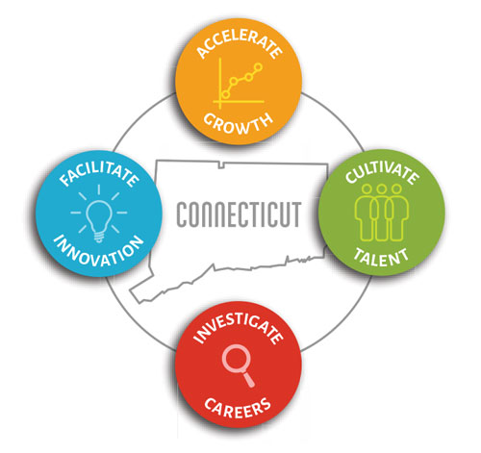

Meeting Agenda

TEAMS Meeting Call In Number: 1-860-840-2075
Participant Passcode: 775 896 709#

Tuesday, December 7, 2021
10:30 a.m. - 12:00 p.m.

- Welcome & Introductions

- October Minutes (Vote)

- Annual Report

- Portfolio

- Energy on the Line (Vote)

- Update on New Initiatives
- Engineering Interns
- Digital Transformation/Cyber Security Roadmaps
- CT Innovators/CT Manufacturers
- Hearts & Minds Advertising Campaign
- Manufacturing Website
- Regional Career Fairs

- Chief Manufacturing Officer Transition

- Other Business

