Artist Respond Grant Program

The Connecticut Office of the Arts (COA) received 258 submissions to the Artist Respond program and was able to award seventy-three (73) grants for a total budget of $88,000. We received a number of strong applications, however, the field’s response far exceeded available funding making the grant process highly competitive. We would like to thank all the artists who took the time to share their amazing ideas with us!

Join us in congratulating the following Artist Respond Grant Recipients:

Kaitrin Acuna, Meriden
Faustin Adeniran, New Haven
Debra Aldo, Sterling
Laura Angiolillo, Glastonbury
Noah Baerman, Middletown
Cheryl Bartley, Winsted
Stephen Bisaccia, Derby
Kevin Bishop, Norwich
Christine Breslin, West Hartford
Darcy Bruce, Quaker Hill
Alicia Cobb, Bridgeport
Felicia Cooper, Stafford Springs
Theodore Coulombe, Sharon
Brandon Couloute, Bristol
Jeanne Criscola, North Haven
Marek Czarnecki, Meriden
Carol Dannhauser, Fairfield
Leslie Elias, West Cornwall
Melanie Faranello, West Hartford
Amy Forbes, Chester
Lindsey Fyfe, Hartford
Derek Graham, Orange
Ashley Hamel, New Haven
Lara Herscovitch, Durham
Karen Hogg, East Haven
Barbara Hopkins, Vernon
Susan Jackson, Redding
Leslie Johnson, Coventry
Hyun "Hannah" Jung, Warren
Sarah Kaufold, Mansfield Center
Shannon Kiley, New Haven
Heidi Kirchofer, Harwinton
Jeffrey Krieger, East Hartford
ShawnaLee Kwashnak, Middlebury
Nicki LaPorte, Bristol
Thomas Lee, Bloomfield
Martha Lewis, New Haven
Hunter Liguore, Bristol
Tondrea Mabins, Stratford
Iyaba Mandingo, Bridgeport
Nadia Martinez, Greenwich
Susan "Sooo-z" Mastropietro, Westport
Susan McCaslin, New Haven
Luciana Quagliato McClure, Hamden
Elizabeth McNally, New Britain
Kathrine McNickle, Groton
Joel Melendez, Harwinton
Dawn Metcalf, Suffield
Christine Mitchell, Goshen
Lara Morton, Madison
Frank Natter, Jr., Deep River
Jill Nichols, Shelton
Kathryn Nolan, Milford
Emma Palzere-Rae, Groton
Bill Pere, Mystic
Adelka Polak, Bethel
Weverson Ponte, Norwalk
Ben Quesnel, Stamfordl
Charlie Rich, New Haven
Valerie Rogotzke, New Haven
Daniel Salazar, Jr., Hartford
Vincent Scarano, New London
Harold Shapiro, Guilford
Nellie Shevelkina, New Haven
Mary Ruth Shields, Portland
Elizabeth Simmons, Hartford
Rene Soto, Norwalk
Rashmi Talpade, Wallingford
Jesse Terry, Pawcatuck
Marcella Trowbridge, Middletown
Laura Walls, Glastonbury
Debra Walsh, West Hartford
Yves Wilson, Bridgeport

The Respond program was supported with a combination from the National Endowment for the Arts ​ (NEA) and state COA funding.

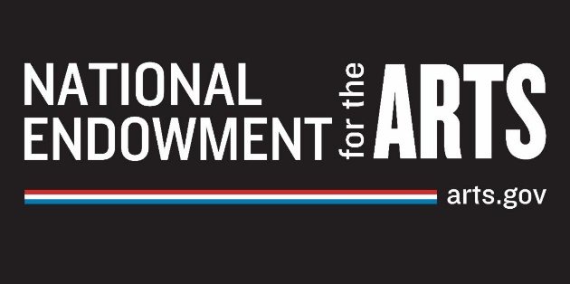



Artist Relief Grant Program

The Connecticut Office of the Arts (COA) received 461 submissions to the Artist Relief program and was able to award 140 grants for a total budget of $70,000. The awarded grants were determined through a random selection process. Recipients have been notified via email.

COA would like to acknowledge the support we received from the New England Foundation for the Arts (NEFA) who contributed $47,000 to Connecticut for direct relief support for artists. We were able to allocate an additional $23,000 state dollars to further support Relief submission to expand our support of Connecticut artists cross the state.

