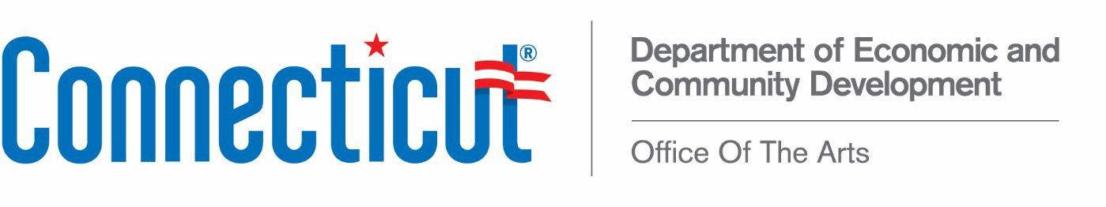

Connecticut Arts Council Foundation Meeting

Tuesday, July 19, 2021 (meeting postponed from June 14 2021)
Via Zoom Video Conference Call 2:15 pm
AGENDA

- Call to Order

- Approval of Minutes for April 12, 2021

- President’s Report - Min Jung Kim

- Treasurer’s Report - Ted Yudain

- Other Business

- Adjournment

The next Connecticut Arts Council Foundation meeting: Monday, September 13, 2021

*Note the Zoom link below is the SAME link as the link for the Council meeting.

DECD is inviting you to a scheduled Zoom meeting.

Topic: Arts Council Meeting/Arts Council Foundation Meeting
Time: Jul 20, 2021 01:00 PM Eastern Time (US and Canada)

Join Zoom Meeting
https://us02web.zoom.us/j/82815293823

Meeting ID: 828 1529 3823
One tap mobile
+13017158592,,82815293823# US (Washington DC)
+13126266799,,82815293823# US (Chicago)

Dial by your location
+1 301 715 8592 US (Washington DC)
+1 312 626 6799 US (Chicago)
+1 929 436 2866 US (New York)
+1 253 215 8782 US (Tacoma)
+1 346 248 7799 US (Houston)
+1 669 900 6833 US (San Jose)
Meeting ID: 828 1529 3823
Find your local number: https://us02web.zoom.us/u/kcHQ93HbJT

450 Columbus Boulevard, Suite 5 | Hartford, CT 06103 | Phone: 860-500-2300
An Affirmative Action/Equal Opportunity Employer An Equal Opportunity Lender

