Workbook for Supported Decision Making 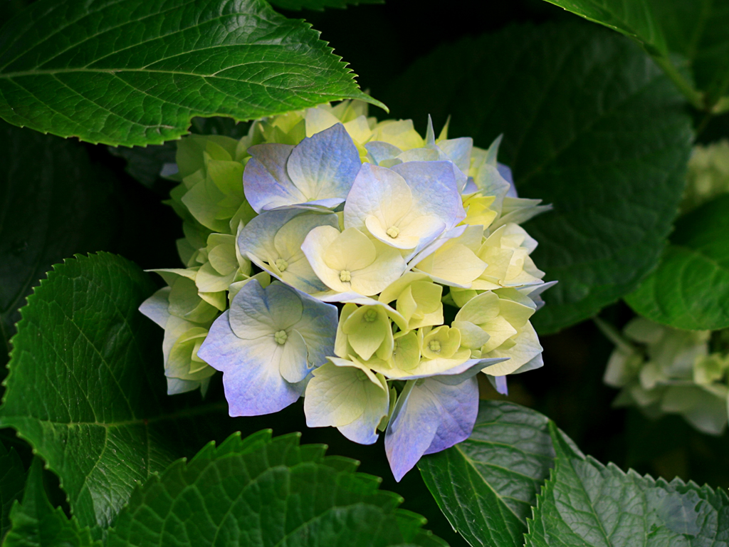

Name of Decision Maker: ______________________________
Name of Decision Supporter: ___________________________

This workbook is designed as a tool to assist anyone who would like to support someone in making a decision. It can be used for any type of decision.

It is important to follow the step by step procedures in order to insure that the decision is fully explained and the implications are clear to the decision maker.

This workbook is created in order to facilitate not only a decision but a new sense of empowerment and understanding.

Pathway A is for people who prefer to talk. Pathway B is for people who use less words and want to make choices.

It is designed as an exercise in partnership as well as learning. Enjoy the decision making process together!

Explanation of Decision:
- This is a description of the decision that needs to be made:
____________________________________________________________________________________________________________________________________________________________________________________________________

- This is why this decision is important in your life:
____________________________________________________________________________________________________________________________________________________________________________________________________

- This is why you are the person who needs to make this decision instead of someone else making it for you:
________________________________________________________________________________________________________________________________________________________________________________________________________
- Here is what will result from this decision once it is made:
____________________________________________________________________________________________________________________________________________________________________________________________________
Let’s break it down!

Option # 1: ____________________________________________________________________________________________________________________________________________________________________________________________________

Option #2:
____________________________________________________________________________________________________________________________________________________________________________________________________

Option # 3:
____________________________________________________________________________________________________________________________________________________________________________________________________

Option #4:
____________________________________________________________________________________________________________________________________________________________________________________________________

What Might Happen
Option # 1:_________________________( Give it a Title)
Possible results:
___________________________________________________________________________________________________________________________________________________

Option # 2: Title: _____________________________
Possible results:
___________________________________________________________________________________________________________________________________________________

Option # 3 Title:______________________________
Possible results:
___________________________________________________________________________________________________________________________________________________

Option # 4 Title:_______________________________
Possible results:
___________________________________________________________________________________________________________________________________________________
PATHWAY A:
Questions to Consider:
- What is in your heart? Deep down inside, what do you really feel? ________________________________________________________________________________________________________________________________________________________________________________________________

- Imagine that you have lived your whole life and you are now very old. What do you think you would have wished you had done right now? ________________________________________________________________________________________________________________________________________________________________________________________________

- Think about someone in your life who was very special to you. They may no longer be living right now. What do you think that person would have told you to do? ________________________________________________________________________________________________________________________________________________________________________________________________

- What do you really want the most right now? ________________________________________________________________________________________________________________________________________________________________________________________________

- What is the most important to you right now? ________________________________________________________________________________________________________________________________________________________________________________________________

- Is there anything that you want to say to other people when you think about this issue? ________________________________________________________________________________________________________________________________________________________________________________________________

Pathway B

Please give stars to each choice as it is reviewed. 5 stars is really great, 1 star is not that good and the rest pretty good, the more stars means the more you like this choice.

Option 1:

Option 2:
_________________________________________________

Option 3:

Option 4:

_________________________________________________

This is my plan:
________________________________________________________________________________________________________________________________________________________________________________________________________________________________________________________________________________________________________________________________________________________________________________________________________________________________

Signature

Copyright 2014 Karyn Harvey Ph.D.

