Directions to Manage Electronic Visit Verification (EVV) Mode in WebResDay
This page is used to set the EVV mode for each DDS provider. The different modes are “DUAL” and “FULL”. The roles that can update modes are “Application Administrator” and “Provider Administrator”. The Application Administrator can set both modes i.e. “DUAL” and “FULL” modes, but the Provider Administrator can only set the “FULL” mode. Providers can see their current mode on this page and the attendance page. The Application Administrator can see all the providers’ modes in the page grid table and may also search for a provider.
Please refer to Screen 10 Manage EVV Mode Page for the workflow.
Screen 10
Role - Provider Administrator
Figure 9: Manage EVV Mode Page
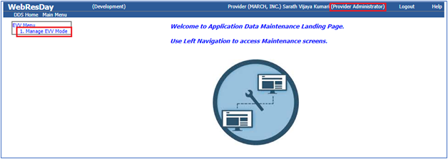
Figure 10: Manage EVV Mode Page
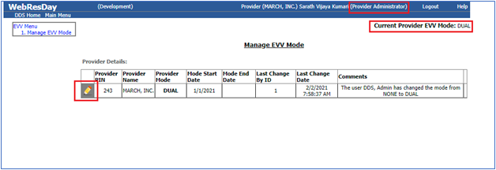
Figure 11: Manage EVV Mode Page
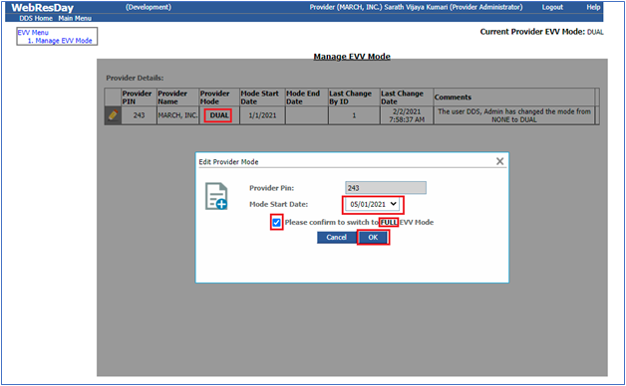
Figure 12: Manage EVV Mode Page
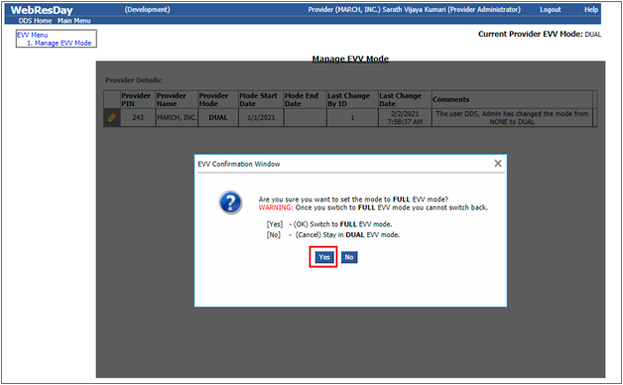
Figure 13: Manage EVV Mode Page
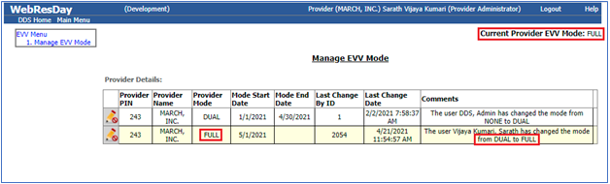
Figure 14: Manage EVV Mode Page
Role - Application Administrator
Same as Figure 9, 10, 11,12,13,14 but role is Application Administrator and can be set to both modes.
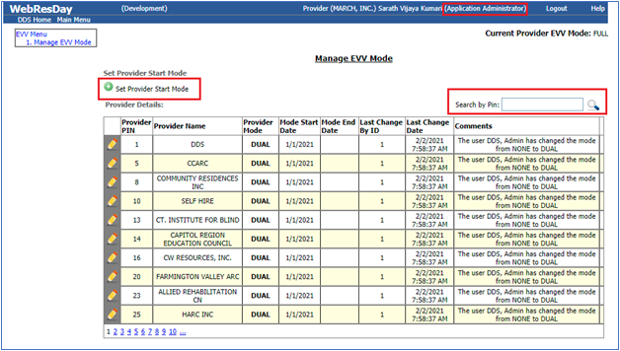
Figure 15: Manage EVV Mode Page
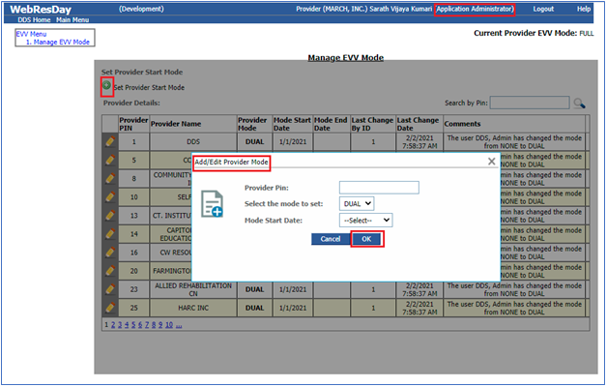
Figure 16: Manage EVV Mode Page
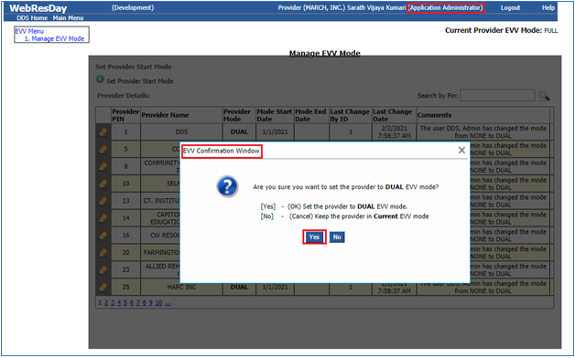
Figure 17: Manage EVV Mode Page

