FOOD LICENSE MAINTENANCE
Certificate of Free Sale and Inactivate License Options
Contents
Online User Experience – Certificate of Free Sale Screen Views 1
First Steps Login through Credential Selections 1
Certificate of Free Sale Process 2
Online User Experience Inactivate License/Registration Process 9

Online User Experience – Certificate of Free Sale Screen Views

First Steps Login through Credential Selections
Login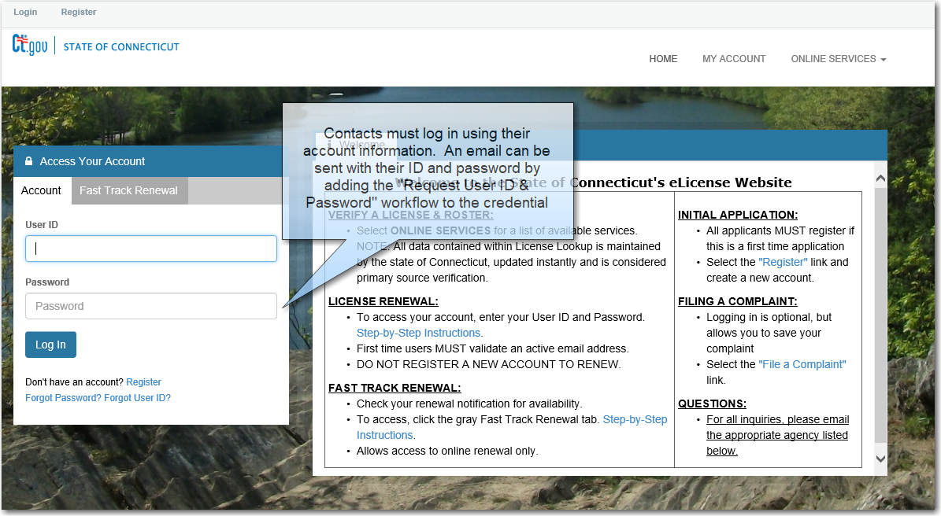
Functional Menu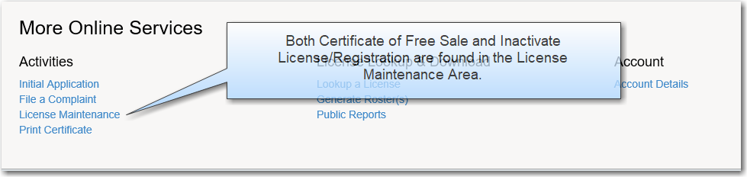
Credential Selection
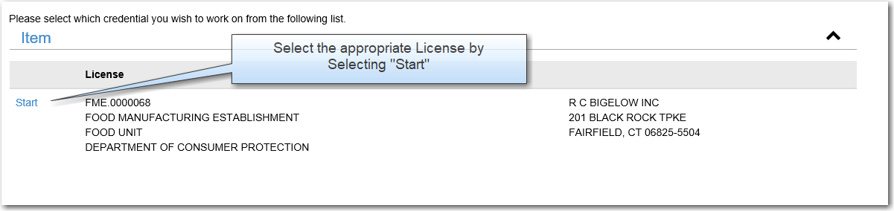

Certificate of Free Sale Process
Menu
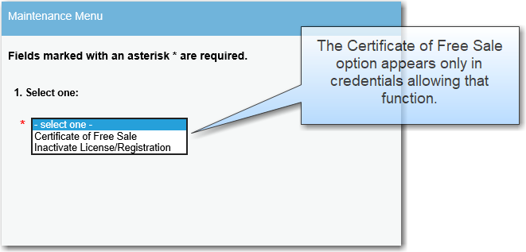
Instructional Page:
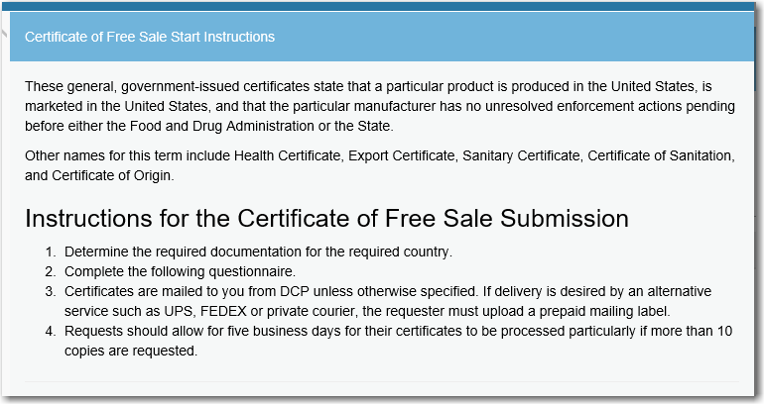
Contact Information: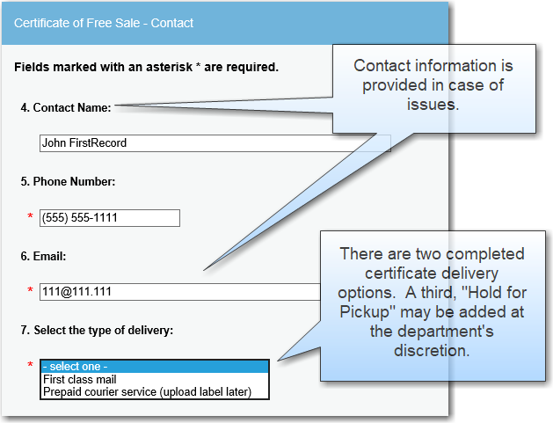
Option: Prepaid Courier Service:
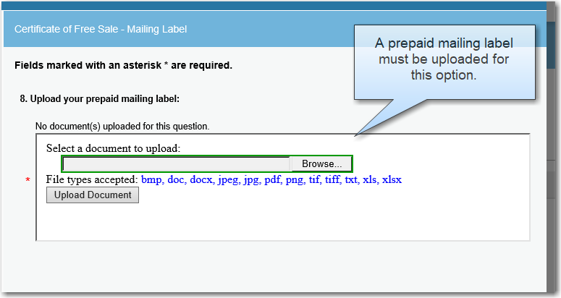
1st Class Mail Option:
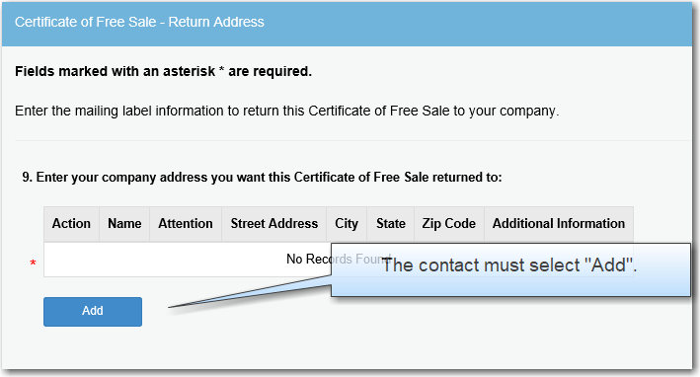
Adding an Address:
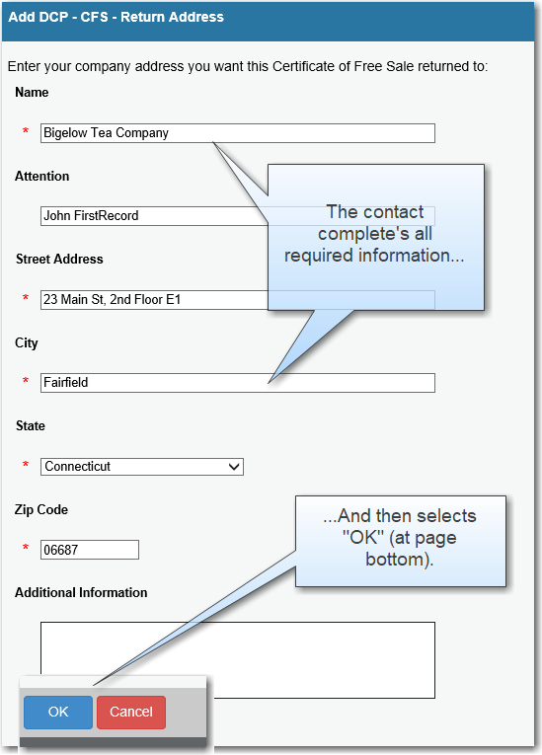
The address will now be shown:
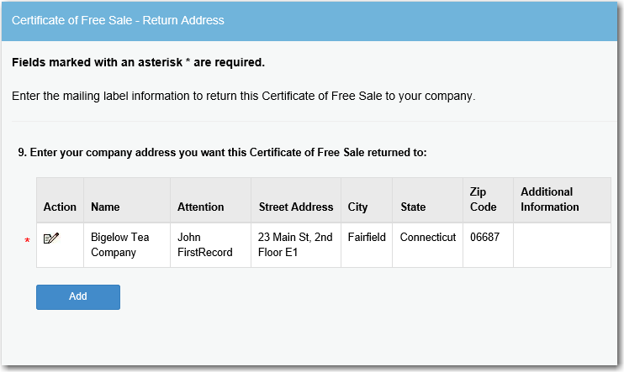
Enter information about the Certificate of Free Sale:
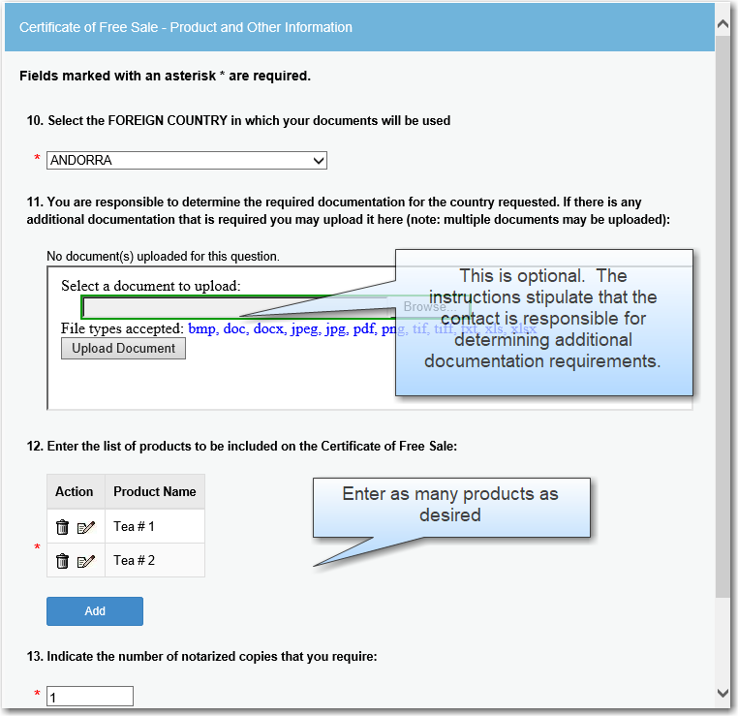
NOTE : For general certificates Please Enter “Food Products” Or “Dietary Supplements.” Instead of a specific item in the Product name field.
Posting notification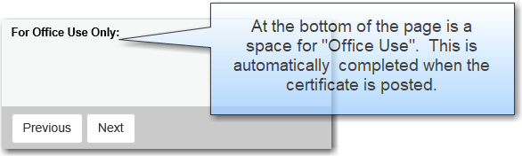
Review:
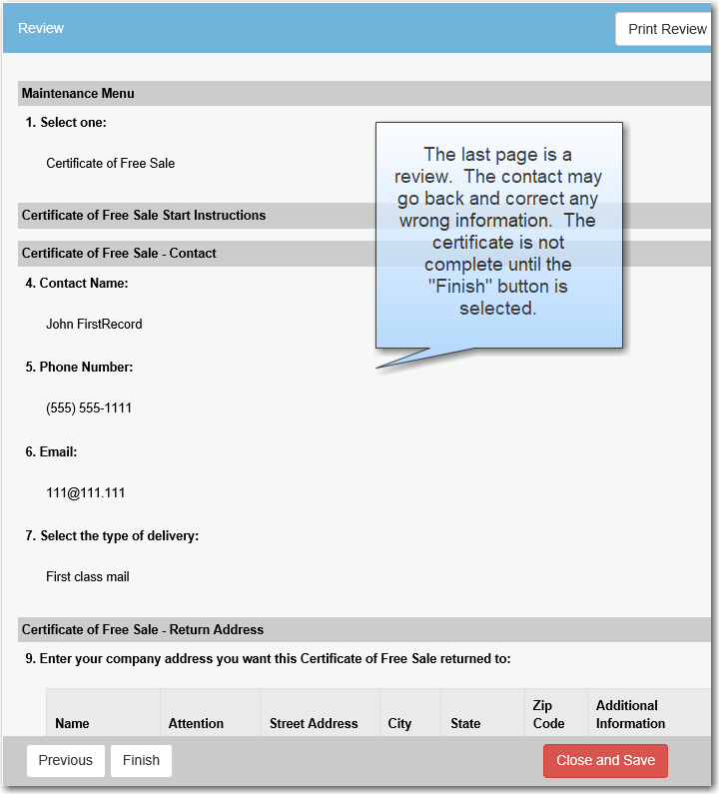

Online User Experience Inactivate License/Registration Process
Menu
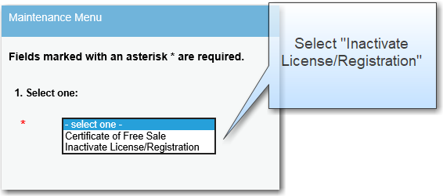
Confirmation Page:
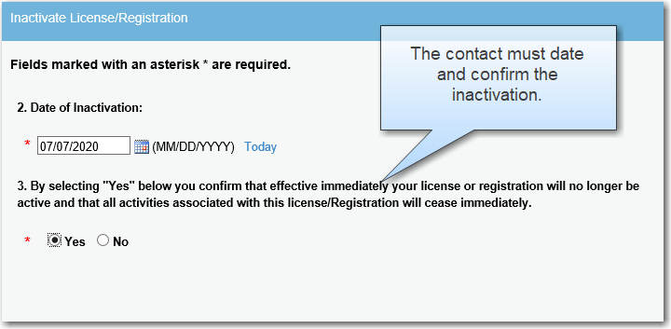
Review

