Department of Children and Families
LEGISLATIVE UPDATE
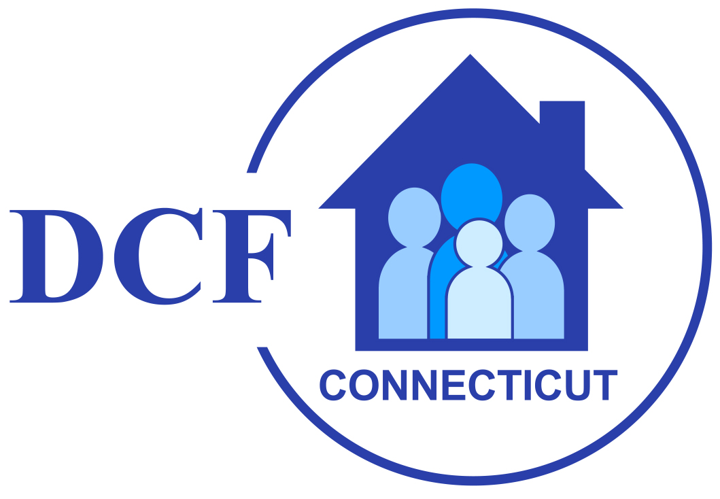

March 20, 2026 Update 2026-7

WELCOME TO DCF's LEGISLATIVE UPDATE

Welcome to the seventh edition of the DCF Legislative Update for the 2026 session of the General Assembly. The legislative session convened on Wednesday, February 4th, which is later than odd numbered years due to the State Biennium budget adoption taking place in the even numbered years.

Updates will be issued periodically during the legislative session and will provide timely notice of bills, meetings and hearings of interest to the Department.

Adjournment: The General Assembly Adjourns on May 6th at midnight, which is earlier than in odd numbered years due to the State Biennium budget adoption taking place in the even numbered years.

Governor Lamont’s Legislative Proposals

Governor Lamont highlighted several different policy areas he would like to see addressed during this legislative session. The Governor's 2026 Legislative Proposals can be found here.

Governor's Deficiency Appropriations & Budget Adjustment Bills

HB 5031 AN ACT MAKING DEFICIENCY APPROPRIATIONS FOR THE FISCAL YEAR ENDING JUNE 30, 2026

HB 5032 AN ACT ADJUSTING THE STATE BUDGET FOR THE BIENNIUM ENDING JUNE 30, 2027

OFA's synopsis of the Governor's budget is available here.

Appropriations Committee Budget Work

HB 5031 was heard in the Appropriations Committee today.

Testimony from today's hearing can be found here.

More information on completed state agency budget hearings and work sessions can be found here.

BILLS OF INTEREST

Multiple committees have already met their deadlines or are nearing them.

A full listing of committee deadlines can be found here.

Bills Reported out of the Committee on Children can be found here.

Joint Favorable (JF) Reports for Bills passed out of the Committee on Children can be found here.

LEGISLATIVE LEADERS – 2026 SESSION

Senator Martin Looney (D) – Senate President Pro Tempore
Senator Bob Duff (D) – Senate Majority Leader
Representative Matthew Ritter (D) – Speaker of the House
Representative Jason Rojas (D) – House Majority Leader
Senator Stephen Harding (R) – Senate Minority Leader
Representative Vincent Candelora (R) – House Minority Leader

COMMITTEE ASSIGNMENTS – 2026 SESSION

COMMMITTEE ON CHILDREN
www.cga.ct.gov/kid/
Cognizance of all matters relating to the Department of Children and Families, including institutions under its jurisdiction, and children.

Chairs: Sen. Ceci Maher (D), Rep. Corey Paris (D)
Vice-Chairs: Sen. Christine Cohen (D), Rep. Mary Welander (D)
Ranking Members: Sen. Jason Perillo (R), Rep. Anne Dauphinais (R)

Members:
Rep. Pat Boyd (D)
Rep. Kai Belton (D)
Sen. Julie Kushner (D)
Rep. Gale Mastrofrancesco (R)
Rep. William Pizzuto (R)
Rep. Robin Comey (D)
Rep. Brian Lanoue (R)
Rep. Rebecca Martinez (D)
Rep. Trenee McGee (D)
Sen. Martha Marx (D)
Rep. Sarah Keitt (D)

UPCOMING MEETINGS AND HEARINGS

Mon, Mar 23 - 10:00 AM | Judiciary Committee Meeting | Room 2C
Mon, Mar 23 - 11:30 AM | Public Health Committee Meeting | Room 1D
Tue, Mar 24 - 10:00 AM | Judiciary Committee Meeting | Room 2C
Wed, Mar 25 - 10:00 AM | HOUSE SESSION
Thur, Mar 26 - 10:00 AM | SENATE SESSION

GENERAL ASSEMBLY WEBSITE

For complete legislative information, visit the Connecticut General Assembly’s website at - www.cga.ct.gov

For additional information regarding legislative matters, contact Michael Carone, DCF Legislative Program Director, at 860-936-6353 or Vincent Russo, DCF Chief Administrator of Government Relations & Policy, at (860) 461-6689.

