Department of Children and Families
LEGISLATIVE UPDATE
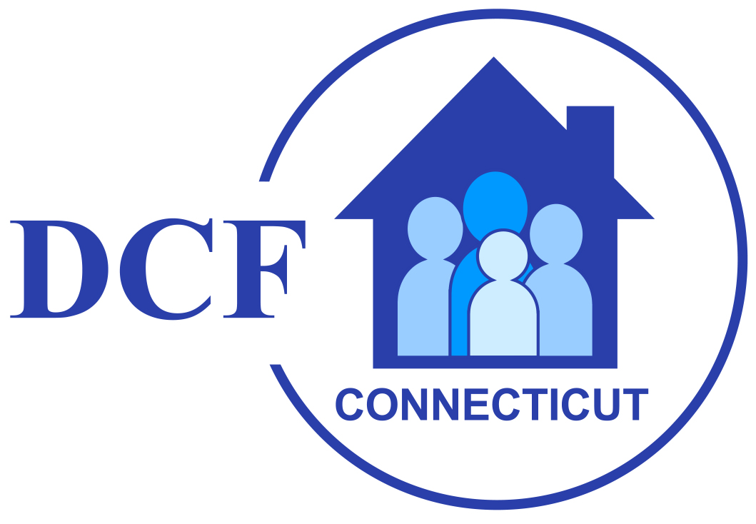

May 12, 2026 Update 2026-13

WELCOME TO DCF's LEGISLATIVE UPDATE

Welcome to the thirteenth and final edition of the DCF Legislative Update for the 2026 session of the General Assembly. The legislative session convened on Wednesday, February 4th, which is later than odd numbered years due to the State Biennium budget adoption taking place in the even numbered years.

Adjournment: The General Assembly Adjourned on May 6th at midnight, which is earlier than in odd numbered years due to the State Biennium budget adoption taking place in the even numbered years.

Budget Adjustment Bills

S.B. No. 1 AN ACT CONCERNING AFFORDABILITY became the new budget adjustment bill and it was amended with Senate Schedule A LCO# 5762 (D).

Fiscal note on the bill: Fiscal Note for Amendment LCO 5762 (See Fiscal Note Details)

S.B. No. 477 AN ACT CONCERNING THE FAILURE TO FILE FOR CERTAIN GRAND LIST EXEMPTIONS AND A MUNICIPAL OPTION TO ABATE DELINQUENT PROPERTY TAXES ON CERTAIN PARCELS OF LAND was used as a "fix" to SB 1.

It was amended with Senate Schedule A LCO# 6140 (D) and Senate Schedule B LCO# 6173 (D)

See Bill Analysis for SB-477, as amended by Senate "A" and "B" for more information.

BILLS OF INTEREST

A list of all bills that have passed can be found here.

Some bills that may be of interest that passed out of both chambers are below.

S.B. No. 155 AN ACT CONCERNING THE RECOMMENDATIONS OF THE DEPARTMENT OF CHILDREN AND FAMILIES

Amended by Senate Schedule A LCO# 4397 (D).

H.B. No. 5004 AN ACT CONCERNING CHILD WELFARE ACCOUNTABILITY AND TRANSPARENCY

Amended by House Amendment Schedules "A" and "C".

H.B. No. 5476 AN ACT CONCERNING OVERSIGHT OF EFFORTS TO PREVENT HUMAN TRAFFICKING

Amended with House Schedule A LCO# 5771 (J).

H.B. No. 5468 AN ACT CONCERNING THE PROVISION OF EQUIVALENT INSTRUCTION

Amended by House Schedule A LCO# 4428 (D).

S.B. No. 475 AN ACT CONCERNING JUDICIAL BRANCH OPERATIONS

Amended by Senate Schedule A LCO# 5719 (J).

S.B. No. 156 AN ACT ESTABLISHING A TASK FORCE TO STUDY THE VOLUNTARY SURRENDER OF INFANTS

Amended by Senate Schedule A LCO# 3650 (D).

H.B. No. 5163 AN ACT ESTABLISHING A TASK FORCE TO STUDY METHODS AND PROGRAMS FOR IMPROVING AFFORDABILITY FOR CHILDREN, FAMILIES AND YOUNG PROFESSIONALS.

Amended by House Schedule A LCO# 3872 (D).

H.B. No. 5447 AN ACT IMPLEMENTING RECOMMENDATIONS OF THE TRANSFORMING CHILDREN'S BEHAVIORAL HEALTH POLICY AND PLANNING COMMITTEE AND CONCERNING TEMPORARY FAMILY ASSISTANCE BENEFITS

Amended by House Schedule A LCO# 5638 (D).

H.B. No. 5044 AN ACT ESTABLISHING CONNECTICUT VACCINE STANDARDS.

Amended by House Schedule A LCO# 4191 (D) and House Schedule B LCO# 4424 (D).

S.B. No. 157 AN ACT CONCERNING MUNICIPAL CAMP SAFETY.

Amended by Senate Schedule A LCO# 3893 (D).

LEGISLATIVE LEADERS – 2026 SESSION

Senator Martin Looney (D) – Senate President Pro Tempore
Senator Bob Duff (D) – Senate Majority Leader
Representative Matthew Ritter (D) – Speaker of the House
Representative Jason Rojas (D) – House Majority Leader
Senator Stephen Harding (R) – Senate Minority Leader
Representative Vincent Candelora (R) – House Minority Leader

COMMITTEE ASSIGNMENTS – 2026 SESSION

COMMMITTEE ON CHILDREN
www.cga.ct.gov/kid/
Cognizance of all matters relating to the Department of Children and Families, including institutions under its jurisdiction, and children.

Chairs: Sen. Ceci Maher (D), Rep. Corey Paris (D)
Vice-Chairs: Sen. Christine Cohen (D), Rep. Mary Welander (D)
Ranking Members: Sen. Jason Perillo (R), Rep. Anne Dauphinais (R)

Members:
Rep. Pat Boyd (D)
Rep. Kai Belton (D)
Sen. Julie Kushner (D)
Rep. Gale Mastrofrancesco (R)
Rep. William Pizzuto (R)
Rep. Robin Comey (D)
Rep. Brian Lanoue (R)
Rep. Rebecca Martinez (D)
Rep. Trenee McGee (D)
Sen. Martha Marx (D)
Rep. Sarah Keitt (D)

GENERAL ASSEMBLY WEBSITE

For complete legislative information, visit the Connecticut General Assembly’s website at - www.cga.ct.gov

For additional information regarding legislative matters, contact Michael Carone, DCF Legislative Program Director, at 860-936-6353 or Vincent Russo, DCF Chief Administrator of Government Relations & Policy, at (860) 461-6689.

