Department of Children and Families
LEGISLATIVE UPDATE
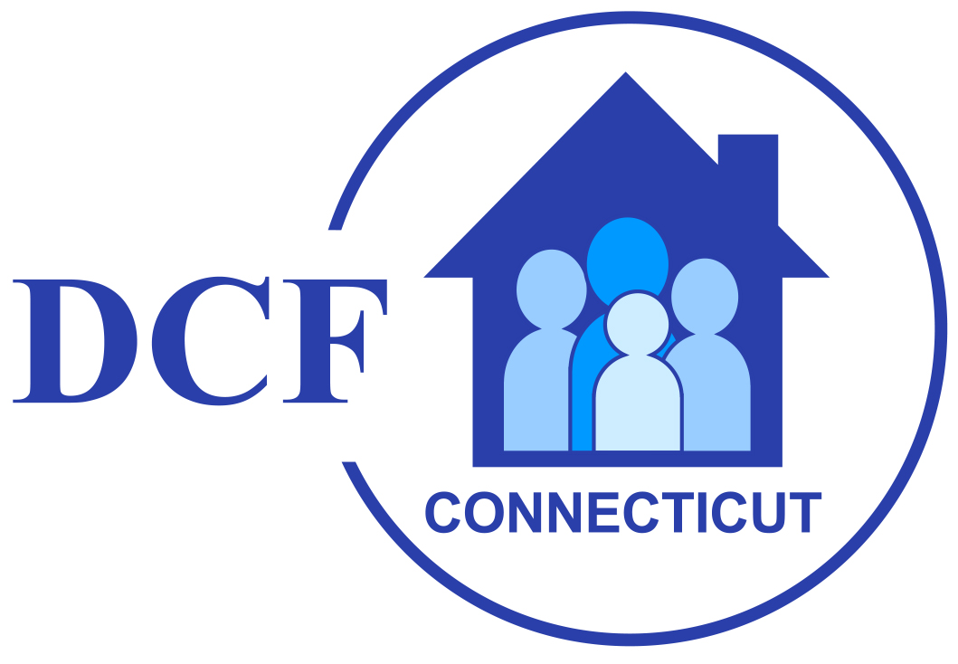

April 17, 2026 Update 2026-11

WELCOME TO DCF's LEGISLATIVE UPDATE

Welcome to the eleventh edition of the DCF Legislative Update for the 2026 session of the General Assembly. The legislative session convened on Wednesday, February 4th, which is later than odd numbered years due to the State Biennium budget adoption taking place in the even numbered years.

Updates will be issued periodically during the legislative session and will provide timely notice of bills, meetings and hearings of interest to the Department.

Adjournment: The General Assembly Adjourns on May 6th at midnight, which is earlier than in odd numbered years due to the State Biennium budget adoption taking place in the even numbered years.

Governor Lamont’s Legislative Proposals

Governor Lamont highlighted several different policy areas he would like to see addressed during this legislative session. The Governor's 2026 Legislative Proposals can be found here.

Governor's Deficiency Appropriations & Budget Adjustment Bills

HB 5031 AN ACT MAKING DEFICIENCY APPROPRIATIONS FOR THE FISCAL YEAR ENDING JUNE 30, 2026

HB 5032 AN ACT ADJUSTING THE STATE BUDGET FOR THE BIENNIUM ENDING JUNE 30, 2027

OFA's synopsis of the Governor's budget is available here.

Appropriations Committee Budget Work

The Appropriations committee amended and passed both budget related bills out of committee. More information is linked below, including their file copies that came out this week.

H.B. No. 5031 AN ACT MAKING DEFICIENCY APPROPRIATIONS FOR THE FISCAL YEAR ENDING JUNE 30, 2026 was amended with LCO No. 3675.

- File No. 635 [doc]

H.B. No. 5032 AN ACT ADJUSTING THE STATE BUDGET FOR THE BIENNIUM ENDING JUNE 30, 2027 was amended with LCO No. 3706.

- File No. 661 [doc]

Appropriations Committee Budget FY 27 Midterm Adjustments
Preliminary Fiscal Notes HB 5031 and HB 5032 for Appropriations Committee Meeting on March 31, 2026

BILLS OF INTEREST

A list of all bills passed can be found here.

Bills Reported out of relevant committees to the Department are linked below:

Appropriations can be found here.
Children can be found here.
Education can be found here.
Human Services can be found here.
Judiciary can be found here.
Public Health can be found here.

Some bills that may be of interest and passed out of the Senate this week are below.

S.B. No. 156 AN ACT ESTABLISHING A TASK FORCE TO STUDY THE VOLUNTARY SURRENDER OF INFANTS was amended and passed.

The bill was amended by Senate LCO Amendment #3650 (D).

S.B. No. 468 AN ACT CONCERNING REPORTING REQUIREMENTS AND PAYMENT OF NONPROFIT HUMAN SERVICES PROVIDERS was amended and passed.

The bill was amended by Senate Schedule A LCO# 4088 D.

S.B. No. 397 AN ACT CONCERNING DEMOCRACY AND GOVERNMENT ACCOUNTABILITY was amended twice and passed. The amendment language is below.

The bill was amended with Senate Schedule A LCO# 4084 (D) and Senate Schedule B LCO# 4114 (D).

LEGISLATIVE LEADERS – 2026 SESSION

Senator Martin Looney (D) – Senate President Pro Tempore
Senator Bob Duff (D) – Senate Majority Leader
Representative Matthew Ritter (D) – Speaker of the House
Representative Jason Rojas (D) – House Majority Leader
Senator Stephen Harding (R) – Senate Minority Leader
Representative Vincent Candelora (R) – House Minority Leader

COMMITTEE ASSIGNMENTS – 2026 SESSION

COMMMITTEE ON CHILDREN
www.cga.ct.gov/kid/
Cognizance of all matters relating to the Department of Children and Families, including institutions under its jurisdiction, and children.

Chairs: Sen. Ceci Maher (D), Rep. Corey Paris (D)
Vice-Chairs: Sen. Christine Cohen (D), Rep. Mary Welander (D)
Ranking Members: Sen. Jason Perillo (R), Rep. Anne Dauphinais (R)

Members:
Rep. Pat Boyd (D)
Rep. Kai Belton (D)
Sen. Julie Kushner (D)
Rep. Gale Mastrofrancesco (R)
Rep. William Pizzuto (R)
Rep. Robin Comey (D)
Rep. Brian Lanoue (R)
Rep. Rebecca Martinez (D)
Rep. Trenee McGee (D)
Sen. Martha Marx (D)
Rep. Sarah Keitt (D)

UPCOMING SESSION DAYS

House Session Days and Times: Mon 12pm, Tue 11am, Wed 11am and Thu 10:30am.

Senate Session Days and Times: Tue 12pm, Wed and Thu TBA.

GENERAL ASSEMBLY WEBSITE

For complete legislative information, visit the Connecticut General Assembly’s website at - www.cga.ct.gov

For additional information regarding legislative matters, contact Michael Carone, DCF Legislative Program Director, at 860-936-6353 or Vincent Russo, DCF Chief Administrator of Government Relations & Policy, at (860) 461-6689.

