Department of Children and Families
LEGISLATIVE UPDATE
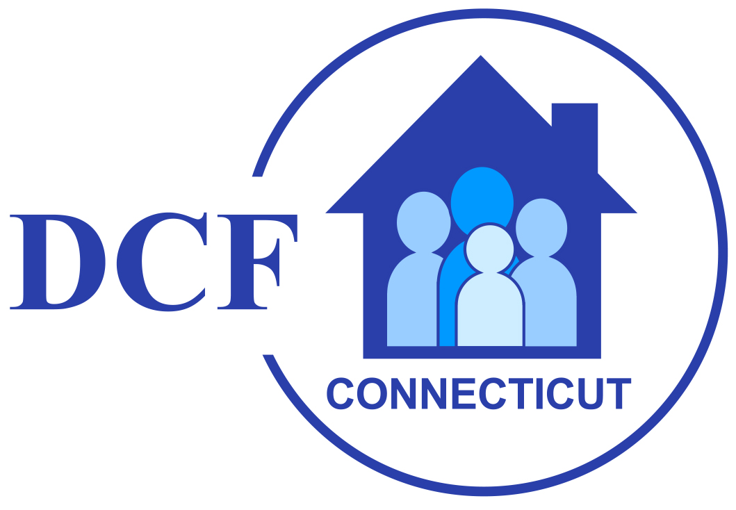

April 10, 2026 Update 2026-10

WELCOME TO DCF's LEGISLATIVE UPDATE

Welcome to the tenth edition of the DCF Legislative Update for the 2026 session of the General Assembly. The legislative session convened on Wednesday, February 4th, which is later than odd numbered years due to the State Biennium budget adoption taking place in the even numbered years.

Updates will be issued periodically during the legislative session and will provide timely notice of bills, meetings and hearings of interest to the Department.

Adjournment: The General Assembly Adjourns on May 6th at midnight, which is earlier than in odd numbered years due to the State Biennium budget adoption taking place in the even numbered years.

Governor Lamont’s Legislative Proposals

Governor Lamont highlighted several different policy areas he would like to see addressed during this legislative session. The Governor's 2026 Legislative Proposals can be found here.

Governor's Deficiency Appropriations & Budget Adjustment Bills

HB 5031 AN ACT MAKING DEFICIENCY APPROPRIATIONS FOR THE FISCAL YEAR ENDING JUNE 30, 2026

HB 5032 AN ACT ADJUSTING THE STATE BUDGET FOR THE BIENNIUM ENDING JUNE 30, 2027

OFA's synopsis of the Governor's budget is available here.

Appropriations Committee Budget Work

The Appropriations committee amended and passed both budget related bills out of committee. More information is linked below.

H.B. No. 5031 AN ACT MAKING DEFICIENCY APPROPRIATIONS FOR THE FISCAL YEAR ENDING JUNE 30, 2026 was amended with LCO No. 3675.

H.B. No. 5032 AN ACT ADJUSTING THE STATE BUDGET FOR THE BIENNIUM ENDING JUNE 30, 2027 was amended with LCO No. 3706.

Appropriations Committee Budget FY 27 Midterm Adjustments
Preliminary Fiscal Notes HB 5031 and HB 5032 for Appropriations Committee Meeting on March 31, 2026

BILLS OF INTEREST

A list of all bills passed can be found here.

Bills Reported out of relevant committees to the Department are linked below:

Appropriations can be found here.
Children can be found here.
Education can be found here.
Human Services can be found here.
Judiciary can be found here.
Public Health can be found here.

Several bills that may be of interest passed through the House this week:

H.B. No. 5166 AN ACT CONCERNING SOCIAL WORK LICENSURE was amended and passed by the House.

The bill was amended by House Schedule A LCO# 3905 (J).

H.B. No. 5259 AN ACT CONCERNING THE EDUCATION OF HOMELESS CHILDREN AND YOUTH was passed by the House.

H.B. No. 5039 AN ACT REQUIRING TRANSPARENCY AND ADDITIONAL OVERSIGHT OF THE DISTRIBUTION OF CERTAIN LEGISLATIVELY DIRECTED FUNDS was amended and passed by the house.

The bill was amended with House Schedule A LCO# 3954 (J).

H.B. No. 5163 AN ACT ESTABLISHING A TASK FORCE TO STUDY METHODS AND PROGRAMS FOR IMPROVING AFFORDABILITY FOR CHILDREN, FAMILIES AND YOUNG PROFESSIONALS was amended and passed by the House.

The bill was amended with House Schedule A LCO# 3872 (D).

LEGISLATIVE LEADERS – 2026 SESSION

Senator Martin Looney (D) – Senate President Pro Tempore
Senator Bob Duff (D) – Senate Majority Leader
Representative Matthew Ritter (D) – Speaker of the House
Representative Jason Rojas (D) – House Majority Leader
Senator Stephen Harding (R) – Senate Minority Leader
Representative Vincent Candelora (R) – House Minority Leader

COMMITTEE ASSIGNMENTS – 2026 SESSION

COMMMITTEE ON CHILDREN
www.cga.ct.gov/kid/
Cognizance of all matters relating to the Department of Children and Families, including institutions under its jurisdiction, and children.

Chairs: Sen. Ceci Maher (D), Rep. Corey Paris (D)
Vice-Chairs: Sen. Christine Cohen (D), Rep. Mary Welander (D)
Ranking Members: Sen. Jason Perillo (R), Rep. Anne Dauphinais (R)

Members:
Rep. Pat Boyd (D)
Rep. Kai Belton (D)
Sen. Julie Kushner (D)
Rep. Gale Mastrofrancesco (R)
Rep. William Pizzuto (R)
Rep. Robin Comey (D)
Rep. Brian Lanoue (R)
Rep. Rebecca Martinez (D)
Rep. Trenee McGee (D)
Sen. Martha Marx (D)
Rep. Sarah Keitt (D)

UPCOMING MEETINGS AND HEARINGS

Mon, Apr 13 - 1:30 PM |  | Appropriations Committee Meeting | Room 2C
Tue, Apr 14 - 12:30 PM |  | SENATE SESSION | Senate Chamber
Wed, Apr 15 - TBD |  | SENATE SESSION | Senate Chamber
Wed, Apr 15 - 2:00 PM |  | Transforming Children's Behavioral Health Policy and Planning Committee Meeting | Room 2D

GENERAL ASSEMBLY WEBSITE

For complete legislative information, visit the Connecticut General Assembly’s website at - www.cga.ct.gov

For additional information regarding legislative matters, contact Michael Carone, DCF Legislative Program Director, at 860-936-6353 or Vincent Russo, DCF Chief Administrator of Government Relations & Policy, at (860) 461-6689.

