

Housing Assistance for Families - Kim Somaroo-Rodriguez
September 9, 2020
The pandemic has created unprecedented strains on families, and we know from various sources, including visits to our own COVID webpage, that housing is a particular challenge for many of the families we serve.

Kim Somaroo-Rodriguez, the Department of Children and Families' housing specialist, is sharing some resources that can help families facing housing instability by connecting them to these housing assistance programs:

- For imminent concerns, families should call 211 or go online at www.211ct.org. The family will be connected to resources through the local Coordinated Access Network (CAN) to find immediate shelter;
- Starting July 15, the Temporary Rental Housing Assistance Program (TRHAP) and the Temporary Mortgage Assistance Program (T-MAP)) was established to provide financial assistance to those impacted by the COVID -19 pandemic and faced job loss or illness. For further information on eligibility and how to apply both renters and homeowners can call 860-785-3111 or www.chfa.org
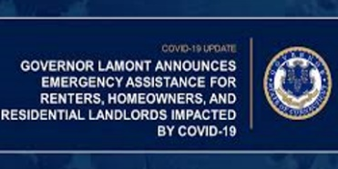
- Families should know that there is currently a state moratorium on evictions that began in April 2020 but was just extended to October 2020 by Governor Lamont. It is important that families understand that this does not remove the obligation renters have for paying rent; it is still owed the landlord. Eviction proceedings have been postponed until October 2020, Families should be communicating with their landlord about their hardship, steps taken to remedy it and make payment arrangements when possible.
- Emergency Shelters are struggling with maintaining a capacity level that allows social distancing through the pandemic. Each area office Worker may access WRAP funds through their Supervisor and Manager. These funds can be used for temporary "hoteling" of a family if shelters are full, security deposits, back rent to sustain housing, or utility payments only if all other local resources have been tried unsuccessfully.

- Any DCF family in On-going Services who is homeless or at risk of homelessness should be referred to our Supportive Housing for Families program. There is a substantial wait list, but families are prioritized based on their level of housing need. Housing is not established upon admission and it may take several weeks to obtain permanent housing after admission.

In addition to these important programs, staff should also advise families of legal assistance available at www.CTLawHelp.org.

Please contact Kim directly at s.kim.somaroo@ct.gov for questions, consultation, or additional referral information.

Thank you, Ms. Somaroo-Rodriguez, for your expertise and dedication in providing housing supports to families! And thank you to staff for sharing this information with your families!

