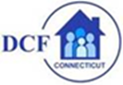

National Foster Youth Institute - Virtual Listening Session 10/2/20
September 30, 2020
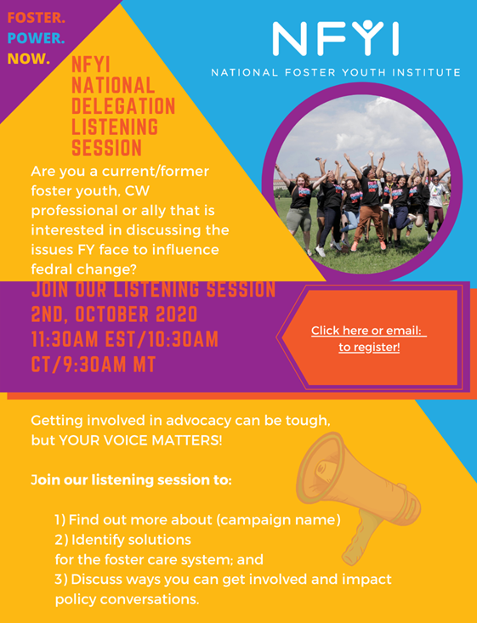
The National Foster Youth Institute is excited to invite to host an upcoming Virtual Listening Session focused around supporting current and former foster youth within the Child Welfare system in the state of (TX, OK, CO, CT). At the event, participants will be discussing the Foster Care PPE Campaign, which focuses on three policy priorities that impact current and former foster youth: providing young people with access to health care until the age of 26 throughout this pandemic; the need to expand Chafee Program funding and access until the age of 26; and dental coverage through Medicaid for all former foster youth.

As you know, these issues are very important to our youth and support is needed now more than ever. The listening session will be a space where young people, community partners, decision makers and allies can come together to discuss the problem and identify both real and tangible solutions. In addition, a conversation will highlight the Policy Priority Issue of Juvenile Justice Reform and Extending Aging Out Services!

We invite you to attend this event and share it with champions in your network!

National Foster Youth Institute is an nationally recognized organization whose mission is to support former foster youth in advocating, organizing and mobilizing youth throughout the nation on a federal level in partnership with community partners, congressional leaders and young people with lived experiences.

The National Foster Youth Institute believes the best way to raise #FosterYouthVoices is to raise all our voices together in the community.

Our event will be taking place on October 2nd,
at 11:30EST/ 1030CT/9:30 AM MT.
To attend click (Here) to register.

This event will be taking place over ZOOM so feel free to invite other leaders, advocates, and decision makers of the community! The Registration Link is included on the attached Flyer and you can also contact (Chiquita Vaughn: chiquitavaughn11@gmail.com) if you have any questions.

Here is the link for your Listening Session:
https://us02web.zoom.us/meeting/register/tZAtfumsrzMuGtENqMYc-xctHjVrM_2KcKUo

