

The 2020 CENSUS is Happening Now. Make Sure You are Counted!
September 22, 2020
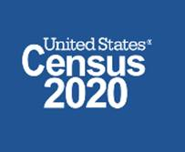
Spread the Word! The 2020 Census is more than a population count. It's an opportunity to shape your community's future! You can inspire others. Tell everyone—your friends and family, neighbors and co-workers — that you will complete the census, and that they should respond now, too!

September 30th is the end date!!!! We need to act fast!!!!

It is easy………….. Click the link here: https://2020census.gov/en.html

Every 10 years, the U.S. census generates a critical snapshot of America. “It is the only survey that asks every single household in the nation to respond, and this gives us the best picture we have of the nation’s current population, says Florencia Gutierrez, a senior research associate with the Annie E. Casey Foundation. The results are critically important because this once-a-decade census data helps businesses, researchers, and communities make decisions. The data will help lawmakers decide how much money your community gets for critical services.

The Census counts every person living in the country – citizens, noncitizens and green-card holders. Connecticut stands to lose approximately $2,900 for every person undercounted.

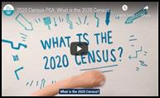
What is at stake here? Nearly $11 billion in federal funding allocations to Connecticut to be used for Medicaid, Medicare, Supplemental Nutrition Assistance Program (SNAP), community block grants, transportation and highway projects, energy assistance for seniors, and many other programs that families across the state rely on every day.

The work of our agency is very much connected to resource allocation. Yet, this is not just about money…The Department is committed to becoming a racially just organization. An accurate baseline accounting of who makes up the population in our state, and local communities, is critically important towards advancing our racial justice work.

Please act now as we encourage all of your families and the families we serve to participate!

The census questionnaire is secure, quick, and easy. You still have time to complete the Census! The 2020 Census is happening now and ends on September 30th!

Again…………..Click the link here: https://2020census.gov/en.html

