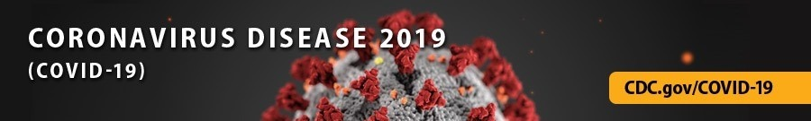

National Forum on COVID-19 Vaccine

  In support of the Biden-Harris Administration’s National Strategy for the COVID-19 Response and Pandemic Preparedness, the Centers for Disease Control and Prevention (CDC) is organizing a virtual National Forum on COVID-19 Vaccine that will bring together practitioners from national, state, tribal, local, and territorial levels who are engaged in vaccinating communities across the nation.
  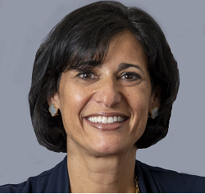
  Read Dr. Rochelle Walensky's letter

The Forum will support the Administration’s goals of mounting safe, effective, and comprehensive vaccine implementation strategies to protect those most at risk and advance health equity, particularly among communities that have been disproportionately affected by COVID-19.

Intended for practitioners focused on vaccine implementation, as well as people and groups that can champion vaccine uptake in communities, the Forum will facilitate information exchange on the most effective strategies to:

- Build trust and confidence in COVID-19 vaccines
- Use data to drive vaccine implementation
- Provide practical information for optimizing and maximizing equitable vaccine access

We invite you to be a part of this important event and join our collaborative effort. Registration is open from February 09-16, 2021. Read the CDC Director’s letter to learn more about the forum and register at: https://www.cdc.gov/coronavirus/2019-ncov/vaccines/forum/index.html.

