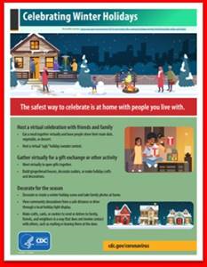
L Memorandum

To: All DCF Staff

From: Commissioner Vannessa Dorantes

Date: 12/20/2020

Re: Update on Department Operations and Commissioner Video

It’s the most wonderful time of the year.

The stress and strain the pandemic have made planning annual traditions and just everyday activity more stressful. Whatever the next week means to you & those you care about, visit the CDC: https://www.cdc.gov/coronavirus/2019-ncov/daily-life-coping/holidays/winter.html and State of CT portals for the latest advisories: https://portal.ct.gov/Coronavirus/Short-Animated-Videos

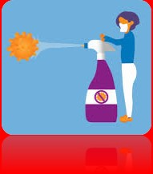
This week's video conversation will clarify some important points:
- Contact tracing in our workspaces
- Definition clarity and language evolution
- Close Contact
- How are the terms, "cleaning" "sanitizing" "disinfecting" different?
Please watch this week's video here è Commissioner's Update Video 12-20-20
Stay Tuned for an all staff memorandum this week on in-person activities of the Department.

Maintaining our high standards of productivity to balance our mission critical work with the health and safety of our workforce must apply UNIVERSAL PRECAUTIONS whether on our units, in administrative areas, in common areas or in the community:
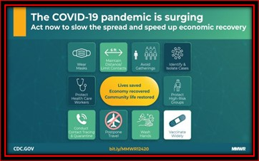
- Wash your hands often
- Wear PPE always
- Watch distance between you & all others

*Remembering before & after use car touchpoint sanitizing, seat spacing & air flow planning during transports has also been extremely helpful in minimizing spread. Cleaning products and Sanitizers should not be kept in cars as temperature extremes effect their potency!

Next discussion:
- 2020 year in review,
- COVID vaccine offering prioritization within CT DCF
- Kwanzaa (Dec 26th-Jan 1st) principles come through in some of our racial justice work
- How we are planning for CTDCF 2021.

Happy Hanukkah(this year Dec 10th-18th) & Merry Christmas (Dec 25th) to those who celebrate.
We will all get through this TOGETHER.
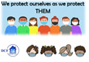VANNESSA L. DORANTES, LMSW
COMMISSIONER
CT DEPT OF CHILDREN & FAMILIES
505 HUDSON STREET
HARTFORD, CT 06106
commissioner.dcf@ct.gov (860)550-6300
" I do my best because I'm counting on YOU counting on me…"
m angelou

