Memorandum

To:        All DCF Staff

From:   Commissioner Vannessa Dorantes

Date:    9/6/2020

Re: Update on Department Operations and Weekly Video

Thank you to the over 1,900 staff who participated in our first ever Virtual ALL DCF STAFF meeting!!!

We had so much fun! Can't wait to SEE you all again!!!

 VIGILANCE …Click here for further updates =>  [Commissioner's Weekly Video 9-6-20](https://youtu.be/iZwLfwtojUw)

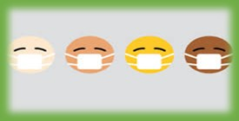The Department of Public Health has reminded us that schools are beginning to open, the weather is nice and we are in a holiday weekend. How do these facts connect to vigilance? We know that in certain areas around our state, the number of cases of COVID-19+ diagnosis have increased. We cannot let our guard down.

All 3,999 children/youth in care can now be the subject of the in-person visitation triage process. While outdoor visits are preferred, staff are permitted in the office to conduct visits or for other tasks. Offices remain closed to the public. Click here for more info on ➔ [Minimizing Risk During Visitation](https://portal.ct.gov/-/media/DCF/Agency/COVID-Emails/Visitation---Minimizing-Risk-Final.pdf)

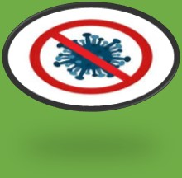Speaking of offices………………….The date of 9/15/20 has received a lot of questions from staff.  That date is the next stage target to measure increased productivity in our planning. To be clear, there is no firm date to have all staff physically return to an office. Multiple factors are at play here. Public Health science will continue to drive decisions as we move towards resuming our full functioning. It is mostly, *how* and *from where* we conduct some of our business that has changed.

This is also a vigilance reminder that it is a workplace requirement that masks are worn when you are conducting in-person work of DCF. Our workplace extends into communities, wherever you are interacting in-person with each other or the public, masks must be kept on. Questions about that should be directed to Human Resources.

The Department continues to have approximately 85% of our staff working remotely. This is an entitlement that can be revoked at any time.  A reminder is in order-- we must ensure vigilance in maintaining confidentiality of our records and case information.  This includes the discussions pertaining to the children and families we serve. Privacy expectations must be adhered to wherever our work is being conducted.

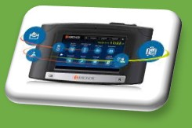

We are still in "practice mode" regarding the soft launch of Kronos……..

Please be patient, continue to send your questions to [DCF.KRONOS@ct.gov](mailto:DCF.KRONOS@ct.gov)

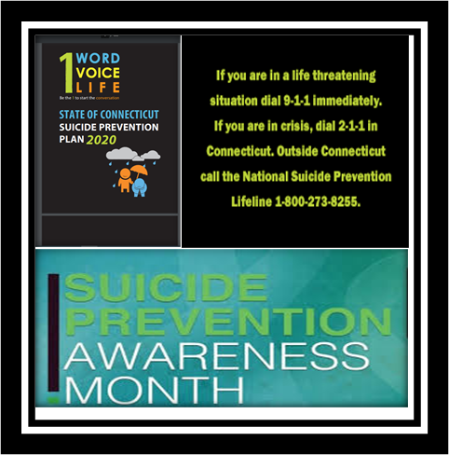Last but certainly not least, September is Suicide Prevention month.

Click here to read the=> [Connecticut State Suicide Prevention PLAN 2020](https://www.preventsuicidect.org/wp-content/uploads/2015/04/Suicide-Prevention-Plan.pdf) (PLAN 2020). It is a working document, designed to frame, organize, prioritize, and direct established and emerging suicide prevention efforts throughout the state through 2020. PLAN 2020 was developed through the ongoing efforts of an expanding group of professionals and suicide survivors who meet regularly as part of the Connecticut Suicide Advisory Board (CTSAB), and of the Statewide Network of Care, under the direction of Co-Chairs from the Connecticut Departments of Mental Health and Addiction Services (DMHAS) and Children and Families (DCF).

Please review this plan and contact [Tim.Marshall@ct.gov](mailto:Tim.Marshall@ct.gov) ,Director Office of Community Mental Health with questions about DCF's work in this area. More information will be shared throughout the month. <https://www.preventsuicidect.org/materials/>

Please continue to take care of yourself and each other. #DCFstrong

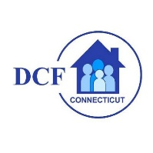**VANNESSA L. DORANTES, LMSW**

COMMISSIONER

CT DEPT OF CHILDREN & FAMILIES

505 HUDSON STREET

HARTFORD, CT 06106

[commissioner.dcf@ct.gov](mailto:commissioner.dcf@ct.gov)  (860)550-6300

*" I do my best because I'm*counting on *YOU counting on me…"*

*m angelou*