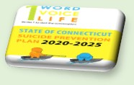Memorandum

To:          All DCF Staff

From:    Commissioner Vannessa Dorantes

[](https://www.preventsuicidect.org/)Date:     9/27/2020

Re:         Update on Department Operations and Weekly Video

[](https://www.recoverymonth.gov/)As Recovery Month comes to an end, we are once again highlighting the strength of those who have accessed supports and changed their lives. In a story found in the next *Spotlight on What's Right* newsletter, you will read about a young mother who has faced many challenges in her life. Due to the collaborative efforts of the Department, and a community partner, she is now raising her little boy while she is in recovery. She tells us, in her own words, *"I did it. No one else… Greatest feeling in the world."*

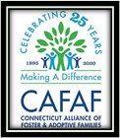Her story also highlights the roles extended family members can play. September is also known as Kinship Placement Month. CT DCF remains proud that over 40% of the children in our care are placed with relatives. However, with an aspirational goal of **70%**, we still have much work to do! You will soon hear more about the Quality Parent Initiative (QPI) and other adjustments being made to our overall Kinship model. Children thrive with actively involved family members in their life. Engagement of relatives, in every aspect of case planning, provides the best supports for children in the long run. (*CAFAF's annual conference is going virtual this year Oct 23rd -24th! Go to their website* [*https://cafafct.org/*](https://cafafct.org/) *to learn more about the upcoming conference and supports for kinship care!*)

Reflecting on the stops along our Listening Tour 2.0, we have heard about the families of our own staff… CT DCF's mission critical work and the responsibilities of everyday family life has been our priority.  With children back to school, many in our workforce are balancing work, school, childcare and much more.  We are all trying our hardest to stay safe and healthy.  I continue to be in awe of you.  The support you are giving each other as well as to the children and families we serve **is** the DCF I know.  **Together** we will make it through the *storm*!

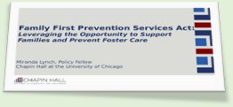On Tuesday, we look forward to hosting our Family First State Prevention Plan Development **re-launch**.   Over 500 community partners and DCF leadership will come together to collaborate in building the best system to provide supports to Connecticut's children and families. This planning process, interrupted by the pandemic, involves creativity and *the will* for reforms.

All voices being heard especially those who have lived-experience with various systems. The current crisis has illuminated the need for sustained, easily accessible services -- provided in equitable fashion, across our communities.

We look forward to getting back to work on this!

Many in our workforce have been required to leave their homes and report physically to our buildings, many others are now doing so to conduct more work of the Department.  Staff may be required to return to a location for longer periods of time to complete certain aspects of our work.

For example, as the weather gets cooler, some supervised visits are moving inside. It is important that your chain of command is aware of your intentions as the Director in each location is responsible to monitor the amount of staff actually in the building.

Special thanks to **Engineering** for making sure our buildings are Safe & Sound too!

The triage processes are to be used to step through in-person activities to mitigate potential transmission points. Do not wait until *during* the in-person activity to trouble shoot…

**PLAN AHEAD TO REDUCE THE SPREAD.**

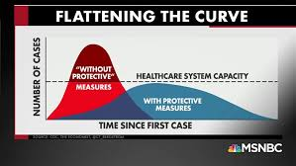As a reminder, wearing PPE, social distancing guidelines and hand hygiene are workplace requirements. Cold and flu season are also upon us. Staff are strongly advised to get a flu shot at any healthcare location that accepts our insurance.

Click here to view the weekly video update ➔  [Commissioner's Weekly Video 9-27-20](https://youtu.be/uJwA2xyhk8c)

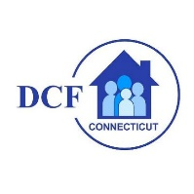**VANNESSA L. DORANTES, LMSW**

COMMISSIONER

CT DEPT OF CHILDREN & FAMILIES

505 HUDSON STREET

HARTFORD, CT 06106

[commissioner.dcf@ct.gov](mailto:commissioner.dcf@ct.gov)  (860)550-6300

*" I do my best because I'm*counting on *YOU counting on me…"*

*m angelou*