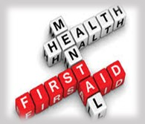
Memorandum

To: All DCF Staff

From: Commissioner Vannessa Dorantes

Date: 9/13/2020

Re: Update on Department Operations and Weekly Video

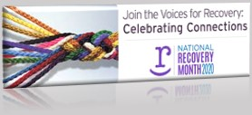
In September, we celebrate National Recovery Month established to increase awareness and lift the stigma of those who are challenged by mental and substance use disorders. We use this time to acknowledge the collaborative efforts of the Department as well as our community partners including sister state agencies.
Our work is humbling, yet we can never underestimate the power of the human spirt. September training slots open for the AWD's offerings on self-care, reflective supervision and psychological first-aid. Click here to register
Congratulations to our Intake staff! This past week, the Juan F Consent Decree's Investigations Outcome Measure was pre-certified! The Court Monitor reported, "The review demonstrated that the Department makes strong efforts to interview children and families in a timely manner, conduct appropriate formal and informal assessments, offer services as needed, and document the resulting findings in the case record." In that report, you will also see my statement of our work over the past 6 months. View that statement here: Commissioner's Statement for Juan F. v Lamont Exit Plan Status Report

The Monitor's findings are also a reflection of the active leadership we have. Thank you to all of our Supervisors, Program Supervisors, Directors, Superintendents, & Administrators for your purposeful efforts!
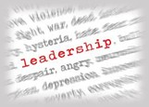
Speaking of leadership………………
this week we have our 2nd Leadership Summit.
In what feels like a lifetime ago, in January, Department leadership came together to discuss Vision 2020. Could we ever have imagined our work where it is today?
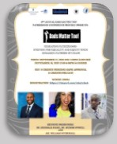
The theme continues to be focused on outcomes & the advancement of our work towards becoming an anti-racist and racially just organization.
This coming week will also bring our annual Fatherhood Conference on Thursday and Friday. This year in a virtual environment, is yet another opportunity to share with colleagues, stakeholders, partners and yes- fathers, about how to enhance our work. Come hear more innovative ways to develop a culture of inclusion and empowerment of fathers in their lives of their children and in our case planning.
CTDCF continues to be a fatherhood practice leader across the country as demonstrated in the CT Fatherhood Initiative https://portal.ct.gov/fatherhood and in our Region 4's participation in a Fatherhood Breakthru Series multi-jurisdiction collaborative.
Register for this year's conference here: https://tinyurl.com/y6y3ckx6

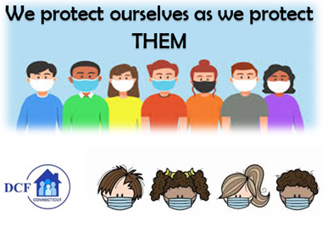
You will also hear in ➔ Commissioner's Weekly Video 9-13-20
the most recent Department data update on COVID-19 positive diagnoses.
This brings us once again to a simple reminder for all of us - remain vigilant in our personal and professional lives.
We cannot lose focus of virus transmission.
Please continue to take all necessary precautions to reduce the spread!

Have a great week everyone!

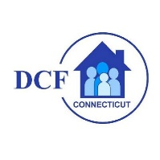
VANNESSA L. DORANTES, LMSW
COMMISSIONER
CT DEPT OF CHILDREN & FAMILIES
505 HUDSON STREET
HARTFORD, CT 06106

commissioner.dcf@ct.gov (860)550-6300
" I do my best because I'm counting on YOU counting on me…"
m angelou

