Memorandum
To: All DCF Staff

From: Commissioner Vannessa Dorantes
Date: 5/7/2021

Re: Update on Department Operations & Weekly Video

Happy Mother's Day weekend to all Mothers ---
Mothers who have had to take on a few extra roles this year…Those who play the role of Mother…Moms who 'stand in the gap' for children who are separated from their Mother ---
We appreciate you and all you do EVERY DAY.

Speaking of mothers, we also celebrate Foster Care Appreciation Month. To all foster mothers who provide children compassionate, loving care. For assisting in reunification and maintaining the parent/child connections - THANK YOU!

I was excited to connect with close to 1700 of you on this past Monday.
ICYMI: Take a look here➔ DCF Town Hall Meeting

"Mental Wellness is Healthcare" is a quote I have said many times - repeated across our state. We are also in Mental Health Awareness month and this coming Monday; we are having our Children's Behavioral Health Summit! We will hear from leaders across the state on how to collectively strengthen the children's behavioral health network as children bounce-back from an entire year of toxic stress.

A huge shout out to our Teachers!
What a year you have had
They have taught kids in masks ….
And had to adapt student tasks
Teaching in a room ….
Or sometimes over ZOOM,
Teachers miss what used to be fun…
We appreciate you more in 2021!

We are also in the middle of Nurses Week -
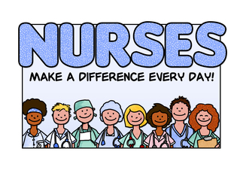
Thank You doesn’t seem nearly enough to reflect on the how you have gotten all of us through the last 14months! We are appreciative of our area office nurses for helping us understand the nuances of COVID -- contact tracing, vaccine -- and everything in between. We are especially thankful to the Healthcare teams at our facilities like Nurse Gloria Jones at North who coordinated protocols and testing schedules as well as our dedicated staff at South who have worked so tirelessly while we address staffing challenges. We are grateful for YOU!

Please watch this => Commissioner's Biweekly Video 5-7-21 for information including:
- Upcoming communication from Governor Lamont regarding restrictions lifting in CT and what that means for us
- Anticipated Emergency Use Authorization planning to make vaccine available for children 12 & older
- Connecticut's pandemic response highlighted at the Child Welfare League of America conference
- COVID 19 trends and statistics for the Department
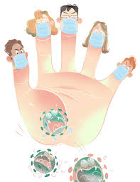
SAFETY ~ PREPARATION ~ PLANNING

See you in about a week for a special edition video with more details on ReEntry to our workspaces

VANNESSA L. DORANTES, LMSW
COMMISSIONER
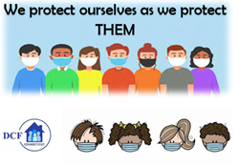
CT DEPT OF CHILDREN & FAMILIES
505 HUDSON STREET
HARTFORD, CT 06106
commissioner.dcf@ct.gov (860)550-6300
" I do my best because I'm counting on YOU counting on me…"
m angelou

