Memorandum

To: All DCF Staff

From: Commissioner Vannessa Dorantes

Date: 4/25/2021

Re: Update on Department Operations and Weekly Video 4_25_21

Staying connected in a virtual environment is difficult…
Communicating effectively to close to 3000 staff members--- even harder.

Through our covid 19 mailbox and from a couple of the labor unions, we have heard your responses to recent messaging. Also, well over 1600 telework surveys have been received -- (There's still two more days to register your feedback à DCF Teleworking Survey 2021)

Our messaging surrounding in-person contacts and re-entry capacity in our offices needs a bit of clarity. Please watch this à Commissioner's biweekly video 4-25-21 for updates on all of that as well as:

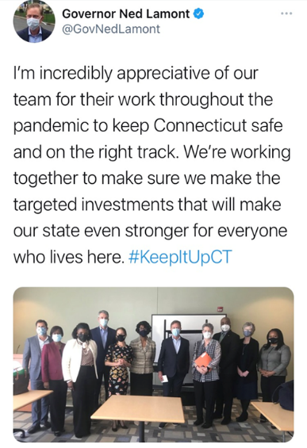
- Thursday of this week DCF is partnering with various faith-based, academic and community organizations together with The Office of the Gov and DMHAS for our 4th collaborative discussion entitled "Healing Strategies: Public Health Crisis, COVID-19 and Racism". This next conversation's theme focusses on the experiences of Black and Brown males ages 12-22 years old. Hear perspectives as someone who identifies in this group or as an observer to learn more about their experiences over this past tumultuous year. To register & for more information, click hereà Let's Talk Part 4.0, A virtual Community Conversation

- Speaking of DMHAS…………Congratulations to my dear colleague, Commissioner Miriam Delphin-Rittmon, for being nominated by the Biden Administration to lead SAMHSA!!! That is the federal agency responsible for policy related to Substance Abuse and Mental Health Services Administration. This is yet another example of CT's leaders setting the path forward for our country.

- Last Friday, I joined Governor Lamont, Lt Bysiewicz and colleagues from our 'sister state agencies' to hear the administrations recommendations on how funding from the American Rescue Plan Act of 2021 will transform the state over the next three years. Listen here to what I said about what is needed to lift families out of the pandemic's shadow
http://ct-n.com/ctnplayer.asp?odID=18551&jump=0:17:24
- The most recent data learned during contact tracing of our staff, foster parents and children in care.
- Connecticut leads the country in vaccine doses per 100 people. As we push towards herd immunity, we are still cautioned to remain vigilant and protective in our daily routines and habits. The state is crawling safely back to some level of normalcy. We will get there TOGETHER.

Thank you all for prioritizing the safety and well-being of CT's children as we continue to navigate our way through the end of this.

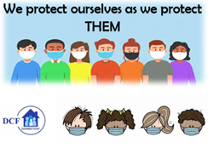
VANNESSA L. DORANTES, LMSW
COMMISSIONER
CT DEPT OF CHILDREN & FAMILIES
505 HUDSON STREET
HARTFORD, CT 06106
commissioner.dcf@ct.gov (860)550-6300
" I do my best because I'm counting on YOU counting on me…"
m angelou

