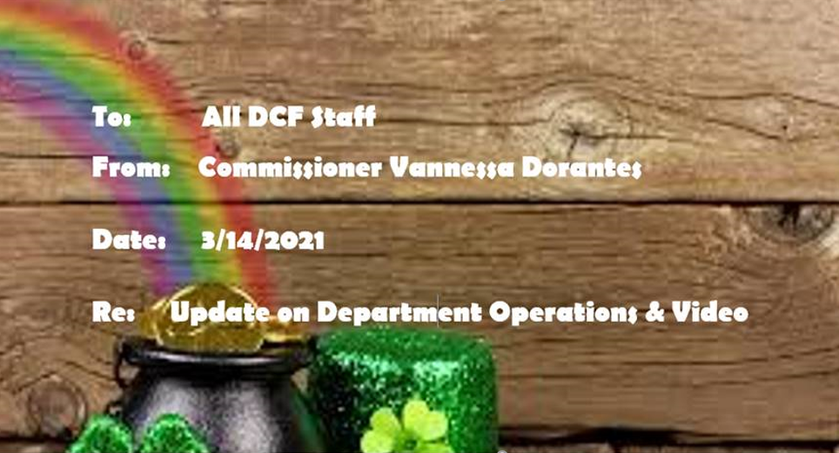
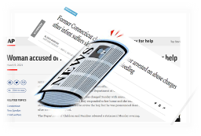
Spring forward and watch this➔ Commissioner's Bi-Weekly Video 3-14-21 as we reflect on approaching one full pandemic year through some recent highs & lows of:
- COVID fatigue relay race
- Media representation --
  - From Gov Lamont's signing of CROWN Act into CT law https://www.fox61.com/video/news/local/crown-act-into-law-signed-into-law/520-8701db13-0013-4237-afea-bf50ac7747f0 ,
  - a great adoption story of an older youth in care https://www.wtnh.com/on-air/connecticut-families/you-are-now-us-teen-finds-forever-home-with-60-year-old-adopted-parents-in-new-milford/ to
  - Headline news stories framing the Department's role in two families experiencing negative outcomes for their respective children
- Women's History Month & Social Worker Appreciation Month afford the opportunity to highlight-
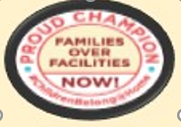
  - permanency outcomes achieved through reunification, adoption & everything in between
  - Dept testimony at virtual legislative public hearings
- An example of our core values recognized nationally-- Children's Rights published a report entitled, "Families over Facilities"
click ➔https://bit.ly/FamiliesOverFacilitiesCR to read. With the tireless commitment of our community provider partners, we balance maintaining children safely within a family & using congregate settings for time-limited, treatment options.

This is very humbling work and It's all relative ….

STAY THE COURSE WORK/LIFE BALANCE  REMAIN VIGILANT MISSION CRITICAL FOCUS

I remain proud of you & the work that happens within this agency Not by chance or luck… It is with purpose, pride & competent SKILL.

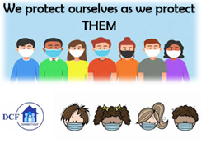
VANNESSA L. DORANTES, LMSW
COMMISSIONER
CT DEPT OF CHILDREN & FAMILIES
505 HUDSON STREET
HARTFORD, CT 06106
commissioner.dcf@ct.gov (860)550-6300

