Memorandum
*Apologies to our "regulars" for any disruption to your routine by not sending this at our regular time!
To: All DCF Staff

From: Commissioner Vannessa Dorantes

Date: 2/28/2021

Re: Update on Department Operations and Weekly Video

Entering Social Worker Appreciation & Women's History Month we continue to mark pandemic-time.

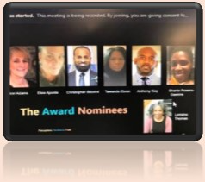
Black History Month celebrated Black history, art, cuisine, music & trailblazing innovation through powerful spoken word, songs, virtual classes, testimonials and even Black History Jeopardy!

Congratulations to DCF New Britain SW Christopher Bidorini, the recipient of this year's Dr. Janet Williams Humanitarian Award

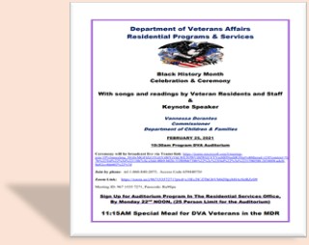
We were also honored to partner with the CT Department of Veteran's Affairs in their annual event recognizing impact of Black Military members and associated Black history. We thank Commissioner Saadi for the invitation & thank all veterans for their service!

In our most recent newsletter, we highlight appreciation for 3 remarkable women. Read who they are & why they are referred to as a "lighthouse in this fog "

Click here=è Spotlight On What's Right - February 2021 Edition

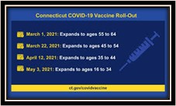
This week's video provides the latest info on the COVID 19 vaccine
Click hereèCommissioner's Bi-Weekly Video 2-28-21

Find a vaccination clinics near you, visit è ct.gov/covidvaccine, and enter your zip code. Those who do not have access to the internet can call Connecticut’s Vaccine Appointment Assist Line at 877-918-2224.
The line is open seven days a week from 8:00 a.m. to 8:00 p.m.

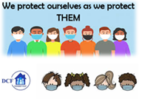
VANNESSA L. DORANTES, LMSW
COMMISSIONER
CT DEPT OF CHILDREN & FAMILIES
505 HUDSON STREET
HARTFORD, CT 06106
commissioner.dcf@ct.gov (860)550-6300
" I do my best because I'm counting on YOU counting on me…"
m angelou

