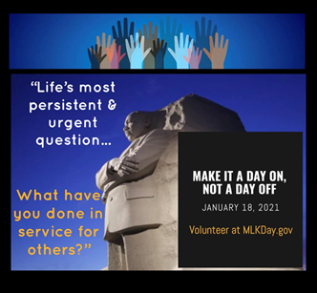
Memorandum

To: All DCF Staff

From: Commissioner Vannessa Dorantes

Date: 1/17/2021

Re: Update on Department Operations and Video

Thank you all in your commitment to serve those most vulnerable in our communities. As Dr. King challenged the world, may we continue to strive to do so equitably and justly. Appreciation always extended to our 24/7 staff who work around the clock on behalf of children & families.

This week we will provide further clarification on these topics:
- What CT's Phase 1B of vaccine roll-out means for DCF
- Important trends learned via contact tracing to mitigate the spread of COVID-19
  - Face shield and surgical mask must be worn if an individual whom we are interacting is not wearing a mask
- Reminders for Foster parents
  - All occupants in foster homes must wear masks during placements or visits by our staff
  - reinforce mask wearing for children in care

- Car cleaning products-- before and after each use and stored indoors
- Remembering a staff member lost
- Department pandemic data
- SAFETY PRECAUTIONS up to and including this historic Inauguration Day
  - Teleworking
  - Visits into the community
Click here to watch è Commissioner's Video 1-17-21
We will get through this TOGETHER.

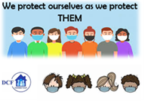VANNESSA L. DORANTES, LMSW
COMMISSIONER
CT DEPT OF CHILDREN & FAMILIES
505 HUDSON STREET
HARTFORD, CT 06106
commissioner.dcf@ct.gov (860)550-6300
" I do my best because I'm counting on YOU counting on me…"
m angelou

